Vegetable Production Tech Training Enhances Farming Prospects in Pulang Bato
Empowering communities through agriculture and sustainable livelihood

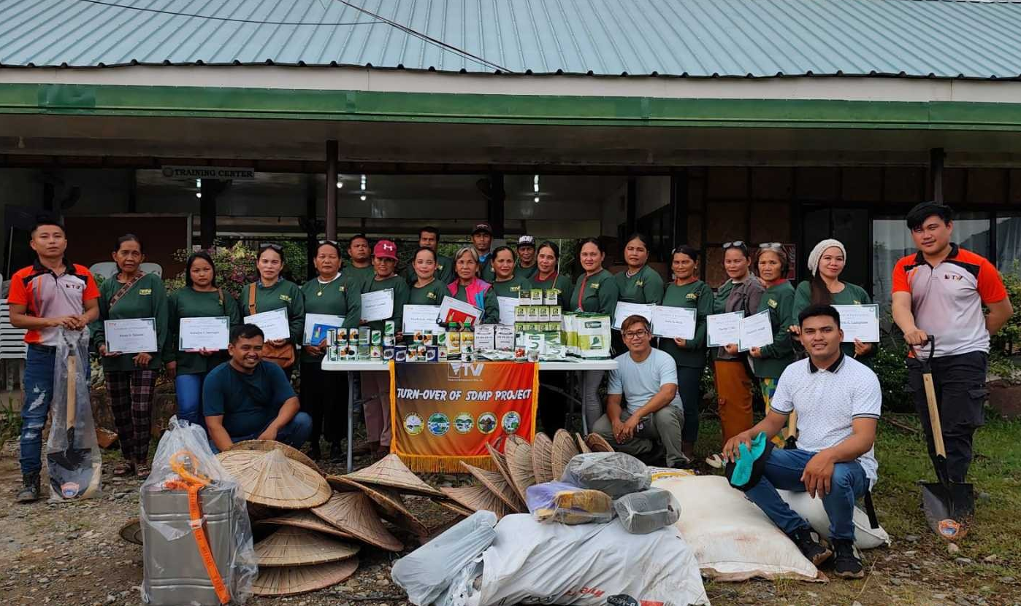
Local farmers, residents, and members of the Pulang Bato Farmers Association received farm implements and starter kits from TVIRD in partnership with the company’s SIDLAK Techno Demo Farm – all for sustainable farming and strengthening community livelihood.

Bayog, Zamboanga Del Sur / June 2025 – Key officers of the Balabag Gold-Silver Project of TVI Resource Development Philippines Inc. (TVIRD), in partnership with the company’s SIDLAK Techno Demo Farm, conducted a training course on the Technology Package for Vegetable Production last June 2–3 in Barangay Pulang Bato of host Bayog Municipality. The said training geared towards sustainable farming consisted of lectures and hands-on sessions that provided participants with a comprehensive understanding of technology and practical farming experience.

Sustaining traditional livelihood
The training was supported by the Local Government Unit of Bayog through the Department of Agriculture (DA) and its local Public Employment Service Office (PESO) – an interagency cooperation that promotes farming as a traditional livelihood of inland communities that has been passed down through generations. A total of 25 participants, primarily farmers, members of the local women’s association and Indigenous Peoples, actively joined the two-day sessions led by trainer Jayson P. Villegas.
The innovative agricultural training equipped local farmers and residents alike with practical skills that not only ensure food security and supplement livelihood income, but also empower participants to engage in more efficient and sustainable farming.
“I am very grateful to have participated in this training, and thank our trainer, Mr. Villegas, for sharing his knowledge with us – for explaining to us how to plant vegetables and how to properly use fertilizers and pesticides for our crops,” said Elvira P. Galvez, a resident farmer of Pulang Bato and program beneficiary.
By ensuring higher productivity, better quality, and improved marketability of crops, the program strengthens food security and creates alternative income opportunities reflecting TVIRD’s broader goal of community empowerment and resilience.

A Lasting Legacy
To ensure the sustainability of the program, participants received seeds, fertilizers, pesticides, and basic tools to aid them in their daily farming activities. Additionally, SIDLAK continues to provide weekly monitoring and guidance, establishing a long-term support system for more sustainable livelihood.
“The program promotes self-sufficiency and supports sustainable practices for long-term livelihood that help both the farmers and the environment,” said TVIRD SIDLAK Farm Specialist Joel Lucmong.
Deeply-rooted in the company’s Social Development and Management Program (SDMP), the initiative prepares host communities for a sustainable post-mining economy by preventing food scarcity and addressing limited technical knowledge. By transforming idle land into productive gardens, the beneficiaries are better prepared for the future beyond the life of the mine.

*******

Press Photos

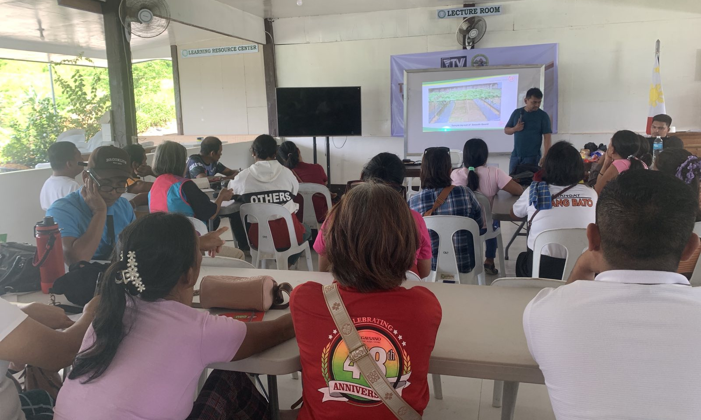
- Trainer Jayson P. Villegas demonstrates proper vegetable planting techniques during the two-day training conducted by TVIRD and its SIDLAK Techno Demo Farm, with support from LGU-Bayog, the Department of Agriculture, and PESO.

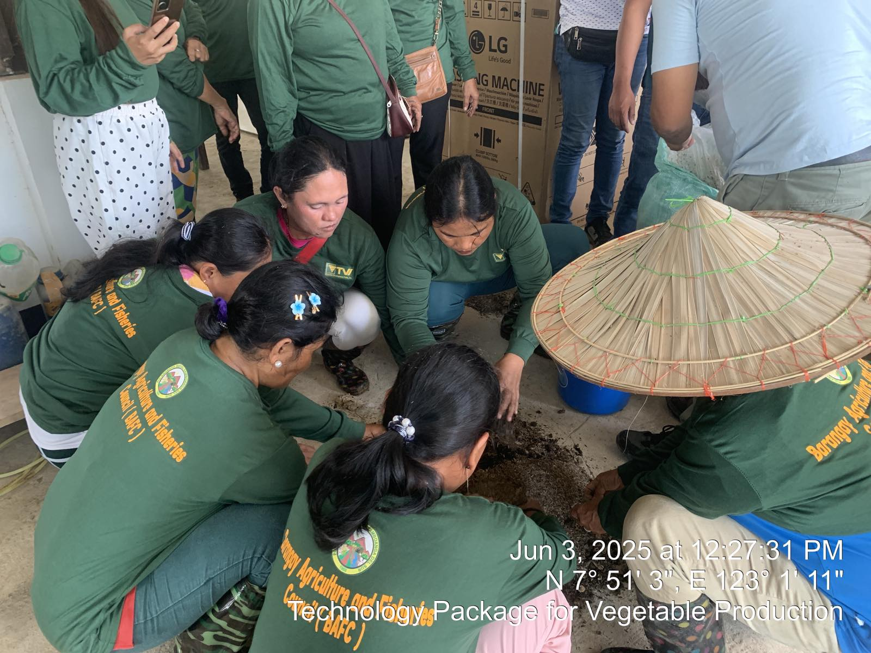
- Beneficiary farmers of the training are immersed in practical demonstrations on sustainable vegetable production.

- 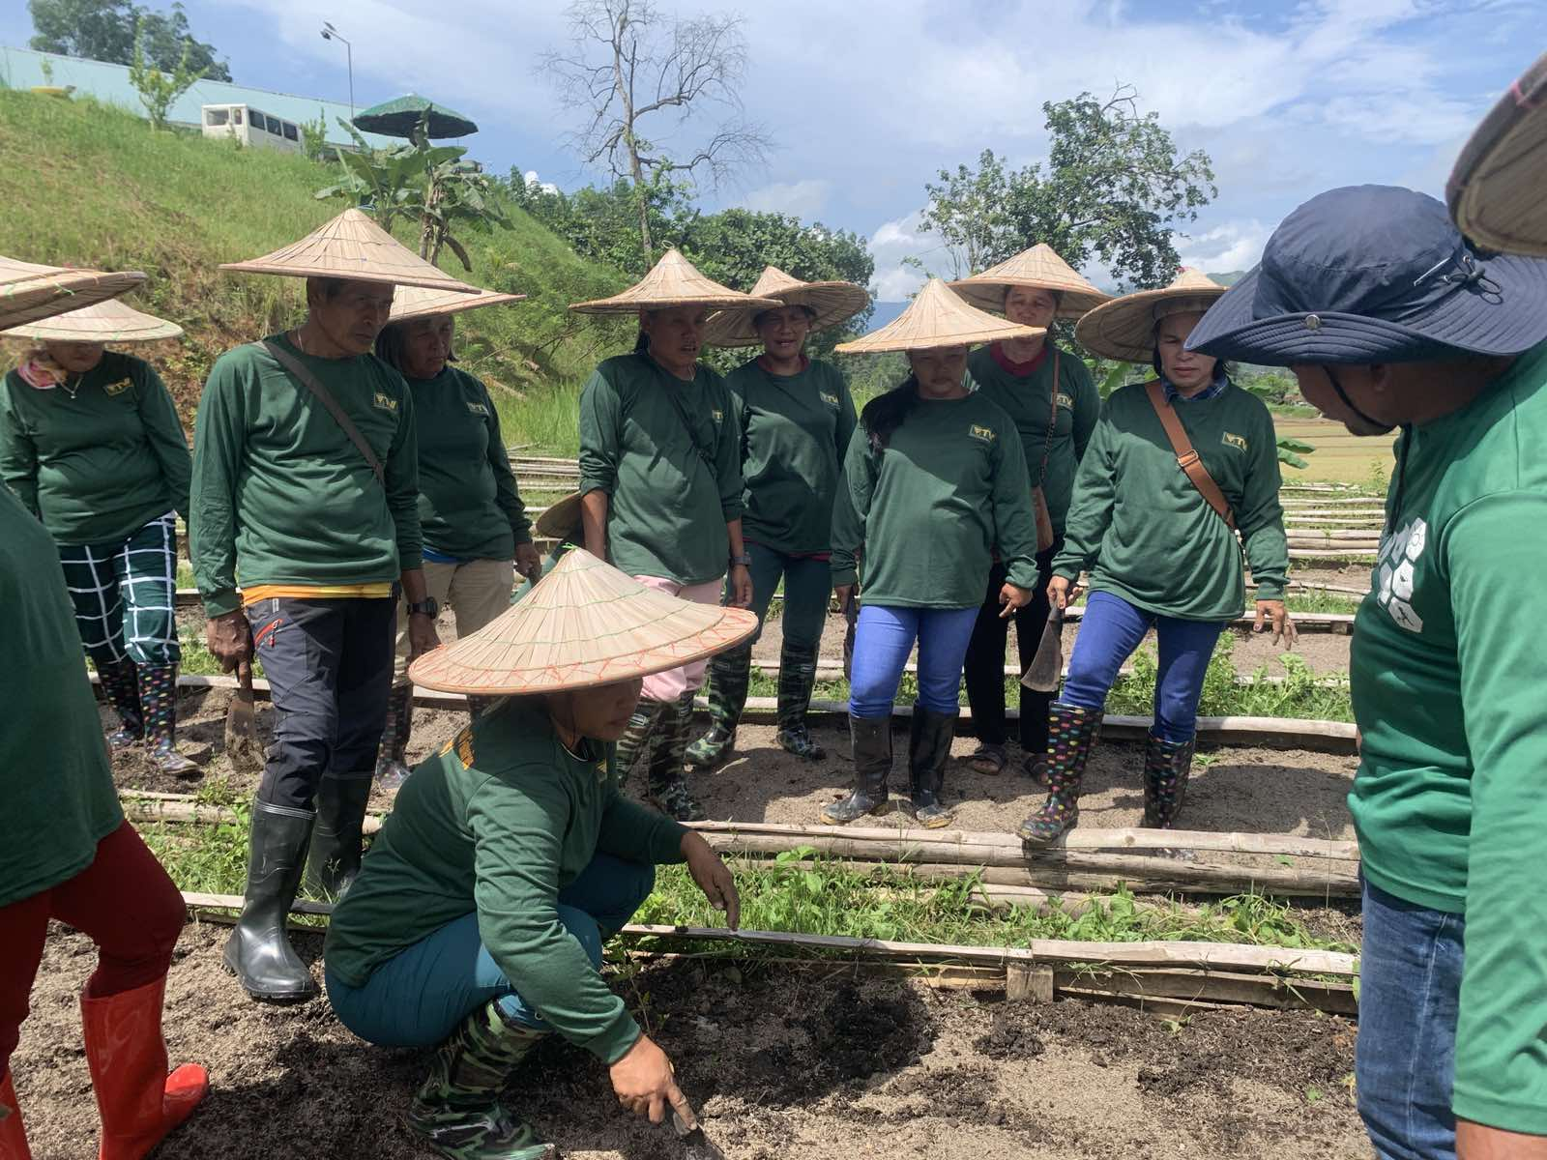
Hands-on learning. Farmers from Barangay Pulang Bato apply their training on vegetable production during interactive field sessions.

About TVI in the Philippines

TVI Resource Development Philippines Inc. (“TVIRD”) is owned in part by TVI Pacific Inc. (TSX: TVI), a publicly-listed Canadian mining company focused on the exploration, development, and production of precious and base metals from district-scale, large-system, high-margin projects located in the Philippines. Concurrent ownership of ventures is shared with partner company Prime Resource Holdings Inc.

The Agata Nickel Laterite Mine is the third successful mining project that TVIRD brought on stream in a period of 10 years, while its Balabag Gold-Silver Mine further cements its position as a steady producer of precious metals in the country. With the commercial operations of its Siana Gold Mine, the company remains committed to exploration and mining practices that promote transparency, responsible stewardship of the environment, and the inalienable rights to life, dignity and sustainable development of its host communities.

www.tvird.com.ph
Contacts:

KAYCEE CRISOSTOMO  Corporate Communications Director  TVI Resource Development Phils., Inc.  Email: kaycee.crisostomo@tvird.com.ph  Phone: +63 2 8728-8491  Mobile: +63 917 579-1528  Fax: +63 2 8728-8515 | BRANDON LOPEZ  Corporate Communications Officer  TVI Resource Development Phils., Inc  Email: Brandon.Lopez@greenstoneresources.com.ph  Phone: +63 2 8728-8491  Mobile: +63 946 068-4772  Fax: +63 2 8728-8515

