ONE YEAR LATER: Greenstone Remembers TSF 3 Incident with Stronger Commitment to Safety and Resilience
Commemorating the past, strengthening the present, safeguarding the future. A tribute to lessons learned and a future built in safety.

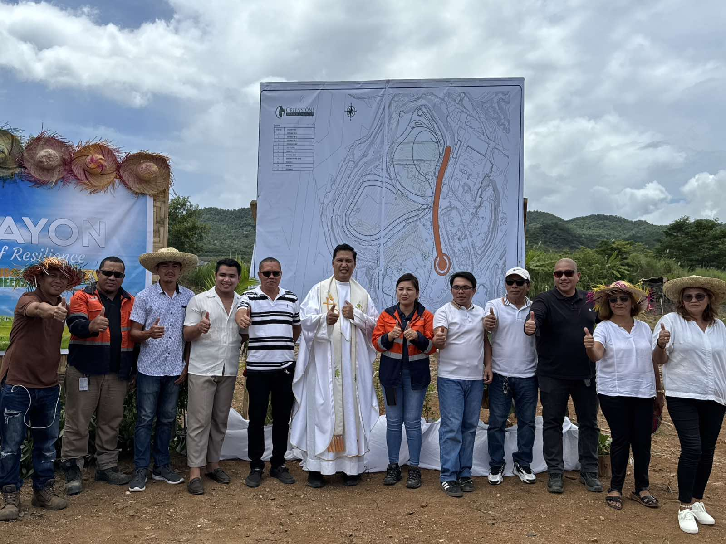
In Photo: Greenstone’s Management team led by Engr. Anthony Quijano together with the Barangay Siana Council and Father Ibale of Diocese of Surigao posing together as they say “Padayon – A Pledge of Resilience” in the proposed ornamental park in the TSF 3 embankment.

Siana, Mainit, Surigao del Norte/ May 2025 — One year since the tailings embankment slippage incident at Tailings Storage Facility 3 (TSF 3), TVI Resource Development Phils., Inc’s wholly owned subsidiary Greenstone Resources Corporation (GRC), the operator of the Siana Gold Project, held a solemn commemoration to honor the milestone of resilience, response, and renewed commitment to operational safety.

On May 11, 2025, employees, contractors, and leaders of Greenstone gathered at the TSF 3 area in the Siana mine site for a commemorative program that served not only to remember the lessons of the past but also to reflect on the collective strength that brought the company and its stakeholders through the crisis. The event was marked with a moment of silence and the laying of a symbolic wreath to honor the safety efforts that prevented any loss of life during the incident.

Remembering the Day
The TSF 3 incident on May 11, 2024, was an unprecedented challenge for Greenstone—a structural failure in the embankment wall, triggered by intense rainfall and geotechnical instability of Surigao del Norte being lying in the infamous Philippine Faultline system, led to the displacement of tailings materials. Despite the magnitude of the event there has been no reported casualties nor injuries due to Greenstone’s pre-established emergency response protocols and swift communication allowed for the timely evacuation of residents and personnel in nearby areas and given immediate needs such as water, shelter and hot meals.

The Commemoration
During the anniversary program, Safety and Health Manager Engr. Aldrin B. Arieta, who led the Emergency Response Team during the incident, recounted the coordinated efforts that unfolded on that day. “It tested not only our systems but also our values. We are proud that no lives were lost, and even prouder of how everyone responded—with professionalism, urgency, and care.”

Since the incident, Greenstone has made significant strides in reinforcing its safety systems. The company engaged third-party geotechnical experts to reassess all tailings facilities, conducted in-depth structural upgrades, and enhanced its Emergency Preparedness and Response Plan. Moreover, community consultations, regular information drives, and multi-sectoral drills have been institutionalized as part of Greenstone’s integrated safety culture.

Speaking on behalf of the management, the President and Concurrent General Manager Engr. Anthony Quijano shared, “This is more than a remembrance. This is a commitment—a promise that we will continuously improve. We do not take safety for granted. This anniversary is about transformation driven by responsibility.”

As part of the commemoration, a handprint wall was made near the reconstructed section of TSF 3, containing a promise and hope of a better and resilient Siana community from Greenstone’s management team and Barangay Siana Council to uphold the highest standards of environmental and occupational safety.

How is Siana today?
One year later, Greenstone stands not only with strengthened embankments but also with strengthened resolve—to never forget, and to never stop improving.

This year, the TSF 3 Embankment had made its groundbreaking idea into reality by making it as an ornamental park resembling a shape of a butterfly signifying metamorphosis and hope with a gazebo in the center to make it as a center of attraction for meeting, seminars, and even livelihood trainings of Greenstone’s Mabakas Techno-Demo Farm. A first ever TSF rehabilitation that turned into a nature park.

Meanwhile, the Greenstone management had given houses to the directly affected families of the recent incident which was turned over last March and April this year at a new place in Siana called “Villa Resilient.”

Press Photos

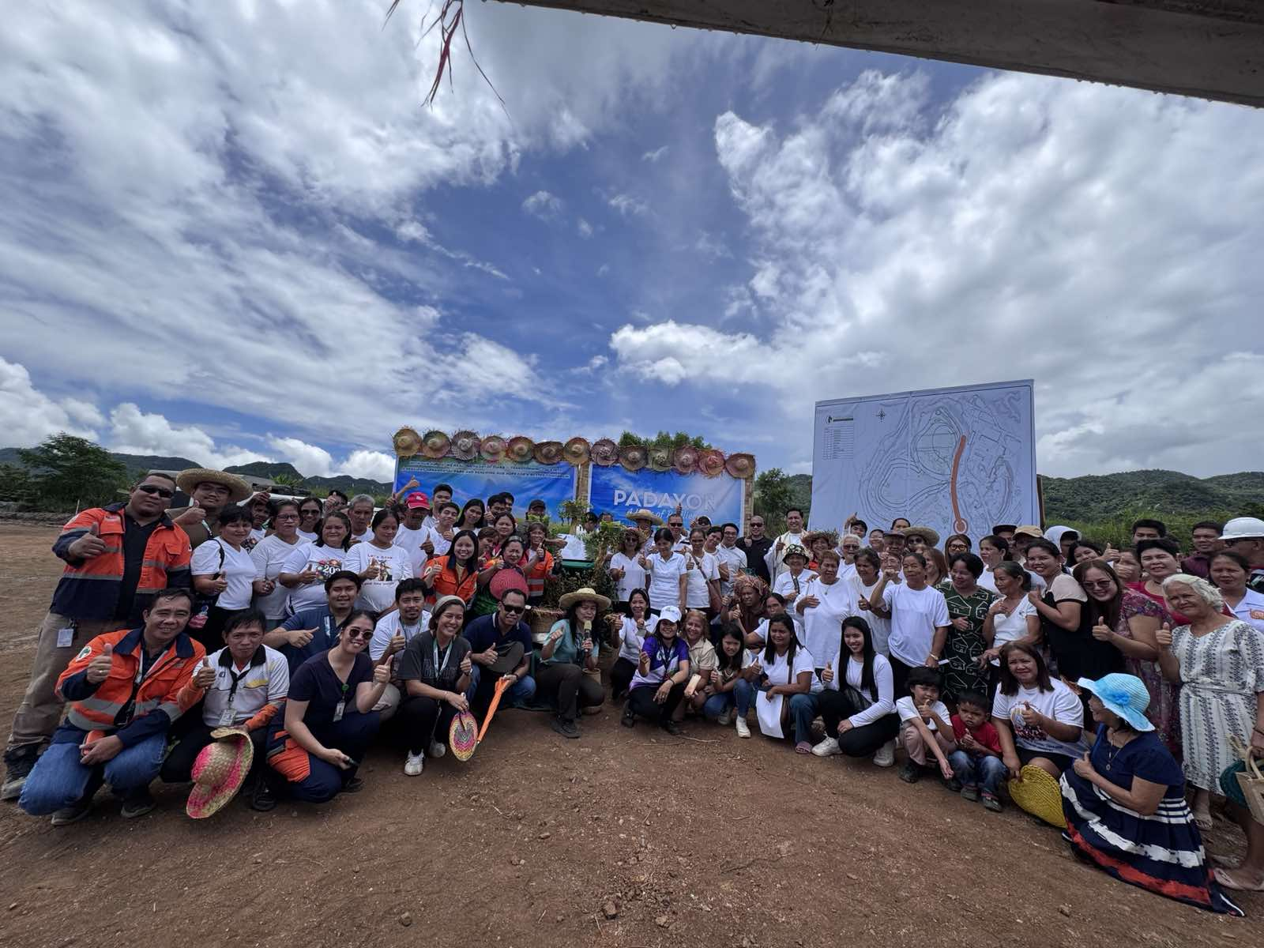
- Greenstone employees and Siana residents poses together for a better and resilient tomorrow of TSF 3.

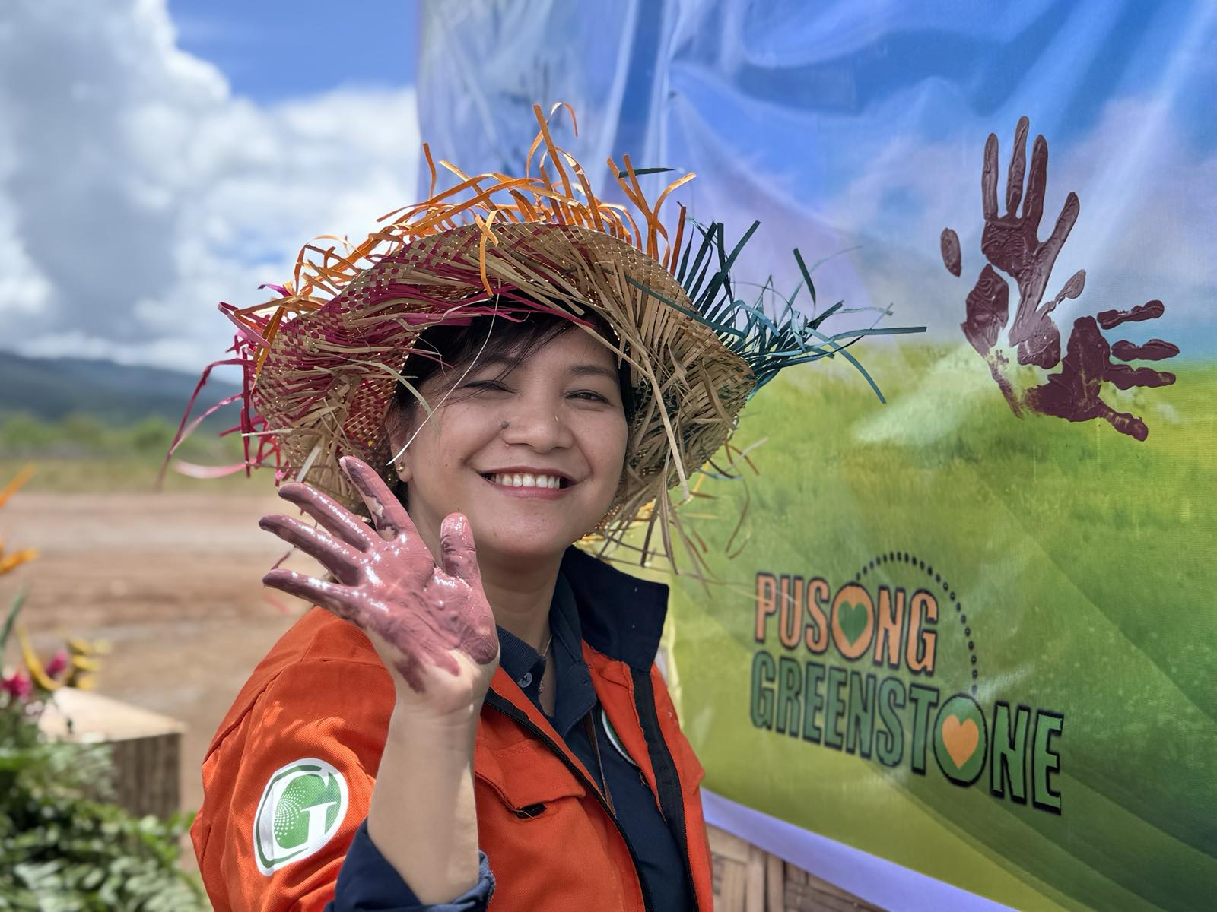
- In Photo: TVIRD’s Director for Tenement Management and Environmental Compliance Jesalyn Guingguing, EnP gave her utmost support to the commemoration and Ornamental Park unveiling by putting her handprint into the resilient board.
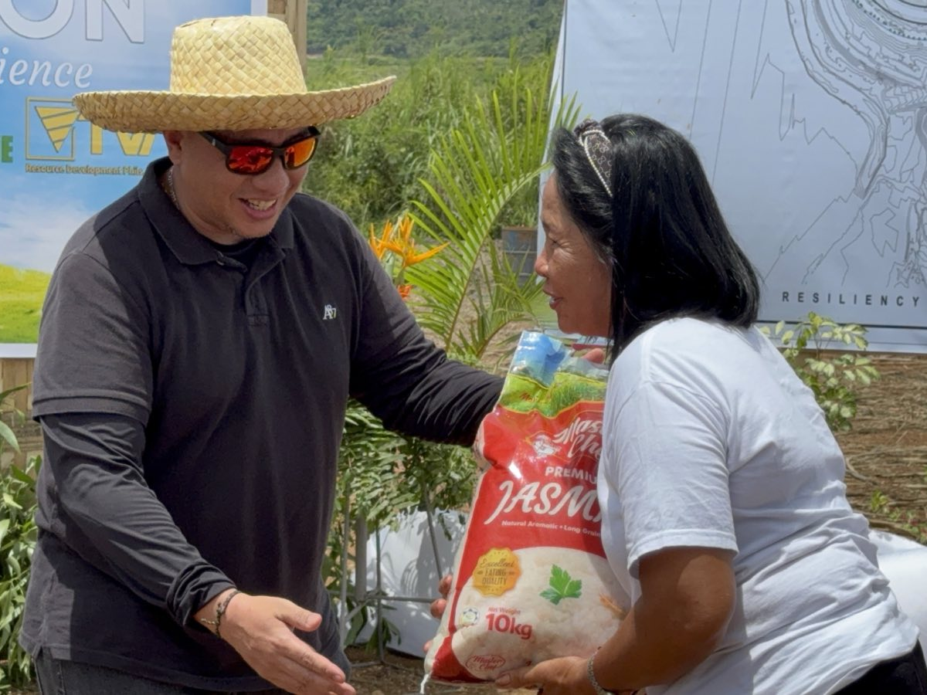
- Greenstone’s President and Concurrent General Manager Engr. Anthony Quijano handing out a sack of rice as a part of the company’s continuous support to the Siana Residents.
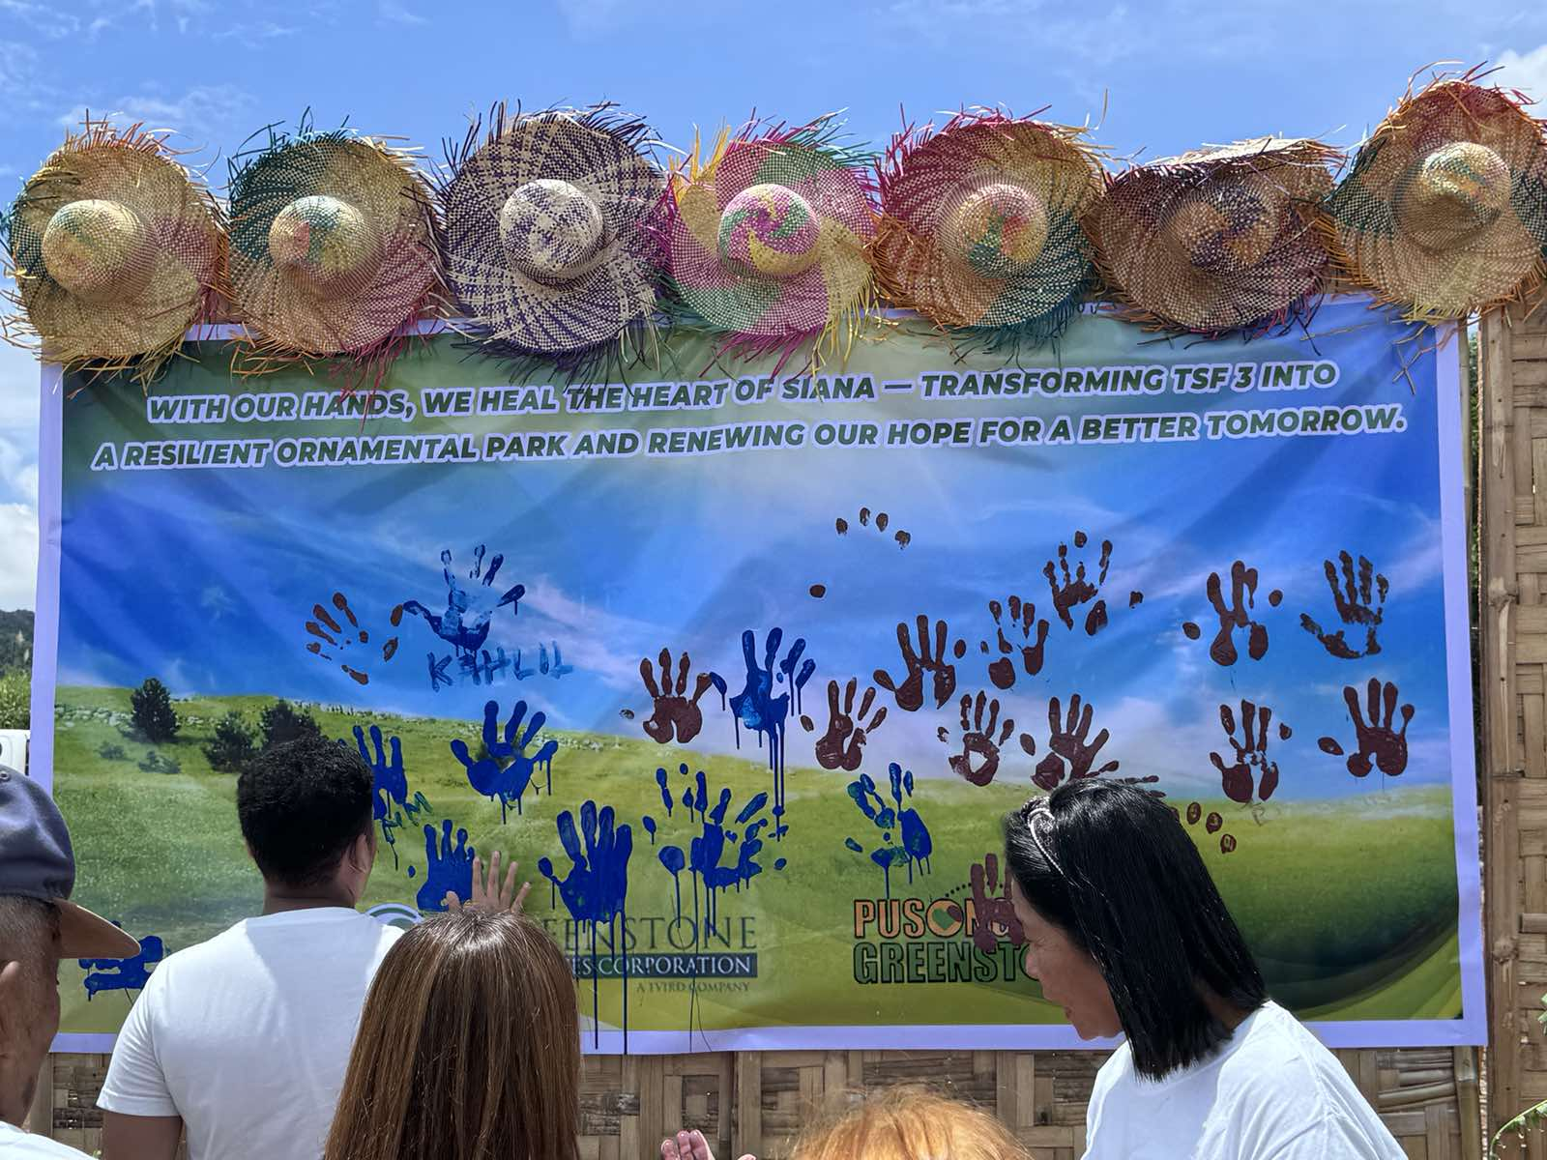
- In Photo: Siana Resident putting its handprint to the resilient board giving hope and promise for a better and resilient tomorrow.

About TVI in the Philippines

TVI Resource Development Philippines Inc. (“TVIRD”) is owned in part by TVI Pacific Inc. (TSX: TVI), a publicly-listed Canadian mining company focused on the exploration, development, and production of precious and base metals from district-scale, large-system, high-margin projects located in the Philippines. Concurrent ownership of ventures is shared with partner company Prime Resource Holdings Inc.

The Agata Nickel Laterite Mine is the third successful mining project that TVIRD brought on stream in a period of 10 years, while its Balabag Gold-Silver Mine further cements its position as a steady producer of precious metals in the country. With the commercial operations of its Siana Gold Mine, the company remains committed to exploration and mining practices that promote transparency, responsible stewardship of the environment, and the inalienable rights to life, dignity and sustainable development of its host communities.

www.tvird.com.ph
Contacts:

KAYCEE CRISOSTOMO  Corporate Communications Director  TVI Resource Development Phils., Inc.  Email: kaycee.crisostomo@tvird.com.ph  Phone: +63 2 8728-8491  Mobile: +63 917 579-1528  Fax: +63 2 8728-8515 | BRANDON LOPEZ  Corporate Communications Officer  Greenstone Resources Corporation  Email: Brandon.Lopez@greenstoneresources.com.ph  Phone: +63 2 8728-8491  Mobile: +63 946 068-4772  Fax: +63 2 8728-8515

