TVIRD Group Unfazed by ISO Audits,
Adherence to Excellent Management Standards Remains Strong
Demonstrating compliance, consistency and continuous improvement

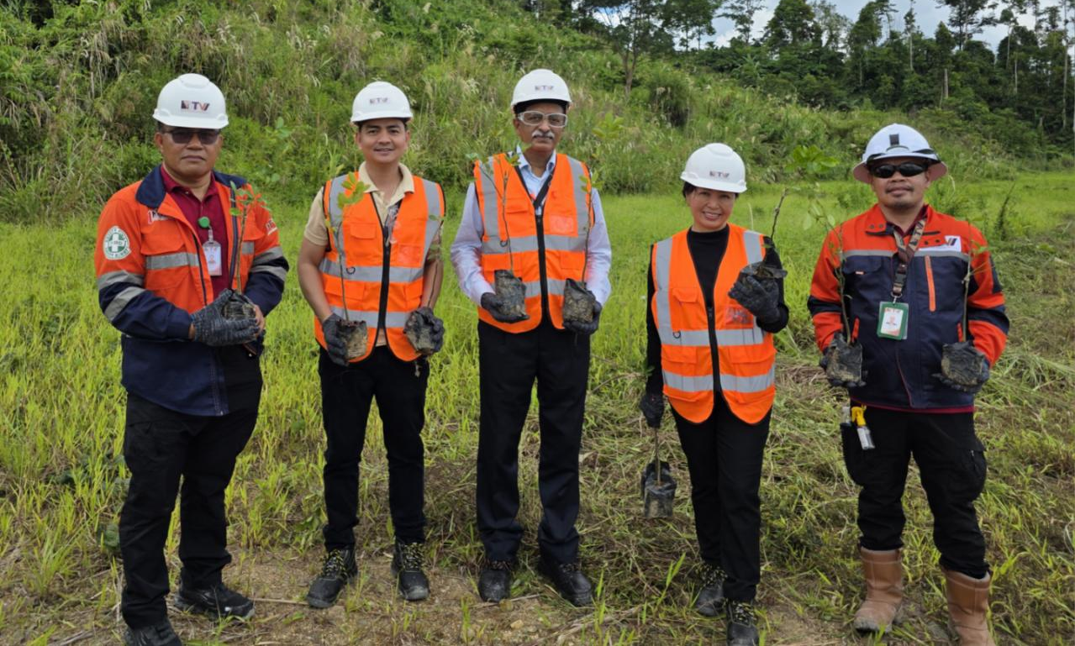
The TVIRD Balabag Project's Management team, accompanied by ISO certifiers from Intertek, planting trees together and signifying their shared commitment to quality environmental management at the Balabag mine.

Makati City, Philippines / July 2025 – The TVI Resource Development Philippine Inc. (TVIRD) group of companies once again completed another round of ISO Surveillance and recertification audits in both its operating gold and silver projects – in Balabag, Zamboanga del Sur and Siana, Surigao del Norte – further affirming their collective commitment to uphold the highest standards in operational excellence.

This year, Greenstone underwent its ISO IMS recertification audit after a three-year cycle of annual surveillance audits. The rigorous inspection last February 17 to 20 validated Greenstone’s high-quality standards as the company was reconfirmed by Intertek, an ISO certification agency. Meanwhile, Balabag underwent its surveillance audit from May 3 to 5 and successfully attained the quality standards for its Environmental Management System - marking the TVIRD Group's capability to meet and exceed global benchmarks.

Adhering to excellence
Greenstone President and General Manager Engr. Anthony B. Quijano emphasized the significance of these accreditations, stating that, "These ISO certifications are not just plaques on the wall — they reflect how we do things every day and are already ingrained in our principles as a company. Every job we do is a portrait of who we are."

The Balabag Gold-Silver Project is certified ISO 14001:2015 Environmental Management System, signifying the company's good track record in managing its environmental responsibilities systematically and contributing to the environmental component of sustainability. Meanwhile, TVIRD's wholly-owned subsidiary, Greenstone Resources Corporation, operator of the Siana Gold Project, maintains three ISO Integrated Management System certifications: ISO 9001:2015 for Quality Management System, ISO 14001:2015 for Environmental Management System, and ISO 45001:2018 for Occupational Health and Safety Management System. These bear witness to Greenstone's comprehensive approach to quality, environmental protection, and health and safety for its employees and stakeholders.

"From Agata's responsible operations in the past to our ongoing work in Balabag and Siana, we've built a culture of starting right and keeping the end in mind. Whether it's taking care of the environment, ensuring the safety of our people, or delivering quality work – we follow systems that meet global standards," shared Tenement and Environment Director Jesalyn Guingging, EnP.

The mandate on ISO
Under Department of Environment and Natural Resources (DENR) Administrative Order (DAO) No. 2015-17, all operating mining companies in the Philippines are mandated to be certified ISO 14001:2015 Environmental Management System. TVIRD thoroughly complies with this directive as well as complements it with its Annual Environment Protection and Enhancement Program, which is aimed at protecting, preserving and enhancing the natural environment surrounding its mine sites.

TVIRD’s nickel joint venture company, Agata Mining Ventures Inc. (AMVI) in Agusan del Norte served as the forerunner and baseline for the group’s succeeding ISO certifications. To date, Agata is presently undergoing its Final Mine Rehabilitation and Decommissioning Program, which transformed the former nickel mine site into an agrotourism and ecology hub.

*******

Press Photos

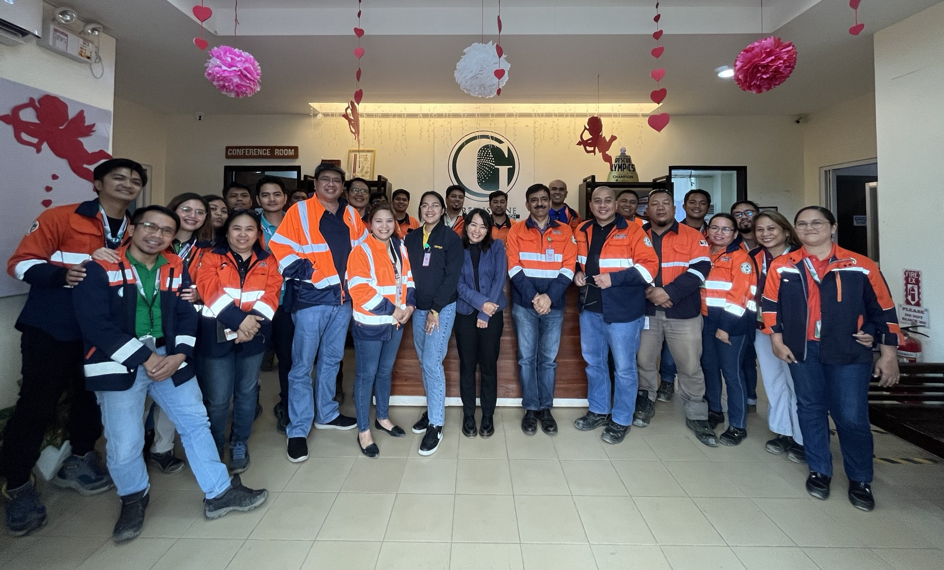
- Greenstone’s Records Controllers and Management Representatives from various departments standing proudly with ISO Auditors. They are joined by officers led by TVIRD President Michael G. Regino at the tail end of the ISO surveillance audit.

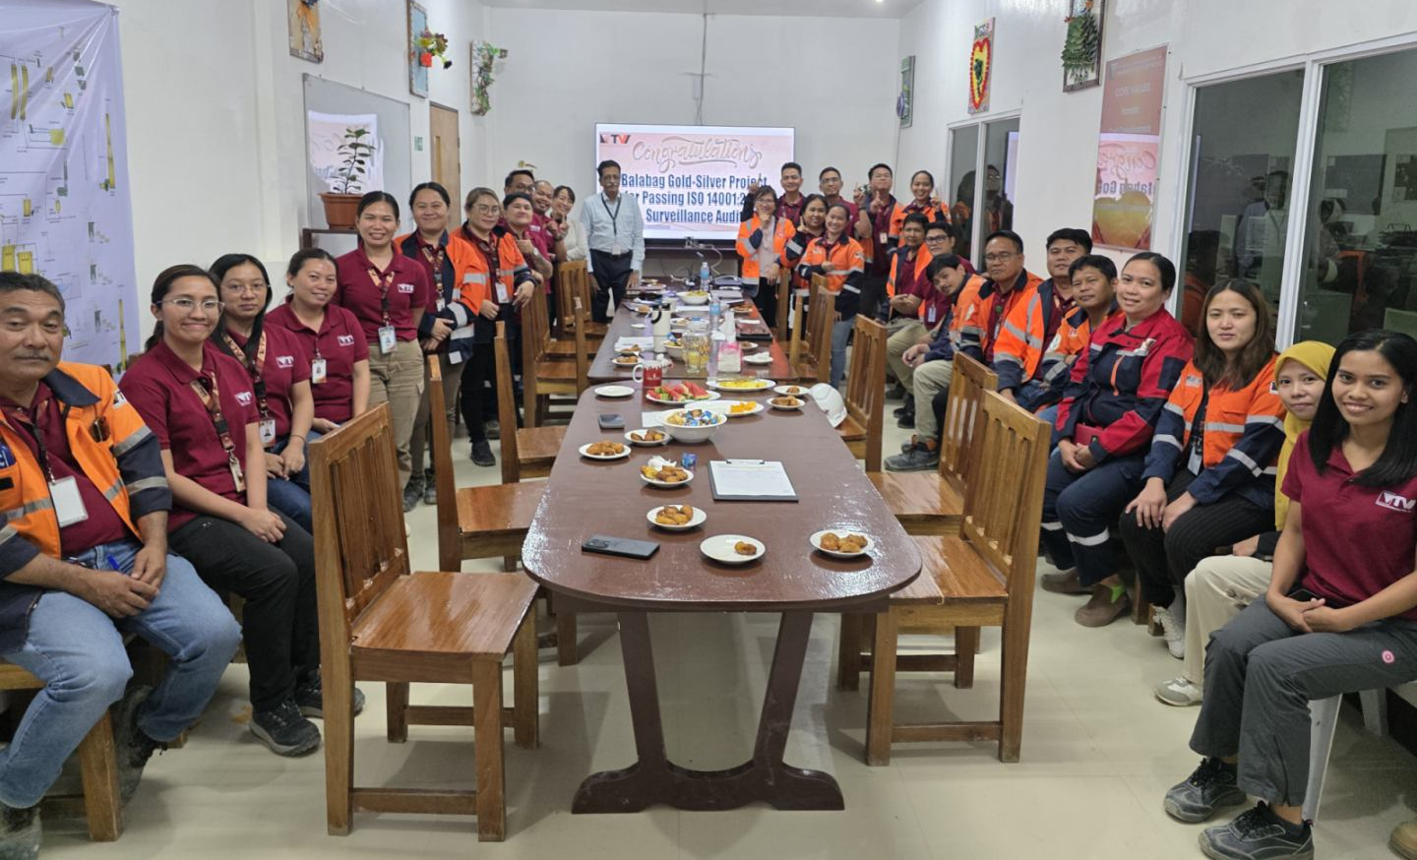
- Celebrating success as the Balabag Project ISO Technical Working Group successfully attained its ISO 14001:2015 Environmental Management System surveillance audit for 2025.

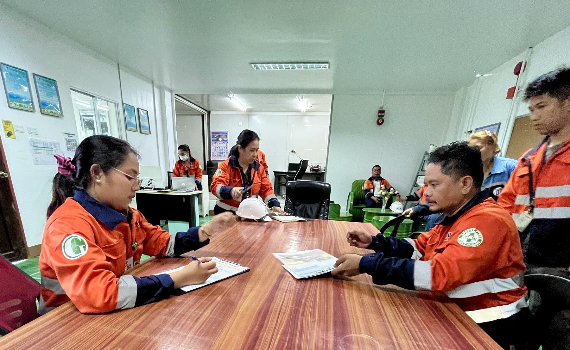
- Greenstone Fixed Plant and Special Projects Manager Jersome Maranga presents a hard copy of his department's ISO manual, while Intertek auditors thoroughly review the company’s Quality Management System processes and documentation.

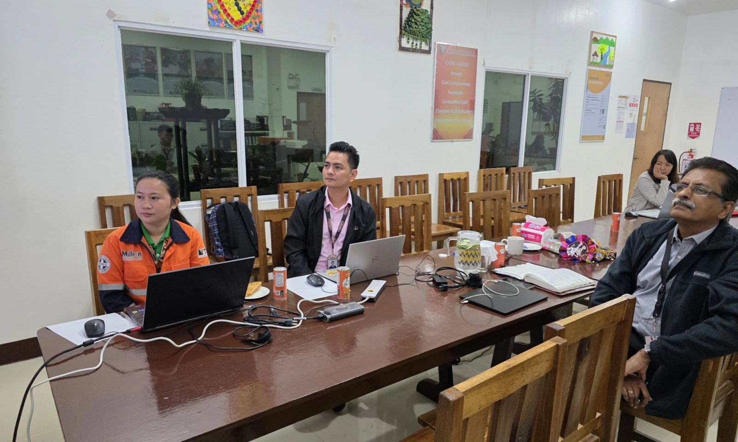
- Screen time. TVIRD Balabag's ISO team with Intertek ISO auditors during the on-site review of environmental aspects and impact assessments.

About TVI in the Philippines

TVI Resource Development Philippines Inc. ("TVIRD") is owned in part by TVI Pacific Inc. (TSX: TVI), a publicly-listed Canadian mining company focused on the exploration, development, and production of precious and base metals from district-scale, large-system, high-margin projects located in the Philippines. Concurrent ownership of ventures is shared with partner company Prime Resource Holdings Inc.

The Agata Nickel Laterite Mine is the third successful mining project that TVIRD brought on stream in a period of 10 years, while its Balabag Gold-Silver Mine further cements its position as a steady producer of precious metals in the country. With the commercial operations of its Siana Gold Mine, the company remains committed to exploration and mining practices that promote transparency, responsible stewardship of the environment, and the inalienable rights to life, dignity and sustainable development of its host communities.

www.tvird.com.ph
Contacts:

KAYCEE CRISOSTOMO  Corporate Communications Director  TVI Resource Development Phils., Inc.  Email: kaycee.crisostomo@tvird.com.ph  Phone: +63 2 8728-8491  Mobile: +63 917 579-1528  Fax: +63 2 8728-8515 | BRANDON LOPEZ  Corporate Communications Officer  TVI Resource Development Phils., Inc  Email: Brandon.Lopez@greenstoneresources.com.ph  Phone: +63 2 8728-8491  Mobile: +63 946 068-4772  Fax: +63 2 8728-8515

