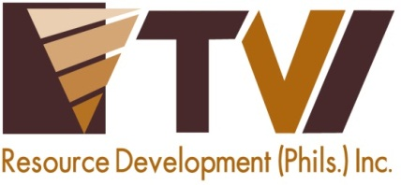
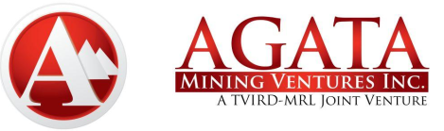 | AMVI-FOR-PA-003 | Press Release
 | Revision No. 03 | Effectivity Date: December, 2016
N E W S R E L E A S E

Empowered Agata Communities Mark Their Day of Unity
AMVI employees and communities gather in solidarity

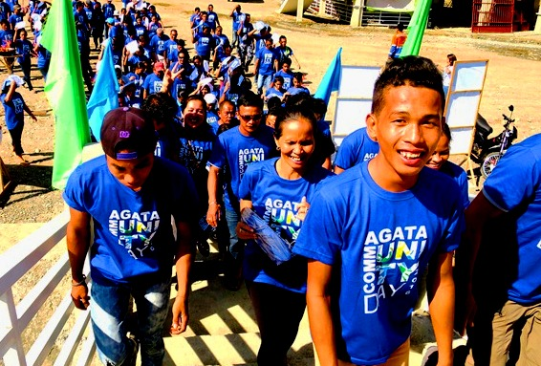
Residents from different communities within AMVI’s MPSA march together with company employees in celebration of overcoming the year’s challenges.

Jabonga, Agusan del Norte / December 2016 – Agata Mining Ventures Inc. (AMVI) a joint nickel mining project of TVI Resources Development Philippines Inc. (TVIRD) and MRL Nickel Philippines Inc., recently staged its annual Community Day – a day of solidarity for the eight barangays that comprise its host communities within its Mineral Processing Sharing Agreement (MPSA) area. The host and neighboring communities in Jabonga, Tubay and Santiago Municipalities of this province are witness to the company’s rise to become one the country’s top nickel producers today. They likewise continue to benefit from employment, livelihood and the overall increased economic activity ushered by AMVI’s operations.

Agata personnel took a break from daily operations and joined local barangay officials and key officers of people’s organizations at the Great Lake Resort in Jabonga where they gathered more than 400 residents from nearby Tubay and Santiago.

The indigenous Mamanwa tribe of Jabonga and Santiago were likewise represented during the yearend celebration as well as partner agencies: the Philippine National Police, Local Government Units and the Provincial Disaster Risk Reduction Management Office (PDRRMO).

In addition to celebrating unity, the Agata Community Day highlighted the safety readiness and awareness of each community where AMVI provides the training and upkeep of the respective Emergency Response Teams. The effort is aimed to fully capacitate communities in times of natural or manmade disasters.

In great shape
The program kicked-off at 6 AM with a warm-up Zumba sa Agata led by AMVI Communications Officer Julius De Villa who is a licensed Fitness Instructor. This was followed by the ceremonial lighting of the torch by Community Relations Vice President Edsel Abrasaldo and barangay officials.

“Right from the start, AMVI has dedicated its mining operations to improve the lives of the people in its communities. This year is the most challenging but we have overcome these (challenges) with the help of the community and its stakeholders in obtaining an ISO 14001-2004 Certification, a PMSEA Titanium Award and various recognitions from the Mines and Geosciences Bureau and other agencies,” according to the executive.

Meantime, Jabonga Mayor Jasmin Monton also noted the accomplishments brought about by AMVI’s unity with the people it serves. “The possibility of sustainable economic development should always be embraced as Agata’s legacy to us. We should always take pride in our accomplishments and unite further to implement further development in our communities,” declared Mayor Monton as she welcomed the participants.

Earlier, the Mayor reaffirmed the social contributions of AMVI that augmented the economic development of its communities, including her town. The company has been instrumental in mobilizing this positive momentum within two years of operating in the municipality.

“Without AMVI’s commitment towards responsible mining operations (for) the people, the long sought answer to poverty will not be at hand,” she highlighted.

Rescue Olympics
Community-based Emergency Response Teams (ERTs) showcased their skills acquired from AMVI-sponsored Disaster Risk Reduction, Mass Casualty and Basic Life Support Trainings. These were conducted jointly by the company and the Agusan del Norte PDRRMO.

The “Rescue Olympics” pitted Community ERTs among their counterparts and proved their skills in disaster assessment and first aid competitions. They were likewise tested with time and accuracy as each team showcased their splinting, bandaging, and moving and lifting routines.

Following the rigorous contest, the ERT from Barangay Binuangan, Tubay was awarded as champion by PDRRMO Officer Erma Suyo. The agency likewise acknowledged AMVI as the first to uphold its responsible mining commitments down to the community level.

There have been over 1,200 jobs created by AMVI from August 2014 to June 2016 – creating a multiplier effect beyond its mining area and increased economic activity in the areas of the three municipalities. Including its contractors’ personnel, an estimated 1,600 people work at the Agata Nickel Project.

*******

Press photos:

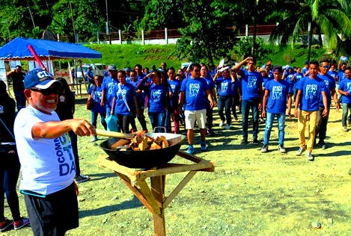
- Burning passion. VP for Community Relations Edsel Abrasaldo leads the Unity Torch Run and the lighting of the symbolic flame that signifies the unified effort of AMVI and its communities towards sustainable development through responsible mining.

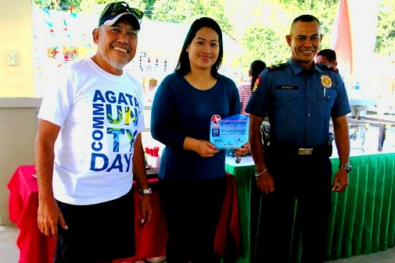
- Honoring the host. Since the start of its operations, Jabonga Municipality has been supportive of its programs aligned towards the welfare of the communities. During the Agata Community Day, VP Community Relations Edsel Abrasaldo (left) turns over a plaque of recognition to Mayor Jasmin Monton (center) together with its newly appointed PNP Station Commander SPO1 Ruaza.

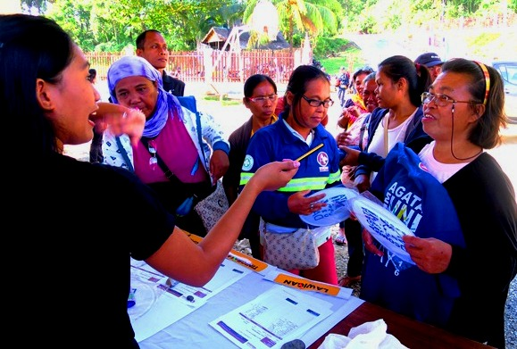
- Residents overwhelm with their warmth and anticipation to be part the year-end celebration. They likewise appreciate AMVI’s contributions and future projects that will sustain their development.

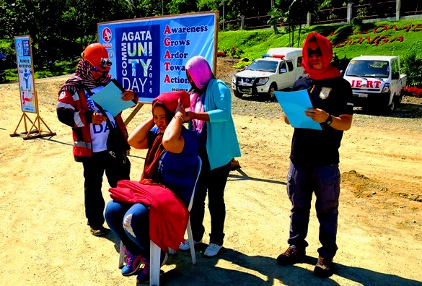
- Rescue Olympians. Different barangays have appointed their trained ERT members to prove their mettle in proper bandaging, basic life support routines and mass casualty assessment competitions. Tubay, Jabonga and Santiago Municipalities were provided proper training and have their respective Community ERTs.

About TVI in the Philippines
TVI Resource Development Philippines Inc. (“TVIRD”), is the local affiliate of TVI Pacific Inc. (TSX: TVI), a publicly-listed Canadian mining company focused on the exploration, development and production of precious and base metals from district-scale, large-system, high-margin projects located in the Philippines. Concurrent ownership of ventures is shared with partner company, Prime Resource Holdings Inc.

The commercial operations of Agata Mining Ventures Inc. (AMVI) mark the third successful mining project that TVIRD brought on-stream in the past 10 years. The company is committed to exploration and mining practices that promote transparency, responsible stewardship of the environment, and the inalienable rights to life, dignity, and sustainable development of its host communities.
www.tviphilippines.com

Contact:

Kaycee Crisostomo Julius M. De Villa
Corporate Communications Director Corporate Communications Officer
TVI Resource Development Philippines Inc. Agata Mining Ventures, Inc.
Email: kaycee.crisostomo@tvipacific.com.ph Email : julius.devilla@agatamining.com.ph
Phone: +63 2 728-8491 ext. 103 Mobile : + 63 918 336-4703 / +63 915 356-3271
Mobile: +63 917 579-1528
Fax: +63 2 728-8515

