 | AMVI-FOR-PA-003 | Press Release
 | Revision No. 03 | Effectivity Date: December, 2016
N E W S R E L E A S E

Enhancing Quality Education:
Agata Supports Tubay Children’s Day Celebration
A recognition of youth leaders to protect children’s rights and welfare

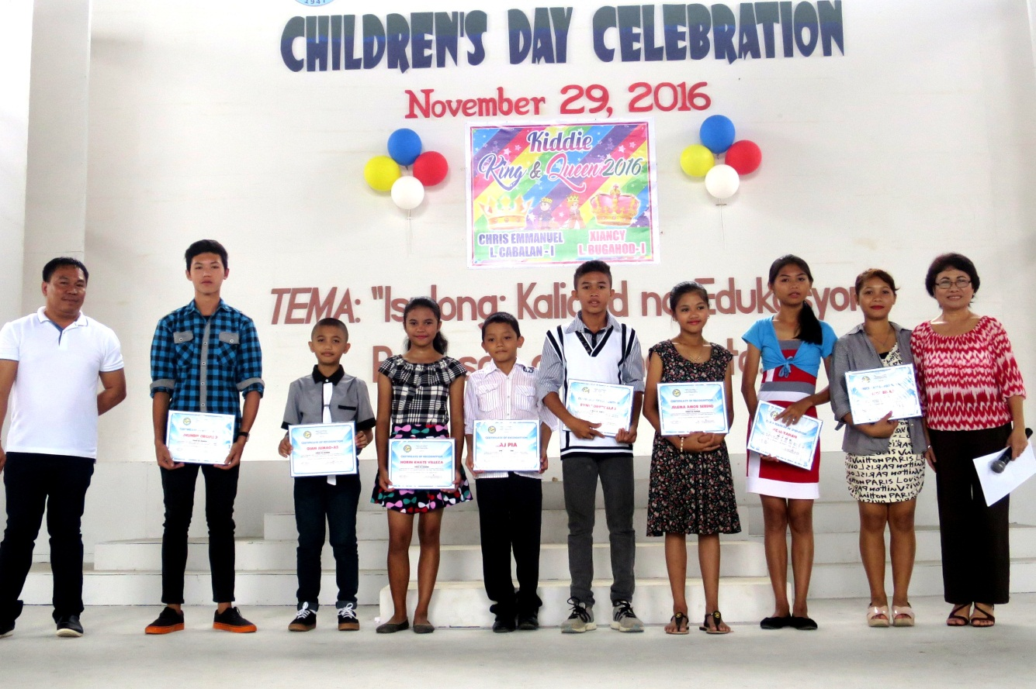
Coming of age. Tubay youth are empowered to participate in local legislation through the support of Vice-Mayor Raquim Cuyos (Left) and that of the Municipal Welfare and Development Office head Evelita Regis.

Tubay, Agusan del Norte / December 2016 – The Municipal Government of Tubay, in partnership with Agata Mining Ventures, Inc (AMVI), highlighted its commemoration of the 24th National Children’s Day by underscoring its commitment to protect the welfare of the youth – an initiative further cemented by the common vision shared by Tubay Mayor Fidel Garcia and AMVI for the overall sustainability of the town.

Adding significance to the celebration, Vice Mayor Raquim Cuyos presented the newly-elected youth leaders at the Municipal Gym in Poblacion 1 and explained their role in the legislation of local laws and ordinances in the community.

“The commitment of the present administration aims at making our young leaders aware and play a role in community-building. The children are the hope of the future. The parents’ crucial role is embracing the responsibility of raising their children to become responsible leaders,” expressed Vice-Mayor Cuyos.

The event was facilitated and organized by the Municipal Welfare and Development Office headed by Ma. Evelita E. Regis and supported by the Philippine National Police and the Department of Education.

Youth leadership
The council of youth leaders for 2016-2017 is led by “Child Mayor” Rica Biñas and “Child Vice Mayor” KC Luyahan from AMVI-supported Doña Rosario National High School.

Just like Tubay’s local government composition, they are supported by “Child Sangguniang Bayan” members: Amor Serino, Gian Jumao-as (Tagmamarkay Elementary School), Ryne Torrevillas (Tubay Central Elementary School), Gia Abby Rizon (Tubay National High School), Raj Pia and Norin Kate Villeza (Doña Rosario National High School), Shane Carestian Juares (Tagpangahoy Elementary School) and Jhundie Orcullo (Tinigbasan Elementary School).

The youth representatives to the Municipal Council for the Protection of the Children are Rica Biñas and Ryne Torrevillas.

Showcasing young talents
Aptly themed, Isulong: Kalidad na Edukasyon Para sa Lahat ng Bata (Advancing Quality Education for All Children), the celebration also showcased the talents of children from different community day care centers and schools in the field of oration, singing and dancing. The competition gathered parents and teachers across the municipality to witness the potentials of their next generation.

Beto Elementary School bagged the championship for Oration while the vocal solo competition winner was from Lawigan Elementary School. Finally, Doña Rosario National High School cornered the group dance competition, which capped the morning’s affair.

Commitment through action
Its support for Tubay’s National Children’s Day celebration is AMVI’s active response to the call for responsible corporate citizenship for the development of the country’s youth sector. Its mining operations and social programs in the communities of Tubay, Santiago and Jabonga have ushered progressive developments that are recognized in the host province of Agusan del Norte.

Within the company’s 4,995-hactare Mineral Production Sharing Agreement (MPSA) are eight barangays that continue to benefit from jobs and livelihood generated by the company as well as its support for 10 schools with close to 4,000 students.

The Agata Company Clinic also promotes wellness in the community by providing medical consultations and medicines free of charge to its nearby residents whose beneficiaries are mostly children.

*******

Press photos:

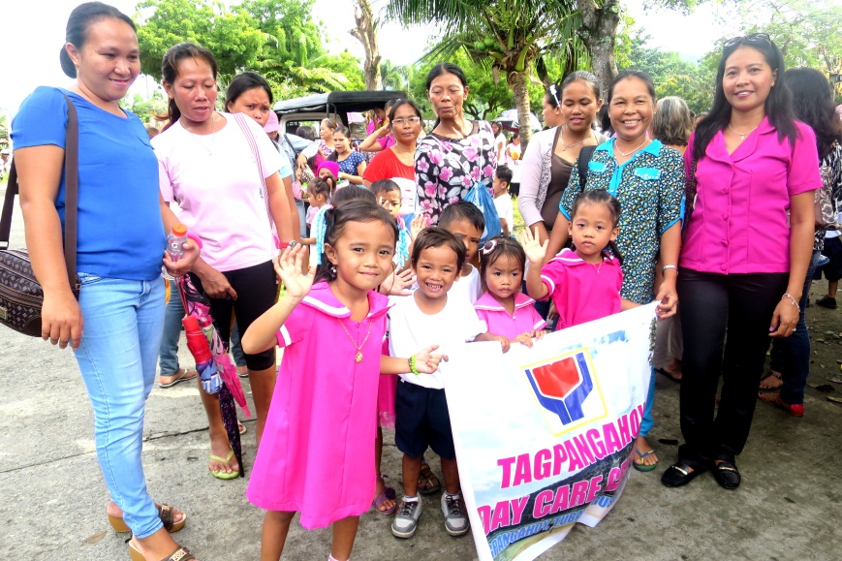
- Kids’ day out. Tagpangahoy Day Care pupils are escorted by their teachers and parents during the parade across the Tubay’s streets to kick-off the celebration of National Children’s Day.

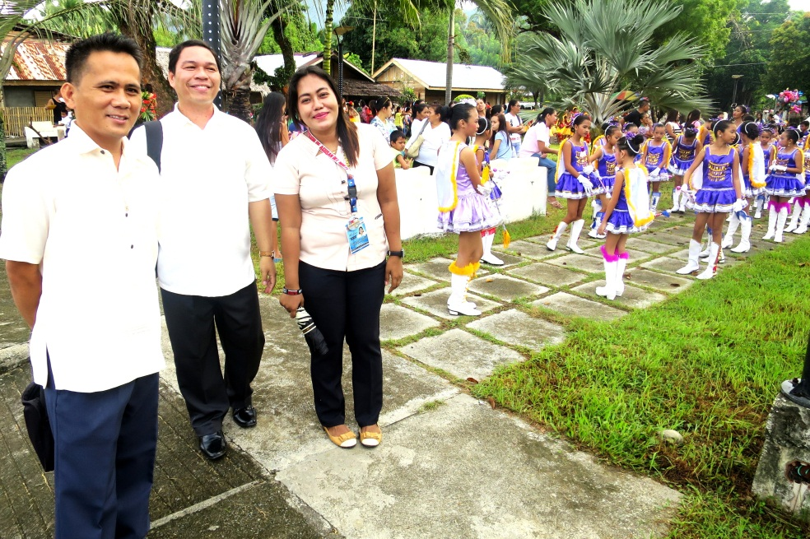
- Highschool Advisers prep the drum and buggle corps of Doña Rosario National High School to hype the parade in Tubay’s Poblacion.

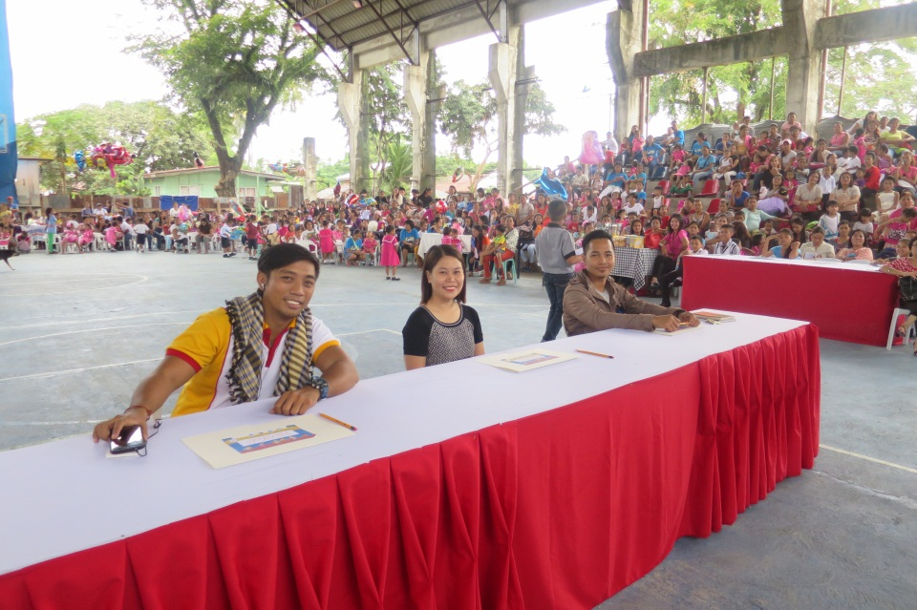
- Board of Judges. A showcase of talents from different schools is scrutinized by a board of judges comprised of Agata Communications Officer Julius M. De Villa and DSWD staff Ana Liezle Bagsican and Marco Anthony Millan.

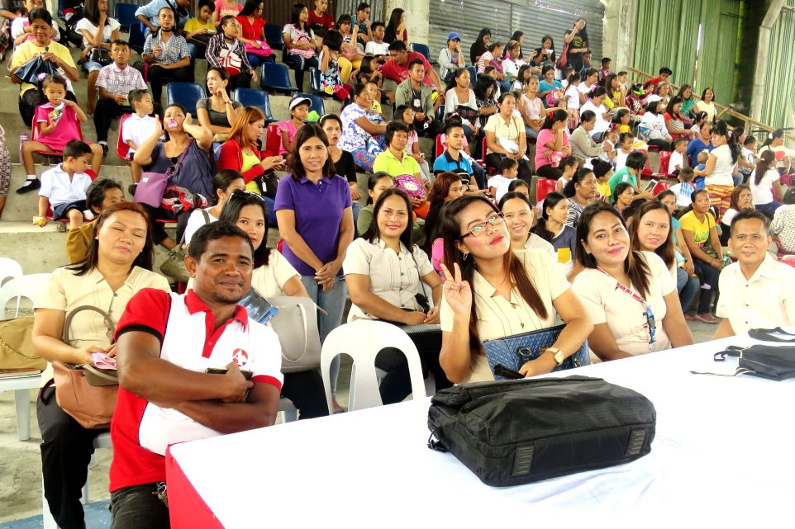
- Agata Community Relations Staff Bernie Nanoy, teachers and parents update scholars and promote the advocacy for protecting children’s welfare in AMVI’s communities.

About TVI in the Philippines
TVI Resource Development Philippines Inc. (“TVIRD”), is the local affiliate of TVI Pacific Inc. (TSX: TVI), a publicly-listed Canadian mining company focused on the exploration, development and production of precious and base metals from district-scale, large-system, high-margin projects located in the Philippines. Concurrent ownership of ventures is shared with partner company, Prime Resource Holdings Inc.

The commercial operations of Agata Mining Ventures Inc. (AMVI) mark the third successful mining project that TVIRD brought on-stream in the past 10 years. The company is committed to exploration and mining practices that promote transparency, responsible stewardship of the environment, and the inalienable rights to life, dignity, and sustainable development of its host communities.
www.tviphilippines.com

Contact:

Kaycee Crisostomo Julius M. De Villa
Corporate Communications Director Corporate Communications Officer
TVI Resource Development Philippines Inc. Agata Mining Ventures, Inc.
Email: kaycee.crisostomo@tvipacific.com.ph Email : julius.devilla@agatamining.com.ph
Phone: +63 2 728-8491 ext. 103 Mobile : + 63 918 336-4703 / +63 915 356-3271
Mobile: +63 917 579-1528
Fax: +63 2 728-8515

