TVIRD Completes Social Development Projects for

Six Siocon Barangays
Sustains community development beyond its operations

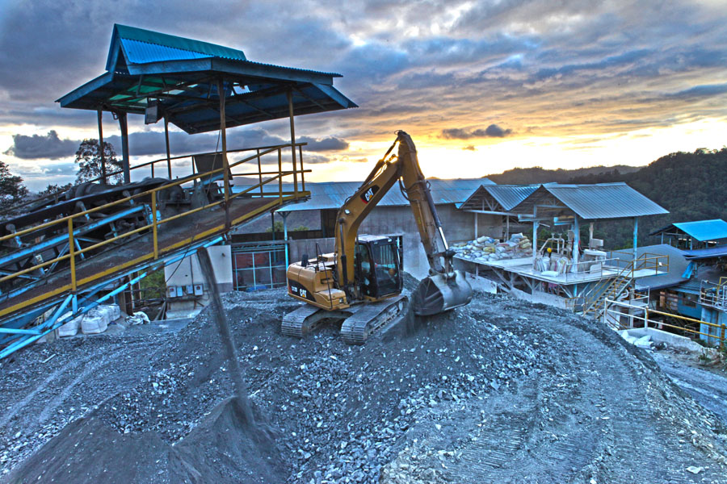
Canatuan basks in the moonlight. (2013 file photo) Dusk falls on TVIRD’s plant, which processed a total mill feed of close to 1 million tons during its operations in 2012. TVIRD initiated the installation of grid electricity to key Siocon communities that were otherwise dependent on power generated by the company for its copper and zinc processing plants.

Siocon, Zamboanga del Norte / Nov 2016 – In a sustained effort to bolster community development beyond its operations, TVI Resource Development Philippines Inc. (TVIRD) turned-over much-needed generator sets, communications and agricultural equipment, and various furniture and fixtures intended for school use to six barangays in its host municipality of Siocon. Now on its final rehabilitation stage following successful gold-silver and copper-zinc operations, TVIRD continues to demonstrate its unwavering commitment to the overall sustainability of its host community.

The recipient barangays Tabayo, Tagaytay, Manaol, Latabon, Sta. Maria and Makiang – all of this municipality – received two power generator units, four handheld radios, monoblock chairs, tables, bookshelves and rolls of interlink wires for reinforced fencing.

Lighting it up
The Zamboanga del Sur Electric Cooperative (ZAMSURECO-II) is the lone electric cooperative that distributes electricity to this municipality and nearby towns of Sirawai and Baliguian. A few years ago, a TVIRD-initiated cooperation with ZAMSURECO-II began the installation of grid electricity to key Siocon communities that were otherwise dependent on power generated by the company for its copper and zinc processing plants.

To date, due to prevailing under capacity and a huge load requirement by the growing communities, these three municipalities frequently experience unsteady power supply. Tabayo, which hosted the mining operations of TVIRD for more than a decade, is one of the 26 barangays of Siocon,

“We experience two to three hours blackouts everyday. This causes delays in our daily duties, specifically paper work that need our immediate response,” according to Tabayo Barangay Captain Nenita P. Davi whose constituents received a generator set from TVIRD.

Davi expressed her gratitude, saying that the generator set is “extremely needed by her barangay during assemblies and meetings where people’s voices need to be heard.”

Canatuan is among the sitios (sub-villages) of Tabayo and is situated some 29 kilometers away from the town proper. Following the conclusion of TVIRD operations in January 2014, it is currently the focal point of the company’s final mine rehabilitation activities.

Like Davi, Latabon Barangay Captain Ameril A. Adanie was also thankful after his constituents received a seven-horsepower generator set from the company.

Keeping connected
As experienced by the company, operating in the hinterlands comes with an inherent challenge to mobile communications. The company recognizes this challenge and helped the community through its donation of two-way radios that keep the local authorities coordinated at all times.

Manaol Barangay Captain Gemma Romina expressed her appreciation to TVIRD for the four handheld radios she received for her barangay tanods. “These are a big help in maintaining peace and order in our barangay,” she stressed.

Romina, who heads the town’s Association of Barangay Captains here, said they are always experiencing difficulties in calling for municipal assistance whenever they need urgent police action owing to their lack of communications equipment.

”We barangay officials do not always have ‘load’ on our mobile phones. These handheld radios are a boost to our peace and order campaign,” she added.

Permanent fixtures
Meanwhile, TVIRD provided 64 school chairs for kindergarten students of Barangay Makiang as well as several tables and bookshelves for the barangay officials of the village.

Equally appreciative of what the company has done is Sta. Maria Barangay Captain Moarip Salvador who received 15 rolls of interlink wires to fence his coastal community’s barangay hall.

“On behalf of my constituents, I am expressing my gratitude to TVIRD for this project. These rolls of interlink wires will be used to fence our public office to secure the barangay properties kept in the hall,” he said.

TVIRD started its mining operations in 2004. Since then, it implemented programs and projects through its Social Development Management Program (SDMP) as mandated by the Mining Act of 1995. Projects under its SDMP were funded from the annual operating cost of the company.

The recent handover to the barangay captains of this town were part of the company’s 2013 SDMP. “These were the projects that we committed to the barangay captains to be turned-over to them before the end of the final mine rehabilitation,” said TVIRD Canatuan General Manager Nilda Callora. In typical TVIRD fashion, commitments were once again delivered ahead of time.

Siocon was a fourth class municipality prior to hosting mining operations. It rose to become a first class town owing to the local taxes regularly paid by the company. At the height of its operations, TVIRD was recognized as the biggest taxpayer for Zamboanga del Norte and also in the Zamboanga Peninsula Region. It was likewise recognized by both local and foreign organizations for its exceptional work in the field of responsible mining.

*******

Press photos:
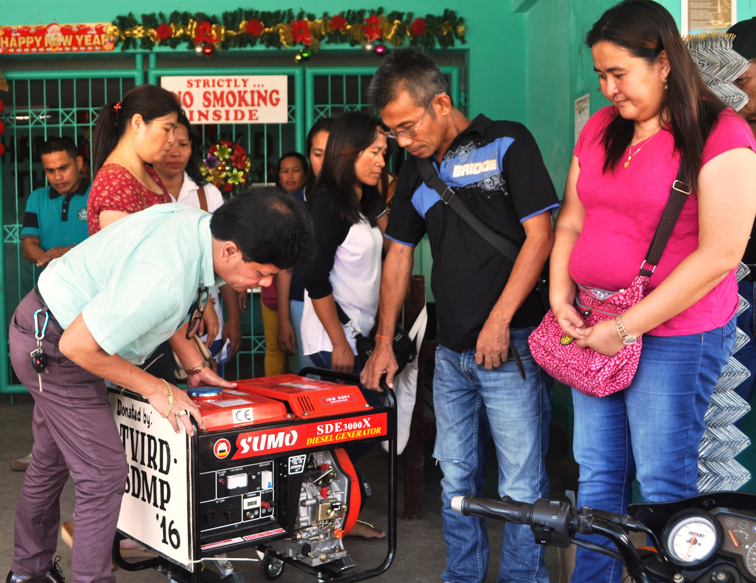

- Power up. Siocon Municipal Administrator Atty. Jose B. Bongalos inspects the seven-horsepower generator set from TVIRD as barangay officials of Latabon look on - including Latabon Chair Ameril A. Adanie (right).
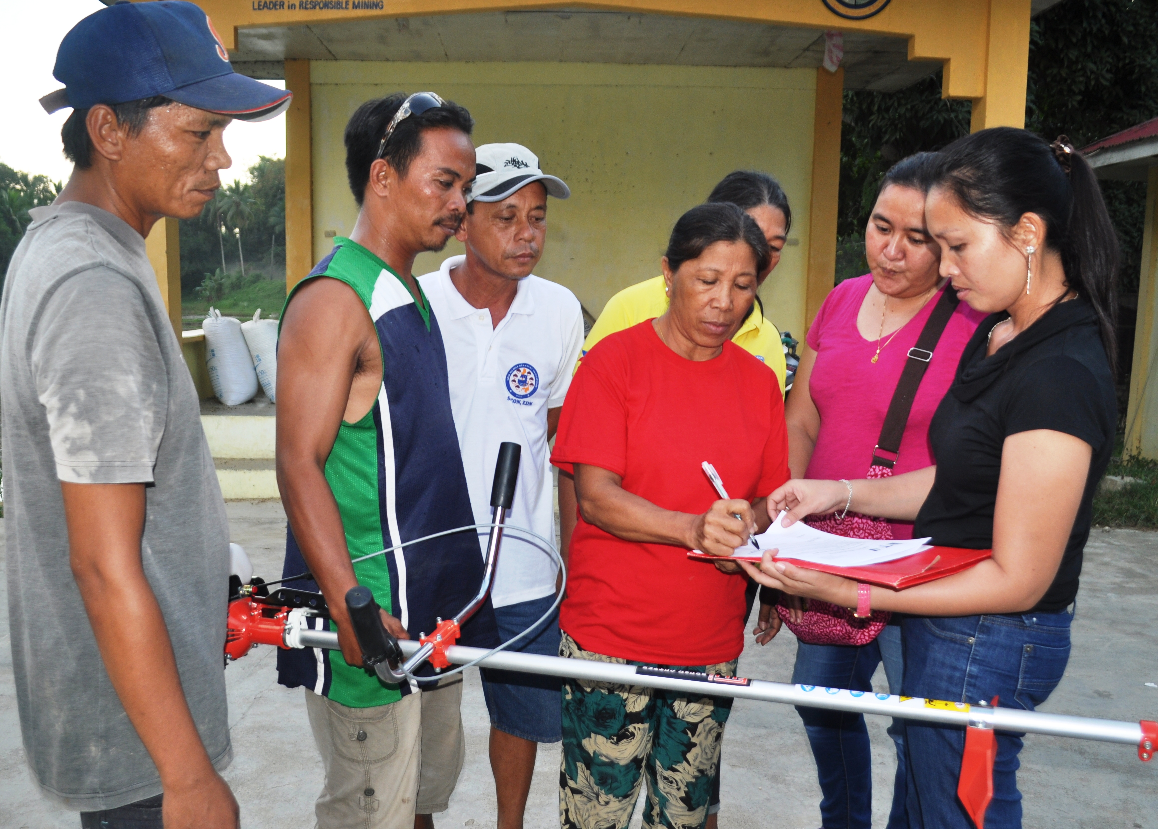

- Tagaytay Barangay Captain Remegia A. Gubantes signs the certificate of acceptance of the TVIRD-donated grass cutter and 39 school chairs received by her barangay.

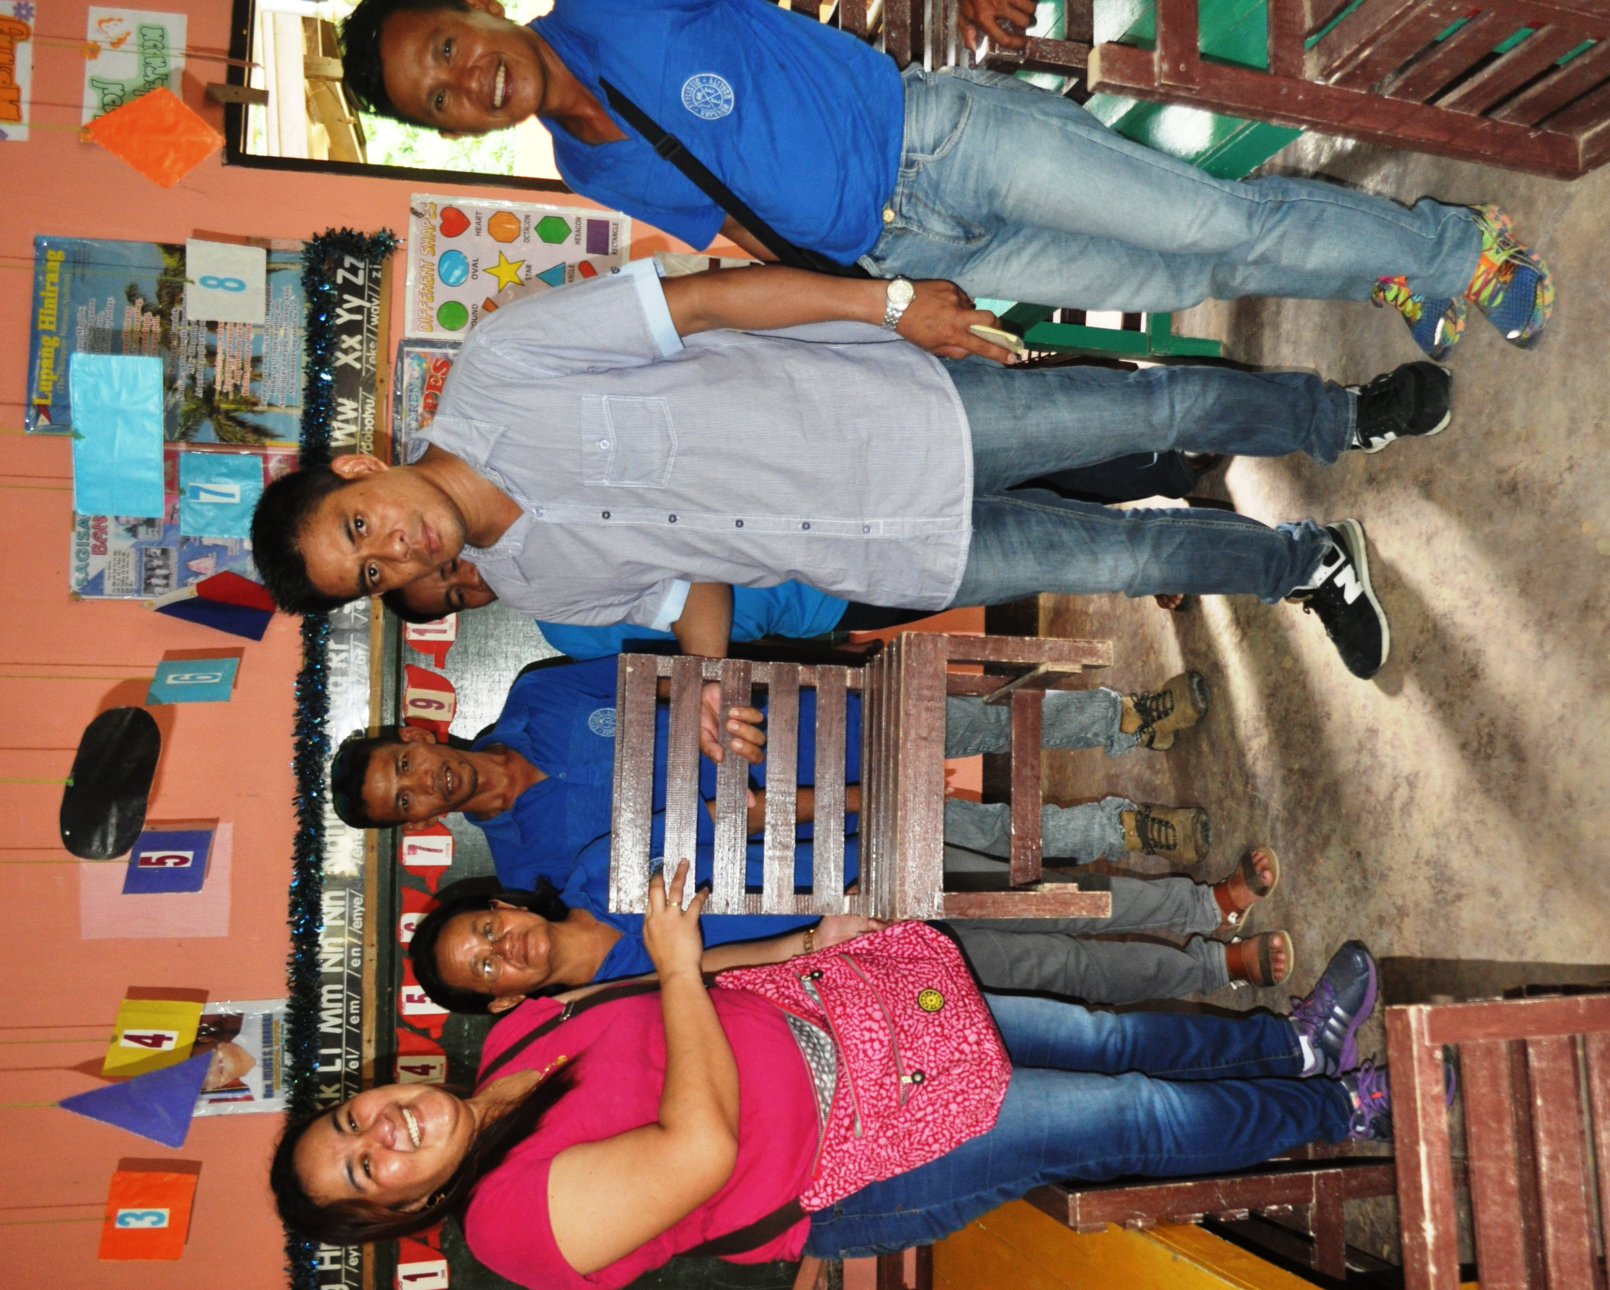

- Barangay Makiang Captain Erdulfo G. Comisas receives chairs donated by TVIRD as well as bookshelves and tables for Makian Kindergateen School. Joining them are barangay councilors and kindergarten school teachers.

About TVI in the Philippines
TVI Resource Development Philippines Inc. (“TVIRD”), is the local affiliate of TVI Pacific Inc. (TSX: TVI), a publicly-listed Canadian mining company focused on the exploration, development and production of precious and base metals from district-scale, large-system, high-margin projects located in the Philippines. Concurrent ownership of ventures is shared with partner company, Prime Resource Holdings Inc.

The commercial operations of Agata Mining Ventures Inc. (AMVI) mark the third successful mining project that TVIRD brought on-stream in the past 10 years. The company is committed to exploration and mining practices that promote transparency, responsible stewardship of the environment, and the inalienable rights to life, dignity, and sustainable development of its host communities.
www.tviphilippines.com

Contact:

Kaycee Crisostomo Dennis Baguio
Corporate Communications Director Communications Officer
TVI Resource Development Philippines Inc. TVI Resource Development Philippines Inc.
Email: kaycee.crisostomo@tvipacific.com.ph Email: dcbaguio@gmail.com
Phone: +63 2 728-8491 ext. 103 Mobile: +63 917 405-9272
Mobile: +63 917 579-1528
Fax: +63 2 728-8515

