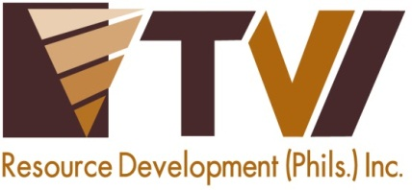
 | AMVI-FOR-PA-003 | Press Release
 | Revision No. 03 | Effectivity Date: 2016
N E W S R E L E A S E

Agata Employees Support Dugong Bombo Anew
Volunteers renew Agata’s solid commitment to Bombo Radyo’s annual blood donation drive

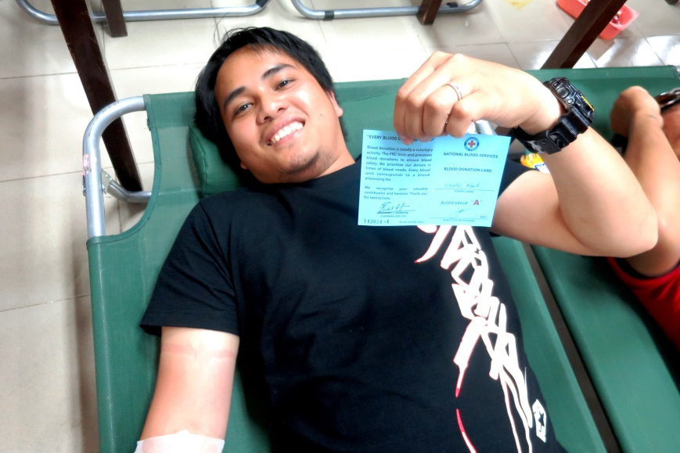
Donor’s privilege. Agata IT Staff Albert Estrada receives a Red Cross Card that he may use at any time of emergency. Albert is one of several employee-volunteers from TVIRD’s Agata Project.

Butuan City / November 2016 – Guided by its strong commitment to serve communities beyond its mining area, Agata Mining Ventures Inc. (AMVI), a joint venture project of TVI Resource Development Philippines Inc. (TVIRD) and MRL Nickel Philippines Inc., renewed its active participation in the annual Dugong Bombo national blood donation drive. The 12th annual event is a charitable initiative of Bombo Radyo – a leading news and public affairs radio station broadcasting in Agusan del Norte Province through DXBR 981 – providing a considerable life-saving donation to thousands of beneficiaries across the country.

Joining the delegation of donors from AMVI, which sponsored the event in Butuan City of this province, were 17 employees led by its Public Affairs and Safety Departments. The provincial training center hosted the bloodletting that generated 4,250 cc of blood from various donors while the nationwide campaign collected over 3.5 million cc of blood.

“TVIRD is pleased that its media partner, Bombo Radyo, continues to engage our associates at the Agata Nickel Project in the yearly Dugong Bombo national blood donation drive. For the third consecutive year, AMVI has been a permanent fixture in Bombo Radyo’s annual campaign. This is a tradition that we are willing to sustain in the years ahead,” said Communications Director Kaycee Crisostomo.

A partnership beyond business
“The dire demand for blood supply is a straightforward challenge in serving and saving peoples’ lives. Thus, Dugong Bombo is a vocal and steadfast program that has been running for several years – and in which AMVI has also been a consistent major sponsor aligned with socio-civic organizations and offices from the public and private sectors,” expressed Bombo Radyo Butuan Station Manager Benjie Balansag.

AMVI and Bombo Radyo have been public affairs partners prior to the mining company’s operations in Tubay, Jabonga and Santiago Municipalities. To date, both organizations have spearheaded and supported public health and welfare initiatives that have benefitted various publics in the Caraga Region.

“Bombo Radyo’s and Agata’s thrust for public health continue to run parallel. The company is also proud to play a consistent role in the annual Bombo Medico – the largest humanitarian mission in Caraga which provided medical care to over 2,000 beneficiaries in the region,” added Crisostomo.

This year, the mission provided medical and dental check-ups, tooth extractions, eye check-ups, prostate and cardiovascular screening, pediatric care, obstetrics and gynecology, pulmonary and entomology examinations as well as reading glasses free of charge.

Consistent collaboration
AMVI likewise supports successful multi-sectoral partnerships such as its collaboration with the Philippine National Red Cross, Rotary Club and the local government unit to which it contributed more than 33,000 cc of blood from 130 donors. AMVI’s succeeding blood drive provided an additional 39 successful donors to the institution.

In July this year, the Red Cross acknowledged the company among its Outstanding Corporate Supporters for its consistent contribution to its various activities.

In the past year, the company provided a total of 6,850 free medical consultations to patients in its beneficiary communities and an additional 6,000 more to its employees, contractors and dependents. These free medical services were administered by nursing staff and the company doctor at the AMVI Clinic in Barangay Lawigan, Tubay Municipality.

“Portraying its commitment through public information and active participation, AMVI shares the same advocacy of Bombo Radyo and the Philippine National Red Cross. These social corporate responsibility activities run parallel to TVIRD’s pledge to its communities,” according to Communications Officer Julius M. De Villa.

TVIRD operates the Agata Nickel Laterite Project. During its prior operations in Canatuan, Zamboanga del Norte, TVIRD was been acknowledged on several occasions by the Philippine National Red Cross for its strong support for the latter’s blood donation drives. It is also the single largest organization to shore-up the most number of employee-volunteers in the region.

*******

Press photos:

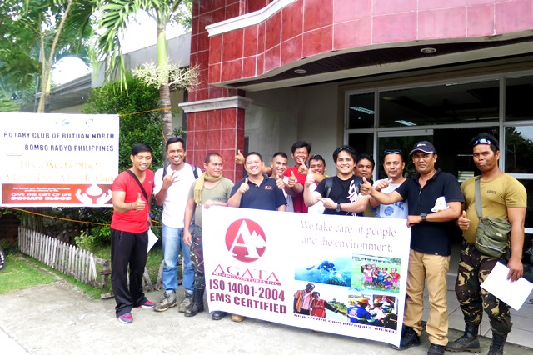
- Agata’s proud donors. Different AMVI departments send their most fit and active blood donation volunteers to support Bombo Radyo’s annual blood donation drive.

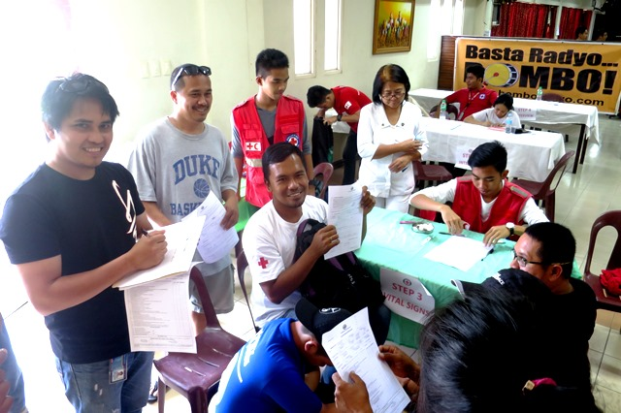
- Employee- volunteers are screened by Red Cross personnel prior to actual blood extraction.

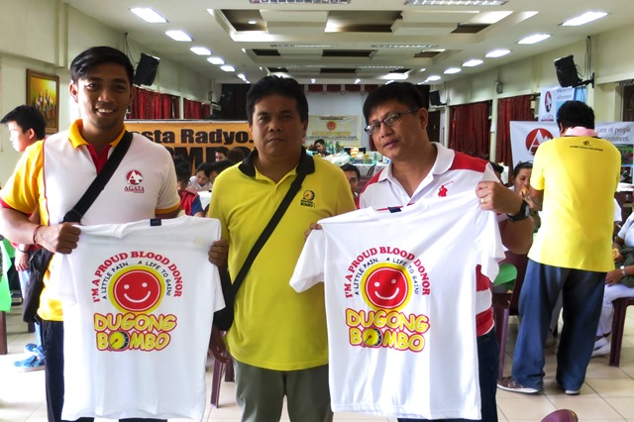
- Partners in Public Service. (from Left): AMVI Communications Officer Julius M. De Villa, Bombo Station Manager Bombo Benjie Balansag, and AMVI Liaison Officer Genome Fortun.

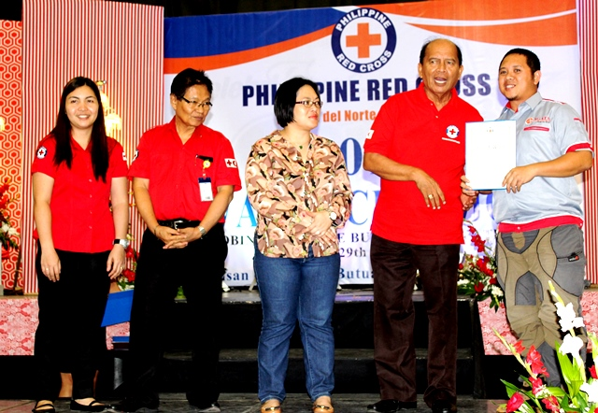
- The Philippine National Red Cross acknowledges AMVI as one of its outstanding partners in their humanitarian programs.

About TVI in the Philippines
TVI Resource Development Philippines Inc. (“TVIRD”), is the local affiliate of TVI Pacific Inc. (TSX: TVI), a publicly-listed Canadian mining company focused on the exploration, development and production of precious and base metals from district-scale, large-system, high-margin projects located in the Philippines. Concurrent ownership of ventures is shared with partner company, Prime Resource Holdings Inc.

The commercial operations of Agata Mining Ventures Inc. (AMVI) mark the third successful mining project that TVIRD brought on-stream in the past 10 years. The company is committed to exploration and mining practices that promote transparency, responsible stewardship of the environment, and the inalienable rights to life, dignity, and sustainable development of its host communities.
www.tviphilippines.com

Contact:

Kaycee Crisostomo Julius M. De Villa
Corporate Communications Director Corporate Communications Officer
TVI Resource Development Philippines Inc. Agata Mining Ventures, Inc.
Email: kaycee.crisostomo@tvipacific.com.ph Email : julius.devilla@agatamining.com.ph
Phone: +63 2 728-8491 ext. 103 Mobile : + 63 918 336-4703 / +63 915 356-3271
Mobile: +63 917 579-1528
Fax: +63 2 728-8515

