 | AMVI-FOR-PA-003 | Press Release
 | Revision No. 03 | Effectivity Date: 2016
N E W S R E L E A S E

A Spark of Hope for the Indigenous Mamanwas’ Mapaso Tribe
Agata implements community resource development program in Santiago Municipality

Tribe invests in education. Through the royalties received from AMVI, the indigenous Mamanwas of the Mapaso Tribe supports the education of their 48 elementary and 31 high school scholars.

Santiago, Agusan del Norte / November 2016 – Ongoing mining operations at Agata Mining Ventures Inc. (AMVI), a joint project of TVI Resource Development Inc. (TVIRD) and MRL Nickel Philippines Inc., provides a spark of hope to the once-struggling Mamanwas of Barangay La Paz, Santiago Municipality. The Mamanwa Mapaso Tribal Sectoral Organization is one of the three tribal sectors in the area that considers AMVI’s Community Resource Development Program (CRDP) as a viable roadmap for optimizing their resources, opening opportunities for employment through sustainable community projects - and most of all - uplifting the morale of their fellow lumads.

TVIRD is the lead operator of the Agata Nickel Project situated in Santiago as well as Tubay and Jabonga Municipalities in the province of Agusan del Norte. Through its CRDP

A legacy of progress
Since bringing operations on-stream in its 4,995-hectare Mining Production Sharing Agreement (MPSA) area, the company rolled-out its Social Development Management Projects (SDMP) for non-tribal communities while its CRDP was designed and implemented specifically for the indigenous sector in order for them to optimize the utilization of their royalty share.

AMVI’s MPSA is home to eight barangay communities and four IP sectors that benefit from the CRDP: Coro Mamanwa Tribal Organization in Brgy. Colorado of Jabonga, Ayrag Mamanwa Tribal Management Organization (AMTMO) and Agata Mamanwa Tribal Organization (AMTO) in Barangay E. Morgado, and Mamanwa Mapaso Tribal Sectoral Organization (MMTSO) in Barangay La Paz in Santiago municipality.

Particularly for the Mamanwas of Mapaso, they grew from 20 households and flourished to more than 50 – a thriving community enabled by ample livelihood.

This IP sector’s medium- to long-term plan is to integrate agroforestry, aquaculture and tourism in an area they are developing. The tribe currently owns a 4-hectare agroforestry area with Falcate, Abaca, Mahogany and fruit-bearing trees using organic fertilizer and vermicompost (organic fertilizer) that the tribe produces.

They likewise invested in a freshwater fish cage and recently had their first successful harvest that validated their chosen investment. A hog-raising project engaging female members of the tribal community is also underway while their new tribal hall is currently under construction – and which will be completed before the year ends.

Eco-tourism and education
The tribe is also developing a tourist camping ground near a hot spring developed by the municipal government into a tourist area. The idea is to establish foot tracks that will pass by their fish pen, through their agroforestry area and which will lead to a limestone cave. Visitors can also pitch tents and spend the night in the area near the hot spring.

Through the royalties received from AMVI, the tribe supports the education of 48 elementary and 31 high school scholars. Its first scholar, Aldrin Moron, graduated with a degree in Hotel and Restaurant Management and is now currently employed overseas.

The TVIRD tradition of lending a hand-up to aspiring students is very much alive in Agata. At the height of its operations in Siocon Municipality, Zamboanga del Norte Province, the company supported 10 schools with close to 4,000 students, including its adopted Canatuan Public School’s growing population of 850 students. Agata scholars today are testament to the same charitable spirit that continues to pave the way for a better future.

A long journey
Historically, the original indigenous settlers in Santiago (not yet a municipality) were welcomed by Datu Mapaso whose name was adapted by the tribe. However peaceful, their community was often disturbed by illegal dynamite fishers, suffered discrimination and had no access to proper education.

Upon the commencement of AMVI’s operations – and the recognition of the National Commission on Indigenous People (NCIP) – the Mapaso Tribe saw a glimmer of hope, especially upon the implementation of the company’s CRDP. Since then, they have planned the utilization of their royalty share and identified sustainable livelihood projects that would bring lasting progress.

Currently, the tribe also receives TESDA trainings as well as educational tours to expand their knowledge on how to manage their agricultural resources.

The Mamanwas of Mapaso confidently gain both momentum and morale as they pursue their various livelihood projects. They are likewise AMVI’s partners in environmental management and can now stand up to the challenges of times.
*******
Press photos:

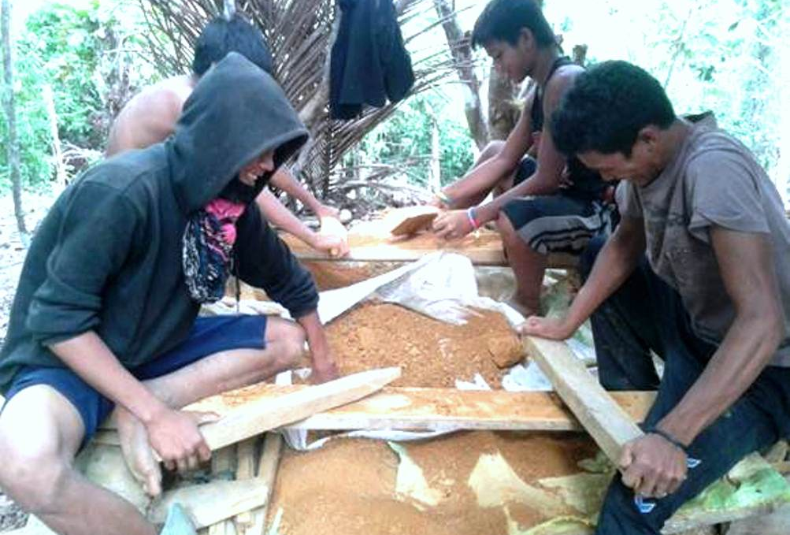
- Agroforestry. Indigenous Mamanwas believe that maximizing their resources coupled with the assistance from AMVI will bring a better future to their community and the next generation.

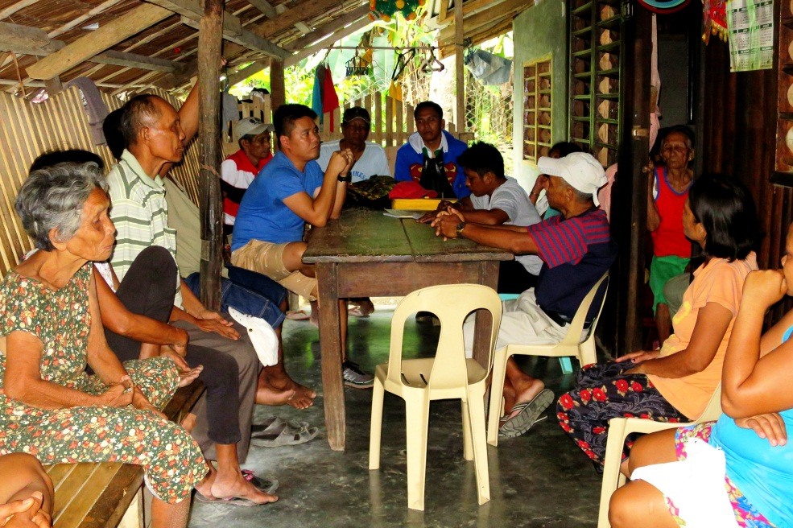
- Partnership for sustainability. Agata’s Community Relations Team conducts regular Information, Dissemination and Communication (IEC) activities to the tribal members.

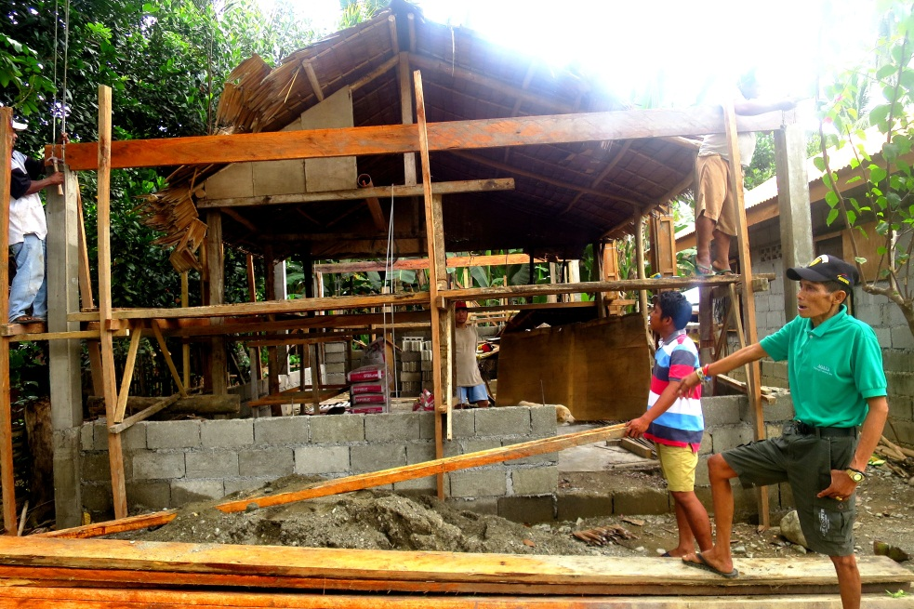
- Datu Mapaso Moron proudly showcases the ongoing construction of their Tribal Hall – which he personally supervises and which was finally realized through their royalty share.

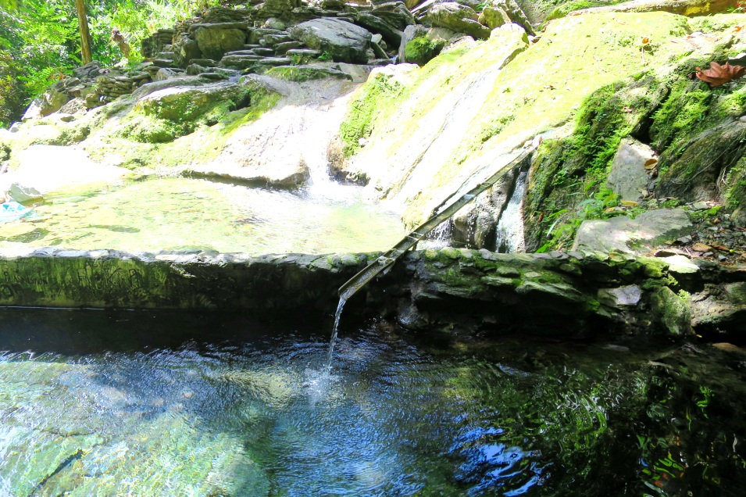
- Mapaso Hot Spring – an eco-tourism and tribal heritage site of the Mapaso’s Mamanwas.

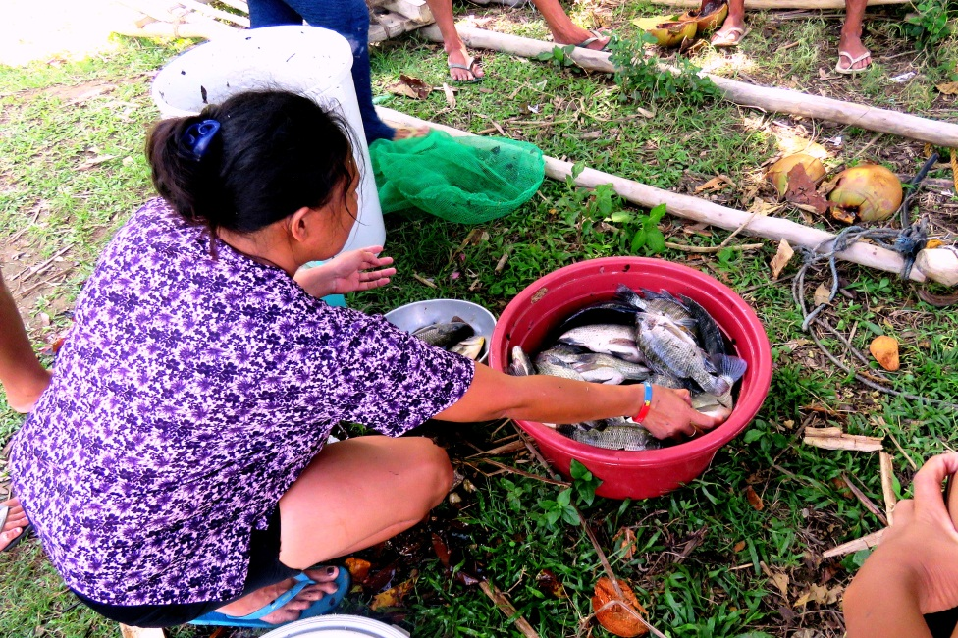
- The tribe invested in a freshwater fish cage and recently had their first successful harvest that validated their chosen investment.

About TVI in the Philippines
TVI Resource Development Philippines Inc. (“TVIRD”), is the local affiliate of TVI Pacific Inc. (TSX: TVI), a publicly-listed Canadian mining company focused on the exploration, development and production of precious and base metals from district-scale, large-system, high-margin projects located in the Philippines. Concurrent ownership of ventures is shared with partner company, Prime Resource Holdings Inc.

The commercial operations of Agata Mining Ventures Inc. (AMVI) mark the third successful mining project that TVIRD brought on-stream in the past 10 years. The company is committed to exploration and mining practices that promote transparency, responsible stewardship of the environment, and the inalienable rights to life, dignity, and sustainable development of its host communities.
www.tviphilippines.com

Contact:

Kaycee Crisostomo Julius M. De Villa
Corporate Communications Director Corporate Communications Officer
TVI Resource Development Philippines Inc. Agata Mining Ventures, Inc.
Email: kaycee.crisostomo@tvipacific.com.ph Email : julius.devilla@agatamining.com.ph
Phone: +63 2 728-8491 ext. 103 Mobile : + 63 918 336-4703 / +63 915 356-3271
Mobile: +63 917 579-1528
Fax: +63 2 728-8515

