 | AMVI-FOR-PA-003 | Press Release
 | Revision No. 03 | Effectivity Date: 2016
N E W S R E L E A S E

AMVI-Tubay Partnership Advances Sustainable Progress
AMVI supports 69th Founding Anniversary of Tubay Municipality

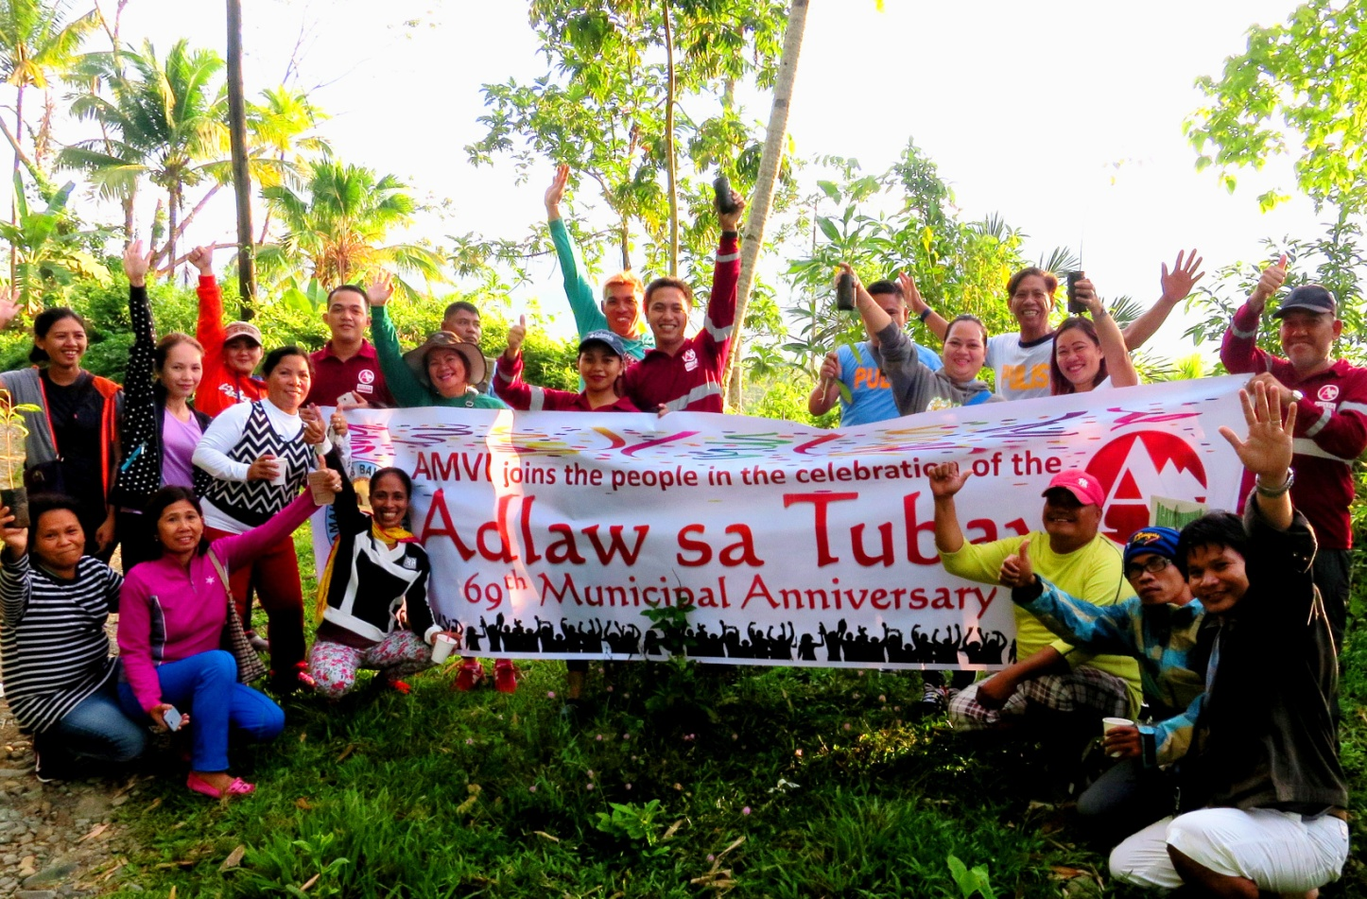
Proud Tubaynons. Together with Community Relations VP Edsel Abrasaldo (extreme right), municipal employees, PNP personnel and barangay volunteers take pride in planting seedlings along the banks of Kalinawan River.

Tubay, Agusan del Norte / November 2016 – Agata Mining Ventures Inc. (AMVI), a joint venture project of TVI Resource Development Philippines Inc. (TVIRD) and MRL Nickel Philippines Inc., recently joined its host Municipality of Tubay in commemorating the town’s 69th founding anniversary – further cementing the common path towards solidarity, peace and sustainable progress for both. AMVI likewise shares the same progressive vision of incumbent Mayor Fidel B. Garcia, Jr. and the Tubay Municipal Board headed by Vice Mayor Raquim Cuyos who both issued a shining commendation of the company’s contributions that “have brought better economic and socio-cultural conditions (and) its efforts that underscore the essence of responsible mining in our country.”

AMVI assumed a major sponsorship of Tubay’s week-long celebration that culminated in the annual Binibining Tubay 2016 beauty pageant. Among 12 candidates representing different local organizations and offices, the Tubay Working Youth Club’s Gypsy Mae Arnado was crowned as the new Binibining Tubay 2016 and concurrent Agata Goodwill Ambassador for environment and social development programs.

“Truly this is one pageant that I admire as it resembles Tubay’s simplicity. These local beauties represent every sector with pride and elegance that reflect a community that is always proud of its endeavors,” said guest of honor Congressman Erlpe Amante.

The commemoration also highlighted the town’s economic growth, which is attributed in part to the company’s mining operations within its 4,995 hectare Mineral Production Sharing Agreement (MPSA) area.

Fostering goodwill
“AMVI’s participation and resounding commitment towards the growth of our coastal communities have always been a pride, and more so towards the coming years of its responsible implementation of their projects,” declared Binibining Tubay Chairperson Fe Delia Garcia, wife of Mayor Garcia, during the pageant.

The yearly event was organized by the pageant committee through the municipal tourism office and is likewise supported by the Department of Education, Philippine National Police, Working Youth Club, Tubay Womens Organization and other sponsors.

AMVI was represented by General Manager Engr. Emilio T. Figueroa III and TVIRD Security Director (Ret.) Brig. General Emmanuel S. Cayton who were among the judges who crowned Binibining Tubay.

Multi-sectoral support
The anniversary celebration kicked-off with sports activities that pitted the different offices of the Local Government Unit in various competitions as well as an inter-barangay basketball tournament for members of the community.

The commemoration activities also included a Senior Citizens Day and dance competition organized by the Municipal Social Welfare and Development Office. Some 10 barangays participated in the competition bested by Barangay Poblacion, which captured the title.

“The anniversary of Tubay reminds us not just of our success, but also our past which we owe to our senior citizens. Without them, Tubay will not consist of competent workers and mindful residents. It reminds us to always respect our elders,” said Vice Mayor Raquim Cuyos during the event.

The official likewise spearheaded the Alay Lakad and Tree Planting along with Agata Community Relations VP Edsel Abrasaldo. Together, they led over 200 employees and residents in a walkathon from the municipal hall to Barangay Tanog-tanogon where they planted more than 200 seedlings along Kalinawan River – AMVI’s adopted tributary.

The Sanggunian Bayan (Municipal Board) and Barangay Awards Night likewise recognized the efforts of distinguished constituents and organizations in the fields of public service, local projects, and various best practices in their communities.

Progress and development
The Agata MPSA includes four of Tubay’s barangays that have since benefitted from the miner’s Social Development Management Projects (SDMP): Lawigan, Tinigbasan, Tagpangahoy and Binuangan. The bulk of its mining operations is conducted within the town and extends to neighboring Jabonga and Santiago Municipalities. Both Tubay and AMVI share a common development roadmap in harnessing its vast mineral resources and developing its dedicated human capital.

AMVI enhances economic activity in the area through direct employment and the generation of several livelihood programs specifically designed to the needs, resources and capabilities of its host communities. It likewise protects the environment and enhances the community by implementing the same successful social development model of TVIRD – lead operator of the Agata Nickel Project.

To date, there are more than 300 jobs created for Tubaynons who receive more than PhP 5.6 million in salaries. In terms of capacity building, AMVI engaged the country’s Technical Education and Skills Development Authority (TESDA) to conduct its NC2 Light Vehicle Driving and Basic Maintenance Training for 30 trainees. There are also five Tubay scholars taking up mining related courses in Caraga State University and whose education are supported by AMVI.

The company plans to undertake infrastructure projects such as the improvement of the Tinigbasan-Tagpangahoy access road in order to improve mobility within the municipality. It also plans to construct a marine sanctuary observation tower in Lawigan – one of which it already constructed for Tinigbasan during last year’s Ocean Month celebration.
*******

Press photos:

- A new queen. Ms. Gypsy Mae Arnado assumes the crown and will represent Tubay and AMVI’s advocacy towards responsible mining efforts and other projects in the communities.

- Executive decision. (L to R): Tubay Mayor Fidel B. Garcia Jr., Congressman Erlpe Amante, TVIRD Security Director (Ret.) Brig. General Emmanuel S. Cayton, Agata General Manager Emilio T. Figueroa III and reigning Binibining Tubay 2016 Gypsy Mae Arnado. Joining them are pageant runners-up during the culmination of Tubay’s founding anniversary celebration.

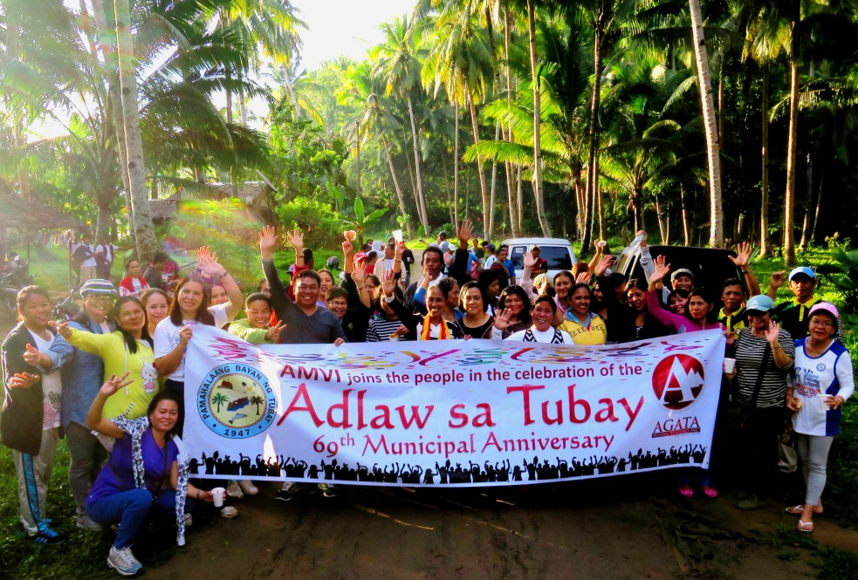
- The joint members of the different offices of the Municipality of Tubay take a unity pose after their commemorative tree planting activity

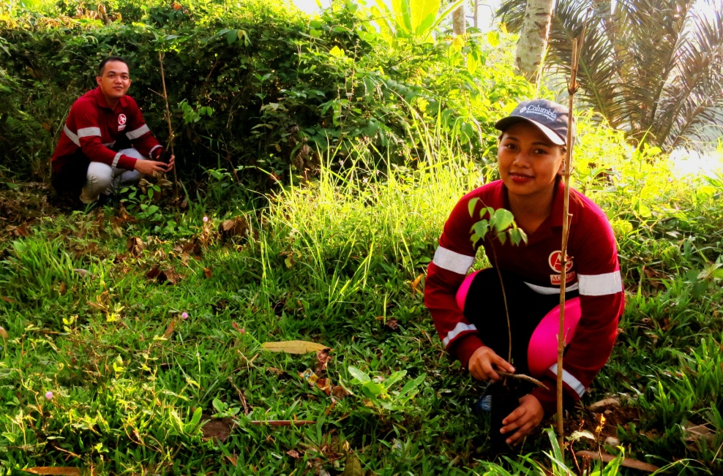.
- AMVI employees do their share – both in commemorating their host municipality’s founding anniversary and in maintaining the environmental upkeep of AMVI’s adopted Kalinawan River.

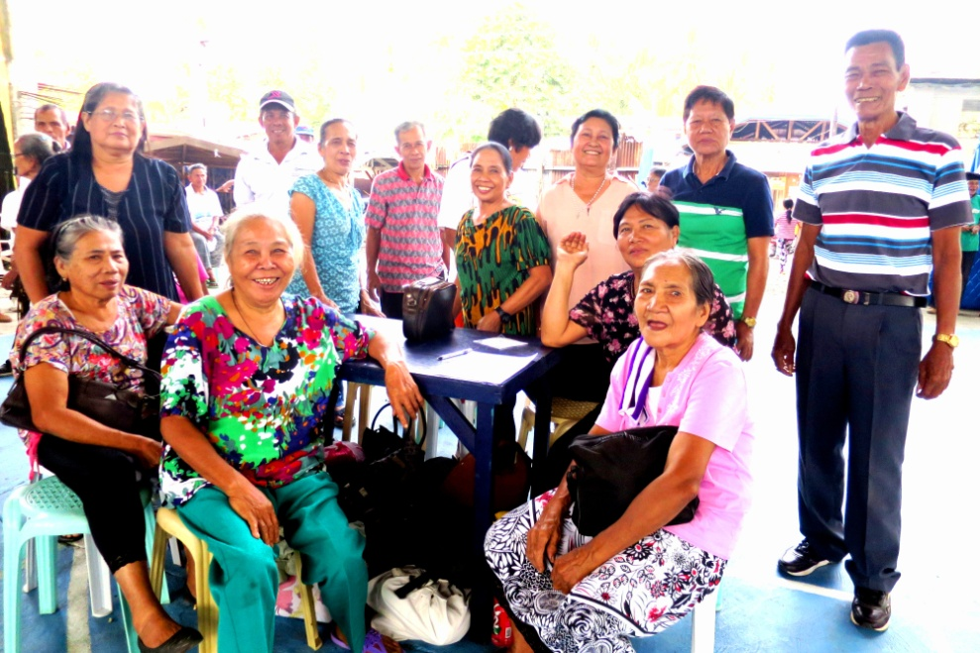
- Elder constituents of Barangay Lawigan join activities of Tubay’s Senior Citizens Day. Some 10 barangays participated in the activities organized by the Municipal Social Welfare and Development Office.

About TVI in the Philippines
TVI Resource Development Philippines Inc. (“TVIRD”), is the local affiliate of TVI Pacific Inc. (TSX: TVI), a publicly-listed Canadian mining company focused on the exploration, development and production of precious and base metals from district-scale, large-system, high-margin projects located in the Philippines. Concurrent ownership of ventures is shared with partner company, Prime Resource Holdings Inc.

The commercial operations of Agata Mining Ventures Inc. (AMVI) mark the third successful mining project that TVIRD brought on-stream in the past 10 years. The company is committed to exploration and mining practices that promote transparency, responsible stewardship of the environment, and the inalienable rights to life, dignity, and sustainable development of its host communities.
www.tviphilippines.com

Contact:

Kaycee Crisostomo Julius M. De Villa
Corporate Communications Director Corporate Communications Officer
TVI Resource Development Philippines Inc. Agata Mining Ventures, Inc.
Email: kaycee.crisostomo@tvipacific.com.ph Email : julius.devilla@agatamining.com.ph
Phone: +63 2 728-8491 ext. 103 Mobile : + 63 918 336-4703 / +63 915 356-3271
Mobile: +63 917 579-1528
Fax: +63 2 728-8515

