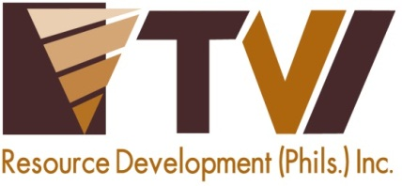
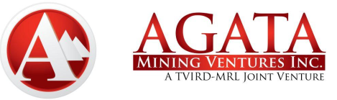 | AMVI-FOR-PA-003 | Press Release
 | Revision No. 03 | Effectivity Date: 2016
N E W S R E L E A S E

TVIRD Concludes Successful ISO 14001 Certification Process
at its Agata Nickel Laterite Project
Intertek Philippines satisfied with compliance audit, completes final certification process

A balanced ecology. Ongoing reforestation activities, which has planted and grown over 173,000 trees at the Agata Nickel Laterite DSO Project, offsets the areas affected by mining activities. (In photo): Indigenous trees thrive right above the Agata Causeway in Tubay, Agusan del Norte.

Tubay, Agusan del Norte / October 2016 – Agata Mining Ventures Inc. (AMVI), a joint project of TVI Resource Development Inc. (TVIRD) and MRL Nickel Philippines Inc., announced that it has received its ISO 14001:2004 certification last 21 October 2016 – bringing the Agata Nickel Laterite Project into full compliance with DENR Administrative Order No. 2015-07. Intertek Philippines, a reputable ISO-accrediting institution, earlier concluded its third party audit and was satisfied with both the company’s internal compliance procedures as well as its Environmental Management System (EMS). The EMS is a fundamental component under the ISO certification process.

The final system audit and the succeeding recent ISO certification concluded the process, which is in line with the DENR requirement for all Philippine mining projects to be certified as compliant with the ISO 14001 system. The recent development likewise underpins that the company’s environmental management standards run parallel with that of international standards.

“Obtaining an ISO certification is just one of the many environmental management safeguards implemented by TVIRD in its previous mining operations that have since been installed as part of the company’s Agata Mining Project,” according to TVIRD Vice President for Environment, Engr. Jay Nelson.

“Apart from achieving regulatory compliance, TVIRD couples this with the proper and sustained implementation of an effective environmental management program. This tandem is what defines responsible mining,” Engr. Nelson explained.

TVIRD operates the Agata Nickel Laterite Project in its 4,995-hectare Mineral Processing Sharing Agreement (MPSA) area in the municipalities of Tubay, Jabonga and Santiago in Agusan del Norte Province.

The road to ISO
In April this year, AMVI launched its enhanced environmental policy, which reflects the company’s commitment to keep the environmental impact of its mining operations within regulated and socially-acceptable levels – both of which are achieved through its Environment Management Plan.

The policy also aimed to facilitate and enhance the decision-making process on environmental management issues by seeking opinion, feedback and participation from AMVI’s stakeholders. It also promotes and encourages awareness and training to ensure individuals are aware of their responsibilities.

Last August – four months after the launch of AMVI’s enhanced environmental policy – Intertek examined the company and found no major non-compliance issues, and in instead, found favorable qualities that made it eligible for certification.

The company likewise institutionalized a periodic review of the EMS and the policy in order to ensure its relevance, effectiveness and to ensure the overall sustainability of its environment.

The highest international standards
Since the start of its gold and silver mining operations in Sitio Canatuan, Siocon Municipality, Zamboanga del Norte in 2004, TVIRD has operated under principles and guidelines identified and recommended by several international organizations.

“Most, if not all mining companies have incorporated these guidelines and principles in their operations long before the requirement for ISO Certification. Many of the mining standards and regulations developed by Canada, Australia and other countries have also long been part of TVIRD’s environmental policy as well as the Philippine mining industry landscape,” Engr. Nelson further noted.

A proven track record
To date, TVIRD has consistently been recognized by various institutions for its exceptional environmental management and safety standards and practices. In its Agata Mining Project, the company’s coral relocation and coastal resource management program became the first in the region and was previously recognized with an Outstanding Performance Award by the DENR.

“In any discussion of responsible mining, the government and the various agencies, departments and bureaus oversee and monitor mining operations within the country. All of us are happy to join in the ISO certification process with the caveat that this is just one tool among many to be used in building an even stronger responsible mining platform,” expressed Agata General Manager Emilio Figueroa III.

In the recent Philippine Mine Safety and Environment Association (PMSEA) awards, the company was likewise given the Titanium Award in the Surface Mining category – a milestone achieved by AMVI within its first year of operations, which is also a significant first for the industry.

*******

Press photos:

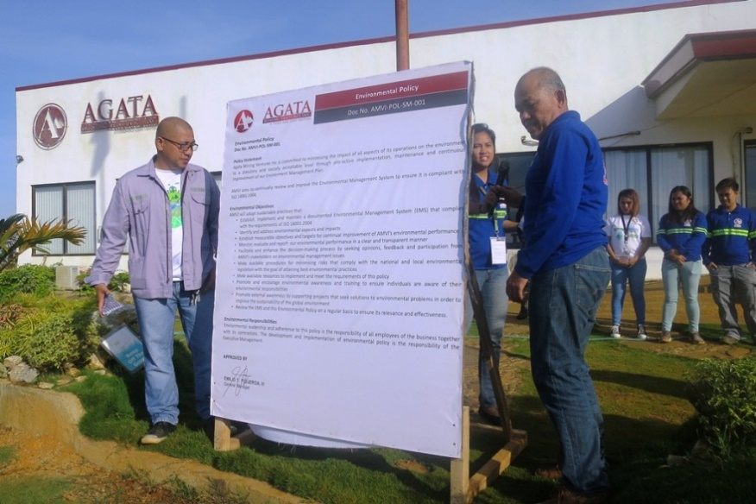
- Unveiling its commitment. The Agata Team headed by Assistant General Manager Anthony B. Quijano and VP-Community Relations Edsel Abrasaldo launched its Environmental Policy during the company’s weekly flag raising ceremony.

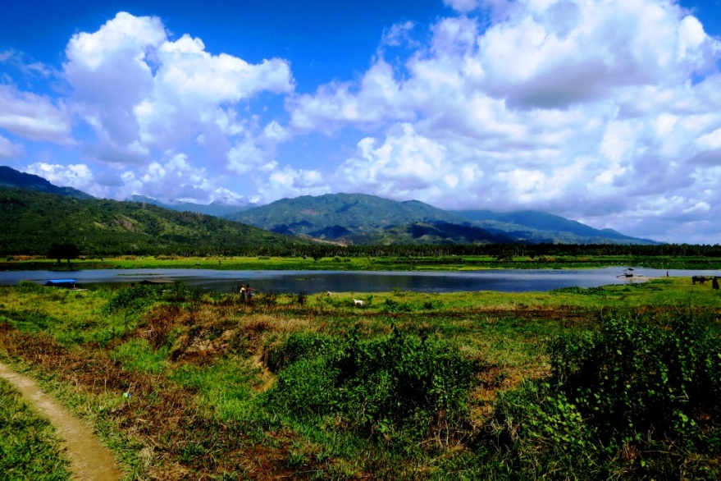
- Checking the waters. The 29-kilometer Kalinawan River is the cleanest inland body of water in the CARAGA region and possibly the entire province of Agusan del Norte. Since 2010, AMVI adopted Kalinawan River, which was inspected by the Intertek Audit Team during the ISO audit along with other smaller tributaries that run through the Agata MPSA.

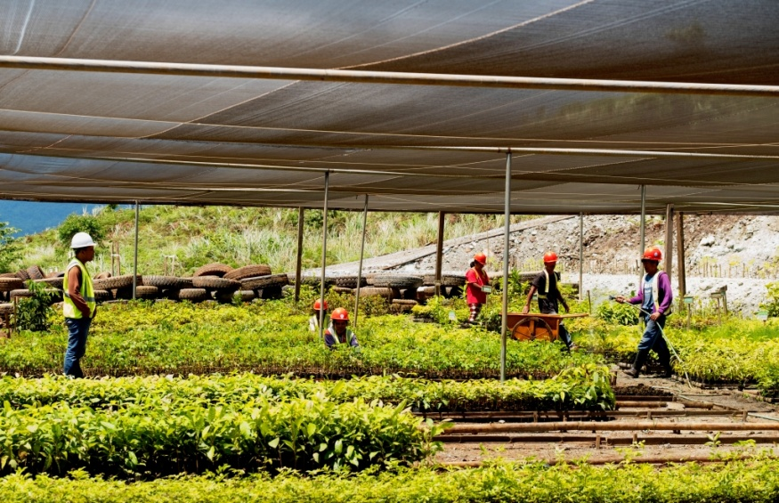
- The Agata Central Nursery currently supplies the seedling requirements of all reforestation projects of AMVI and the community within and outside the MPSA area. The facility encompasses a one- hectare area within the Payong-payong ridge, housing over 100,000 seedlings of various forest and fruit tree species. The AMVI reforestation area presently covers approximately 150.5 hectares.
.

About TVI in the Philippines
TVI Resource Development Philippines Inc. (“TVIRD”), is the local affiliate of TVI Pacific Inc. (TSX: TVI), a publicly-listed Canadian mining company focused on the exploration, development and production of precious and base metals from district-scale, large-system, high-margin projects located in the Philippines. Concurrent ownership of ventures is shared with partner company, Prime Resource Holdings Inc.

The commercial operations of Agata Mining Ventures Inc. (AMVI) mark the third successful mining project that TVIRD brought on-stream in the past 10 years. The company is committed to exploration and mining practices that promote transparency, responsible stewardship of the environment, and the inalienable rights to life, dignity, and sustainable development of its host communities.
www.tviphilippines.com

Contact:

Kaycee Crisostomo Julius M. De Villa
Corporate Communications Director Corporate Communications Officer
TVI Resource Development Philippines Inc. Agata Mining Ventures, Inc.
Email: kaycee.crisostomo@tvipacific.com.ph Email : julius.devilla@agatamining.com.ph
Phone: +63 2 728-8491 ext. 103 Mobile : + 63 918 336-4703 / +63 915 356-3271
Mobile: +63 917 579-1528
Fax: +63 2 728-8515

