N E W S R E L E A S E

Agata Mining: Back-to-Back Awardee for Outstanding Coastal Resource Management Program
MGB confers yet another award for AMVI’s successful conservation program

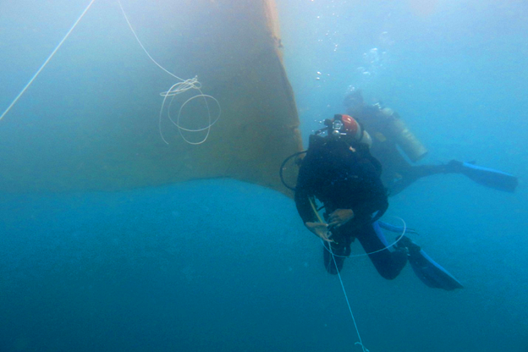
An Iron Curtain. AMVI Environment Manager Jesalyn Guingguing leads the periodic maintenance of Silt Curtains that surround the protected fish sanctuaries in Barangays Tinigbasan and Lawigan in Tubay Municipality. Keeping run-off silt from escaping into AMVI’s protected marine sanctuaries, the program signifyies the company’s strong commitment towards environment protection and conservation.

Surigao City, Surigao del Norte / January 2016 – After recently being the first mining company with only a year of operations, to have received a Titanium Award from the Philippine Mineral Industry and Environmental Awards (PMIEA) in November last year, Agata Mining Ventures Inc. (AMVI) once again received two awards: first for its successful implementation of its Coastal Resource Management Program (CRMP), and second for its exemplary performance in promoting responsible mining through the enhancement of environmental protection, social responsiveness and health and safety practices. AMVI was awarded by the DENR’s Mines and Geosciences Bureau (MGB) through the Caraga Mine Environmental Management Council (CMEMC) in Gateway Hotel, Surigao City. The program was attended by the respective members of the Mine Environmental Protection and Enhancement Office (MEPEO) from several operating mining companies in the Caraga Region.

AMVI is a joint venture of MRL Nickel Philippines Inc. (MRL) and TVI Resources Development Philippines Inc. (TVIRD), which operates the Agata Nickel Project – the third successful project that TVIRD brought on-stream within the past ten years. The company draws best practices from TVIRD and MRL – both of which are recipients of various awards and hold excellent track records duly recognized by respective governing agencies in the mineral industry.

Back-to-Back recognition
During the agency’s 27th anniversary celebration in June 2014, the Department of Environment and Natural Resources (DENR) recognized and awarded AMVI for the successful implementation of its CRMP, specifically its Coral Relocation Project which was conceived and initiated from its exploration phase with TVIRD joint-venture partner MRL.

Aside from undertaking a successful coral relocation project, AMVI’s CRMP also focused mainly on the protection of two marine sanctuaries in close coordination with both the local farmers and fisher-folks associations of Barangays Lawigan and Tinigbasan together with the local government unit of Tubay Municipality.

AMVI was also recognized to be the first mining company to ever undertake a successful coral relocation project prior to constructing its port facilities and prior to the commencement of its Direct Shipping Ore (DSO) operations in the fourth quarter of 2014.

Aside from its outstanding CRMP, the DENR-MGB awarded AMVI another recognition for its exemplary performance in Environment Protection and Enhancement Program (EPEP) in December 2015 - making AMVI a consecutive yearly awardee of the agency. This also consistently signifies AMVI’s strong commitment towards environment protection and conservation as well as social responsiveness its health and safety practices.

"The main focus of awarding these commendations is to give companies due recognition for the outstanding initiatives each has undertaken to protect and enhance the mining environment", says MGB Regional Office XIII Forester Enjie Pacillos during the awarding ceremonies.

Marine Sanctuary Improvements
Following AMVI’s improvement of the Tinigbasan Tower House Observatory, which it constructed in 2015, and its recent turnover to the Tinigbasan Farmers and Fisher-folks Association (TIFFA) last year, the company started undertaking the improvement of a similar facility for the Lawigan Farmers and Fisher-folks Association (LAFFA) as well as its lighthouse, which marks the barangay’s marine sanctuary.

Construction is on-going for upgrading the observatory, including the widening of the foundation, upgrading the overall structure and the construction of a hanging bridge that will soon connect LAFFA’s observatory to its lighthouse.

“Once all these improvements have been completed, LAFFA marine sanctuary can offer activities to boost tourism in Barangay Lawigan and in the Municipality of Tubay by promoting the availability of marine recreational activities such as snorkeling, scuba diving and paddle kayaking among others. These activities can also provide additional job opportunities and an alternative source of income for LAFFA and Barangay Lawigan’s community,” said AMVI Community Relations Officer Tyron Hans Salas at the end of a recent on-site inspection.

*******

Press photos:

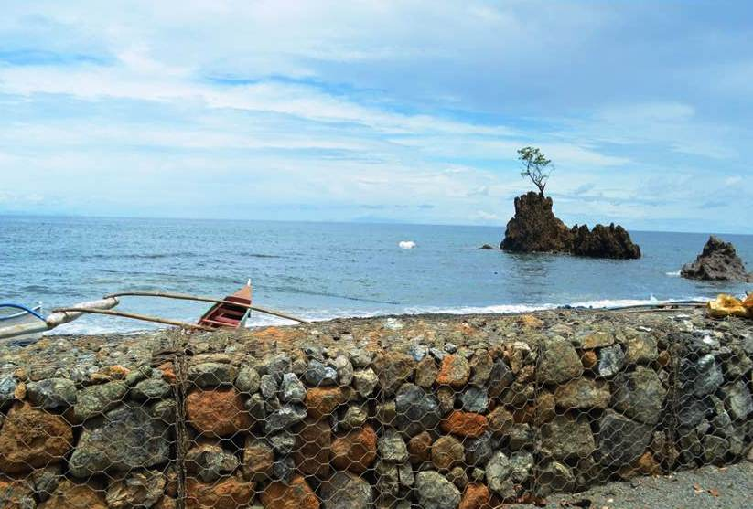
- Several Gabion Baskets fortified with Coco-nets and or Geotextile fabric installed surround AMVI’s Port and Causeway area serve as a barrier designed to trap silt and other unwanted debris from reaching the coastal waters of Tubay.

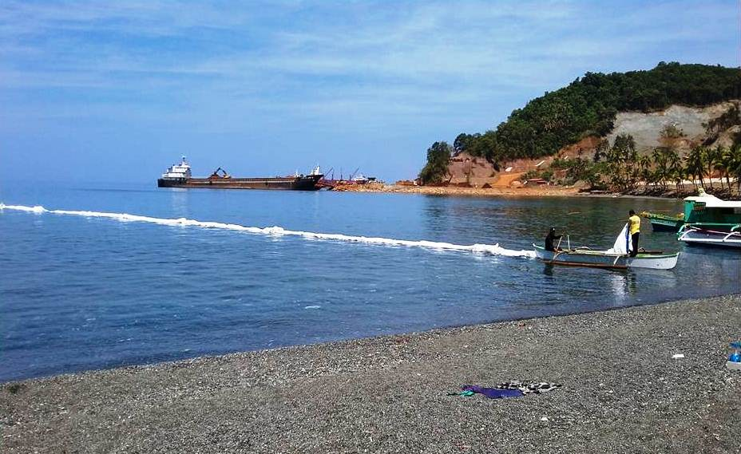
- A combination of inter-woven Abaca sacks, Coco-nets and Geotextile fabric surround the coral relocation site and AMVI’s protected fish sanctuaries located in Barangays Tinigbasan and Lawigan in Tubay.

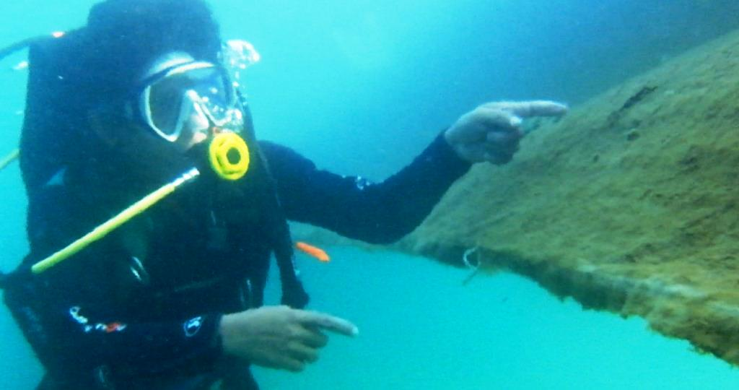
- AMVI Environment Manager Jesalyn Guingguing shows how a cordon of silt curtains made of geotextile fabric and inter-woven abaca coco-nets effectively trap silt and debris under water.

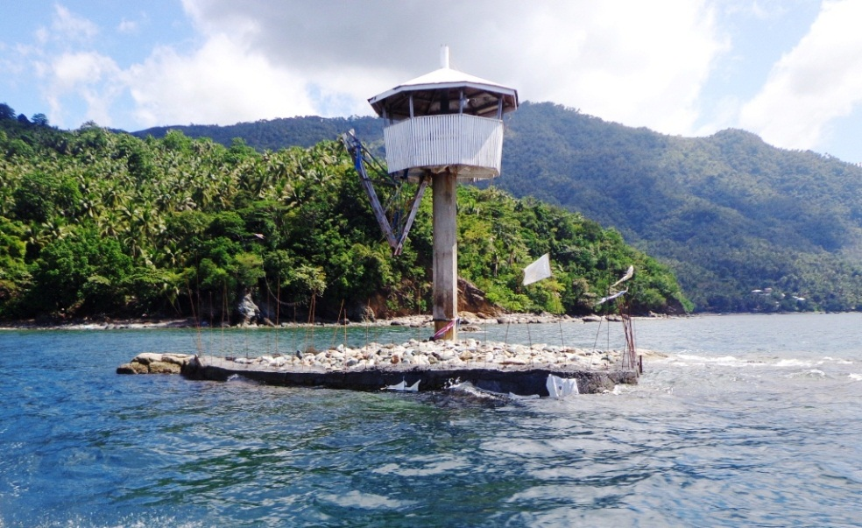
- Construction work for improving LAFFA’s Lighthouse facility already commenced in Barangay Lawigan’s Marine Sanctuary. AMVI plans to widen, fortify and construct a hanging bridge that will connect LAFFA’s observatory to its lighthouse.

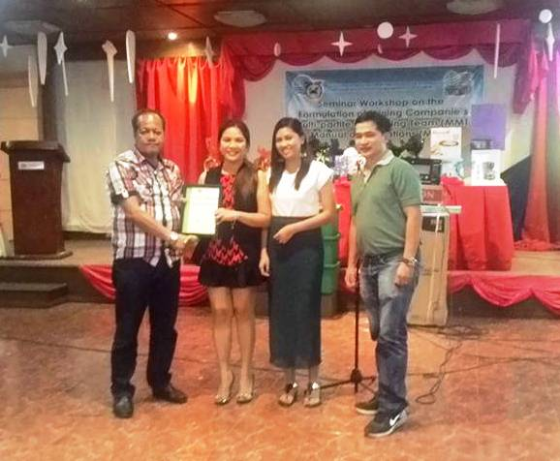
- Back-to-back Recognition. (In photo): MGB OIC Regional Director Eng’r. Daniel Belderol, AMVI Environment Manager Jesalyn Guingguing, AMVI Environment Officer Sheila Maffrah Espenido and MGB-MESD Chief Engr. Glen Suante at the awarding ceremonies.

About TVI in the Philippines
TVI Resource Development Philippines Inc. (“TVIRD”), is the local affiliate of TVI Pacific Inc. (TSX: TVI), a publicly-listed Canadian mining company focused on the exploration, development and production of precious and base metals from district-scale, large-system, high-margin projects located in the Philippines. Concurrent ownership of ventures is shared with partner company, Prime Resource Holdings Inc.

The commercial operations of Agata Mining Ventures Inc. (AMVI) marks the third successful mining project that TVIRD brought on-stream in the past 10 years. The company is committed to exploration and mining practices that promote transparency, responsible stewardship of the environment, and the inalienable rights to life, dignity, and sustainable development of its host communities.
www.tviphilippines.com

Contact:

Kaycee Crisostomo
Corporate Communications Director
TVI Resource Development Philippines Inc.

Email: kaycee.crisostomo@tvipacific.com.ph
Phone: +63 2 728-8491 ext. 103
Mobile: +63 917 579-1528
Fax: +63 2 728-8515

