N E W S R E L E A S E

Mining Firm and Spanish Foundation Restart Healthcare Services to Tubay Coastal Communities
Agata Mining and Sociedad Española de Beneficiencia provide medical and dental services to nearly 800 beneficiaries in four coastal barangays

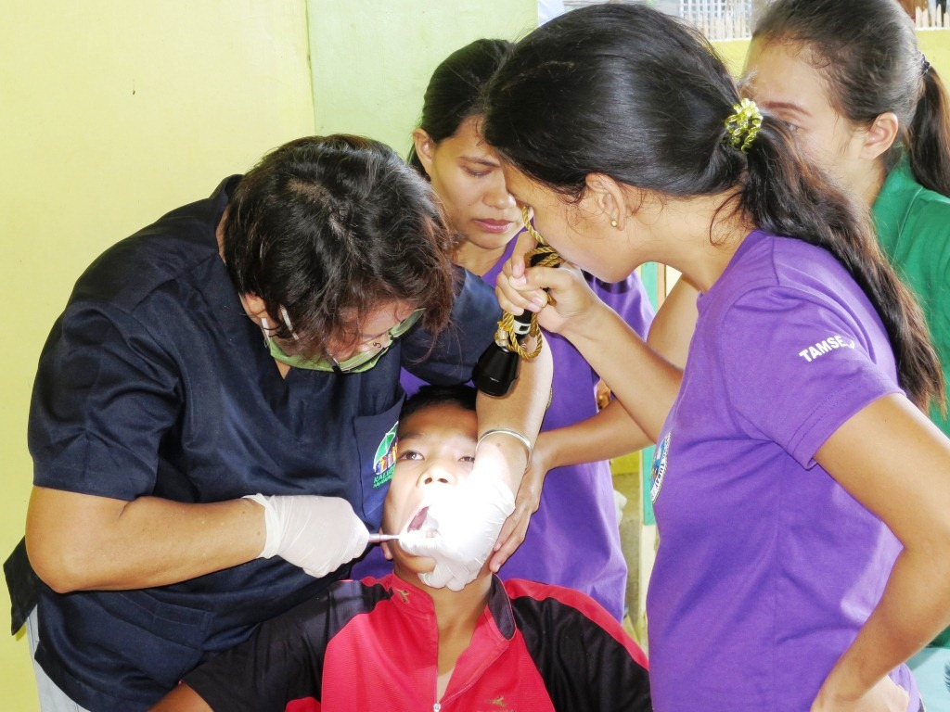
Goodbye Tooth Decay. Children comprise more than half of the total dental beneficiaries during Agata Mining’s medical and dental mission in Tubay Municipality. Dental service is an addition to the regular healthcare services formally requested by the company’s host communities.

Tubay, Agusan del Norte / January 2016 – Underscoring the need for adequate healthcare in far-flung rural communities, Agata Mining Ventures Inc. (AMVI), a joint venture of TVI Resource Development Philippines Inc. (TVIRD), and Sociedad Española de Beneficencia Inc. (SEB-Manila), a charitable institution dedicated to the care of both Spanish and Filipino indigents in the country, conducted the first leg of its humanitarian missions for the benefit of the company’s host community in Tubay, Agusan del Norte this year. In addition to medical services, the company added a dental component to the mission, upon the request of community members from the coastal barangays of Lawigan, Tinigbasan, Tagpangahoy and Binuangan for whom the mission was conducted. The mission was held in Barangay Tinigbasan’s covered gymnasium.

In 2014, AMVI rolled-out several medical missions as part of its Health and Sanitation Program – a number of which were in support of its media partners in Butuan and which were the largest humanitarian missions in the CARAGA Region. This time around, the AMVI medical mission was complemented with additional dental services; thus expanding the reach of donated medicines from mission partner, SEB-Manila.

The mission was likewise supported by Barangay health workers, doctors and dentists from Tubay and Nasipit Municipal Health Offices, the Department of Education (DepEd), the Department of Health (DOH) and Cabadbaran Diagnostic Center. It also gained the strong support of Tubay Municipal Mayor Fidel Garcia along with the current Miss Tubay and Agata Goodwill Ambassador Gwyneth Amanda Yutiamco from Tubay Women’s Federation (TWF).

“The whole community is very pleased to avail of the added dental services as well as the abundance of medicines and vitamins this year. We are thankful for AMVI and SEB-Manila for steadily increasing healthcare services during their barangay medical missions that continue to advance health and wellness in our communities,” said Tinigbasan Barangay Captain Dante Mandam on the sidelines of the mission.

More medicines and services
The mission benefited close to 800 participants who availed of free medical and dental consultations, check-ups, medicines and tooth extractions. The common health issues addressed by the mission include urinary tract infection, hypertension, acute respiratory infection, upper respiratory tract infection, muscle spasms, skin diseases, arthritis and various gastro-intestinal problems along with a considerable number of cases of tooth decay.

In addition to medicines, SEB-Manila also provided vaccines, antibiotics and vitamins while AMVI procured the necessary dental supplies as part of its Social Development and Management Program (SDMP). Following the success of the mission, the company is likewise planning a similar activity for host inland and riverside barangays.

Health Equals Wealth
To date, AMVI has initiated and supported various activities and programs that promote health and wellness for various communities. Last year, the company supported the Philippine Drug Enforcement Agency’s (PDEA) Drug Control and Prevention Month – which promotes the agency’s drug-free program for high school students. It likewise supported the National Food Authority’s (NFA’s) Food Guardian Campaign through its conservation rice and making it accessible, available, affordable and safe for consumers.

AMVI also supported RMN and Bombo Radyo as well as Mindanao Centro Daily on each of their respective medical missions in Butuan City – which provided healthcare to a combined 3,000 participants in the region.

*******

Press photos:

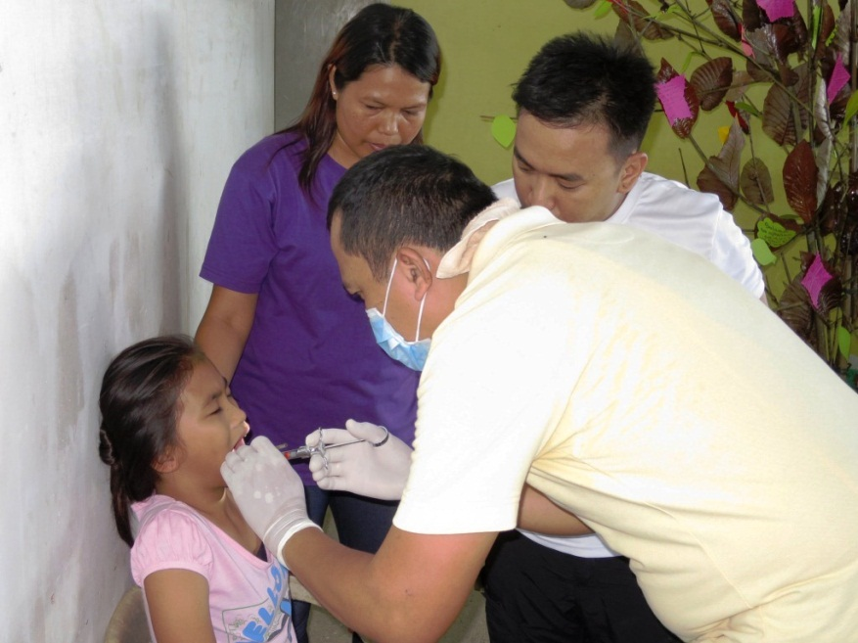
- Nasipit Municipal Health Office Dentist Dr. Fernando Y. Malunhao performs tooth extraction on one of several children who benefited from the mission’s dental services.
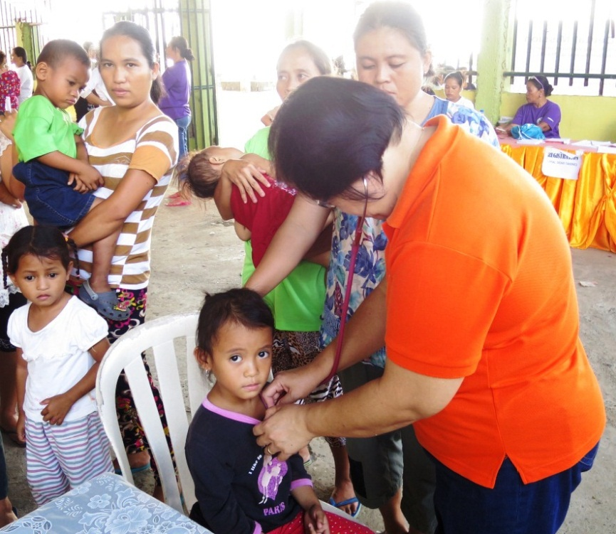
- Cabadbaran Diagnostic Center’s resident doctor Dra. Rhodora Gliceria M. Anino provides check-ups and medical consultations to children who make up more than 50 percent of the beneficiaries.

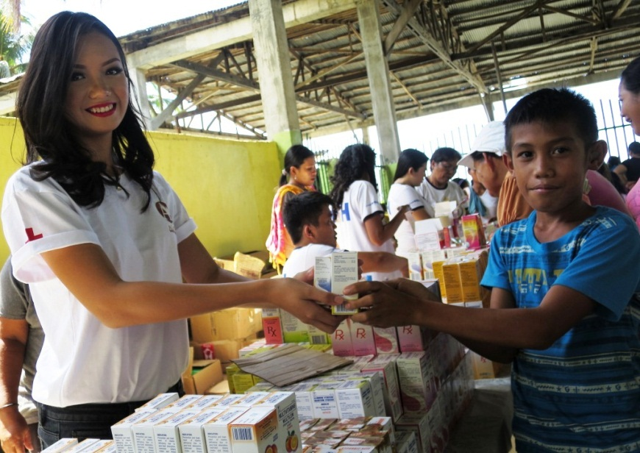
- Gift of Healthcare. Miss Tubay 2015 and AMVI Goodwill Ambassador Gwyneth Amanda Yutiamco lends a helping hand in during the mission’s medicine distribution.

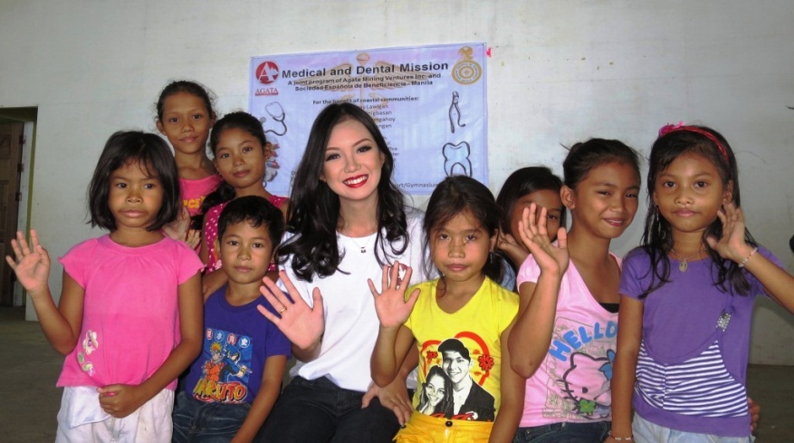
- Miss Tubay and AMVI Goodwill Ambassador Gwymeth Amanda Yutiamco shares a light moment with the mission’s highest number of beneficiaries – the children of Tubay.

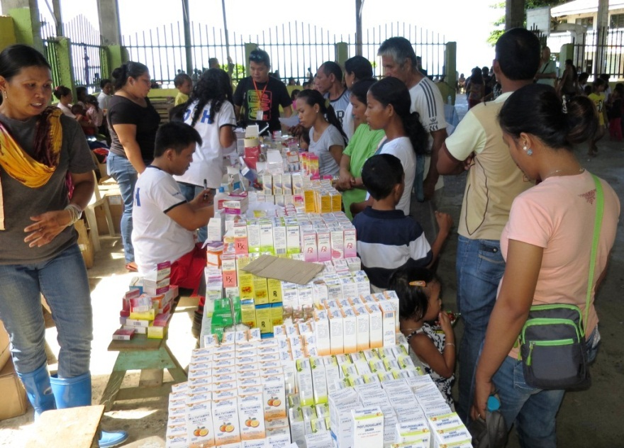
- Fully Loaded. The generosity of Sociedad Española coupled with AMVI’s additional procurement of dental supplies goes a long way in serving the needs of its communities.

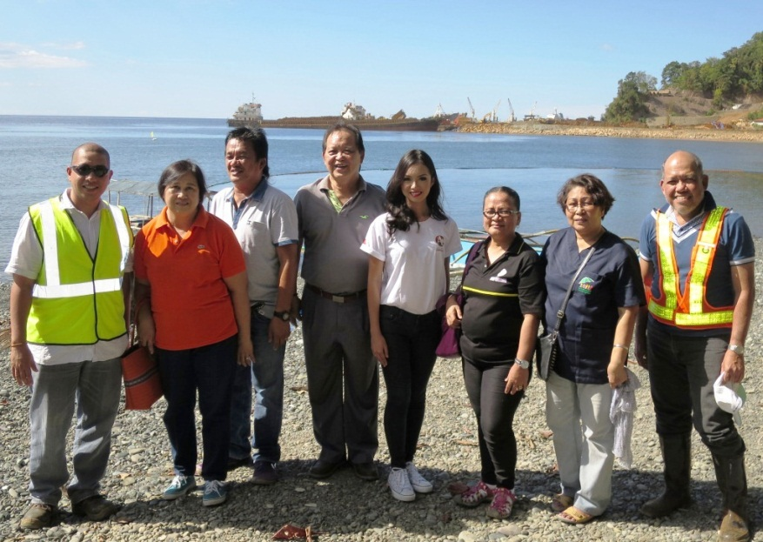
- Mission Complete. Doctors, dentists and AMVI key officers are joined by Tubay Mayor Fidel Garcia and Agata Goodwill Ambassador Gwyneth Amanda Yutiamco in Barangay Tinigbasan.

About TVI in the Philippines
TVI Resource Development Philippines Inc. (“TVIRD”), is the local affiliate of TVI Pacific Inc. (TSX: TVI), a publicly-listed Canadian mining company focused on the exploration, development and production of precious and base metals from district-scale, large-system, high-margin projects located in the Philippines. Concurrent ownership of ventures is shared with partner company, Prime Resource Holdings Inc.

The commercial operations of Agata Mining Ventures Inc. (AMVI) marks the third successful mining project that TVIRD brought on-stream in the past 10 years. The company is committed to exploration and mining practices that promote transparency, responsible stewardship of the environment, and the inalienable rights to life, dignity, and sustainable development of its host communities.
www.tviphilippines.com

About Sociedad Española de Beneficencia - Manila
Sociedad Española de Beneficencia (SEB) is a private charitable institution founded in 1948. Its primary goal is to protect indigent Spanish citizens and their families in the Philippines. It provides financial and healthcare assistance, hospitalization and funeral expenses, as approved by its Board of Trustees.

With the decline in the number of indigent Spanish citizens living in the Philippines, SEB has broadened its scope towards improving the living conditions of disadvantaged Filipino children and elderly across the country.

http://www.sociedadespanoladebeneficencia.org

Contact:

Kaycee Crisostomo
Corporate Communications Director
TVI Resource Development Philippines Inc.

Email: kaycee.crisostomo@tvipacific.com.ph
Phone: +63 2 728-8491 ext. 103
Mobile: +63 917 579-1528
Fax: +63 2 728-8515

