 | AMVI-FOR-PA-003 | Press Release
 | Revision No. 02 | Effectivity Date: April 4, 2016
N E W S R E L E A S E

Jabonga LGU Commends Agata’s Contribution
to Poverty Reduction
AMVI’s social programs enhance living conditions in its extended communities

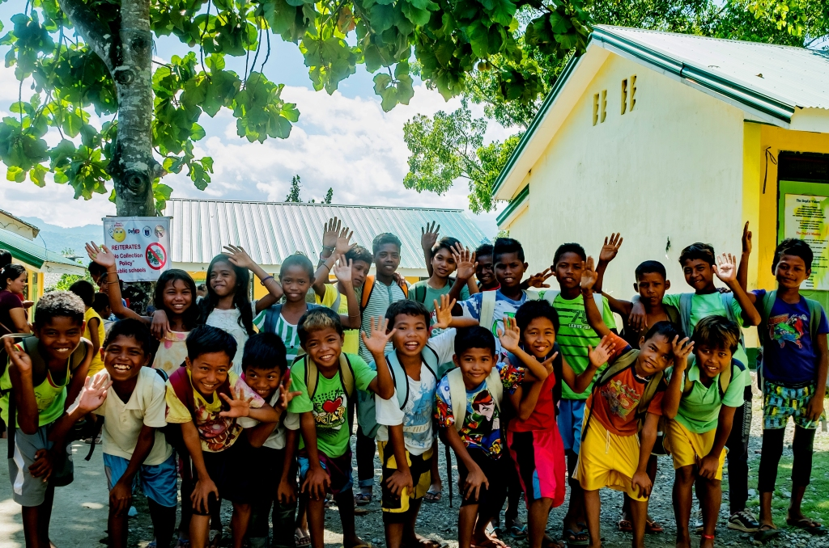
Students of Agata-supported Narcisa Bermudez Elementary are motivated to go back to school as AMVI renews its support in the form of school supplies, teaching materials and facility enhancements – and through the indigenous Mamanwas’ royalties received – a multi-purpose stage on which to conduct school-wide activities.

Butuan, Agusan del Norte / October 2016 – Jabonga Municipal Mayor Hon. Jasmin F. Monton reaffirmed the social contributions of Agata Mining Ventures Inc. (AMVI) that augmented the economic development of the communities within its MPSA. AMVI, a joint nickel laterite project of TVI Resources Development Inc. (TVIRD) and MRL Nickel Philippines Inc. (MRL), has been instrumental in mobilizing this positive momentum within just two years of operating in the municipality as well as in neighboring Santiago and Tubay where it primarily conducts it business.

The company was recognized for “contributing substantially invaluable impact in terms of employment generation and other income generation opportunities” for the municipality’s constituents. The certificate of recognition also cited AMVI’s involvement “provided multiplier effects” that ultimately reduced the incidence of poverty in the municipality. The official document was co-signed by Vice Mayor Glicerio Monton.

Change is here
AMVI rolled-out its Social Development Management Program (SDMP) in the communities of Jabonga, supporting local health, education, livelihood, public infrastructure and socio-cultural activities in the municipality. In the area of health services, the improvement and repair of the barangay health center and provision of medicines for Botika ng Barangay (community pharmacy) were provided.

Meantime, in support of responsive education, Colorado Elementary School received a public address (PA) system and continued support for its school activities and programs.

In terms of livelihood, the company provided financing to the Colorado Sustainable Farmer’s Association (CSUFA) and the Bigasan Income Generating Project of the Colorado Womens’ Organization (CWO) – which is a rice-vending program to address the community’s needs.

Jabonga’s main agricultural product is Coconut where copra production is evident and engages all of its barangays. Fresh water and shell fishes are likewise found in Lake Mainit and Kalinawan River while native furniture is also famous in the municipality owing to the abundance of bamboo. Despite unsuitable soil conditions for rice production – adding to the lack of irrigation in the area – the CSUFA and CWO are focused on augmenting available rice with additional supplies from nearby Cabadbaran.

The company’s SDMP also addressed the town’s need for adequate infrastructure through the improvement of dryers for their rice and corn harvest, the repair of the Dao Creek Foot-bridge that connects Sitio Coro to the Barangay Site and its senior citizen’s office where most socio-cultural activities and meetings take place.

“We are hoping Agata’s operations will be even more beneficial to the residents of Jabonga who are already enjoying (benefits). These will also add to municipal funds through taxes, in addition to possible infrastructure developments within our communities,” expressed Vice Mayor Glicerio Monton, Jr. during AMVI’s presentation to the Sangguniang Bayan’s (municipal board) regular session.

Preserving cultural heritage
The company likewise helps in the preservation of the people’s cultural heritage by supporting socio-cultural activities and the celebration of the town fiesta, which is a major yearly event for the municipality and its communities.

The Mamanwa indigenous community in Coro benefitted from the IP Royalty Share and established a sari-sari (general merchandise) store for its tribesmen’s daily needs. They likewise invested in a Falcata plantation and a multi-purpose delivery vehicle used for the transportation of goods, their fellow lumads and other emergency purposes.

Other than their ongoing hog-raising investment, the Mamanwas are also opting to engage in aquaculture in its nearby freshwater resource in Kalinawan River – a livelihood learned from their educational tour to successful sustainable organic farms and people’s organizations in Agusan del Sur and Davao City.

Most recently, they have emerged from marginalized and discriminated Mamanwas into adopting the Narcisa Bermudez School and its students through the improvement of school facilities, landscaping, and provision of school supplies to students and teachers.

Presently, the tribe’s royalty fund is able to support the education of 26 tribal highschool scholars from Barangay Colorado. Parallel to this, AMVI’s SDMP sends 11 scholars who are enrolled in CARAGA State University taking-up mining-related courses.

Creating jobs
The employment of Jabonga residents is included among more than 1,200 jobs created from August 2014 to June 2016 – creating a multiplier effect and increased economic activity in the area. Including its contractors’ personnel, an estimated 1,600 people work at the Agata Nickel Project.

AMVI has also supported trainings in the community such as the Community-based Disaster Risk Reduction Management Training, and Basic Life Support and Mass Casualty Response Training. Both are aimed at providing safety readiness and awareness in the community against unpredictable natural disasters that the municipality has faced even before AMVI’s operations.

The company likewise conducted the TESDA NC2 Driving and Light Vehicle Maintenance Training in order to equip beneficiaries with necessary skills that are marketable in the mining industry and to allow them to pursue other opportunities beyond the Agata mine.

*******

Press photos:

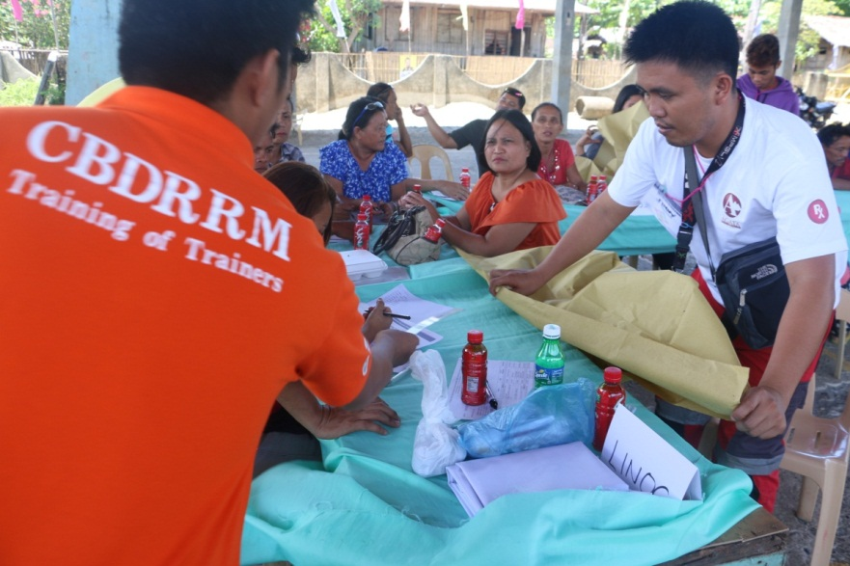
- Agata staff and Barangay Colorado officials and residents work together during the Community Based Disaster Risk Reduction Management training conducted by the Agusan del Norte Provincial Disaster Risk Reduction Management Office.

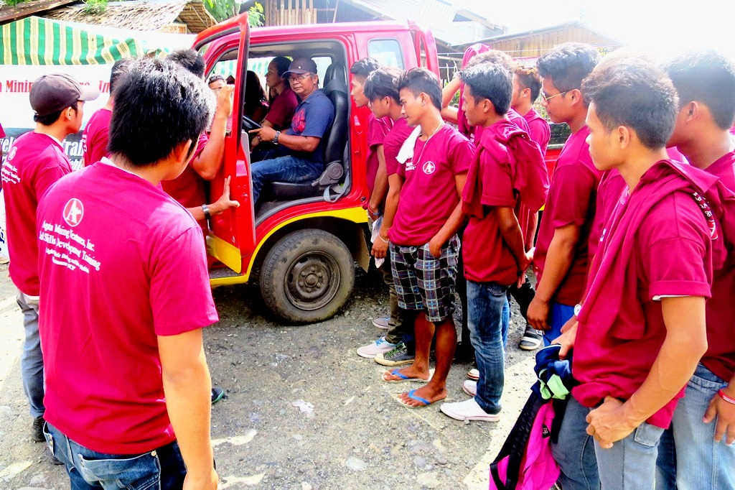
- TESDA NC2 Driving and Light Vehicle Maintenance Training produced 26 graduates who are now skilled to responsibly operate cargo and passenger-type vehicles.

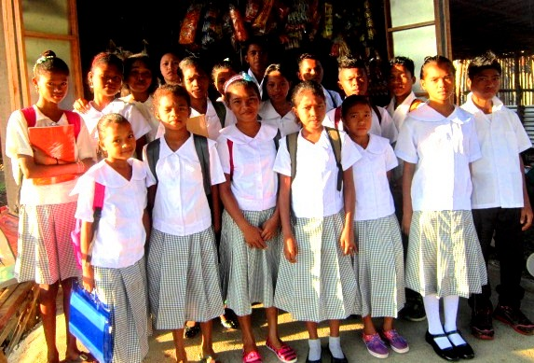
- K12 Tribal Scholars supported by Coro Mamanwa Management Organization, which fully educates their young ones to sustain their tribe’s future.

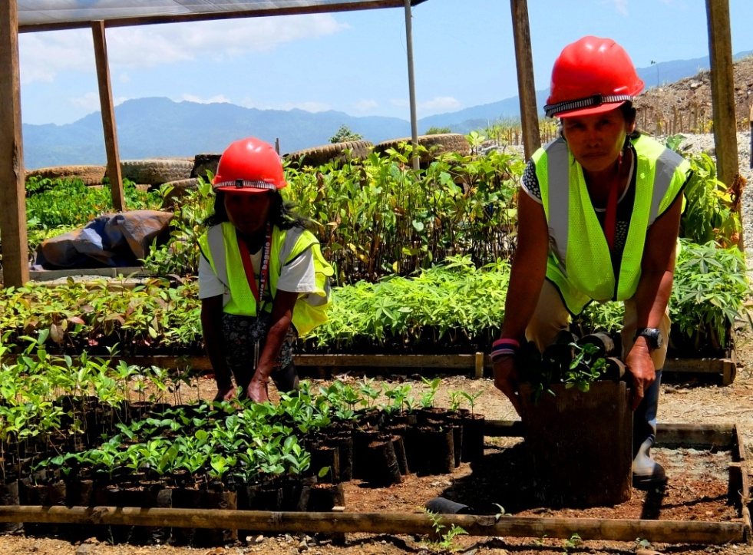
- Employment opportunity for the IP women of Sitio Coro where they tend seedlings at the Agata Agroland Nursery.

About TVI in the Philippines
TVI Resource Development Philippines Inc. (“TVIRD”), is the local affiliate of TVI Pacific Inc. (TSX: TVI), a publicly-listed Canadian mining company focused on the exploration, development and production of precious and base metals from district-scale, large-system, high-margin projects located in the Philippines. Concurrent ownership of ventures is shared with partner company, Prime Resource Holdings Inc.

The commercial operations of Agata Mining Ventures Inc. (AMVI) marks the third successful mining project that TVIRD brought on-stream in the past 10 years. The company is committed to exploration and mining practices that promote transparency, responsible stewardship of the environment, and the inalienable rights to life, dignity, and sustainable development of its host communities.
www.tviphilippines.com

Contact:

Kaycee Crisostomo Julius M. De Villa
Corporate Communications Director Corporate Communications Officer
TVI Resource Development Philippines Inc. Agata Mining Ventures, Inc.
Email: kaycee.crisostomo@tvipacific.com.ph Email : julius.devilla@agatamining.com.ph
Phone: +63 2 728-8491 ext. 103 Mobile : +63 917 318-6113
Mobile: +63 917 579-1528
Fax: +63 2 728-8515

