 | AMVI-FOR-PA-003 | Press Release
 | Revision No. 02 | Effectivity Date: April 4, 2016
N E W S R E L E A S E

IP Educational Tour Boosts Agro-Livelihood Prospects
Farm technology and opportunities are viable investments for the Mamanwa Royalty Fund

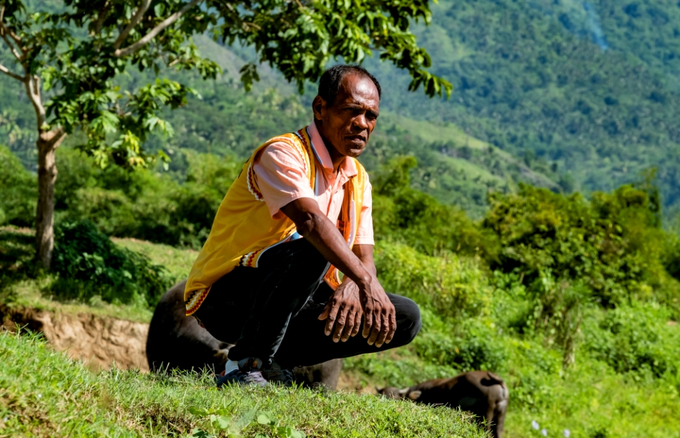
Our land provides. Mamanwa tribal leader, Datu Rogelio Bebe oversees the cultivation of farm lands within Agata’s indigenous people’s communities. Since receiving royalties from the company’s mining operations, the tribe has embarked in various livelihood opportunities that primarily include agriculture and farming.

Butuan, Agusan del Norte / September 2016 – Agata’s Mamanwa Indigenous People’s (IP) community recently embarked on a sustainable source of income through the utilization of their Royalty Fund, which they receive from Agata Mining Ventures, Inc. (AMVI) – a subsidiary of TVI Resource Development Philippines Inc. (TVIRD) in Tubay, Santiago and Jabonga Municipalities, Agusan del Norte Province. The company recently conducted a five-day educational tour to various farms, visiting peoples’ cooperatives and IP organizations across CARAGA, Davao City and Davao del Sur. The tour hosted 32 IP leaders with the objective of providing more viable investment and livelihood opportunities in the fields of sustainable organic agriculture, aquaculture and livestock.

AMVI has four Indigenous Peoples (IP) sectors within its 4,995-hectare Mineral Processing Sharing Agreement (MPSA) area who are receiving royalty fees generated by the company’s mining operations. These are the Mamanwa Tribal Management Organization, Coro Mamanwa Management Organization, Agata Mamanwa Tribal Organization and Mamanwa Mapaso Tribal Sectoral Organization – all of whom comprise a population of more than 600.

And since receiving royalties from AMVI – in addition to employment for some of their fellow lumads – the Mamanwas have enhanced their way of life through sustainable livelihood programs ushered by the Agata Nickel Laterite Project.

Exploring sustainable opportunities
During the tour, IP leaders witnessed the opportunities available in high-potential Cacao farming at the Kennemer Cacao Nursery in San Francisco Municipality of this province – the biggest nursery in the country with a seedling capacity of more than 2 million – and which is engaged in the growing, sourcing and trading of high-quality agricultural crops such as fermented cacao beans sourced from local farmers.

The IP leaders likewise received information on technical support and market linkages that help farmers optimize their livelihood.

They also toured Minkah’s Urban Farm & Kitchen located at the heart of Davao City – an organic restaurant where livestock, herbs, fruits and vegetables are grown naturally from Evasco Farms. Proprietors of the organic farm provided a free formula for feeds production to the visiting IPs who agreed that agri-tourism is a viable opportunity in the areas of Barangay Colorado, Jabonga and Barangay E. Morgado. The area showcases eco-tourism potential owing to the Mapaso Hot Springs and the 29-kilometer Kalinawan River.

Meantime, the Metsa Farm in Los Amigos, Tugbok District in Davao City showcased organic Tilapia and Carpa growing. Los Amigos Hito Industry showcased the potential opportunities in an aquaculture venture, which the tribe is already exploring in Santiago.

The group also toured other successful cooperatives and saw their various produce and activities: Biao Multi-purpose Cooperative - cacao, coconut, fruits processing and marketing; Cacao Research, Farmers Development Cooperative (FARDECO) - diversified farming, fruits marketing, cacao processing; Subasta Integrated Farmers - cacao processing and marketing; Foundation for Agrarian Reform Cooperatives in Mindanao Inc. (FARMCOOP) - organic banana production, processing and marketing; Lao Integrated Farms, Inc. - diversified farming, goat milk production and processing, coco sugar production, organic production of ginger, malungay and turmeric tea); and Mt. Carmel Farm - SALT Technology, forage crop.

The tour became a springboard for the Mamanwa tribes to enhance their existing farm plans and further motivated the leaders and key members with new-found market linkages. Following this, a sustainable farm planning workshop is envisioned by AMVI in cooperation with Kahayag Farm.

A head start
To date, the Mamanwas have established two sari-sari (general merchandise) community stores and funded the improvement of their Tribal Hall through AMVI’s Community Royalty Development Plan (CRDP). They likewise purchased a Bongo Transport Vehicle, which is used for delivering goods – in addition to securing a TESDA NC2 Driver Training for their designated drivers.

The tribal organization also started a rice and feeds supply center as well as acquired a new 10-seater “Multicab” to transport their tribesmen. In the field of agroforestry, the tribe also invested its funds in a four-hectare plantation with Falcata, Abaca, Mahogany and fruit-bearing trees.

“The presence of the mining company brought us new hope. It gave us confidence and the opportunity to improve our lives, send our children to school and secure job opportunities,” expressed Mamanwa tribal leader Datu Rogelio Bebe.

Inspiration through others
During the tour, the cooperatives were pleased with seeing the Agata IP leaders’ motivation towards sustainable agriculture. According to Kahlil Tabernero, AMVI Community Relations Officer, “The lumads were the traditional and oldest cooperative in the community. They hold communal governance over the management of resources; thus, they should succeed with their future endeavors as we continue in committing responsible mining in the communities.”

“With the support of AMVI in solving our problems and challenges in the community, we are confident that the same success the organizations we have visited will be replicated in our sector,” enthused Datu Bebe. “We will try our best to be an example to motivate other IP communities and convince other sectors that responsible mining does exist.”

On his part, Mapaso Tribal Sectoral Organization acting chairman Raymond Moron is aggressive in looking for other feasible programs for his tribe.

“We used to be the marginalized, deprived, and poorest sector in our community. We never dreamt of anything except to utilize the opportunities given to us and show to others that we are also capable of having a sustainable future with the support of AMVI,” said the IP leader

*******

Press photos:

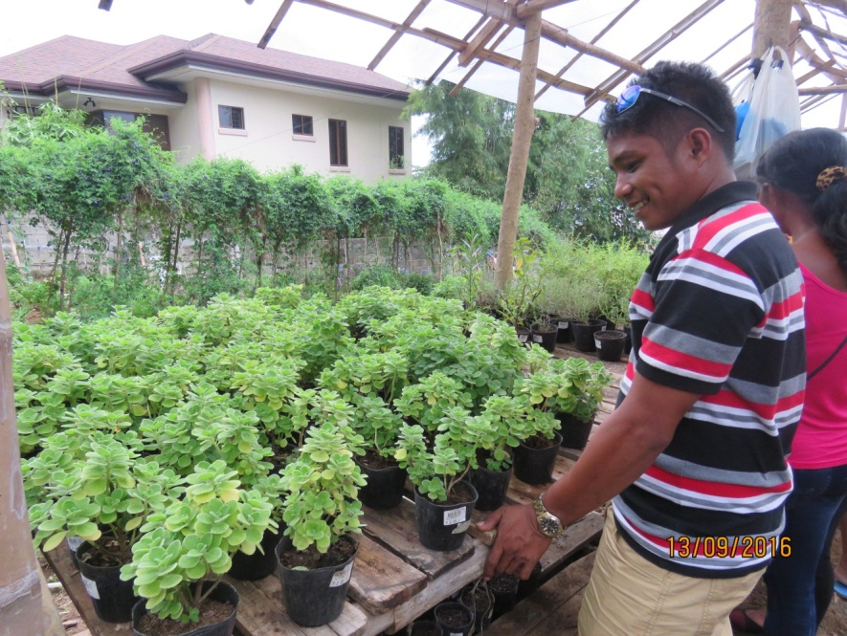
- Sustainable communities within reach. Raymond Moron, acting chairman of Mapaso Tribal Sectoral Organization, approves of the opportunities presented by farming organic crops and vegetables at Minkah’s Farms.

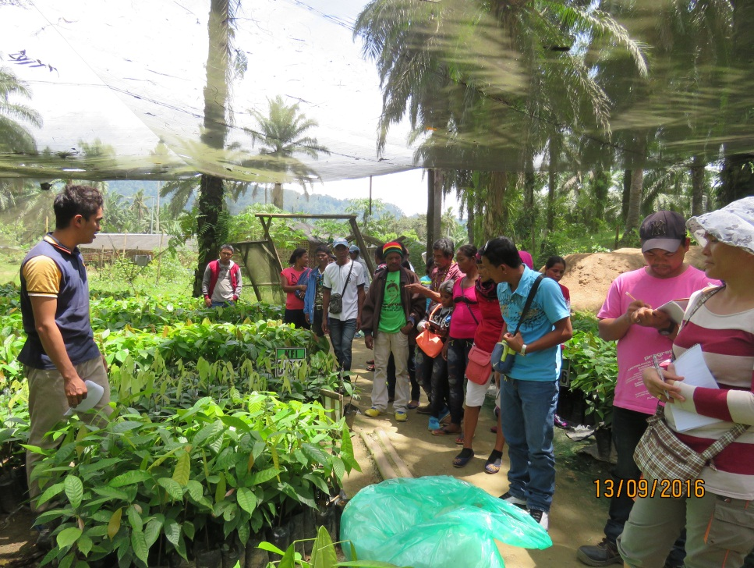
- The IP Beneficiaries of AMVI embraces the opportunity during the visit of a successful farm site at Kennemer Cacao Nursery in San Francisco, Agusan del Sur.

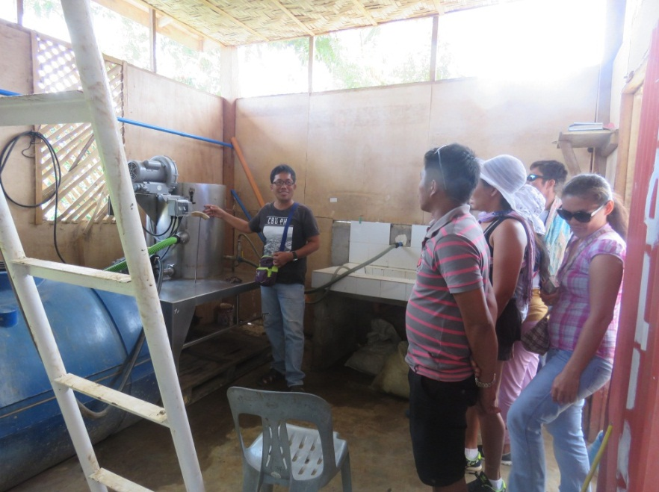
- A demonstration of foliar-processing facility for organic farming that is replicable in Agata’s IP community.

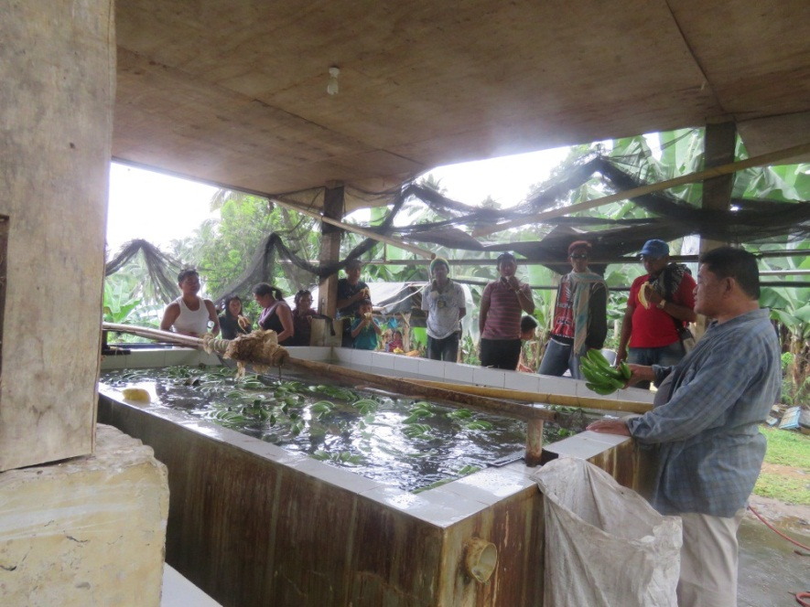
- The IPs visit FARMCOOP in Sibulan, Davao City – which is presently engaged in organic banana farming.

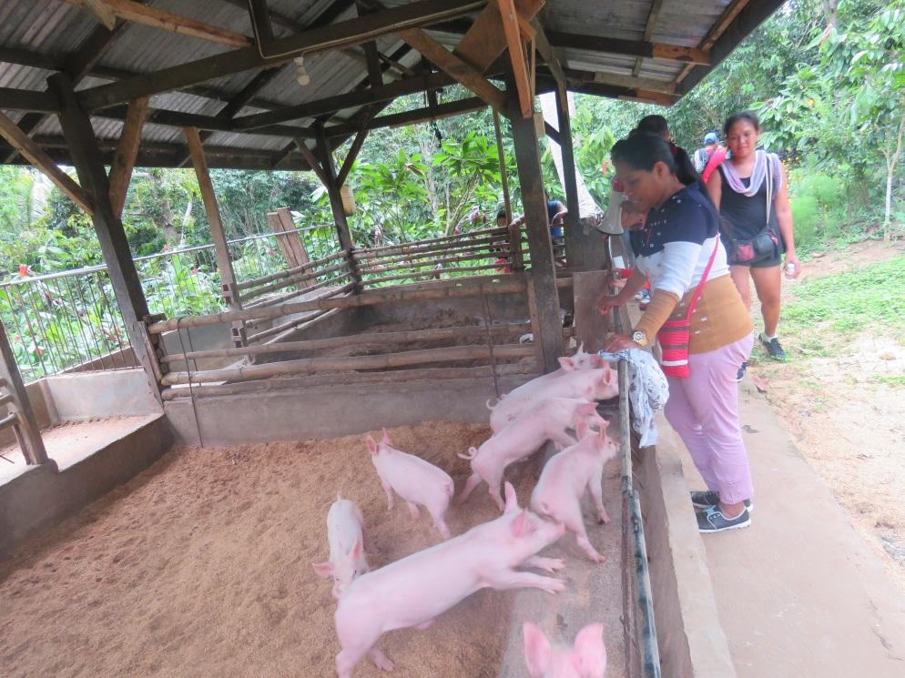
- Hog raising through Korean Technology in Lao Farm in Bansalan, Davao del Sur opens the eyes of the IP members who have already started a similar project.

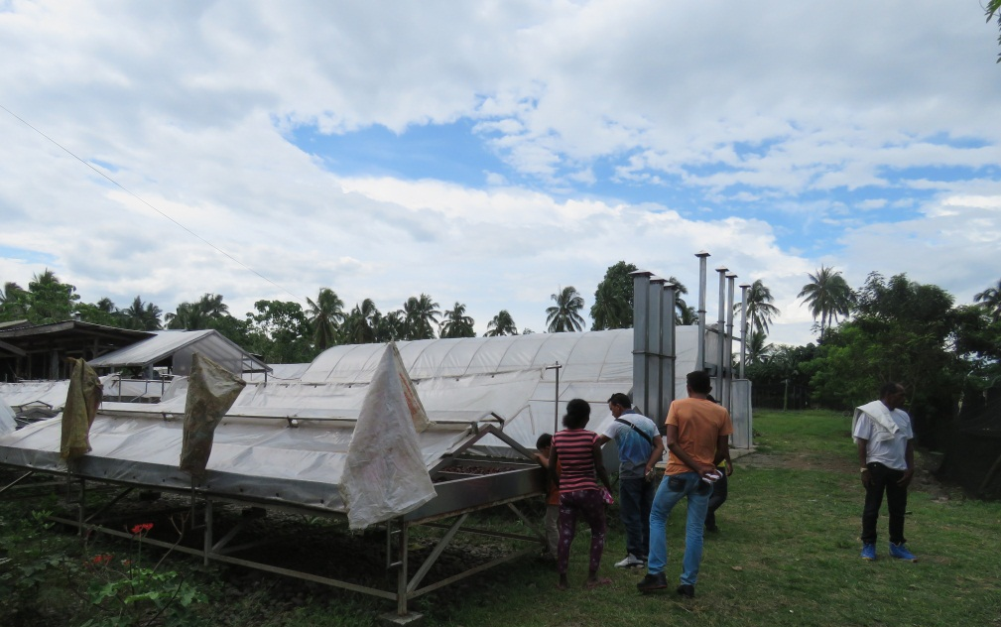
- Inspecting the mechanical dryers of Biao Multi-purpose Coop – a new perspective seen by the IP organizations of AMVI during the tour.

About TVI in the Philippines
TVI Resource Development Philippines Inc. (“TVIRD”), is the local affiliate of TVI Pacific Inc. (TSX: TVI), a publicly-listed Canadian mining company focused on the exploration, development and production of precious and base metals from district-scale, large-system, high-margin projects located in the Philippines. Concurrent ownership of ventures is shared with partner company, Prime Resource Holdings Inc.

The commercial operations of Agata Mining Ventures Inc. (AMVI) marks the third successful mining project that TVIRD brought on-stream in the past 10 years. The company is committed to exploration and mining practices that promote transparency, responsible stewardship of the environment, and the inalienable rights to life, dignity, and sustainable development of its host communities.
www.tviphilippines.com

Contact:

Julius M. De Villa
Corporate Communications Officer
Agata Mining Ventures, Inc.
Lawigan, Tubay, Agusan del Norte
Email: julius.devilla@agatamining.com.ph
Mobile: +63 926 024 9587

Kaycee Crisostomo
Corporate Communications Director
TVI Resource Development Philippines Inc.

Email: kaycee.crisostomo@tvipacific.com.ph
Phone: +63 2 728-8491 ext. 103
Mobile: +63 917 579-1528
Fax: +63 2 728-8515

