 | AMVI-FOR-PA-003 | Press Release
 | Revision No. 02 | Effectivity Date: April 4, 2016
N E W S R E L E A S E

RMN Health Mission Marks Another Success with Agata
Medical services and wellness treat for Butuan and Agusan del Norte communities

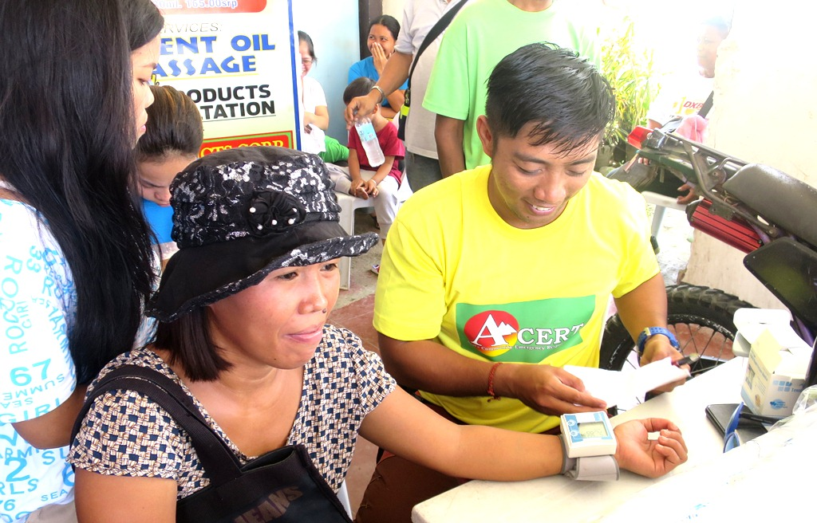
AMVI Staff taking vital stats while sharing awareness. Communications Officer Julius M. De Villa assists in the frontline of DXBC RMN Butuan’s yearly medical mission. The company supported RMN’s public health initiative for the second consecutive year.

Butuan, Agusan del Norte / September 2016 – In commemoration of Radio Mindanao Network’s (RMN) 64th Anniversary, TVIRD’s Agata Mining Ventures Inc. (AMVI), renewed its commitment to provide the medical and wellness needs of partner communities in the CARAGA region via its sponsorship of the RMN Medical Mission held last month. Conducted at the DXBC RMN Butuan station along South Montilla Boulevard, the mission provided free medical consultations, dental check-ups and tooth extraction, bloodletting, therapy and a feeding program for some 1,000 beneficiaries.

AMVI is a joint venture project of MRL Nickel Philippines Inc. and TVI Resource Development Philippines Inc. (TVIRD), which operates the Agata Nickel Project in the municipalities of Tubay, Jabonga and Santiago of this province.

During the mission, company staff assisted in checking vital signs and conducted information awareness towards responsible mining. AMVI also provided medicines for hypertension, gastric pain, mucolytics, decongestants, antihistamine, antispasmodic drugs, analgesics, anti-diarrhea, multi vitamins, diabetes control and pediatrics medicines. Also included for the patients’ dental needs were anesthesia and other medical supplies.

Sustained partnerships
This year’s RMN mission once again tapped the cooperation of government agencies and the private sector. It gained the support of the Department of Health, Philippine National Police, Philippine Army, Philippine Medical Association (PMA) and Philippine Dental Association (PDA) – doctors and dentists who were present all throughout the event.

The Philippine National Red Cross was also onboard to facilitate blood donations while AMVI was the only mining company who provided medicines, on-site personnel and has supported the event for the second year in a row.

RMN-Butuan Station Manager Ramil Bangues expressed during the event that “the continuing support of AMVI to RMN’s advocacy of uniting communities and sectors and in serving the people crystallizes its holistic commitment as one of the responsible mining entities in the region – (as well as a) a multi-awarded company in the country.”

“Its (AMVI’s) communities are fortunate enough to have this company operating with dedication to address public welfare and as well as employment and livelihood opportunities,” he added. AMVI was formally represented by Corporate Communications Officer Julius M. De Villa and Liaison Officer Genome A. Fortun.

Sustaining commitment
In 2014, the RMN mission reached over 1,000 beneficiaries in Butuan and over 27,000 nationwide. Last year, RMN doubled its beneficiaries in Butuan – adding to a total of over 40,000 recorded beneficiaries nationwide.

The missions recorded more than 1,000 medical checkups while dental services recorded more than 100 tooth extractions related to cavities and tooth decays, which are attributed to poor personal hygiene and sanitary conditions combined with habitual cigarette smoking and excessive alcohol intake. Nonetheless, RMN’s various services and sufficient medical and dental supplies ensured that all beneficiaries received proper medical attention to address their immediate health concerns.

AMVI and RMN’s shared commitment to combine various social services to elevate the community dovetails with the company’s roll-out of its health and sanitation programs in communities where it operates. These also include AMVI’s holistic social development program that includes education, livelihood and infrastructure projects that are tailor-fit to enhance the community’s available resources and harness their skills.

*******

Press photos:

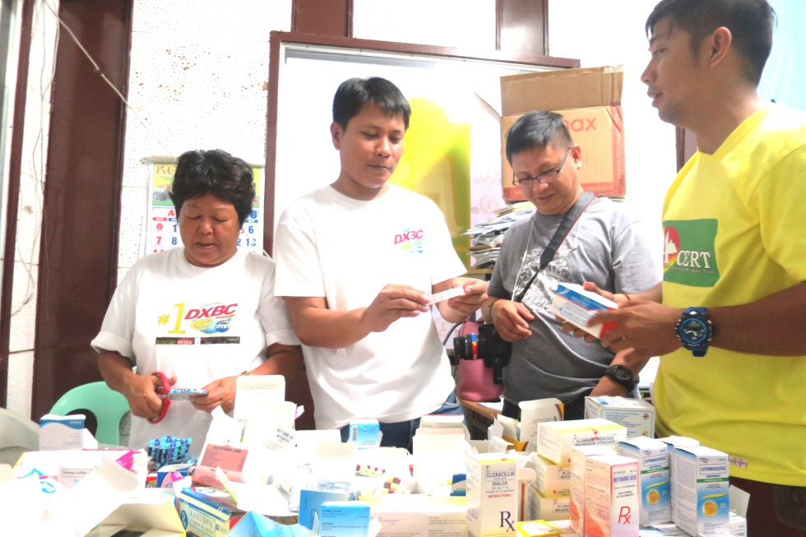
- Medicine distribution. (from 2nd Left): RMN DXBC Station Manager Ramil Bangues, AMVI Laiason Officer Genome A. Fortun and Communications Officer Julius De Villa conduct an inventory of medical supplies during the recent mission.

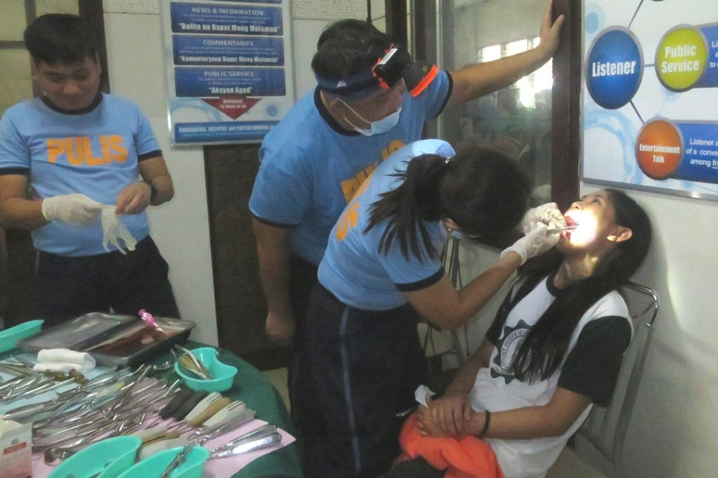
- Tooth extraction. Volunteer dentists from the Philippine National Police conducted dental check-ups and tooth extraction.

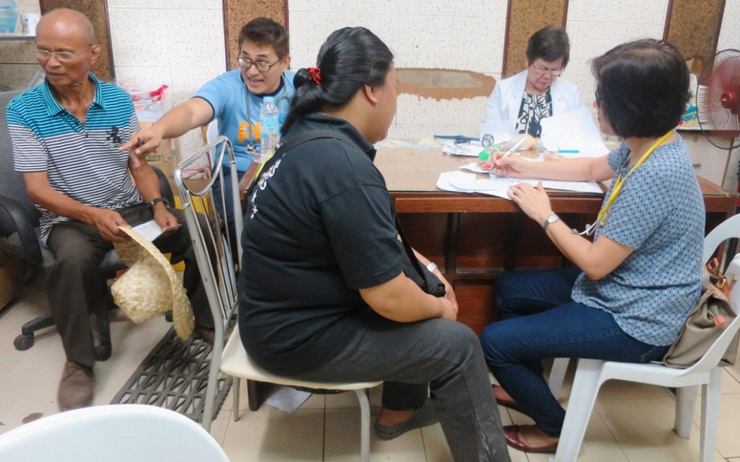
- Medical consultations. Philippine Medical Association and Philippine National Police volunteer doctors back-to-back in providing diagnosis and prescriptions for patients coming from various communities in the province.

- Feeding program. Individuals from the private sector facilitated the mass feeding and awareness program that provides beneficiaries ample knowledge on balanced nutrition.

About TVI in the Philippines
TVI Resource Development Philippines Inc. (“TVIRD”), is the local affiliate of TVI Pacific Inc. (TSX: TVI), a publicly-listed Canadian mining company focused on the exploration, development and production of precious and base metals from district-scale, large-system, high-margin projects located in the Philippines. Concurrent ownership of ventures is shared with partner company, Prime Resource Holdings Inc.

The commercial operations of Agata Mining Ventures Inc. (AMVI) marks the third successful mining project that TVIRD brought on-stream in the past 10 years. The company is committed to exploration and mining practices that promote transparency, responsible stewardship of the environment, and the inalienable rights to life, dignity, and sustainable development of its host communities.
www.tviphilippines.com

Contact:

Julius M. De Villa
Corporate Communications Officer
Agata Mining Ventures, Inc.
Lawigan, Tubay, Agusan del Norte
Email: julius.devilla@agatamining.com.ph
Mobile: +63 926 024 9587

Kaycee Crisostomo
Corporate Communications Director
TVI Resource Development Philippines Inc.

Email: kaycee.crisostomo@tvipacific.com.ph
Phone: +63 2 728-8491 ext. 103
Mobile: +63 917 579-1528
Fax: +63 2 728-8515

