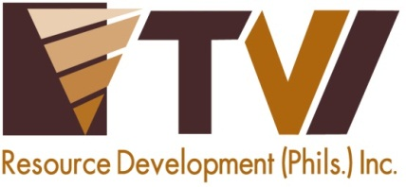
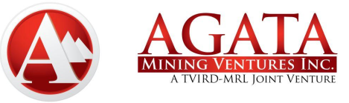 | AMVI-FOR-PA-003 | Press Release
 | Revision No. 02 | Effectivity Date: April 4, 2016
N E W S R E L E A S E

Building-up Emergency Preparedness in Agata Communities
Joint Partnership with Provincial Disaster Risk Reduction and Management Office

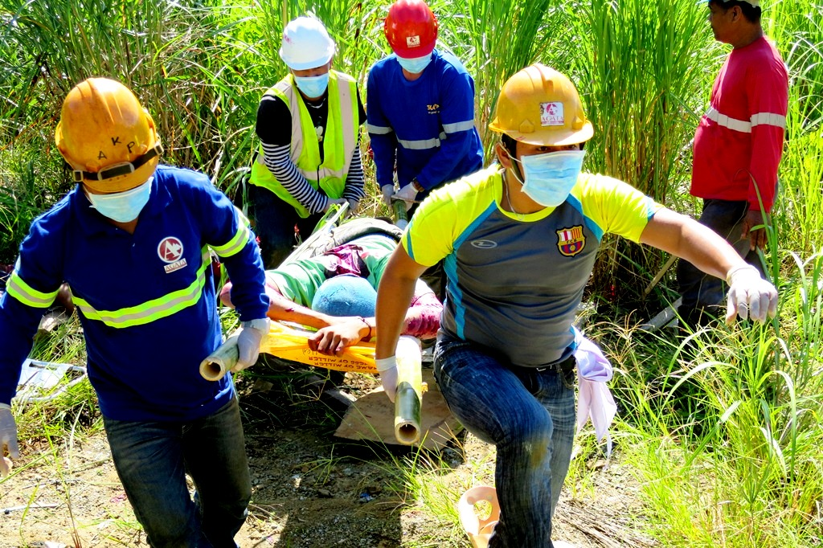
Lifesaving responsibility. Agata realizes responsible mining through its dedication towards saving lives and managing possible untoward incidents within its communities.

Tubay, Agusan del Norte / September 2016 – Agata Mining Ventures Inc. (AMVI), a joint venture project of MRL Nickel Philippines Inc. and TVI Resource Development Philippines Inc. (TVIRD), forged another legacy-building best practice in the region through back-to-back five-day community trainings on Basic Life Support (BLS), Standard First Aid (SFA) and Mass Casualty Incident (MCI) Management. The initiative was conducted in partnership with the Agusan del Norte Provincial Disaster Risk Reduction and Management Office (PDRRMO) led by Civil Defense Officer Erma R. Suyo.

Through AMVI, the agency also aims to capacitate communities in the region, including those in the company’s 4,995-hectare Mineral Processing Sharing Agreement (MPSA) area that spans the municipalities of Tubay, Santiago and Jabonga in the same province.

Investing in community safety
“AMVI’s investment in this training (shows) its inspiring character that embodies responsible mining. Every participant from both the company and the community should always bear in mind their role during disaster incidents,” said Ms. Suyo who likewise urged everyone to encourage other sectors to take part.

The training team was composed of 17 instructors and facilitators from different offices: the Department of Health, Cabadbaran Emergency Response Team, Municipal Disaster Risk Reduction Management Council of Cabadbaran, and Tubay’s Emergency Response Team. The team was likewise supported by AMVI’s Engineering, Environmental Management, Community Relations and Safety Departments.

“AMVI’s direct contribution to its community’s safety and disaster management is a commendable effort that should (also) be undertaken by other mining companies in the region – not in anticipation of mining-related incidents but to save lives and guide communities in natural disasters or accidents.” expressed training team leader Jorge Vincent Pagaran.

The said community-based trainings were facilitated by the AMVI’s Community Relations Department Officers Sheila Mae Arcala and Tyron Hans Salas. According to Ms. Arcala, “The dedication of the participants from the community to withstand the physical and mental challenges of the trainings is priceless. AMVI’s relationship with them became closer and broader.”

Successive trainings
The first leg of the training last July 18-22 at the company’s Tubay mine site was conducted for AMVI employees, contractors, selected host Barangay Tinigbasan officials and the Special Civilian Active Auxiliary (SCAA) personnel detailed by the Armed Forces of the Philippines to maintain peace and order in the area.

The succeeding sessions were conducted for communities in Jabonga and Santiago (August 1-5) and Tubay (August 10-14), including police men who also join the training that provided lifesaving skills to over 80 participants.

Some 40 community volunteers were also involved in different capacities while a total of 50 barangay officials, Civilian Volunteer Organization members, health workers and teachers underwent examinations and drills during the training that also further established AMVI’s readiness to respond to real-life incidents and disasters.

In terms of occupational health and safety, the company achieved over 7 million safe man hours – testament to its constant improvement of work standards for employees and the community as well as its zero tolerance for accidents through its growing Safety Department.

Agata: a frontrunner
At the onset, the PDRRMO conducted an Incident Command System Executive Course for all key company officers and staff in April 2016 during which AMVI was hailed by the agency as “the first mining company in the province to be pro-active in initiating the most ideal mitigating dynamics in the mining industry.”

The accolade came at the heels of back-to-back trainings on mitigating disaster-related risks conducted through the cooperation of the agency and AMVI for its primary stakeholders, particularly nearby communities in its eight host barangays. The trainings likewise enhanced the existing emergency preparedness of AMVI’s Safety Department in terms of managing possible occurrences of natural and man-made disasters. The training is likewise a call for prevention, which has always been a driving concern of both Safety Department and Environment Groups.

Given the rolling terrain of the company’s MPSA area across three municipalities and its proximity to coastal waters, it is crucial that necessary systems are in place to safeguard people and properties from imminent risks. The trained graduates now form part of Emergency Response Teams (ERT) detailed in the area.

The TVIRD-led Agata Nickel Project continues its direct shipping ore operations while holding responsibility for the occupational health and safety of some 600 employees as well as thousands of residents in the surrounding communities.

*******

Press photos:

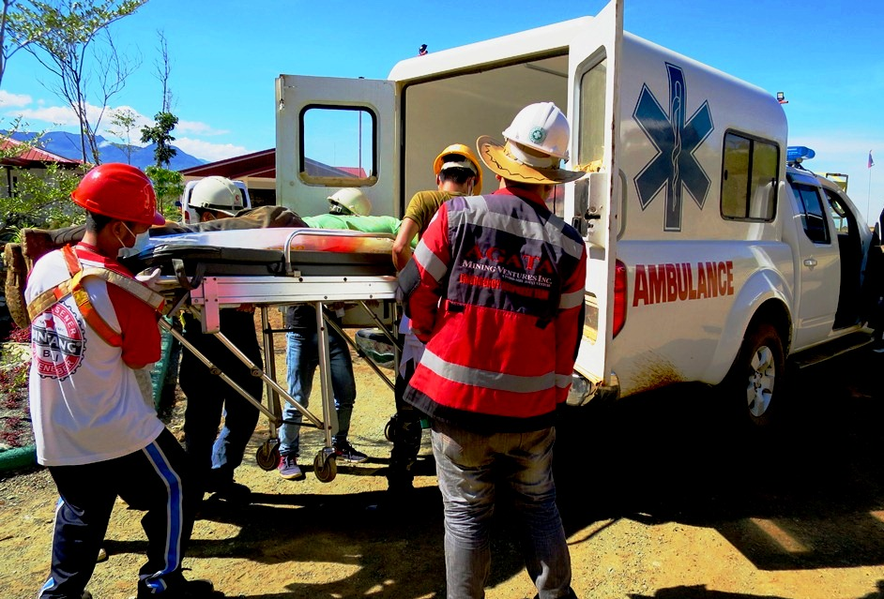
- We know the drill. An incident drill at the mine site portrays possible reactions and measures the company can provide and which its personnel can efficiently perform.

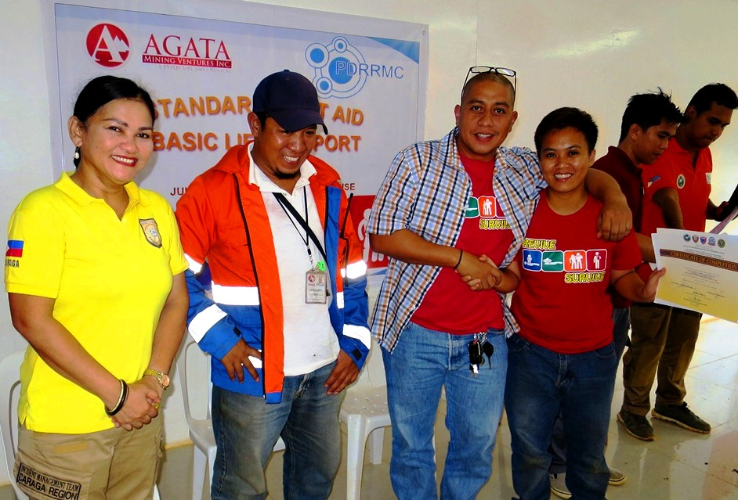
- (from left) PDRRMO Civil Defense Officer Erma R. Suyo, AMVI Senior Safety Officer Aldrin Arieta, and Assistant General Manager Anthony B. Quijano congratulates Environment Staff CJ Maagad who was recognized as one of the outstanding participants during the training.

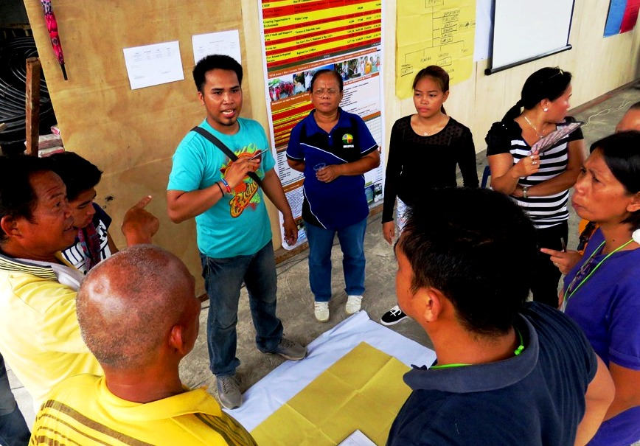
- Community participants from the municipality of Santiago were grouped together and plot the actions in a possible mass casualty incident situation.

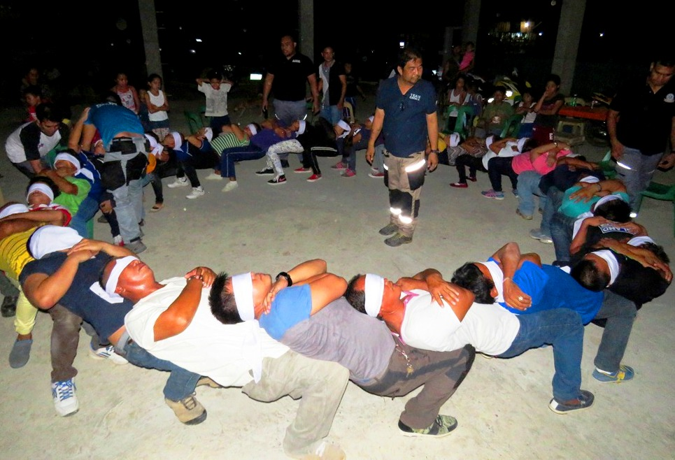
- Circle of trust. The training course instilled discipline and mutual trust among team mates in an emergency situation.

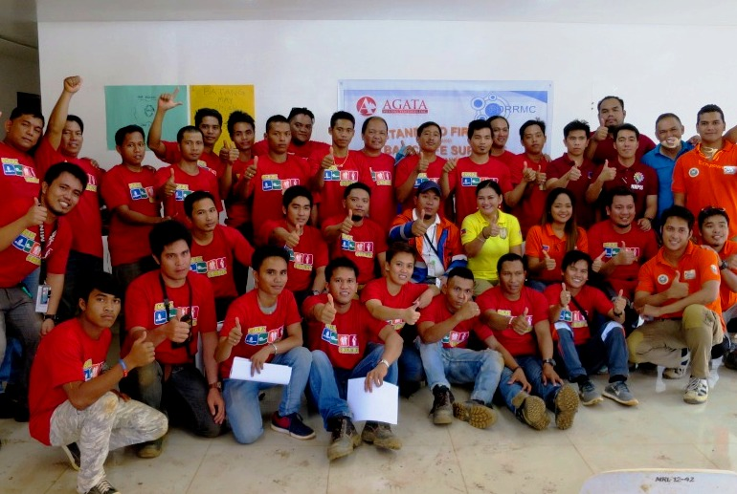
- A growing team. Participants of the training course were encouraged by PDRRMO to be part of AMVI’s Emergency Response Team.

About TVI in the Philippines
TVI Resource Development Philippines Inc. (“TVIRD”), is the local affiliate of TVI Pacific Inc. (TSX: TVI), a publicly-listed Canadian mining company focused on the exploration, development and production of precious and base metals from district-scale, large-system, high-margin projects located in the Philippines. Concurrent ownership of ventures is shared with partner company, Prime Resource Holdings Inc.

The commercial operations of Agata Mining Ventures Inc. (AMVI) marks the third successful mining project that TVIRD brought on-stream in the past 10 years. The company is committed to exploration and mining practices that promote transparency, responsible stewardship of the environment, and the inalienable rights to life, dignity, and sustainable development of its host communities.
www.tviphilippines.com

Contact:

Julius M. De Villa
Corporate Communications Officer
Agata Mining Ventures, Inc.
Lawigan, Tubay, Agusan del Norte
Email: julius.devilla@agatamining.com.ph
Mobile: +63 915 356 3271

Kaycee Crisostomo
Corporate Communications Director
TVI Resource Development Philippines Inc.

Email: kaycee.crisostomo@tvipacific.com.ph
Phone: +63 2 728-8491 ext. 103
Mobile: +63 917 579-1528
Fax: +63 2 728-8515

