N E W S R E L E A S E

Tubay Municipal Government and Communities Approve of Responsible Mining in Agata
Tubay Mayor, Vice-Mayor, Municipal Council, IP communities, fisherfolks and the farming sector acknowledge AMVI’s contributions

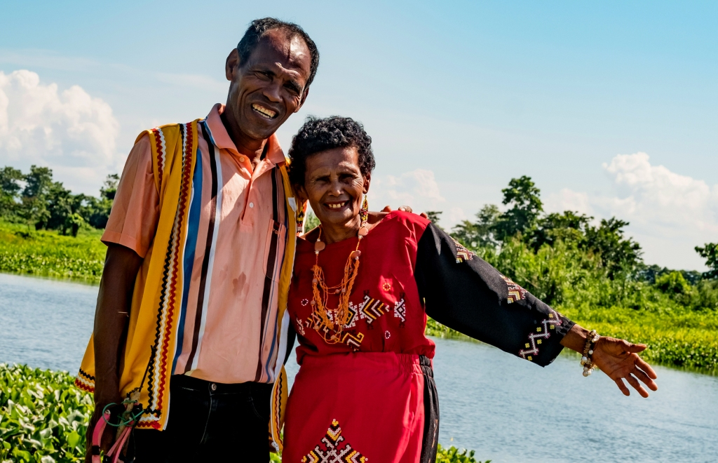A better life. Mamanwa Chieftain Datu Rogelio Bebe and his wife embrace a better life and a greener future ushered by AMVI’s responsible mining efforts that likewise mobilize sustainable livelihood for their tribe.

Tubay, Agusan del Norte / August 2016 – Agata Mining Ventures Inc. (AMVI), a joint venture company of TVI Resource Development Philippines Inc. (TVIRD), recently obtained a vote of confidence from re-elected Tubay Municipal Mayor Fidel B. Garcia Jr. and Vice-Mayor Raquim Cuyos who jointly commended AMVI’s dedication as a responsible mining company. The company operates the Agata Nickel Laterite Project in its 4,995-hectare Mineral and Production Agreement (MPSA) that also spans the municipalities of Santiago and Jabonga.

In a letter addressed to DENR Secretary Regina Paz Lopez, Mayor Garcia and Vice-Mayor Cuyos jointly stated that “These contributions brought by AMVI to our municipality and residents of coastal barangays have brought better economic and socio-cultural conditions. With our utmost trust and confidence towards AMVI’s operations in our municipality, we are further commending its efforts that underscore the essence of responsible mining in our country.”

Aside from the excise tax received by the municipality, the local chief executive also highlighted the advent of employment ushered by the company – which provides monthly salaries amounting to P2.5 million for 243 of his constituents.

He likewise noted that some of the local hires are former illegal small-scale miners who are “now engaged in a safe and responsible mining profession.” Today, they join 600 other employees from CARAGA who are Agata’s “partners in realizing responsible mining.”

Environmental and social development
“AMVI’s coastal resource management and monitoring program is highly recognized by (the) DENR-CARAGA Regional Office as one of the milestone efforts in preserving the coral reefs,” according to Mayor Garcia, in addition to the company’s adoption of two marine sanctuaries and the Kalinawan River in his municipality.

The company’s activities in the areas of local government partnerships, empowering women and the youth, capacity-building for local farmers and fishermen, providing clean water sources for communities, education, transportation, social infrastructure and its maintenance of 151 hectares of reforested areas with over 189,000 trees planted were also acknowledged.

Empowering communities
Through resolutions of support, the sectoral organizations Lawigan Fisherfolks Association, Tinigbasan Farmers and Fisherfolks Association, alongside the leadership of four lumad organizations representing the entire indigenous Manobo-Mamanwa community acknowledge AMVI’s contribution in formulating the Community Royalty Development Plan (CRDP) – a social development framework geared towards translating royalty share into sustainable livelihood investments.

“We have previously suffered from social discrimination and poverty due to lack of education and limited access to livelihood and employment opportunities. Presently, with the Agata Nickel Laterite Project, we have gained momentum to become empowered people in our communities,” according to the joint declaration of the tribes, which has a combined population of 600 in the municipalities of Tubay, Jabonga, and Santiago.

The major components of the CRDP focus on infrastructures, education, health and livelihood projects – all of which are vertically-aligned to the United Nations Millennium Development Goals for developing economies. It is also comprised of components that address proper nutrition and focus on preserving the cultural heritage of the host indigenous communities.

Through their royalty share, Agata’s indigenous communities were able to establish tribal offices and general merchandise (sari-sari) stores, acquire service and delivery vehicles, tap entrepreneurial opportunities, establish an agroforestry plantation, procure livestock and refinance their outstanding loans at significantly lower interest rates.

Through AMVI’s intervention, the tribe was also able to electrify their village – giving light to households that previously did not have access to utilities.

*******

Press photos:

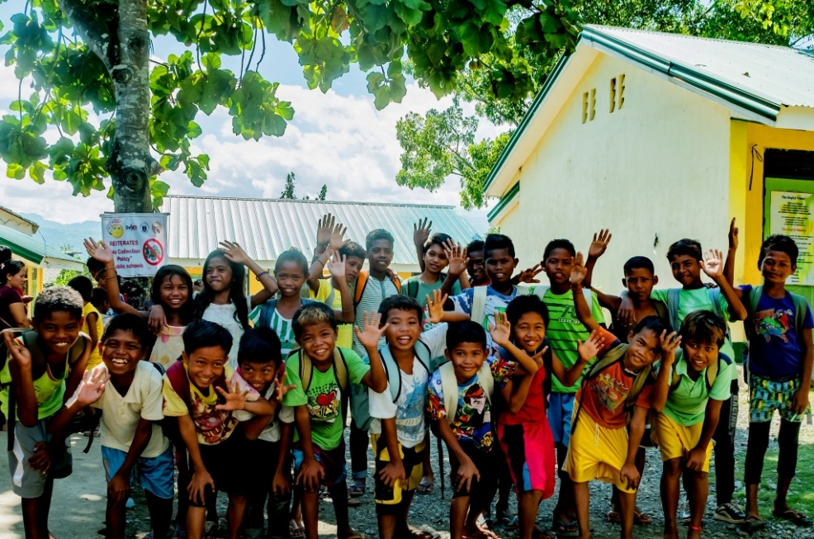
- Children of Narcisa Rodriguez Elementary School in Barangay Colorado, Jabonga Municipality are glad to be back in their classrooms after the long break. AMVI supports Narcisa Rodriguez Elementary and 9 other schools with a student population of close to 4,000.

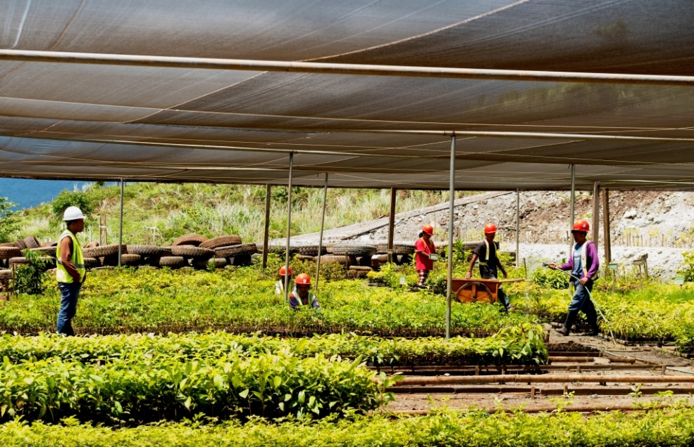

Ready to plant a forest. The Agata Central Nursery currently supplies the seedling requirements of all reforestation projects of AMVI as well as the community within and outside its MPSA area. The 1-hectare nursery on the Payong-payong ridge can house over 100,000 seedlings of various species of forest and fruit tree that AMVI continuously propagates.

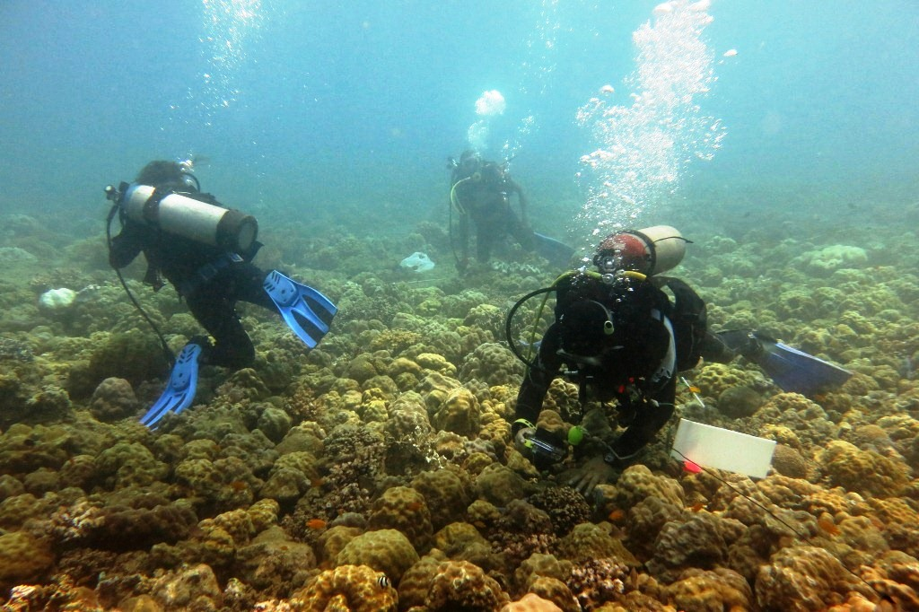

Constant monitoring and evaluation of marine life and ecosystems in the coastal waters of Barangay Tinigbasan are led by AMVI Environment Manager Jesalyn Guingguing along with divers from the local community trained by Bantay Dagat.

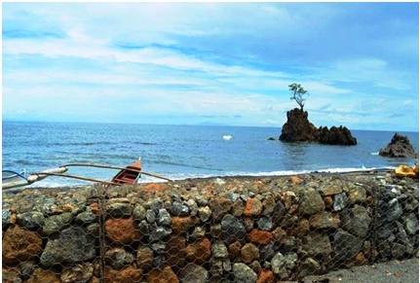
- Several Gabion Baskets fortified with Coco-nets and or Geotextile fabric installed surround AMVI’s Port and Causeway area serve as a barrier designed to trap silt and other unwanted debris from reaching the coastal waters of Tubay

About TVI in the Philippines
TVI Resource Development Philippines Inc. (“TVIRD”), is the local affiliate of TVI Pacific Inc. (TSX: TVI), a publicly-listed Canadian mining company focused on the exploration, development and production of precious and base metals from district-scale, large-system, high-margin projects located in the Philippines. Concurrent ownership of ventures is shared with partner company, Prime Resource Holdings Inc.

The commercial operations of Agata Mining Ventures Inc. (AMVI) mark the third successful mining project that TVIRD brought on-stream in the past 10 years. The company is committed to exploration and mining practices that promote transparency, responsible stewardship of the environment, and the inalienable rights to life, dignity, and sustainable development of its host communities.
www.tviphilippines.com

Contact:

Kaycee Crisostomo Julius M. De Villa
Corporate Communications Director Corporate Communications Officer
TVI Resource Development Philippines Inc. Agata Mining Ventures, Inc.
Email: kaycee.crisostomo@tvipacific.com.ph Email : julius.devilla@agatamining.com.ph
Phone: +63 2 728-8491 ext. 103 Mobile : + 63 918 336-4703
Mobile: +63 917 579-1528
Fax: +63 2 728-8515

