N E W S R E L E A S E

More Scholars Receive a Hand-up from Agata
AMVI provides additional college and high school scholarships for eligible youths

A fair shot. An aspirant undergoes a screening application for a chance to become one of AMVI’s College Scholarship recipients for school year 2016-2017.

Tubay, Agusan del Norte / July 2016 – Agata Mining Ventures Inc. (AMVI), a joint venture company of TVI Resource Development Philippines Inc. (TVIRD) deepens its commitment towards responsive educational by providing full scholarship grants to eligible and deserving students in its communities. Among the applicants, the company provided academic scholarships to 11 new successful candidates – enabling them to enrol in any course for up to five years in any AMVI-accredited college or university. The grant is part of its Social Development and Management Program (SDMP) implemented among the company’s host communities in Santiago, Jabonga, and Tubay Municipalities, Agusan del Norte Province.

Community Relations Officer Sheila Mae Arcala earlier engaged the assistance of Caraga State University (CSU) faculty members headed by Marilou Tenepa in screening the aspirants who underwent proper examinations. In order to retain their scholarships, the students must maintain an annual weighted grade of 2.5 and above.

The new Agata scholars from the three municipalities will receive funding for tuition fees and other fees based on their chosen school‘s billing assessment or statements of account per semester. In addition, they will be provided monthly stipends and other privileges like performance-based cash incentives for achieving a dean’s list citation or other academic distinctions. Other incentives include a graduation allowance upon successfully completing their chosen course.

Legacy for the youth
The TVIRD tradition of lending a hand-up to aspiring students is very much alive in Agata. At the height of its operations in Siocon Municipality, Zamboanga del Norte, the company supported 10 schools with close to 4,000 students, including its adopted Canatuan Public School’s growing population of 850 students. Agata scholars today are testament to the same charitable spirit that paved the way to a better future.

“I am truly grateful for Agata’s educational assistance. It surely brought a higher morale to our community and my fellow lumads.” expressed by Aldrin Moron, a lumad from Barangay La Paz, Santiago Municipality and who is now presently employed in Cebu City. Aldrin is the first successful Agata scholar who recently graduated with a Bachelor of Science degree in Hotel and Restaurant Management from the Caraga State University.

Other Agata scholars are likewise pursuing their chosen degrees like Ejie Mae Tiňa from Santiago who will soon be a licensed Mining Engineer. Another is Maria Mae Pajantoy, a young female Mamanwa from Jabonga who is taking up BS Sustainable Agriculture. Both Ejie and Mae are currently enrolled in the Caraga State University.

“It (education scholarship) gives hope to our tribe to face the challenges of poverty. We are fortunate enough that Agata’s commitment helps us realize our dreams,” said Mae who is now on her graduating year.

Some 26 Mamanwas in Jabonga National High School are also supported by AMVI with uniforms and school supplies. Students from Barangay Lawigan are likewise provided with daily transportation via pump boat to their school in Tinigbasan National High School, which is situated in the coastal area of the company’s Mineral Processing Sharing Agreement (MPSA) area.

Social development agenda
Agata’s engagement with its host communities across its 4,995-hectare MPSA brought a higher morale to the working youth sector. It has consistently supported the Working Youth Club in Tubay and provided Technical Vocational Trainings on Hydraulic Excavators as well as NC2 Light Vehicle Maintenance and Driving Lessons in partnership with the country’s Technical Education and Skills Development Authority (TESDA).

In the current school year, AMVI supported the school building project of Tinigbasan National High School, which is located in its host barangay where its private port and loading operations are located. The company also provided construction materials and paints for the renovation of different schools in its area: Tubay District Elementary School, Doňa Rosario National High School, Lawigan Elementary School, Tagpangahoy Elementary School and Coro Elementary School.

*******

Press photos:

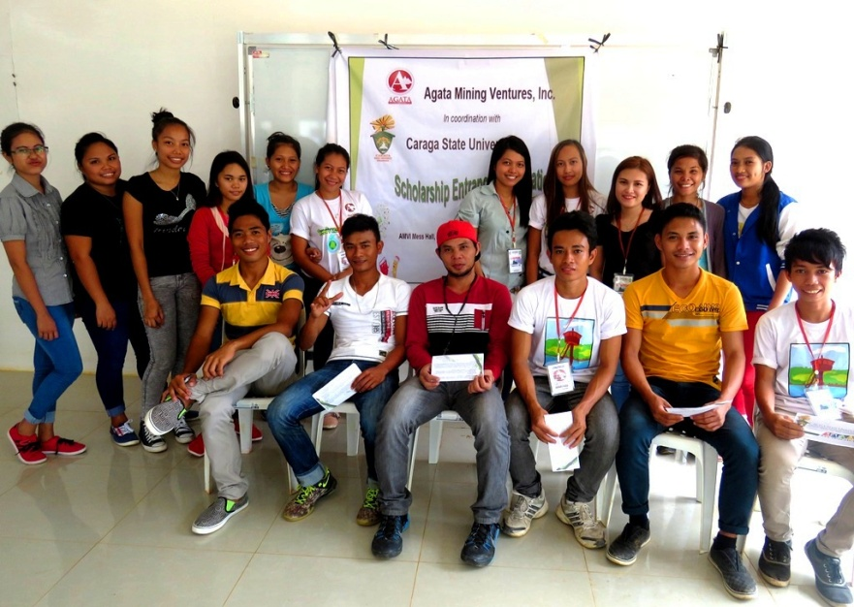
- The hopeful aspirants from the communities in AMVI’s barangays within the municipalities of Jabonga, Santiago and Tubay, Agusan del Norte Province.

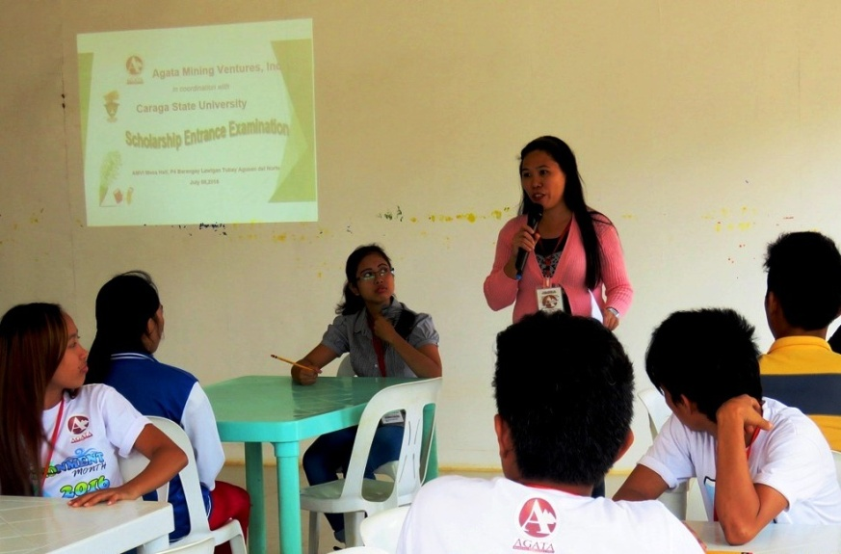
- The Examiner. Acting as proctor and team leader of Caraga State University, Marilou Tenepa gives instructions during the screening of scholars. AMVI staff worked closely with CSU proctors in searching for the company’s next batch of scholars.

- Another school day. Young Mamanwas bright and early in their new uniforms and Agata school bags – on their way to the first day of senior high school.
.
- Kids wait for their parents during dismissal time in Tinigbasan Elementary School, which is located in AMVI host barangay in tubay Municipality.

About TVI in the Philippines
TVI Resource Development Philippines Inc. (“TVIRD”), is the local affiliate of TVI Pacific Inc. (TSX: TVI), a publicly-listed Canadian mining company focused on the exploration, development and production of precious and base metals from district-scale, large-system, high-margin projects located in the Philippines. Concurrent ownership of ventures is shared with partner company, Prime Resource Holdings Inc.

The commercial operations of Agata Mining Ventures Inc. (AMVI) mark the third successful mining project that TVIRD brought on-stream in the past 10 years. The company is committed to exploration and mining practices that promote transparency, responsible stewardship of the environment, and the inalienable rights to life, dignity, and sustainable development of its host communities.
www.tviphilippines.com

Contact:

Kaycee Crisostomo Julius M. De Villa
Corporate Communications Director Corporate Communications Officer
TVI Resource Development Philippines Inc. Agata Mining Ventures, Inc.
Email: kaycee.crisostomo@tvipacific.com.ph Email : julius.devilla@agatamining.com.ph
Phone: +63 2 728-8491 ext. 103 Mobile : + 63 918 336-4703
Mobile: +63 917 579-1528
Fax: +63 2 728-8515

