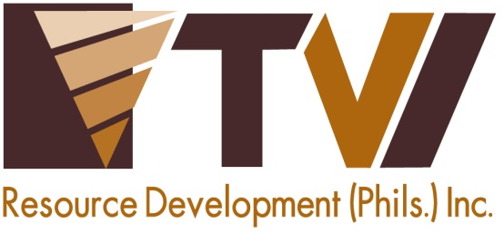
N E W S R E L E A S E

Agata Renews Support for
CARAGA’s Largest Humanitarian Mission
AMVI and Bombo Radyo provide health services and medicines to over 2,000 beneficiaries in Butuan City

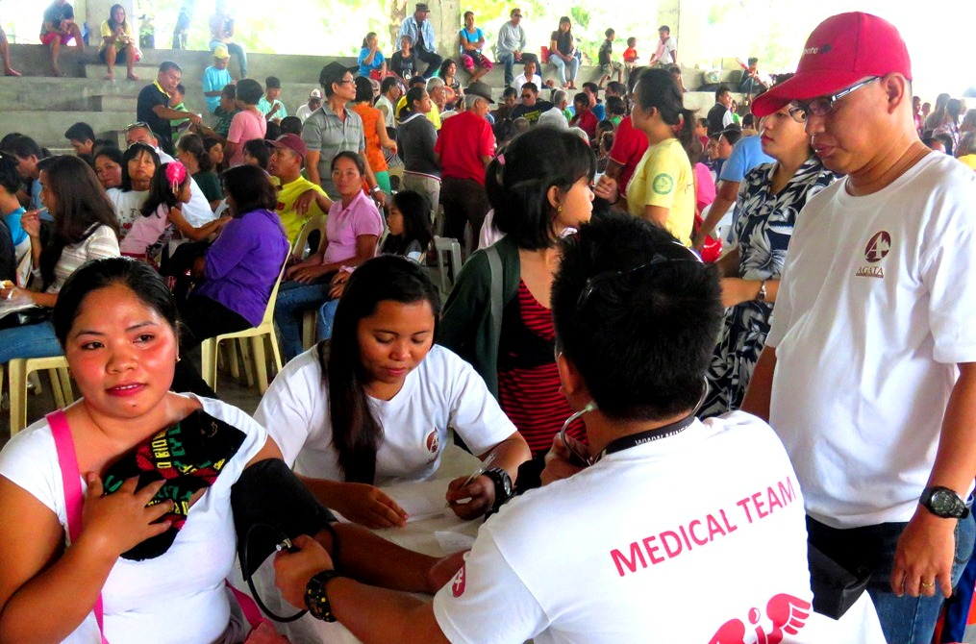Proper screening. AMVI medical staff records the vital signs and information of every Bombo Medico participant prior to consultation with volunteer doctors. Medicines donated by the company are likewise dispensed on-site upon presentation of prescriptions issued by the doctors.

Tubay, Agusan del Norte / July 2016 – Furthering its commitment to provide holistic wellness for the community, TVIRD’s Agata Mining Ventures Inc. (AMVI) once again assumed sponsorship and provided essential medicines for the yearly Bombo Medico Medical and Dental Mission last 10 July 2016 at the Provincial Capitol Covered Gymnasium in Butuan City of this province. Over 2,000 beneficiaries were provided medical and dental check-ups, tooth extractions, eye check-ups, prostate and cardiovascular screening, paediatric care, obstetrics and gynaecology, pulmonary and entomology examinations as well as reading glasses free of charge.

AMVI sent its medical and public affairs staff to assist in checking blood pressure and screening vital signs, dispensing medicines and conducting a general wellness campaign for the patients. The company provided much-needed medicines such as Amoxicillin, Mefenamic Acid and Tranexamic Acid as well as other surgical supplies in order to address the needs of the beneficiaries.

The annual Bombo Medico is the CARAGA Region’s largest humanitarian mission and the widest in terms of scope. Last year, Bombo’s simultaneous mission generated over 55,000 beneficiaries nationwide. AMVI and Bombo Radyo’s shared commitment towards public health runs parallel to the Health and Sanitation programs of TVI Resource Development Philippines Inc. (TVIRD), which leads the Agata Nickel Project in Tubay, Santiago and Jabonga Municipalities.

Sustained responsible efforts
Bombo Radyo Station Manager Benjie Balansag once again spearheaded the mission in Butuan City – which catered to residents from all over Agusan del Norte Province. An estimated 10 percent of patients received dental care while close to 30 percent were given eye prescriptions and received eyeglasses. Close to 20 percent of mission beneficiaries were children who received paediatric care – further emphasizing the need for proper nutrition, especially in urbanized communities.

Another 20 percent of patients were internal medicine cases while the rest included hernia and those cases related to entomology, OB, cardiovascular, prostate, orthopaedic and other cases. In addition, close to 800 also benefited from the mission’s massive feeding program. This year’s more than 2,000 beneficiaries bring the year-on-year increase to 25 percent compared to that of 2015.

“AMVI never fails to live-up to our expectations especially (this) second time around,” said Balansag on the sidelines of Bombo Medico. He likewise expressed his gratitude for AMVI’s unceasing commitment to support the mission along with different medical and dental organizations: the Philippine Medical Association, Philippine Dental Association, Philippine Nurses Association, Lions Club and Rotary Club of Butuan, and other socio-civic organizations.

Extensive collaboration

In Bombo Medico 2015, the AMVI delegation joined other volunteers in providing immediate relief to common ailments, on-the-spot check-ups and medical assistance to beneficiaries from all over Butuan, including small communities located in the outskirts of the city. The mission was also supported by the Provincial Government, Mayor’s Office, Department of Health (DOH), Philippine Charity and Sweepstakes Office (PCSO), Rotary Club and pharmaceutical companies.

Throughout its various joint projects, AMVI remains Bombo Radyo’s strong partner in social development and has been continuously supportive of the radio station’s sustainable programs. Previously, the company supported the network’s annual nationwide blood donation drive, Dugong Bombo, which generated 3 million cc of blood. The company also supported Debate sa Bombo – an intercollegiate series of debate competitions that aims to empower young minds through a healthy exercise of well-sourced research and well-executed academic reasoning.

AMVI is a joint venture between MRL Nickel Philippines Inc. and TVIRD. The joint venture aims to move forward with the highest environmental standards that has brought it much acclaim from various award-giving bodies. It likewise sustains its commitment to social development through its sustainable programs in the areas of responsive education, health and livelihood.

*******

Press photos:

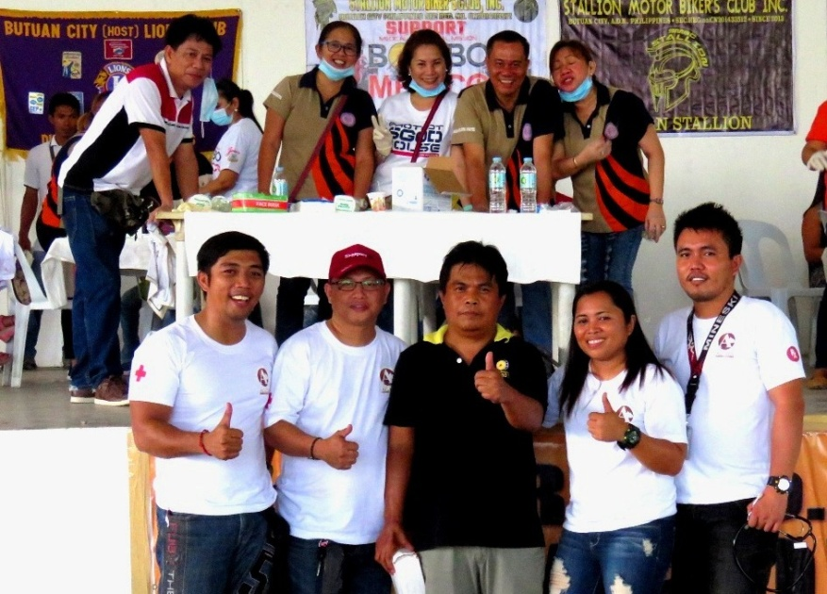
- One for the books! Bombo Butuan’s Station Manager Benjie Balansag (Front row, Center) gives his approval to the Agata delegation (from left): Communications Officer Julius M. De Villa, Liaison Officer Genome Fortun, Community Relations staff Sheila Mae Arcala, and company nurse Jimmy Ceballos. They are also joined by participating dentists from the Agusan del Norte Dental Association.

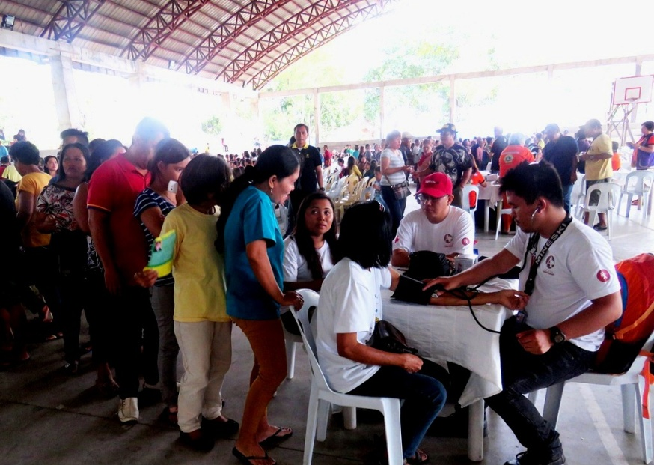
- Agata’s medical team receives a long line of patients from various municipalities across Agusan del Norte. The mission provided medical care and wellness to more than 2,000 beneficiaries.

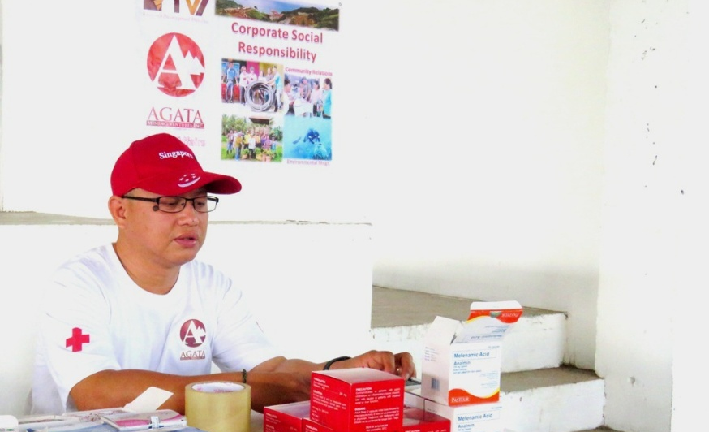
- Liaison Officer Genome Fortun mans the frontline to ensure the donated medicines from AMVI are sufficient for the mission.

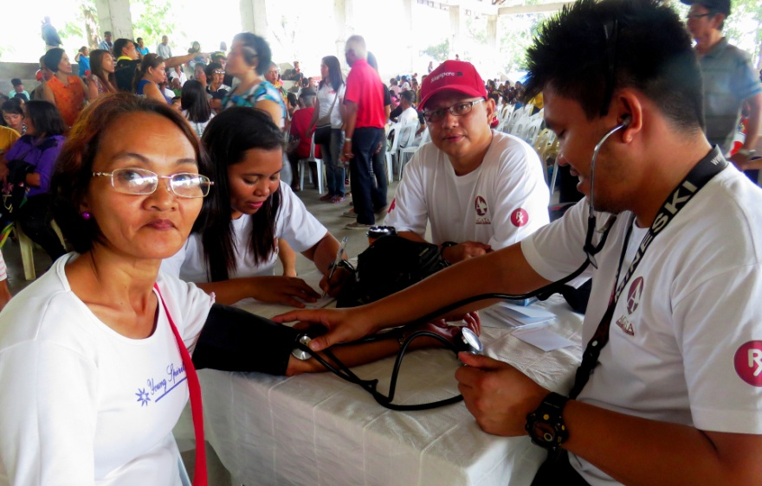
- AMVI company nurse, Jimmy Ceballos, keeps the patients comfy and relaxed as he checks blood pressure and vital signs.
.

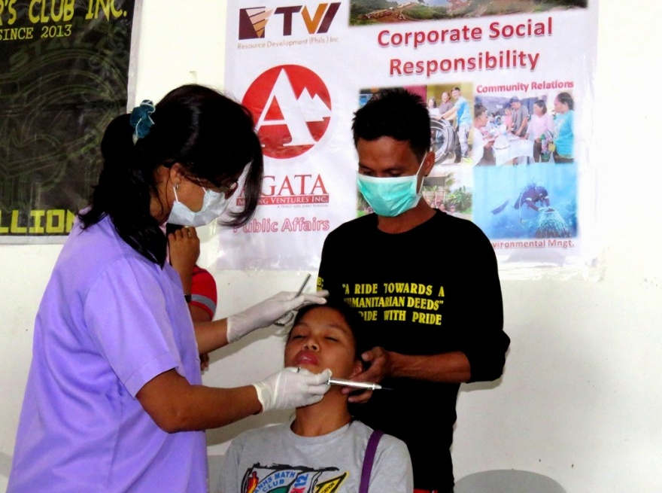
- A strong cooperation between a volunteer dentist from the private sector and a socio-civic volunteer – all supportive to Bombo Medico.

About TVI in the Philippines
TVI Resource Development Philippines Inc. (“TVIRD”), is the local affiliate of TVI Pacific Inc. (TSX: TVI), a publicly-listed Canadian mining company focused on the exploration, development and production of precious and base metals from district-scale, large-system, high-margin projects located in the Philippines. Concurrent ownership of ventures is shared with partner company, Prime Resource Holdings Inc.

The commercial operations of Agata Mining Ventures Inc. (AMVI) mark the third successful mining project that TVIRD brought on-stream in the past 10 years. The company is committed to exploration and mining practices that promote transparency, responsible stewardship of the environment, and the inalienable rights to life, dignity, and sustainable development of its host communities.
www.tviphilippines.com

Contact:

Kaycee Crisostomo Julius M. De Villa
Corporate Communications Director Corporate Communications Officer
TVI Resource Development Philippines Inc. Agata Mining Ventures, Inc.
Email: kaycee.crisostomo@tvipacific.com.ph Email : julius.devilla@agatamining.com.ph
Phone: +63 2 728-8491 ext. 103 Mobile : + 63 918 336-4703 / +63 915 356-3271
Mobile: +63 917 579-1528
Fax: +63 2 728-8515

