N E W S R E L E A S E

Agata Hailed Overall Champion
of MGB CARAGA Environment Month Competition
AMVI bests 17 mining companies in skills, advocacy and industry best practices

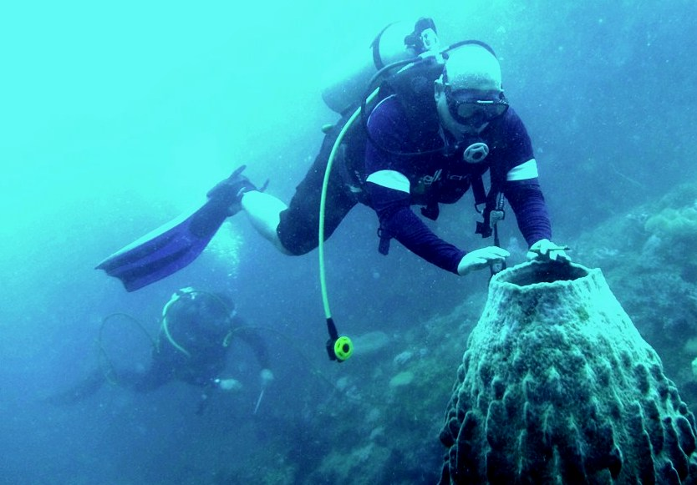
“Commitment from the Top” – an award-winning photo taken by Tubay resident diver Ryan Pagal during a coral monitoring and validation activity conducted by AMVI Assistant General Manager Anthony B. Quijano (foreground) and Security Manager Col. Edgardo Amores at the company’s adopted marine sanctuary.

Tubay, Agusan del Norte / July 2016 – The Department of Environment and Natural Resources’ Mines and Geosciences Bureau (DENR-MGB) conducted a month-long competition pitting the skills, advocacies and environmental practices of 17 mining companies in the CARAGA Regional – a challenge that was heeded by TVIRD’s Agata Mining Ventures, Inc. (AMVI) as it brought to fore both its professionals and industry best practices. Aptly themed “Combat Biodiversity, Beat Climate Change,” the agency’s commemoration of Environment Month 2016 was participated primarily by Agata’s Environment Management Group as well as its allied departments: Community Relations, Human Resources and Administration, Public Affairs and key members of Agata’s beneficiary communities.

After a series of competitions during the month, Agata bagged top honors, including overall champion. It likewise brought home the best technical paper, best presenter, first place recycling competition (practical category), second place photography contest, second place Quiz Bee, and third place environmental video advocacy awards. Agata led by 200 points from the next competitor and received the highest recognition during the MGB’s culmination ceremonies.

Responsibility across the ranks
AMVI Environment Manager Jesalyn Guingging presented Agata’s technical paper on coral relocation and performance monitoring program in its coastal areas adjacent to its private port – which impressed the panel of experts from the Department of Science and Technology (DOST), Department of Trade and Industry (DTI, the academe, and even MGB’s Chief Geologist, Romeo Dalodado. The paper bagged first place during the competition as it highlighted the company’s early challenges and its cooperation with the community – which ultimately helped realize the success of the program.

“The core responsibility of environmental management in preserving ecosystems and mitigating measures is not just simply conducting routine checks. It requires commitment and responsible acts for which AMVI has dedicated time and resources for its communities to be protected,” according to Guiingging.

The AMVI recycling team came up with the most practical product: a cabinet made of recycled packaging boards, while the photo entry titled “Commitment from the Top” taken by Tubay resident diver Ryan Pagal won second place. The photo features the company’s coral monitoring and validation activity conducted by Agata executives Assistant General Manager Anthony B. Quijano and Security Manager Edgardo P. Amores.

Meantime, AMVI’s environmental video advocacy entry bagged third place. The short film produced by Corporate Communication Officer Julius M. De Villa documented the company’s conservation efforts across its MPSA area and biodiversity preservation from ridge-to-reef.

The company’s Quiz Bowl team cornered second place while high school student, Alberto Macasocol of AMVI-supported Doňa Rosario National High School and youth representatives of Barangay Lawigan respectively participated in the hand painting and interpretative dance competitions. Finally, AMVI also participated in the landscaping competition, which was conducted in a location designated by the MGB.

Up to expectations
Agata General Manager Emilio Figueroa III pushed for the company’s participation in the event, riding on the confidence of its award-winning performance right from the start.

“Big or small achievements are an ongoing aspiration for Agata and its employees. We live up to the expectations of the community, the authorities – and even ourselves as competent and responsible mining professionals in the region,” said Figueroa. “We may not expect to be perfect but we always strive more than ever to be more responsible.”

At the moment, AMVI is processing its ISO 14001 Certification on Environmental Management and has just conducted flora and fauna monitoring within its MPSA area last June 2016. It likewise conducts continuous environmental awareness activities such as planting and growing trees along the riverbanks, watersheds and waste dumps as well as river and coastal clean-up and waste segregation activities with residents from the communities and local government units.

AMVI’s coral relocation and coastal resource management program is the first in the region and was previously recognized with an Outstanding Performance Award by the DENR. In the recent Philippine Mine Safety and Environment Association (PMSEA) awards, the company was also given the Titanium Award in the Surface Mining – a milestone achieved by AMVI within its first year of operations.

*******

Press photos:

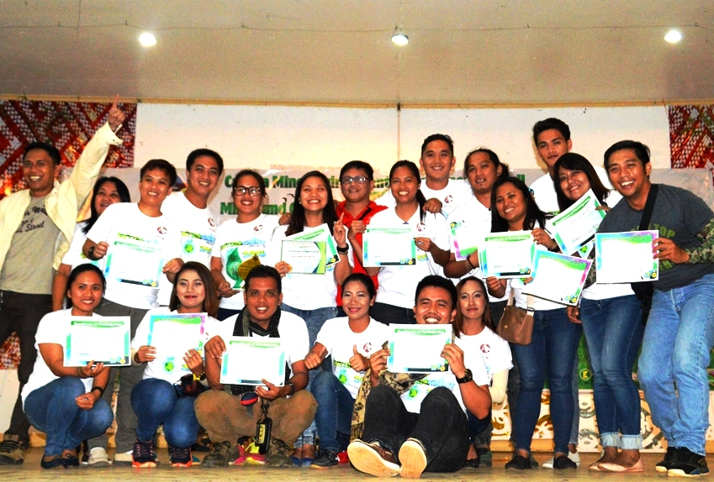
- For the Win! The Agata Team receives the honor of being overall champion during the DENR-MGB’s series of competitions to commemorate Environment Month 2016.

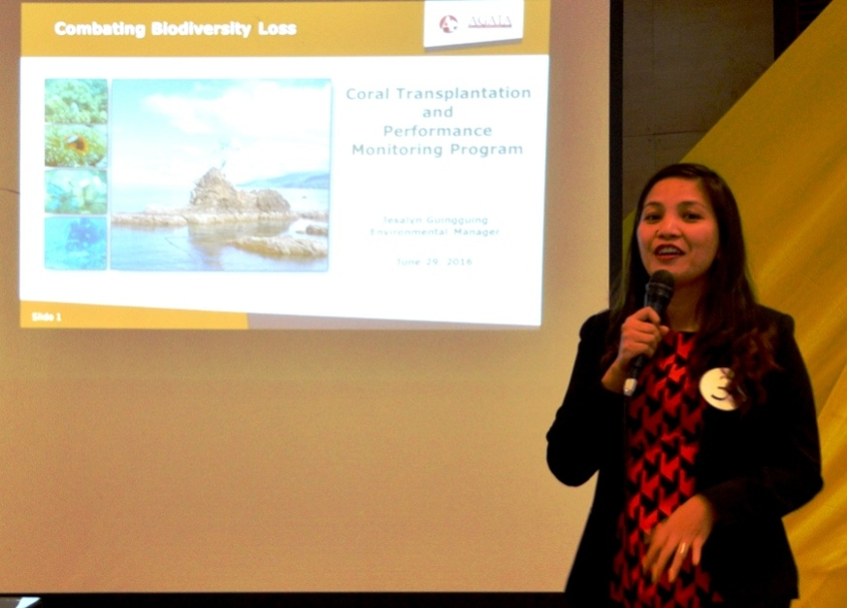
- Best technical paper and presenter. Environment Manager Jesalyn Guingging takes pride in AMVI’s green legacy to the community.

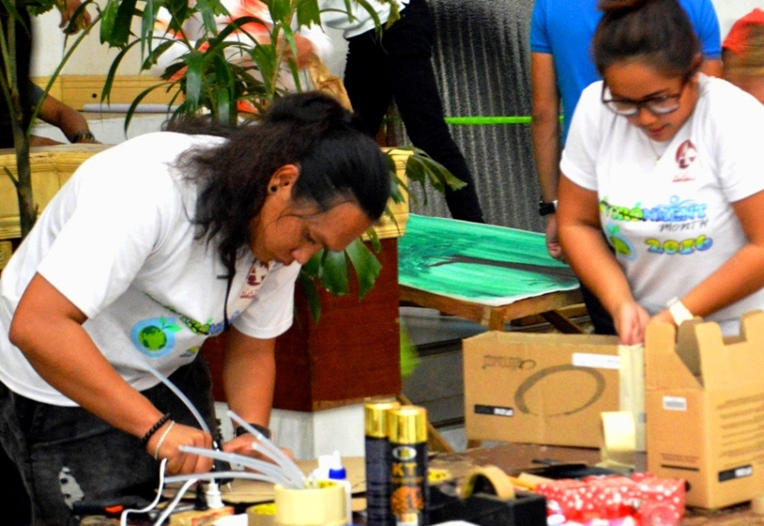
- AMVI’s Jocer Castro and Phebe Aca-ac set-up a cabinet made out of recyclable materials during the month-long competition.
.

About TVI in the Philippines
TVI Resource Development Philippines Inc. (“TVIRD”), is the local affiliate of TVI Pacific Inc. (TSX: TVI), a publicly-listed Canadian mining company focused on the exploration, development and production of precious and base metals from district-scale, large-system, high-margin projects located in the Philippines. Concurrent ownership of ventures is shared with partner company, Prime Resource Holdings Inc.

The commercial operations of Agata Mining Ventures Inc. (AMVI) mark the third successful mining project that TVIRD brought on-stream in the past 10 years. The company is committed to exploration and mining practices that promote transparency, responsible stewardship of the environment, and the inalienable rights to life, dignity, and sustainable development of its host communities.
www.tviphilippines.com

Contact:

Kaycee Crisostomo Julius M. De Villa
Corporate Communications Director Corporate Communications Officer
TVI Resource Development Philippines Inc. Agata Mining Ventures, Inc.
Email: kaycee.crisostomo@tvipacific.com.ph Email : julius.devilla@agatamining.com.ph
Phone: +63 2 728-8491 ext. 103 Mobile : + 63 918 336-4703 / +63 915 356-3271
Mobile: +63 917 579-1528
Fax: +63 2 728-8515

