N E W S R E L E A S E

Agata Marks Environment Month with 9,000 New Trees
AMVI celebration engages employees and communities towards propagating forests

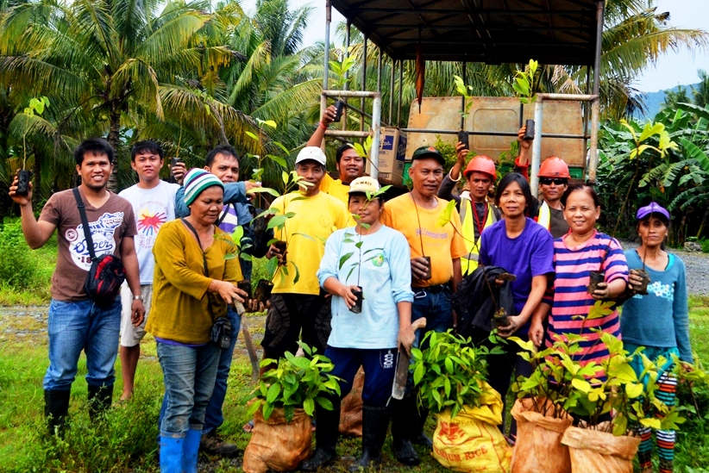
Erosion control. A team led by AMVI Forester Jacob Estandarte (extreme Left) engage Barangay La Paz Council Members and women’s sector representatives from Santiago Municipality in Agusan del Norte in transplanting seedlings along the river banks.

Tubay, Agusan del Norte / June 2016 – In active response to the Department of Environment and Natural Resources’ (DENR) call to preserve biodiversity and mitigate the effects of climate change, Agata Mining Ventures Inc. (AMVI) mobilized its Environment Personnel to rally its communities in the municipalities of Tubay, Jabonga, and Santiago in Agusan del Norte towards propagating the natural habitat of various species across its 4,995-hectare Mineral Processing Sharing Agreement (MPSA) area. The joint venture company operated by TVI Resource Development Inc. (TVIRD) once again embarked on an array of multi-sectoral activities aimed at promoting a balanced ecology in its host barangays, engaging both tribal and non-tribal communities in a massive “greening” effort.

A team led by AMVI Forester Jacob Estandarte enjoined various communities in simultaneous tree-planting in different locations: the Barangay La Paz river banks, the Barangay Tagbuyacan watershed area, and even in waste dumps within the mining areas. The joint effort was able to transplant close to 7,000 saplings in its 6-hectare reforestation area, some 500 trees in the Barangay Lawigan’s waste dump area, and 600 more trees in Barangay Tagbuyacan’s water source in Santiago Municipality.

The effort likewise planted 600 trees along the riverbanks of Kalinawan – AMVI’s adopted river – and 300 more in Barangay E. Morgado, bring the team’s one-month total to 9,000 trees. Cumulatively, the company has planted a total of 173,598 trees within its MPSA.

Envi month launch
Prior to its Environment Month activities, AMVI joined the CARAGA Regional Office of the DENR’s Mining and Geosciences Bureau (MGB) in commemorating Environment Month. Aptly themed “Combat Biodiversity Loss, Beat Climate Change,” the event was launched through a motorcade across Surigao City – capital of the country’s foremost mining province. The opening ceremonies held in Luneta Park highlighted the role of mining companies towards enhancing biodiversity while adhering to the highest standards of responsible mining.

“The company’s efforts in mitigating measures, social development and strengthening collective environmental management for communities within its MPSA are testament that it (responsible mining) is achievable through dedication,” said AMVI Environmental Manager Jesalyn Guingging on the sidelines of the DENR sortie.

This year, AMVI’s award-winning efforts both in its coastal and terrestrial ecosystem was likewise highlighted in the month-long celebration’s various competitions: environmental video, technical forum, photo contest, hand painting, recycling, landscaping – and even interpretative dance and a quiz bowl.

Pushing the environmental agenda
In its area, students from different high schools supported by AMVI participated in the hand painting competition and dance contest.

“The youth should know their role in becoming responsible stewards of nature, be it in simply sharing their craft or segregating waste properly,” said General Manager Emilio Figueroa who awarded cash prizes to the winners.

The art contest was participated by public schools students at the company’s mess hall, and visually interpreted the youth’s response to “Why combat biodiversity loss?”

Growing trees for Communities
Since its early exploration phase, the company has planted and grown trees across 148 hectares at a forest density of 1,110 trees per hectare within its MPSA – which is above the effective forest density of the National Greening Program.

Also since then, the company has set to go beyond to realize a nursery and seedling propagation station in Barangay Tinigbasan’s Agroland, adapting the same TVIRD model that gave birth to the local agro-forestry industry in Siocon Municipality, Zamboanga del Norte where it operated its gold-silver and copper-zinc projects.

“These seedlings are not just a legacy for our children, but also a constant reminder of AMVI’s efforts being a responsible mining company,” acknowledged Tagbuyacan Barangay Captain Carlito Balinos, Jr. during an upland tree planting activity. The pocket event was joined by women and teachers who are his active constituents.

*******

Press photos:

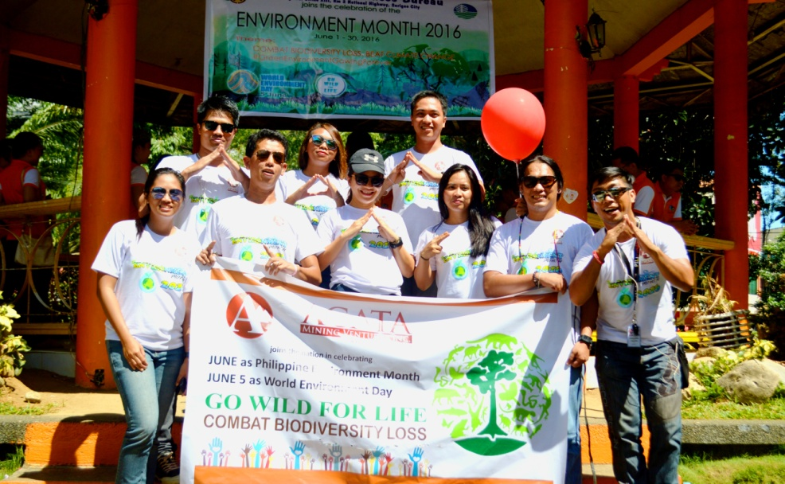
- The AMVI Team shows a grade “A” performance during the opening of Environment Month 2016 and World Environment Day in Surigao City.

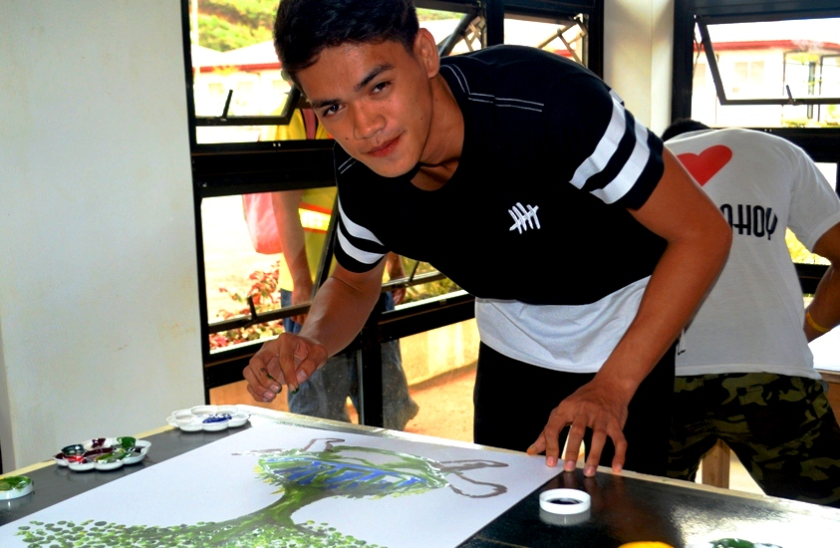
- Handy and creative. A participating student from AMVI-supported Dona Rosario National High School in Tubay, Agusan del Norte demonstrates his skills during the hand painting competition.

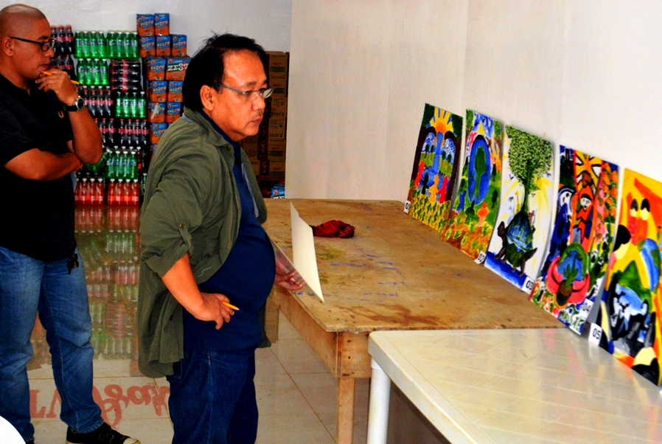
- Managers choice. General Manager Emilio Figueroa III (right) and Assistant GM Anthony B. Quijano judge entries from students of AMVI-supported high schools.

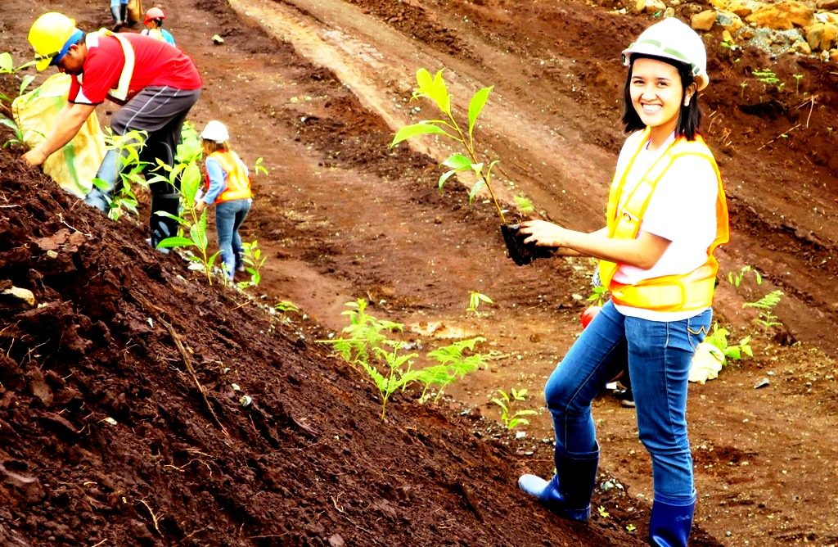
- AMVI Environment Liaison Crislyn U. Sumpo takes a break in the office and engages in the company’s “greening” efforts.

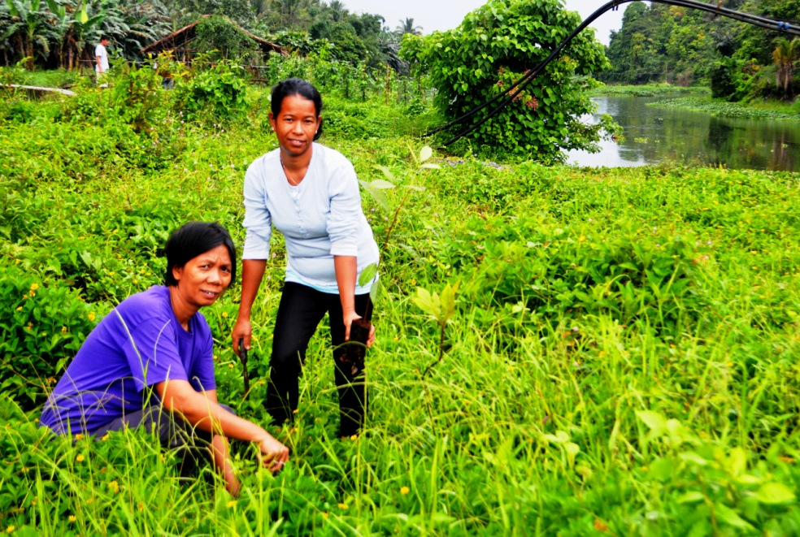
- Adopted river. The women’s sector of Barangay La Paz, Santiago Municipality spends a day in nurturing the Kalinawan river bank and planting more trees.

About TVI in the Philippines
TVI Resource Development Philippines Inc. (“TVIRD”), is the local affiliate of TVI Pacific Inc. (TSX: TVI), a publicly-listed Canadian mining company focused on the exploration, development and production of precious and base metals from district-scale, large-system, high-margin projects located in the Philippines. Concurrent ownership of ventures is shared with partner company, Prime Resource Holdings Inc.

The commercial operations of Agata Mining Ventures Inc. (AMVI) mark the third successful mining project that TVIRD brought on-stream in the past 10 years. The company is committed to exploration and mining practices that promote transparency, responsible stewardship of the environment, and the inalienable rights to life, dignity, and sustainable development of its host communities.
www.tviphilippines.com

Contact:

Kaycee Crisostomo Julius M. De Villa
Corporate Communications Director Corporate Communications Officer
TVI Resource Development Philippines Inc. Agata Mining Ventures, Inc.
Email: kaycee.crisostomo@tvipacific.com.ph Email : julius.devilla@agatamining.com.ph
Phone: +63 2 728-8491 ext. 103 Mobile : + 63 918 336-4703 / +63 915 356-3271
Mobile: +63 917 579-1528
Fax: +63 2 728-8515

