N E W S R E L E A S E

CENRO Salutes Agata Support to Coastal Communities
Joint effort of AMVI and coastal communities highlight Ocean Month celebration

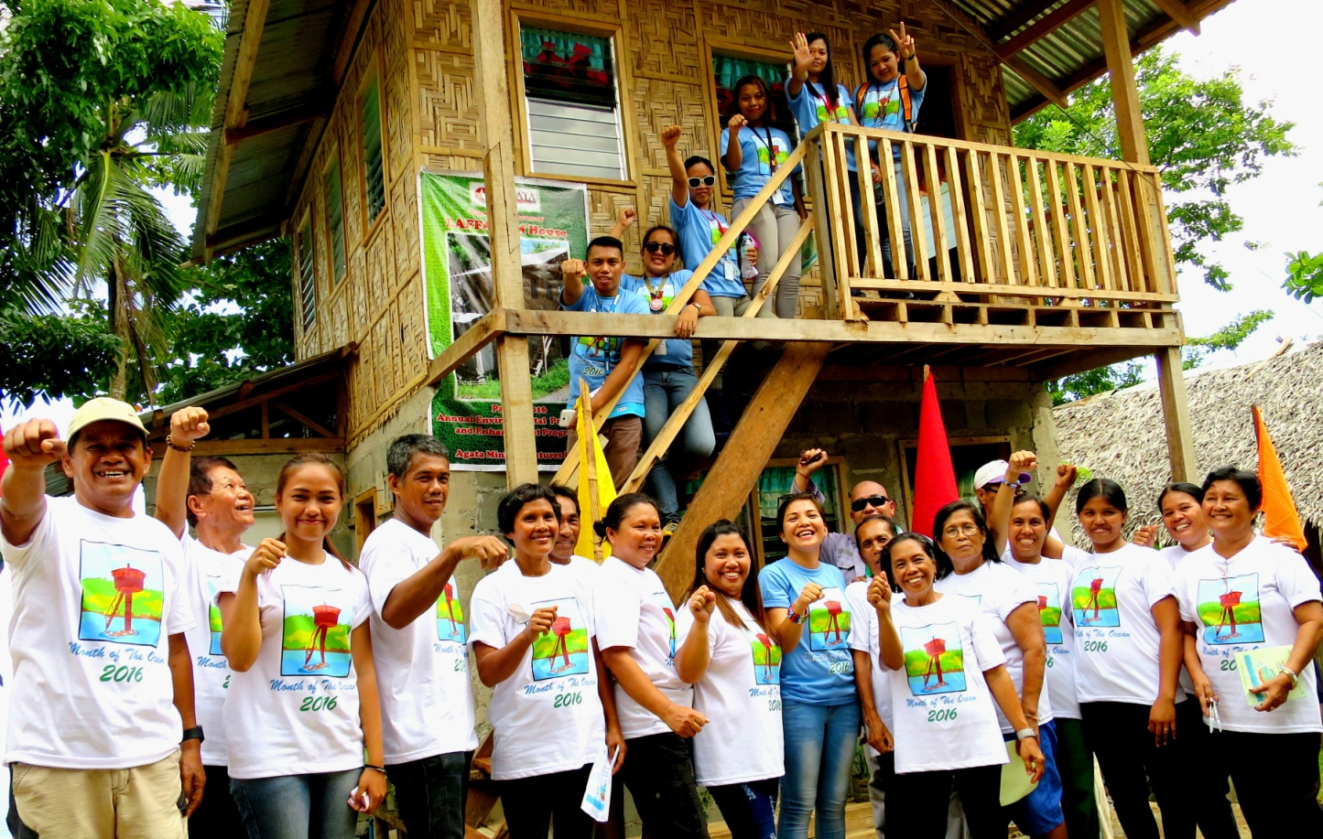
The new two-story community building funded by AMVI’s SDMP was opened by multi-sectoral organizations DENR, PAWD and CENRO together with company employees (in background). Joining them are LAFFA officers, Barangay Lawigan Council representatives and staff.

Tubay, Agusan del Norte / June 2016 – Tubay Municipality’s Community Environment and Natural Resources Office (CENRO) representatives once again witnessed the Ocean Month celebration in Agata Mining Ventures Inc. (AMVI) and lauded the company for its ongoing commitment towards responsible mining – a dedication instilled by project proponent and operator, TVI Resources Development Philippines Inc. (TVIRD). On the same occasion, AMVI opened the Barangay Lawigan Fisher Folks Association’s two-storey community building that the company supported through its Social Development and Management Program (SDMP).

The multi-purpose building situated in the heart of the community has been a long-time request of the organization to house their documents, equipment as well as host meetings and livelihood activities. The company provided all the necessary construction materials and architectural design while the community collectively contributed their labor into the structure.

On the occasion of this year’s Ocean Month, the edifice will serve as a lasting testimony to the ongoing cooperation between AMVI and the people of Lawigan.

Coastal care
AMVI’s 4,995-hectare Mineral Processing Sharing Agreement (MPSA) area is located in the municipalities of Santiago, Jabonga and Tubay in Agusan del Norte Province. There are two marine sanctuaries situated in Tubay’s coastal barangays Tinigbasan and Lawigan. In those areas, AMVI adopted the entire 10.5-hectare Sitio Payong-payong Marine Sanctuary and another 10-hectare protected area in Lawigan.

Agata’s environmental management team performs technical monitoring, mobilization assistance and maintains two lookout towers in these sanctuaries. During its Ocean Month celebration last year, AMVI constructed an inland tower house observatory, which was officially formally turned-over by the company to the communities.

The Payong-payong Silt Recovery Project conducted earlier in January this year, another joint cooperation geared towards caring for Tubay’s coastal resources, was initiated in partnership with community organizations, Tinigbasan and Lawigan Fisher Folks Association. The facility enables joint de-silting efforts – a process that removes silt from the shore and backfills it in a designated pit.

Sustained recognition
AMVI’s coral relocation – a project that has gained recognition for the company’s Coastal Resource Management Program – is monitored through daily ocular inspection and patrolling as well as the installation of floaters and buoy markers around the site to prevent seafarers from inadvertently damaging the corals. This project and AMVI are recognized by the DENR’s Mines and Geosciences Bureau (MGB) and accorded the Outstanding Implementor Award to AMVI being the first mining company to ever undertake the successful relocation of corals.

The agency likewise recognized the company’s exemplary performance in its Environmental Protection and Enhancement Program (EPEP) last December 2015. This was based on an actual joint ocular inspection conducted by the CENRO team headed by Forester Barlou Aparte and DENR Protection and Wildlife Division representative Loi Marie Olaguer during this year’s Ocean Month.

“Efforts to protect the bounty of the seas mirror the dedication of people depending on it, and at the same time, secure the future generations’ harvests. I have long been a witness of the (Lawigan) people’s battles to fight illegal fishing. The strong dedication of partners like AMVI brings a sustainable legacy for generations to come,” Aparte said.

“We used to dream of protecting the jewels our marine sanctuaries. We used to dream of someday having a structure that will emerge in the middle of Lawigan’s sanctuary. We used to pray for everything good for our community. Now, the dream is finally here – a stronger organization, a tower house observatory and a dedicated Agata team to sustain our realized dreams,” said AMVI Environment Manager Jesalyn Guinguing.
*******

Press photos:

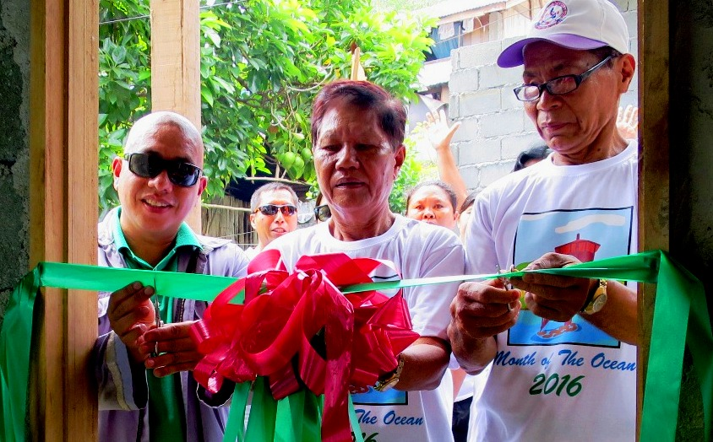
- Multi-sectoral Participation. CENRO Tubay witnessed the concerted efforts of the Barangay Lawigan Fisher Folks Association headed by Hon. Edgar Capon and AMVI – a cooperation that led to the establishment of a two-storey community building in the barangay.

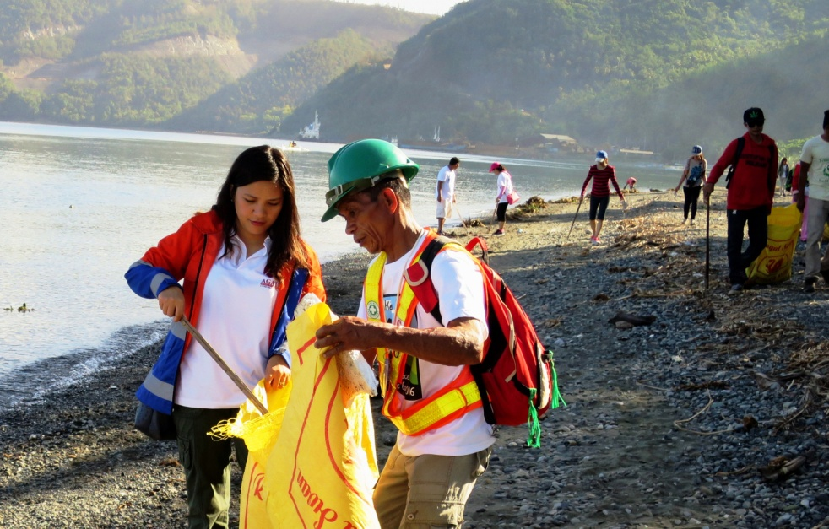
- By example. AMVI Environment Manager Jessalyn Guingging lead the Ocean Month coastal clean-up activity participated by co-workers and community members along the coastline of La Fraternidad in Tubay.

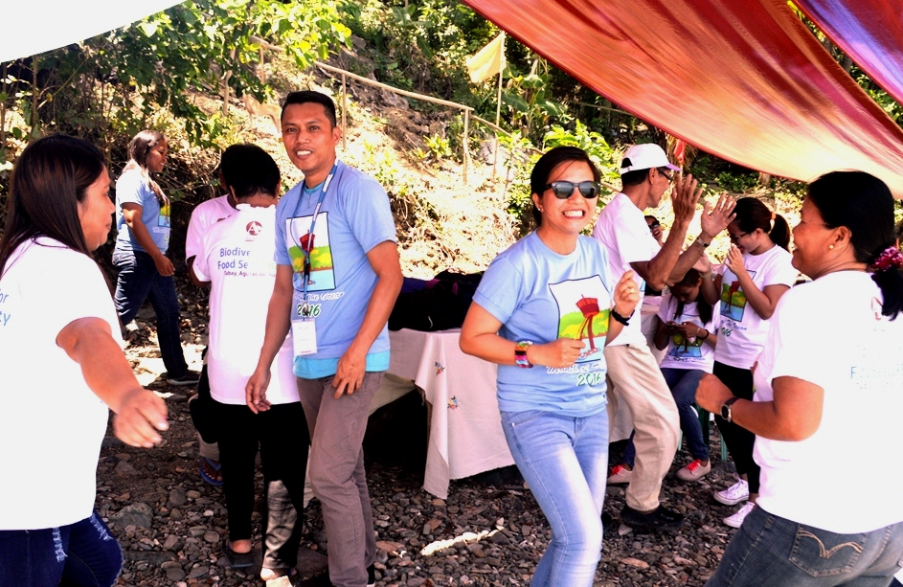
- AMVI and LAFFA’s Ocean Month 2016 celebration culminated in a community dance sortie.

About TVI in the Philippines
TVI Resource Development Philippines Inc. (“TVIRD”), is the local affiliate of TVI Pacific Inc. (TSX: TVI), a publicly-listed Canadian mining company focused on the exploration, development and production of precious and base metals from district-scale, large-system, high-margin projects located in the Philippines. Concurrent ownership of ventures is shared with partner company, Prime Resource Holdings Inc.

The commercial operations of Agata Mining Ventures Inc. (AMVI) marks the third successful mining project that TVIRD brought on-stream in the past 10 years. The company is committed to exploration and mining practices that promote transparency, responsible stewardship of the environment, and the inalienable rights to life, dignity, and sustainable development of its host communities.
www.tviphilippines.com

Contact:

Kaycee Crisostomo Julius M. De Villa
Corporate Communications Director Corporate Communications Officer
TVI Resource Development Philippines Inc. Agata Mining Ventures, Inc.
Email: kaycee.crisostomo@tvipacific.com.ph Email : julius.devilla@agatamining.com.ph
Phone: +63 2 728-8491 ext. 103 Mobile : + 63 918 336-4703 / +63 915 356-3271
Mobile: +63 917 579-1528
Fax: +63 2 728-8515

