N E W S R E L E A S E

It’s Back-to-School with Agata’s Brigada Eskwela 2016
AMVI kicks-off new school year with restoration program to benefit students in host communities

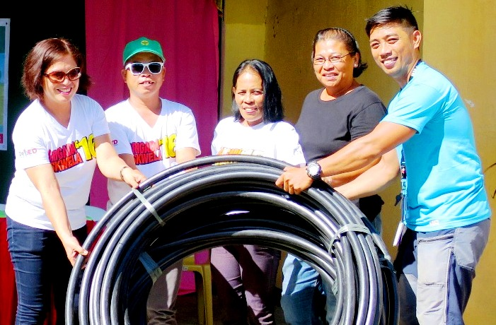
AMVI Corporate Communications Officer Julius M. De Villa (extreme Right) turns-over needed piping materials to Tubay Municipal Elementary School faculty and staff led by School Principal Corazon Beray (Extreme left). Once installed, the water pipes will extend to all the school’s classrooms and address the essential sanitary needs of every student and teacher

Tubay, Agusan del Norte / June 2016 – In line with TVIRD’s tradition of supporting responsive education for its host communities, Agata Mining Ventures Inc. (AMVI) devoted an entire day to cleaning, reparing and providing building materials for different schools located within its mining concession area in the Tubay, Jabonga and Santiago municipalities – all these in anticipation of more new students in the incoming school year. The initiative also comes as the company’s active response to and participation in the Department of Education’s (DepEd’s) yearly back-to-school program, Brigada Eskwela (School Brigade).

AMVI management and staff took time off from their daily duties to assist the parents, teachers, local government officials and even the Philippine National Police in repairing and cleaning the vicinity of several public schools in the 4,995-hectare Agata Mineral Processing Sharing Agreement (MPSA) area. The Agata Nickel Project is operated by TVI Resource Development Philippines Inc. (TVIRD).

Hands-on support
AMVI General Manager Emilio T. Figueroa III, along with key Agata officers and staff, personally turned over construction materials for the repair and refurbishment of Barangay Tinigbasan Elementary School, which is located in the primary community that hosts AMVI’s ship loading operations.

“The call to heed responsible mining is not expressed in mere phrases. It is contextualized in deeds and unifying moments such as improving and protecting the welfare of communities within AMVI’s area of operations,” expressed Figueroa in his opening message during the ceremony. On the same occasion, the adjacent Lawigan Elementary School also received an endowment of school and office supplies for its students and teachers.

These aforementioned schools are from coastal communities within the Agata MPSA. Both the company’s Engineering and Community Relations Groups were mobilized to assist in cleaning the surroundings and repairing the facilities of both schools, which serve some 300 students every school year.

A shared connection
“We truly appreciate AMVI’s response to the existing challenges and the facilities our school currently lacks. The water pipes that extend to different classrooms will address the essential sanitary needs of every student and teacher,” expressed Tubay Municipal Elementary School Principal Corazon Beray.

Most of AMVI’s employees send their children to Tubay Elementary School, which is located at the heart of the municipality in Barangay Poblacion 2. Even with more than 600 students last year, the school is anticipating a further increase in enrolment this school year.

“AMVI’s ability to assist reflects their sincerity to build communities and expand its connections to those who need their assistance,” Beray added.

AMVI staff led by Communications Officer Julius M. De Villa joined a motorcade conducted by Beray and her faculty, SPO4 Marino Asuncion and officers of the Philippine National Police, and Barangay Councilor Margenia Quita Luison. The motorcade generated awareness and support for Brigada Eskwela and kicked-off the cleaning activities participated in by students and their parents.

“AMVI’s social responsibility lies in the TVIRD philosophy of building better communities by enabling the next generation. Education is the primary contribution of AMVI in the development of Tubay Municipality,” De Villa explained upon turning-over piping material for the school’s use.

IP education
The Indigenous Mamanwa tribes that form AMVI’s host indigenous people’s (IP) community were given ample school supplies consisting of school bags, pad papers and pencils for 152 beneficiary students who received the items delivered to the tribal halls in two locations: in Barangay Colorado, Jabonga Municipality and in Barangay E. Morgado, Santiago Municipality.

“AMVI’s support aims to motivate young Mamanwas to attain education and preserve the cultural heritage of our ancestors. We can be confident and fully-equipped to fight poverty and contribute to the development of our community,” said AMVI’s Bernie Nanoy to his fellow Lumads (tribesmen).

AMVI’s support to Brigada Eskwela is part of its Social Development Management Program, which has earmarked some Php 255,000 specifically for the event. It likewise upholds TVIRD’s humanitarian effort of molding students into productive citizens. At the height of its operations in Zamboanga del Norte, TVIRD supported 10 schools with over 4,000 students both from tribal and non-tribal communities.

*******

Press photos:

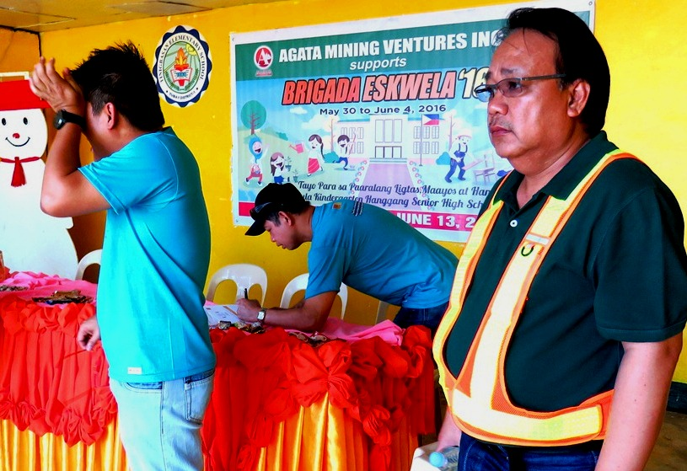
- Managers on watch. AMVI General Manager Emilio T. Figueroa III (extreme Right) personally overlooks the opening ceremony and succeeding repairs and cleaning activities of Brigada Eskwela at Tinigbasan Elementary School.

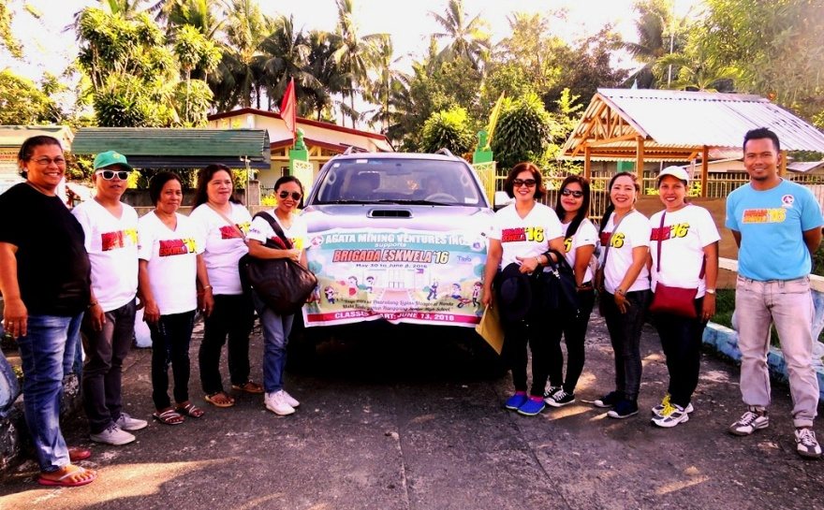
- School administrators and teaching staff are joined by AMVI Community Relations and Public Affairs personnel, local barangay officials and parents in conducting a motorcade to kick-start Brigada Eskwela in Tubay Elementary School.

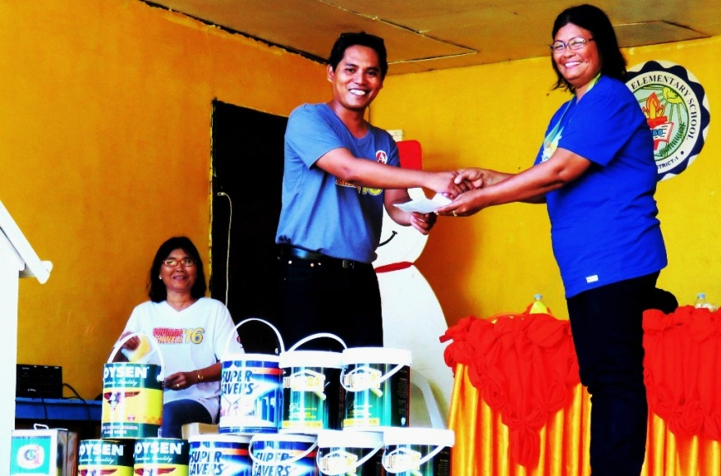
- Local barangay officials receive construction materials from AMVI – which will provide school children a more conducive learning environment when school starts.

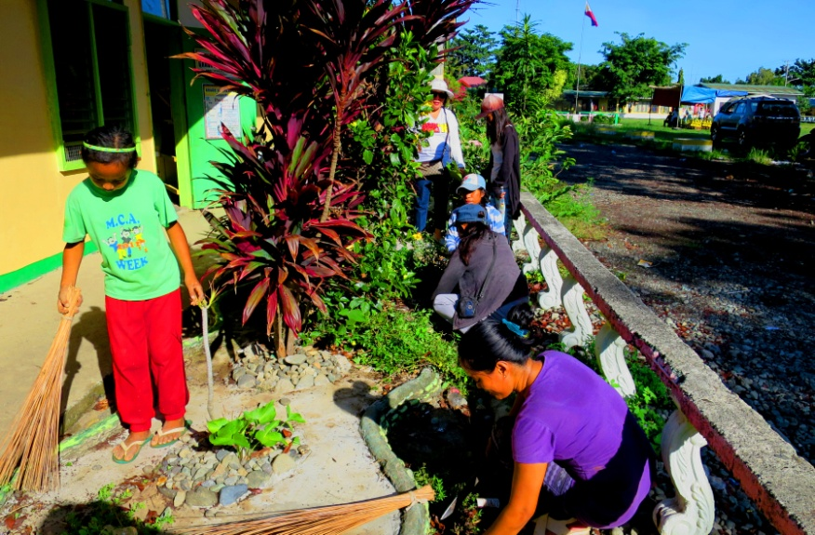
- Students, parents, and teachers bask in the warm morning sun while cleaning their school grounds.

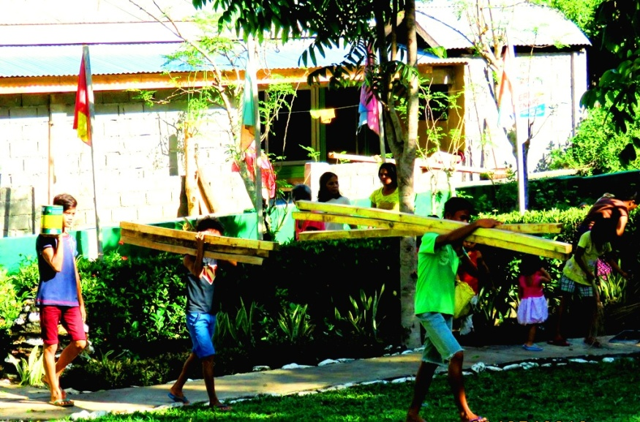
- Carry on. Students and community members carry light construction materials donated by AMVI for damaged classrooms during the recent typhoons.

About TVI in the Philippines
TVI Resource Development Philippines Inc. (“TVIRD”), is the local affiliate of TVI Pacific Inc. (TSX: TVI), a publicly-listed Canadian mining company focused on the exploration, development and production of precious and base metals from district-scale, large-system, high-margin projects located in the Philippines. Concurrent ownership of ventures is shared with partner company, Prime Resource Holdings Inc.

The commercial operations of Agata Mining Ventures Inc. (AMVI) marks the third successful mining project that TVIRD brought on-stream in the past 10 years. The company is committed to exploration and mining practices that promote transparency, responsible stewardship of the environment, and the inalienable rights to life, dignity, and sustainable development of its host communities.
www.tviphilippines.com

Contact:

Kaycee Crisostomo Julius M. De Villa
Corporate Communications Director Corporate Communications Officer
TVI Resource Development Philippines Inc. Agata Mining Ventures, Inc.
Email: kaycee.crisostomo@tvipacific.com.ph Email : julius.devilla@agatamining.com.ph
Phone: +63 2 728-8491 ext. 103 Mobile : + 63 0918 336-4703 / +63 915 356-3271
Mobile: +63 917 579-1528
Fax: +63 2 728-8515

