N E W S R E L E A S E

Driven to Succeed: TESDA NC2 Training
Fast-Tracks Agata Community Development
26 program beneficiaries include young workers and indigenous Mamanwas from Agata’s host communities

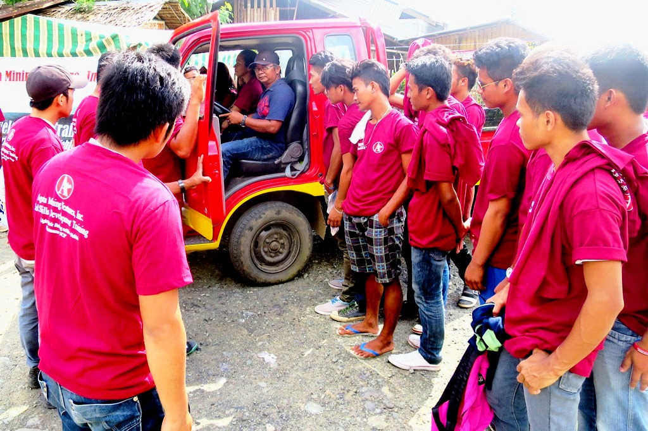
Hands-on Demo. The training participants from AMVI’s communities are all eager to become responsible drivers and bring mobility closer to their people.

Tubay, Agusan del Norte / June 2016 – Agata Mining Ventures Incorporated (AMVI), a joint venture project of MRL Nickel Philippines Inc. and TVI Resource Development Philippines (Inc.), provides its communities with enabling competencies to access opportunities – not just in the mining industry but also for employment prospects and business ventures. AMVI recently facilitated a 15-day National Certification Level-02 (NC2) Training on Driving Skills and Light Vehicle Maintenance for its partner barangays within its mining concession area, most especially for its indigenous Mamanwa hosts who have benefited from the company’s livelihood programs and royalties from its mining operations.

Since 2014, AMVI has operated its nickel laterite direct shipping ore (DSO) project in the municipalities of Tubay, Santiago and Jabonga in Agusan del Norte Province. Since its early exploration days in the 1990s, it has forged a relationship based on cooperation with its indigenous cultural communities.

AMVI organized and financed the training, which was conducted by the regional Technical Education and Skills Development Authority (TESDA). The company provided meals, vehicle rental, venue and transportation allowances for the 26 participants who were lectured on road ethics, safety and traffic guidelines, basic vehicle maintenance and troubleshooting as well as hands-on driving - during which they used the Mamanwas’ newly-acquired Bongo delivery truck.

Mobilizing progress
All 26 participants successfully graduated from the training course and received their national certificates during the culmination rites at the Barangay Doña Rosario Training Center in Tubay. The event was attended by AMVI Assistant GM Anthony B. Quijano who urged the graduates to “(carry) your confidence with responsibility, discipline and wisdom.”

In terms of livelihood, the ability to drive is clearly differentiated from the mere ability to operate a vehicle. Manners, proper etiquette while on the road and a general concern for other fellow motorists are what separate drivers and “vehicle operators.” On hindsight, the country’s congested roads and chaotic traffic situation could have been tempered-down if public utility drivers were required to take the same NC2 training.

“The most important thing that one should always bear is respect,” emphasized TESDA Instructor Alfredo Javier to the graduates.

For AMVI’s Mamanwas, the drivers’ training of their fellow lumads means that they can now mobilize both people and goods – further mobilizing trade between their communities and traders in the cities.

Enabling people
Re-elected Tubay Mayor Hon. Fidel E. Garcia, Jr. and the newly-elected council members - Vice-Mayor Raquim Cuyos and seven councilors - also graced the ceremony and approved of the company’s initiative for developing the communities’ skills and thus making them more self-sufficient.

Mayor Garcia lauded “The commendable efforts of AMVI, (that) in spite of the challenges in the industry, motivate each participant from our community. Aside from bringing employment and projects to our community, the company even pushed for developing skills on an individual level.”

According to TESDA, the drivers’ training also holds various employment opportunities for its graduates who now hold NC2 licenses. Further to regular assessments held by different TESDA centers in the province, driving skills is one of the most in-demand employment requirements both here and abroad.

Bernie Nanoy, representative of Mamanwa participants from Jabonga Municipality, shared: “Mining has been in our community for 17 years and has brought better opportunities to our people. Agata has given this (driving) skill to us – and it can bring us employment and develop our confidence as a community.”

*******

Press photos:

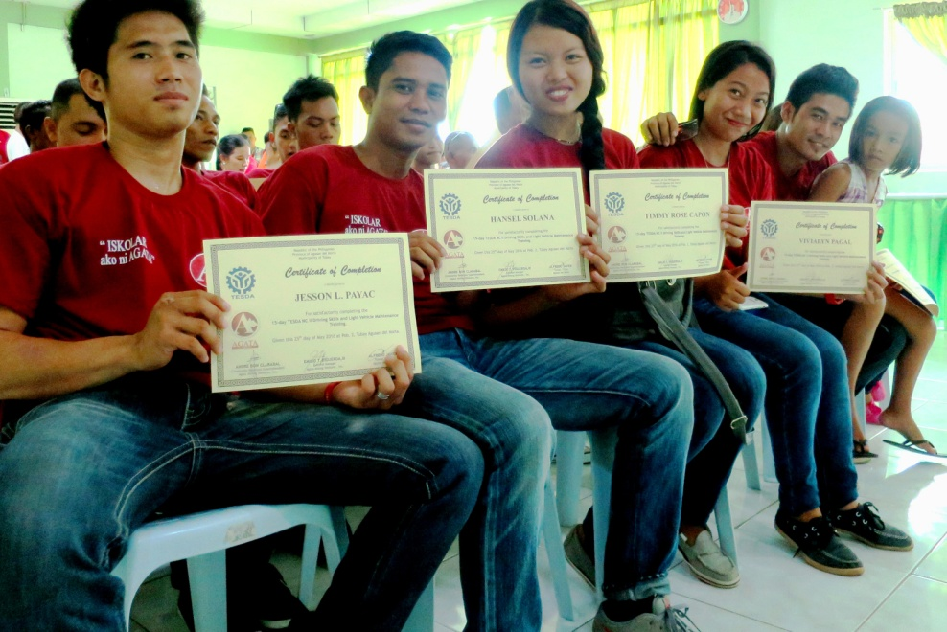
- Pride and responsibility. Majority of the training participants are young residents of AMVIs partner barangays, which are composed of both tribal and non-tribal communities.

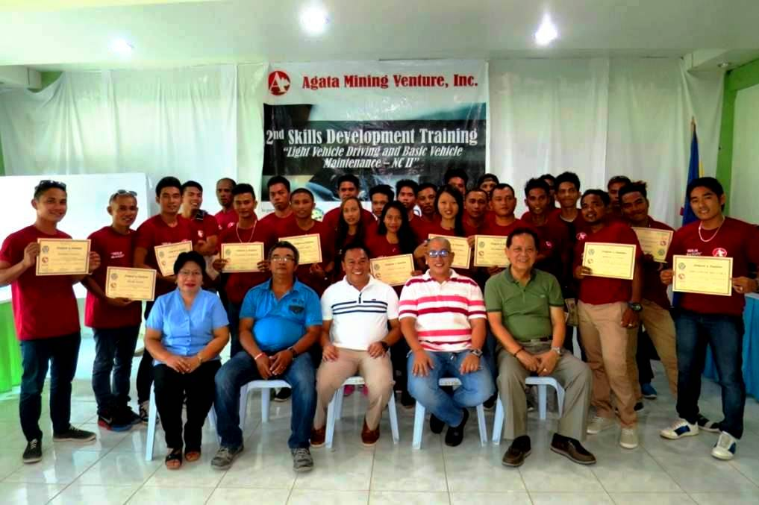
- Together as one. The complete set of newly-elected Tubay municipal officials headed by ( front row, from Right) Mayor Fidel Garcia, AMVI Assistant General Manager Anthony B. Quijano, Vice Mayor Raquim Cuyos, Training Instructor Alfredo Javier, TESDA Provincial Coordinator Hayde P. Tabilo, and the graduates.

About TVI in the Philippines
TVI Resource Development Philippines Inc. (“TVIRD”), is the local affiliate of TVI Pacific Inc. (TSX: TVI), a publicly-listed Canadian mining company focused on the exploration, development and production of precious and base metals from district-scale, large-system, high-margin projects located in the Philippines. Concurrent ownership of ventures is shared with partner company, Prime Resource Holdings Inc.

The commercial operations of Agata Mining Ventures Inc. (AMVI) marks the third successful mining project that TVIRD brought on-stream in the past 10 years. The company is committed to exploration and mining practices that promote transparency, responsible stewardship of the environment, and the inalienable rights to life, dignity, and sustainable development of its host communities.
www.tviphilippines.com

Contact:

Kaycee Crisostomo Julius M. De Villa
Corporate Communications Director Corporate Communications Officer
TVI Resource Development Philippines Inc. Agata Mining Ventures, Inc.
Email: kaycee.crisostomo@tvipacific.com.ph Email : julius.devilla@agatamining.com.ph
Phone: +63 2 728-8491 ext. 103 Mobile : + 63 0918 336-4703 / +63 915 356-3271
Mobile: +63 917 579-1528
Fax: +63 2 728-8515

