N E W S R E L E A S E

Agata Stages a “Greener” Earth Day
Agata management and staff devote a whole day to tree planting and IECs for a healthier environment

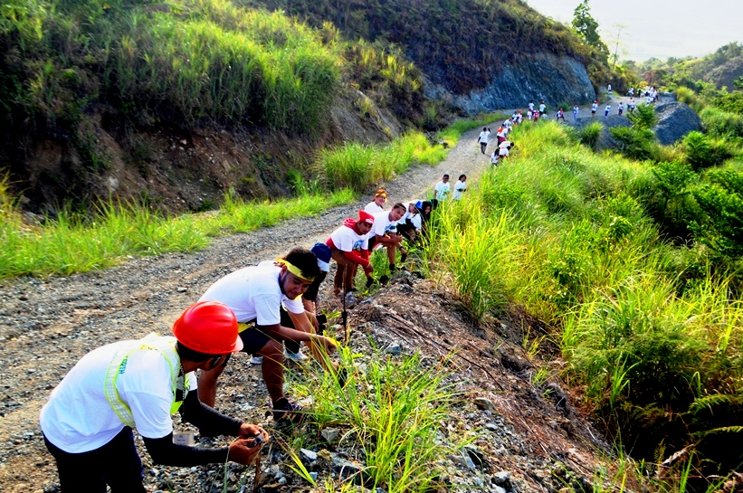
Gaining more traction. AMVI employees planted some 300 seedlings along a one-kilometer stretch on the road to the Paiton Water Supply Site.

Tubay, Agusan del Norte / July 2016 – As part of its progressive rehabilitation program as well as support to the TVIRD philosophy on environmental conservation, Agata Mining Ventures Inc. (AMVI) has dedicated itself towards “greening” its natural environment – which will eventually be better and “greener” than before the company commenced operations in Tubay, Agusan del Norte. This dedication is highlighted more than ever during AMVI’s recent commemoration of Earth Day 2016 during which key officers and staff took a break from their daily operations and came together to herald the importance of properly managing and conserving the country’s natural resources.

AMVI is a joint venture between MRL Nickel Philippines Inc. and TVI Resource Development Philippines Inc. (TVIRD), which leads the development of the Agata Nickel Laterite DSO Project. The company’s 4,995-hectare Mineral Processing Sharing Agreement (MPSA) area spans the municipalities of Tubay, Santiago and Jabonga.

Since its early exploration phase, the company has planted 164,298 seedlings across 148 hectares within AMVI’s MPSA as of March, 2016. This translates into a forest density of 1,110 trees per hectare – which is above the effective forest density of the National Greening Program. Cumulatively, the company has planted a total of 173,598 trees within its MPSA.

Fraternity and commitment
During the opening ceremony at daybreak, employees gathered at the AMVI recreational area to witness the lighting of the torch by Assistant General Manager Anthony B. Quijano who formally kicked-off the Earth Day activities. This was followed by a tree planting activity and a hike towards the company’s water supply site. Participants planted some 300 seedlings along a one-kilometer stretch on the road to the Paiton Water Supply Site.

The participants were then organized into teams for the Eco-Obstacle Race, which took the runners uphill to an activity area where each team underwent obstacles all the way to the finish line. In the afternoon, an impromptu slogan making contest was conducted at the AMVI Mess Hall.

In the evening, employees once again signed pledges to the environment – taking-off from the pledges signed in the previous year and bringing commitments even further with plans to become more responsible in “greening” the environment and creating more awareness on the importance of planting trees.

Finally, to cap the day-long activity – and in true Agata tradition – the yearly search for Mr. and Ms. Earth crowned Safety Officer Charles Dawn Beltran Admin Staff Ailen Ruaya as the winners. They will continue as the strongest advocates representing the employees of the company towards environmental awareness.

More than expected
“The essence of the Earth Day celebration is remembering the great importance of trees to the natural environment as well as the communities that we serve,” said Environment Manager Jesalyn Guinguing.“

“As employees of a responsible mining company, we should not just be limited to the required standards of the DENR. But rather, we should go beyond because we know the greater benefits of committing to proper resource conservation, managing the environment and the continued observance of proper waste disposal.” she added.

Since it brought operations on-stream in 2014, TVIRD has introduced various environmental measures to the Agata Nickel Project. Civil works and engineering comply with the highest standards in order to prevent soil erosion and possible environmental hazards. Dust and pollution control measures are likewise in place, including the installation of “coconets” around the Agata private port which prevents siltation from spreading into Tubay’s coastal areas.

Also during Earth Day, the company conducts tree planting, clean-up and IEC activities in its areas near the Kalinawan River – its adopted river. This year’s addition of trees brings the cumulative effort to a total of more than 9,000 trees planted within an 11-km stretch under AMVI’s adopted area along Kalinawan River.

Responsible management
“I am inspired by how our employees managed to face the challenge amidst their hectic schedules both in the office and in the field. It is amazing how creative, innovative and competitive each team is, particularly in recycling waste material for the Mr. and Ms. Earth costumes,” Quijano expressed during the closing ceremonies.

“The commitment of Agata employees heeds the challenge to continue to be productive, responsible and constantly aware of managing the environment,” he concluded.

Aside from receiving consistent public recognition for its safety and environmental practices, AMVI is currently putting systems in place in order to achieve an ISO Certification 14001 on Environmental Management Standards.
*******
Press photos:

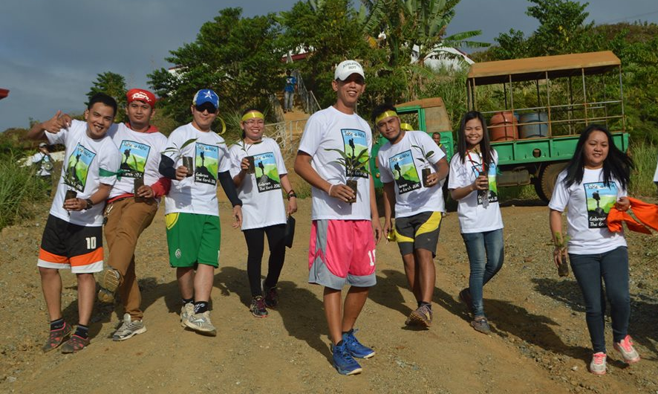
- Feeling sporty. Agata employees pledge their support for a greener environment while feeling the joy of planting another tree while in competition form.

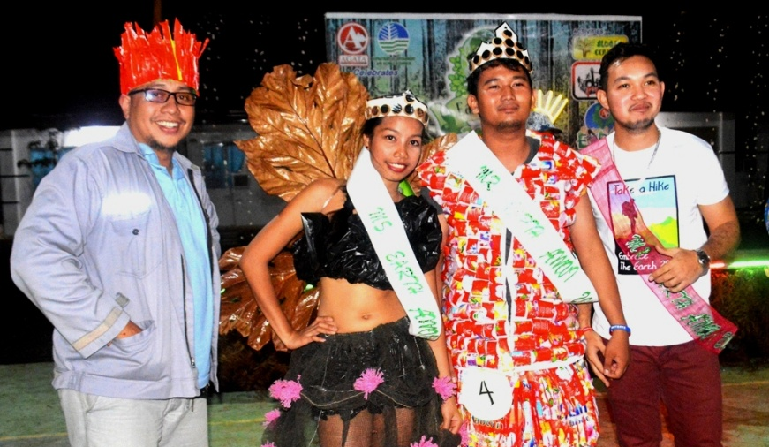
- AMVI Asst. General Manager, Anthony B. Quijano crowned Mr. and Ms. Earth: Safety Officer Charles Dawn Beltran and Admin Staff Ailen Ruaya.

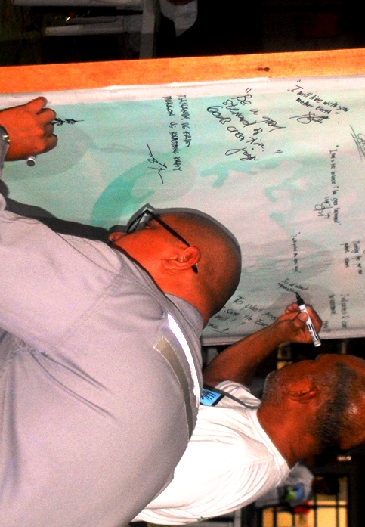
- Hand-in-hand towards advancing AMVI’s social responsibility: Assistant Manager Anthnoy B. Quijano and Vice President Edsel Abrasaldo sign their commitments and renew their vows on the “Envi-Wall.”

About TVI in the Philippines
TVI Resource Development Philippines Inc. (“TVIRD”), is the local affiliate of TVI Pacific Inc. (TSX: TVI), a publicly-listed Canadian mining company focused on the exploration, development and production of precious and base metals from district-scale, large-system, high-margin projects located in the Philippines. Concurrent ownership of ventures is shared with partner company, Prime Resource Holdings Inc.

The commercial operations of Agata Mining Ventures Inc. (AMVI) marks the third successful mining project that TVIRD brought on-stream in the past 10 years. The company is committed to exploration and mining practices that promote transparency, responsible stewardship of the environment, and the inalienable rights to life, dignity, and sustainable development of its host communities.
www.tviphilippines.com

Contact:

Kaycee Crisostomo Julius M. De Villa
Corporate Communications Director Corporate Communications Officer
TVI Resource Development Philippines Inc. Agata Mining Ventures, Inc.
Email: kaycee.crisostomo@tvipacific.com.ph Email : julius.devilla@agatamining.com.ph
Phone: +63 2 728-8491 ext. 103 Mobile : + 63 0918 336-4703 / +63 915 356-3271
Mobile: +63 917 579-1528
Fax: +63 2 728-8515

