N E W S R E L E A S E

Agata leads cleanup in Kalinawan River
Gains more community support for sustainability of its Adopt-a-River Program

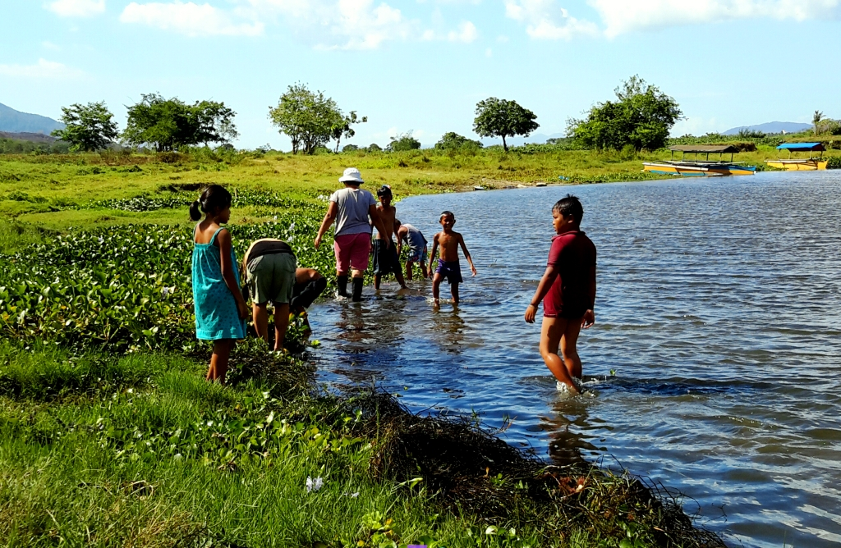
Community support. AMVI’s biannual river clean-up endeavors to maintain the cleanliness of Kalinawan river. The company enjoins barangay residents both young and old to support the activity alongside AMVI employees who are just as committed to the program.

Tubay, Agusan del Norte / July 2016 – Agata Mining Venture Inc. (AMVI) employees led by Environmental Management Jessalyn Guingging as well as members of the local community conducted a massive riverside clean-up and replanting activity along Kalinawan River – AMVI’s adopted river and the major tributary that runs through the company’s 4,995-hectare Mineral Processing Sharing Agreement (MPSA) area that spans the municipalities of Tubay, Jabonga and Santiago. The activity was implemented in coordination with the DENR’s Environmental Management Bureau and Barangay E. Morgado Women’s Organization through its leaders, Hilda Ubbos and Agnes Evangelista.

Since its launch on Earth Day 2009, the adopt-a-river program of Agata Mining Ventures Inc. (AMVI) has been expanded to include the participation of its host communities, particularly in the portions of Barangays Tagbuyakan, E. Morgado and Colorado. Also since then, the proponents fostered community empowerment, generated livelihood through agro-forestry, and conducted clean-up drives and re-greening activities along the Kalinawan riverside. As one of the life-giving natural formations within the Agata MPSA, it is also but natural for the mining company to make good on its ongoing commitment for the care and protection of the 29-kilometer Kalinawan River.

During the event, barangay residents both young and old arrived with their garden tools alongside AMVI employees and staff near the Dunguan site – which is where pump boats directly transport residents from the other side. AMVI’s biannual activity endeavors to maintain the cleanliness of the river, which is a major source of water for the surrounding communities especially in Barangay E. Morgado, part of the municipality of Santiago, Agusan del Norte. Previous clean-up activites were held at Barangay Tagbuyacan also of the same municipality.

To date, the company also continues to engage the local government units, particularly the barangays, in the regular upkeep of the program. Quarterly inspection and monitoring activities are jointly conducted by AMVI’s environment team and local barangay officials.

A long-term commitment
In 2010, AMVI entered into a Memorandum of Agreement (MOA) with riverside barangays, the Community Technical Working Group of Barangay Colorado and the Department of Natural Resources (DENR) through the Community Environment and Natural Resources Office of Cabadbaran for the adoption of a portion of Kalinawan River.

AMVI has since stepped-up its efforts to enhance the natural foliage along the tributary’s riverside community of Barangay La Paz in Santiago, which is one of three municipalities covered by the company’s MPSA. Last year, employees, barangay council members and other local officials planted some 450 seedlings along the river. This year’s addition brings the cumulative effort to a total of 9,484 trees – or an average of 860 trees per kilometer under AMVI’s adopted area under the program.

The adopted area was also re-surveyed and mapped-out in order to identify potential riverside zones in need of tree planting. This was followed by regular maintenance and protection of the planted seedlings, which are all supported by municipal and barangay ordinances.

Kalinawan River – its name meaning “clarity” – is one of the province’s cleanest inland bodies of water. The stretch of pristine and picturesque river is Lake Mainit’s only outlet and passes through AMVI’s host municipalities before it finally empties into Butuan bay.

It is also one of the oldest trading routes in the Philippines and has been the indigenous Mamanwas’ fishing ground since time immemorial.

Continued cooperation
Last year, AMVI supported the DENR’s TreeVolution: Greening MindaNOW – a massive tree-planting activity conducted simultaneously across six regions in Mindanao – which successfully planted 3.2 million tree seedlings, beating India for the most number of trees planted in one hour.

AMVI is a joint venture between MRL and TVI Resource Development Philippines Inc. (TVIRD), which itself carved a ‘green’ legacy in its flagship Canatuan Mining Project. The commercial operations of Agata Mining Ventures Inc. (AMVI) marks the third successful mining project that TVIRD brought on-stream in a period of 10 years.

*******

Press photos:

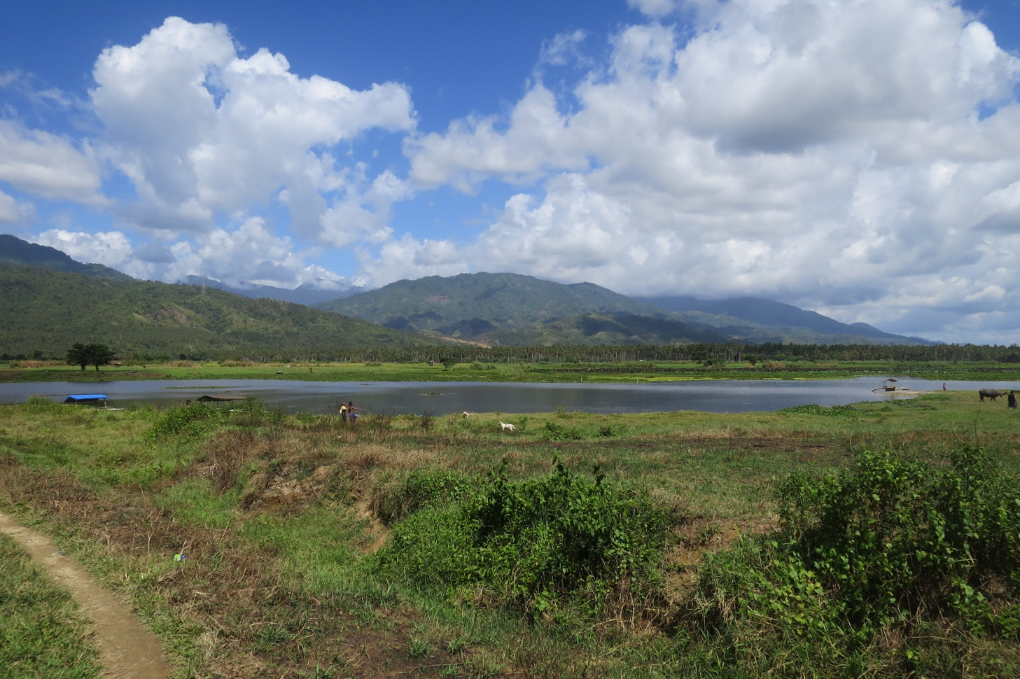
- Clean as you go. The 29-kilometer Kalinawan River Kalinawan River is the cleanest inland body of water in the Caraga region and possibly the entire province of Agusan del Norte.

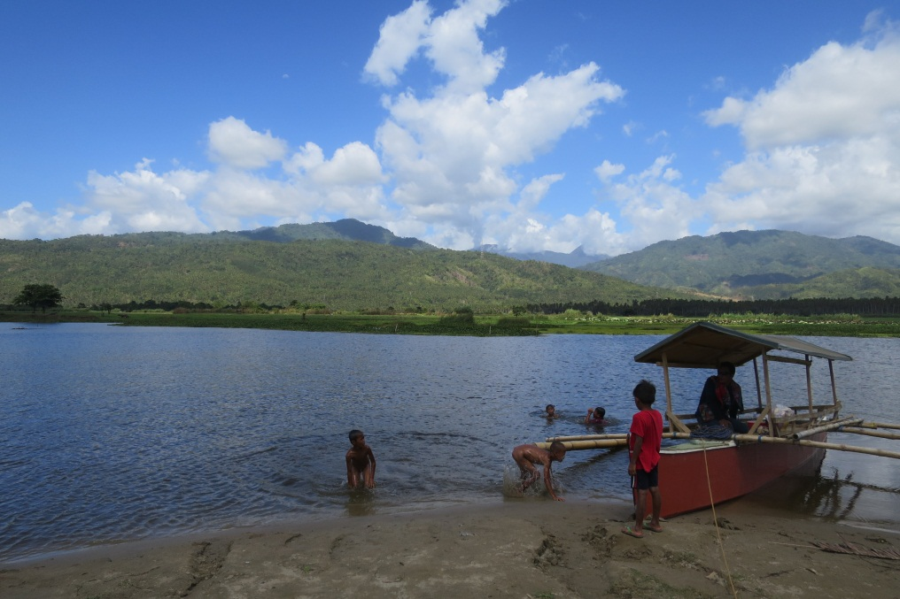
- Extraordinary swimming day. Kids enjoying the waters on a hot summer afternoon, hoping they can tag along during playtime to clean up their favorite play ground.

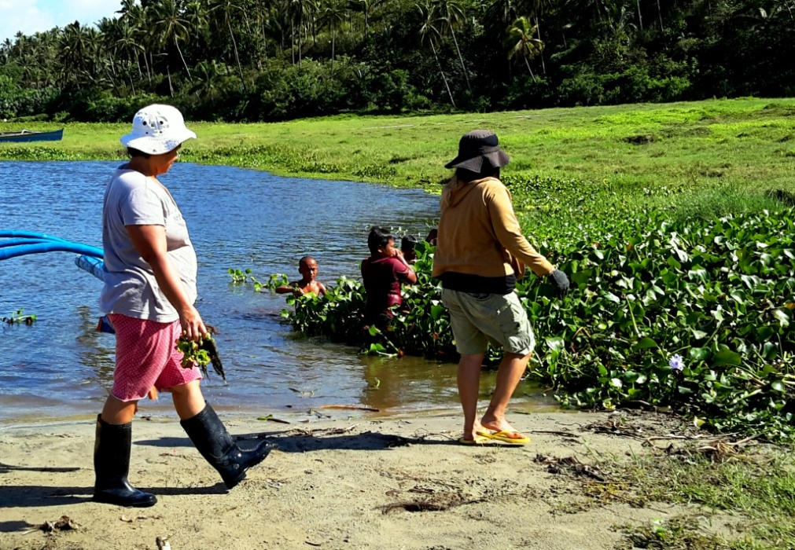
- Water lily traffic. Members of the Barangay E. Morgado Women’s Organization help clean-out water lilies that cause transportation delays and other problems to the residents along the river.

About TVI in the Philippines
TVI Resource Development Philippines Inc. (“TVIRD”), is the local affiliate of TVI Pacific Inc. (TSX: TVI), a publicly-listed Canadian mining company focused on the exploration, development and production of precious and base metals from district-scale, large-system, high-margin projects located in the Philippines. Concurrent ownership of ventures is shared with partner company, Prime Resource Holdings Inc.

The commercial operations of Agata Mining Ventures Inc. (AMVI) marks the third successful mining project that TVIRD brought on-stream in the past 10 years. The company is committed to exploration and mining practices that promote transparency, responsible stewardship of the environment, and the inalienable rights to life, dignity, and sustainable development of its host communities.
www.tviphilippines.com

Contact:

Kaycee Crisostomo
Corporate Communications Director
TVI Resource Development Philippines Inc.

Email: kaycee.crisostomo@tvipacific.com.ph
Phone: +63 2 728-8491 ext. 103
Mobile: +63 917 579-1528
Fax: +63 2 728-8515

