N E W S R E L E A S E

Agata Gives Tubay WYC Sportsfest a Hand-up
AMVI supports yearly event to advance public health and youth development

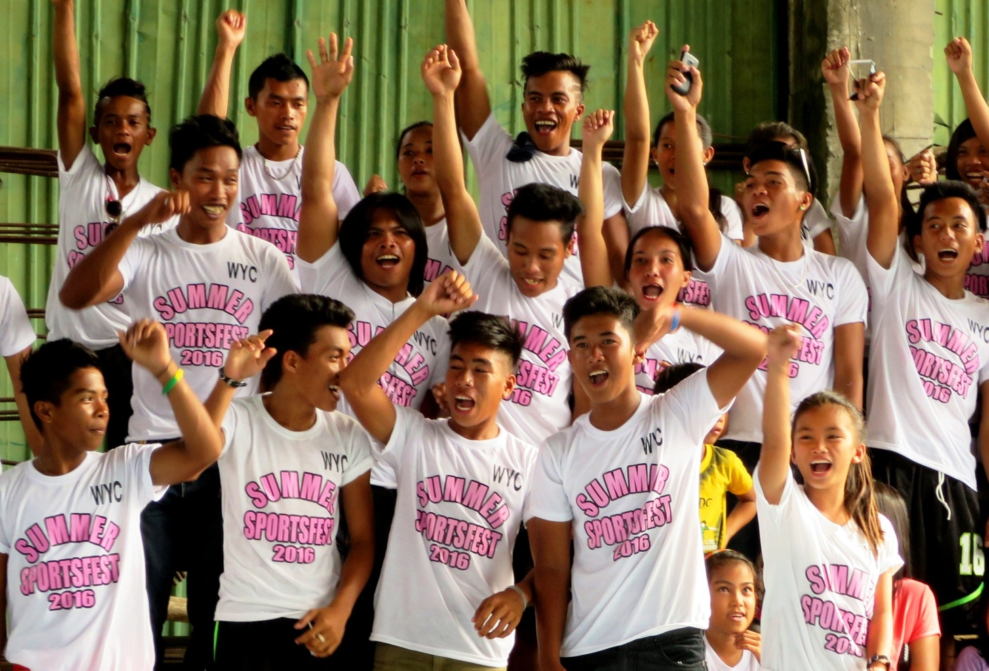
Young Tubaynons come together to cheer for their respective barangays at the 2016 WYC Sportsfest sponsored by Agata Mining.

Tubay, Agusan del Norte / (April) 2016 – In a successful bid to promote a healthy community and a vibrant youth, TVIRD’s Agata Mining Ventures Incorporated (AMVI), proudly supported Tubay Municipality’s Working Youth Club (WYC) Sportsfest 2016 last April 11 to 15. The company assumed a major sponsorship, which further cemented its commitment towards its health and youth development programs within and beyond its host communities.

The WYC Sportsfest is a yearly summer event initiated some five years ago by then Tubay Mayor Sadeka Tomaneng-Garcia, who is a committed youth leader herself and founder of the federation. During her message as guest of honor, she declared that, “this should be a reminder of the youth’s role in community-building – being the most active, creative and capable working sector.”

The WYC is a federation of youth organizations from Tubay’s 13 barangays. Since its inception, the WYC Sportsfest has fostered unity and camaraderie amongst Tubaynons, especially among its next generation of constituents.

Partners in development
The event opened with a parade that culminated in a gathering in the New Tubay Gym where the main program was held. This was followed by the sportsfest led by current WYC Federation President Raquim D. Cuyos who welcomed showed his appreciation for the youth who organized the event.

“The valuable role of youth in building the future of the community is more than just having fun. We believe that unity, responsibility and sportsmanship are potent ingredients that make our WYC worthy, (And) it is with great pride and gratefulness that AMVI shares the same virtue in sustaining our yearly activity through their support,” said Cuyos in his opening remarks. Aside from its sponsorship, AMVI also provided prizes for the nine different sports events, the modern dance contest and for the Ms. Teen Tubay pageant.

AMVI has supported the WYC Federation for three consecutive years. Community members are active participants of the yearly event, which has elevated the youth’s morale to be productive and responsible citizens. It has also cultivated a competitive spirit, sportsmanship and a healthy, socially-active consciousness far away from dangerous vices and delinquency.

“There are more than 1,000 out-of-school youths who are actively participating in the WYC Federation. Among these are our host communities: Barangays Binuangan, Tinigbasan, Lawigan, and Tagpangahoy,” said AMVI Community Relations Manager Andre Bon Clarabal.

Health and youth development
Since the roll-out of its health and sanitation programs, AMVI has conducted various humanitarian missions for the benefit of both its host communities and the urban poor in the provincial capitol of Butuan. AMVI’s most recent mission benefited close to 800 participants in Tubay’s coastal barangays – majority of who were children. The town’s constituents availed of free medical and dental consultations, check-ups, medicines and tooth extractions.

In addition to medicines, the mission also provided vaccines, antibiotics, vitamins and dental supplies as part of its Social Development and Management Program (SDMP).

To date, AMVI has initiated and supported various activities and programs that promote health and wellness. Last year, the company supported the Philippine Drug Enforcement Agency’s (PDEA) Drug Control and Prevention Month – which promotes the agency’s drug-free program for high school students. It likewise supported the National Food Authority’s (NFA’s) Food Guardian Campaign through its conservation rice and making it accessible, available, affordable and safe for consumers.

*******

Press photos:

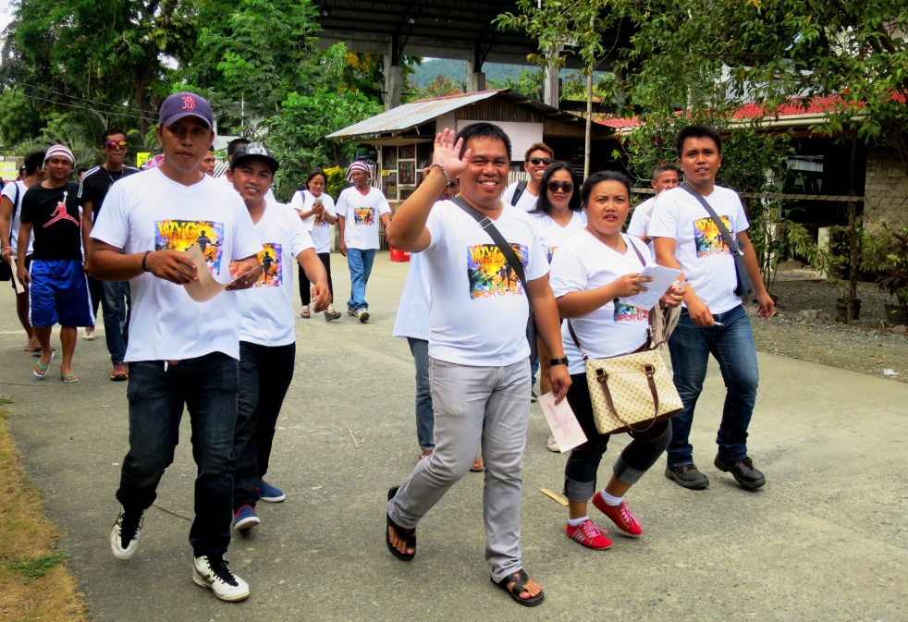
- Victory march. WYC Federation Chairman Hon. Raquim Cuyos waives his hands as he joins fellow youth leaders in the WYC Sportsfest Opening Day.

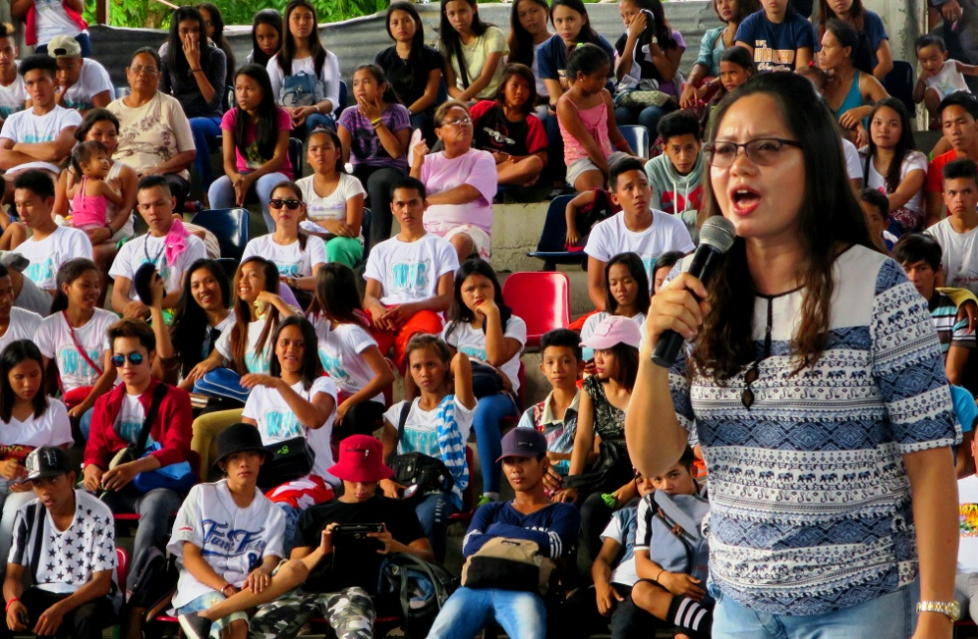
- She started it all. Former Tubay Mayor and current Provincial Board Member Sadeka Tomaneng-Garcia inspires the youth once more – young Tubaynons who are the town’s future.

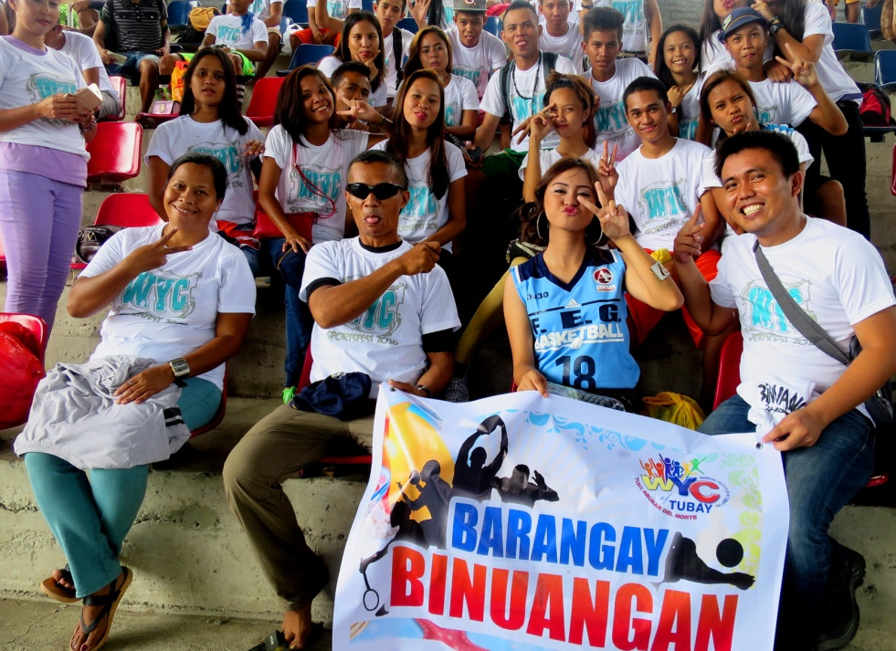
- Fun times. Barangay Binuangan youth members and community leaders expressed their excitement in being part of the WYC Sportsfest. They are joined by their adviser, AMVI Safety Officer Jimmy Ceballos.

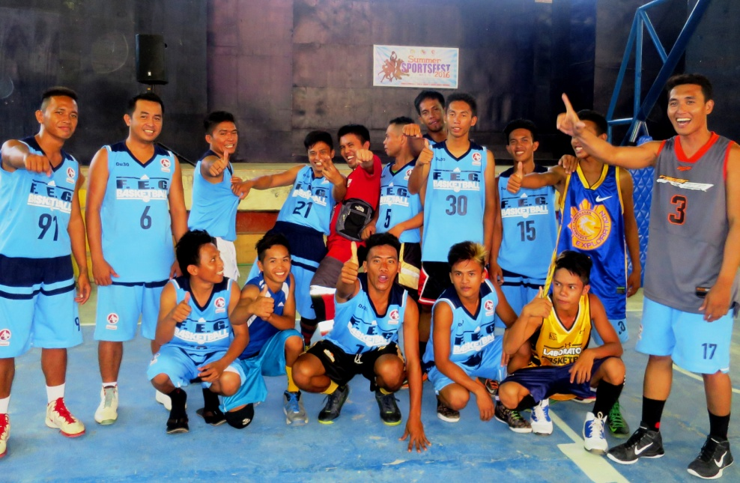
- Five-time champion, Barangay Binuangan, show their game faces before proving their mettle on the hard court this year.

About TVI in the Philippines
TVI Resource Development Philippines Inc. (“TVIRD”), is the local affiliate of TVI Pacific Inc. (TSX: TVI), a publicly-listed Canadian mining company focused on the exploration, development and production of precious and base metals from district-scale, large-system, high-margin projects located in the Philippines. Concurrent ownership of ventures is shared with partner company, Prime Resource Holdings Inc.

The commercial operations of Agata Mining Ventures Inc. (AMVI) marks the third successful mining project that TVIRD brought on-stream in the past 10 years. The company is committed to exploration and mining practices that promote transparency, responsible stewardship of the environment, and the inalienable rights to life, dignity, and sustainable development of its host communities.
www.tviphilippines.com

Contact:

Kaycee Crisostomo
Corporate Communications Director
TVI Resource Development Philippines Inc.

Email: kaycee.crisostomo@tvipacific.com.ph
Phone: +63 2 728-8491 ext. 103
Mobile: +63 917 579-1528
Fax: +63 2 728-8515

