N E W S R E L E A S E

Fellowship and Solidarity
Mark Earth Hour 2016 in Agata
AMVI joins the commemoration Earth Hour – a global movement to mitigate climate change
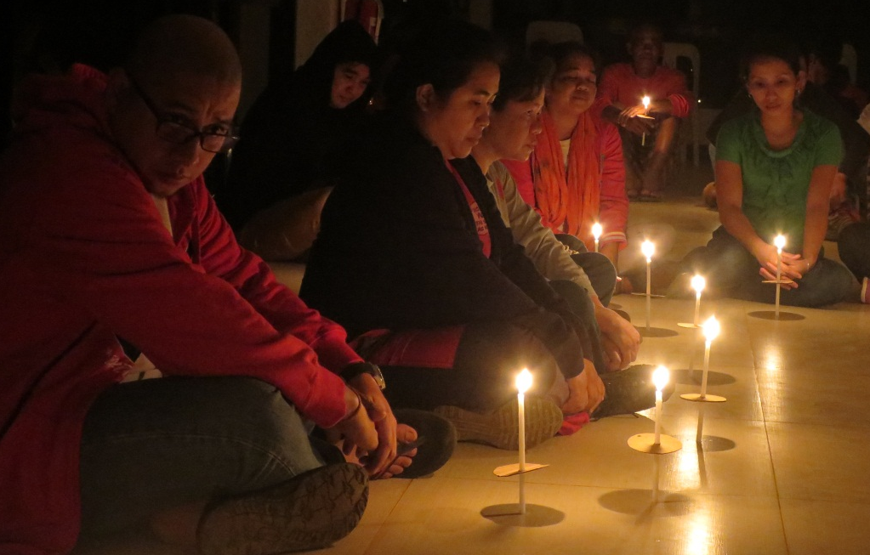
A candle for Mother Earth. AMVI Assistant Manager Anthony B. Quijano (extreme left), together with AMVI workers, sits on the floor as Earth Hour commences.

Tubay, Agusan del Norte / March 2016 – In light of the damaging effects of climate change and the heightened awareness towards the ecology, TVIRD’s Agata Mining Ventures Inc. (AMVI) joins millions worldwide in the commemoration of Earth Hour 2016 – a global movement aimed at resource conservation. AMVI key officers and staff gathered for a “lights-out” ceremony at the company’s Tubay mine site last March 19 to express their solidarity as well as to foster fellowship and unity in delivering a common environmental commitment.

The activity was opened by a bonfire at the company’s recreation area, signalling the shut-down of all electrical lighting equipment on site. AMVI Environment Manager Jessalyn Guinguing led the candle-lighting ceremony and delivered a presentation on the rationale of Earth Hour and on-going environmental awareness campaigns.

All the departments offered various “serenades for mother nature” while messages from the AMVI Assistant Manager Anthony B. Quijano underscored the importance of each one’s role towards responsible mining even in its simplest ways – and not just during Earth Hour.

Earth Hour originated from Sydney, Australia in 2007 and is now observed in 172 countries. Its proponents continue to campaign for the reduction of carbon emission and for the conservation of energy.

Continued observance
The event was the second observance of Earth Hour at the Agata Nickel Project since TVIRD brought operations on stream in 2014. Earlier, at the height of its copper and zinc operations in Zamboanga del Norte, TVIRD and the Indigenous Subanon people in Canatuan showed their solidarity in switching-off their electrical lights and joining the movement against the threat of global warming.

The solidarity in the tiny Subanon village for an hour-long symbolic show of support was also a testament of the common commitment to conserve the Earth’s natural resources.

Activities like these that are geared towards raising both awareness and commitment further established TVIRD at the forefront of environmental protection and in upholding the safety, health and rights of its employees and host communities.

Greener than before
Before TVIRD’s entry, Canatuan was a haven for illegal miners who flocked to the gold-rush area in the mid 90’s. Rampant cutting of trees denuded its forest while Lituban and Siocon rivers, two of Siocon town’s biggest rivers, were heavily contaminated with mercury and toxic chemicals.

Canatuan is different from what it was years ago. There are now lines of trees standing where un-engineered tunnels and waste dumps were previously operated by illegal miners. Through its massive environmental clean-up activities and progressive rehabilitation program, TVIRD planted over 400 thousand trees prior to concluding its operations in Canatuan. This number is five times more than the number of trees affected by TVIRD’s operations during its operations.

This is the same successful model that the company established in Agata when it first explored the area – the same model that delivers a commitment to care for natural environment of Tubay, Jabonga and Santiago Municipalities that host AMVI’s operations.

*******

Press photos:

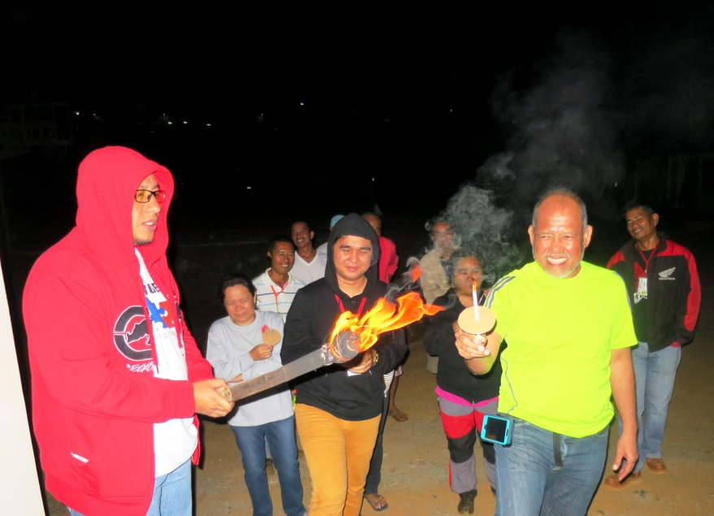
- AMVI Assistant Manager Anthony B. Quijano (Left) shares the flame of the torch – a symbol for sharing environmental awareness to other colleagues.

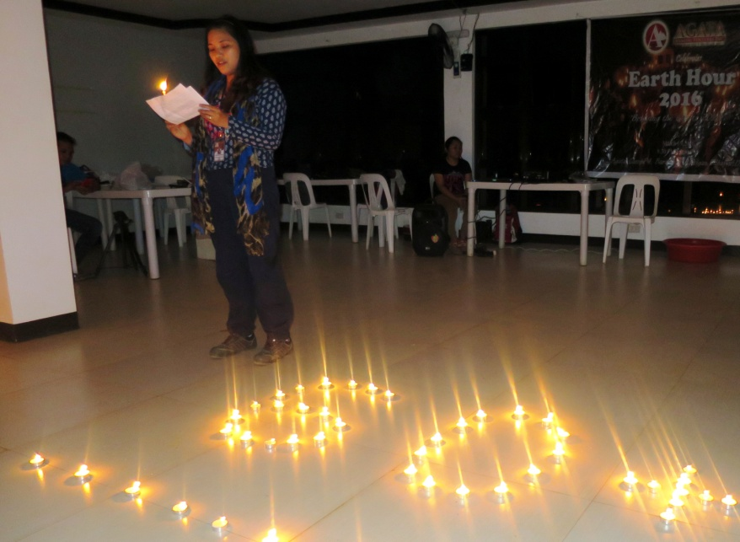
- Environment Manager Jessalyn Guinguing delivers the rationale of the Earth Hour event as candles forms the symbolic icon of the movement.

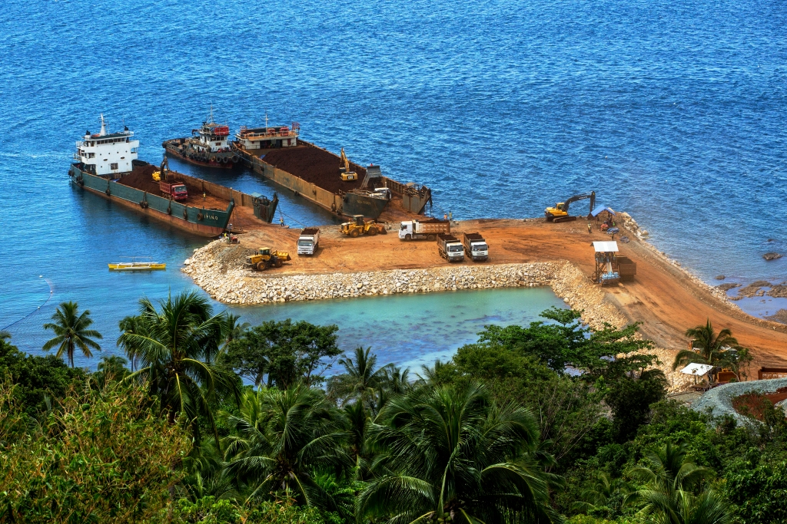
- A balanced ecology. Ongoing reforestation activities, which has planted and grown over 150,000 trees at the Agata Nickel Laterite DSO Project, offsets the areas affected by mining activities. (In photo): Indigenous trees thrive right above the Agata Causeway in Tubay, Agusan del Norte.

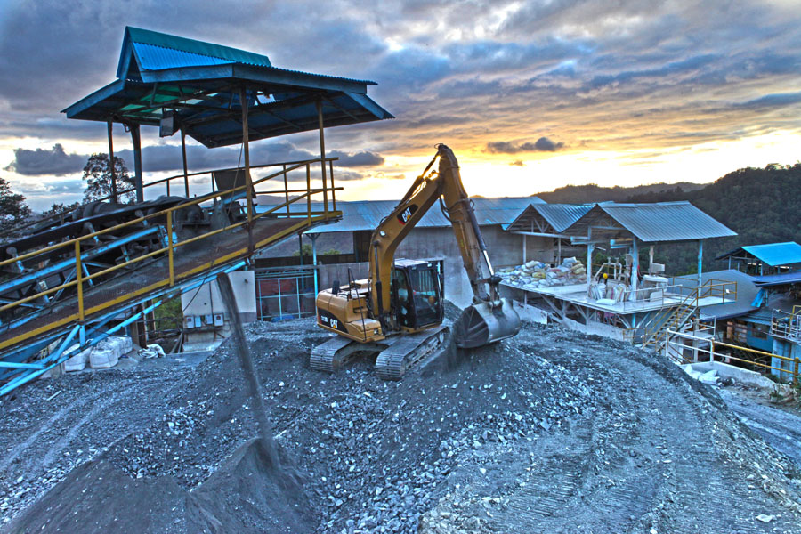
- Operational efficiency. TVIRD’s Canatuan plant processed a total mill feed of close to 1 million tons in 2012. Save for the processing plant, the company shut-off its energy consumption during Earth Hour, joining millions worldwide in commemorating the event.

About TVI in the Philippines
TVI Resource Development Philippines Inc. (“TVIRD”), is the local affiliate of TVI Pacific Inc. (TSX: TVI), a publicly-listed Canadian mining company focused on the exploration, development and production of precious and base metals from district-scale, large-system, high-margin projects located in the Philippines. Concurrent ownership of ventures is shared with partner company, Prime Resource Holdings Inc.

The commercial operations of Agata Mining Ventures Inc. (AMVI) marks the third successful mining project that TVIRD brought on-stream in the past 10 years. The company is committed to exploration and mining practices that promote transparency, responsible stewardship of the environment, and the inalienable rights to life, dignity, and sustainable development of its host communities.
www.tviphilippines.com

Contact:

Kaycee Crisostomo
Corporate Communications Director
TVI Resource Development Philippines Inc.

Email: kaycee.crisostomo@tvipacific.com.ph
Phone: +63 2 728-8491 ext. 103
Mobile: +63 917 579-1528
Fax: +63 2 728-8515

