N E W S R E L E A S E

International Women’s Day:
A Celebration of Empowerment in Agata Communities

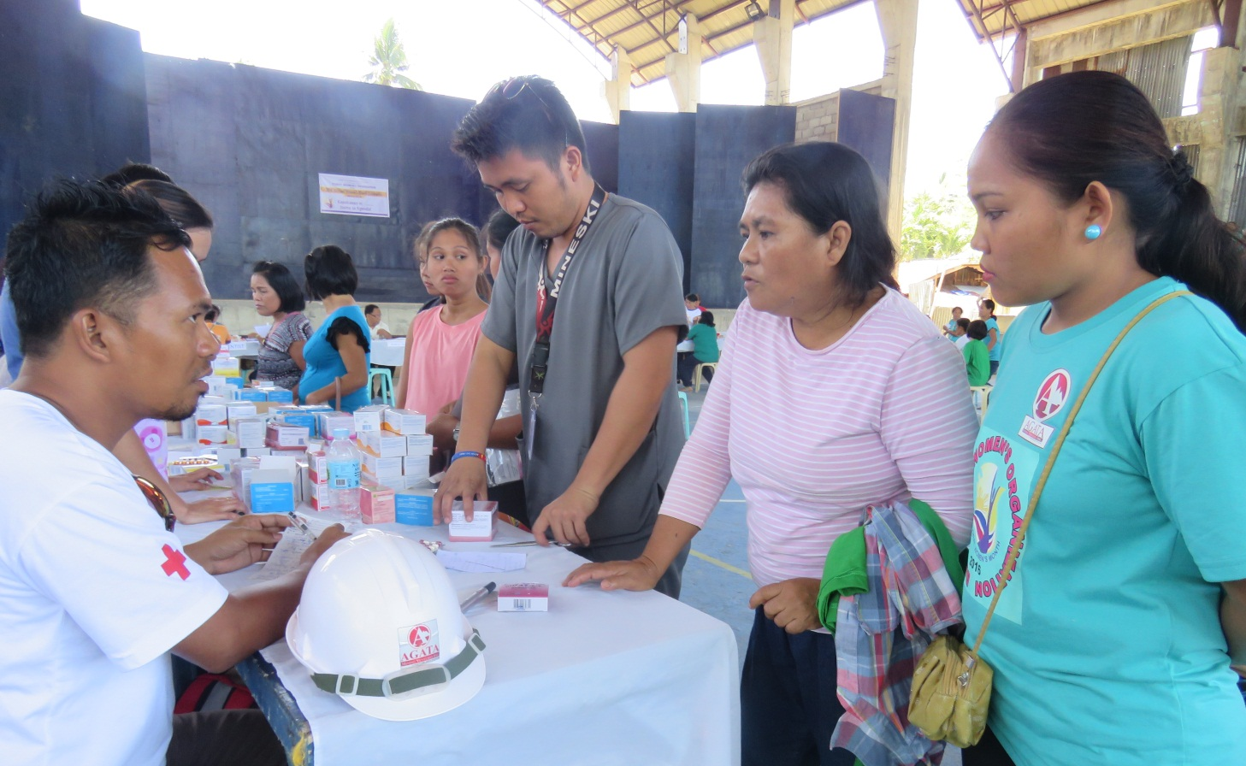
Giving communities a hand. Agata staff receive prescriptions and dispense medicines to patients who are member-beneficiaries of the company’s adopted communities in Tubay Municipality.

Tubay, Agusan del Norte / March 2016 – Agata Mining Ventures Inc. (AMVI), a joint venture project of TVI Resource Development Inc. (TVIRD) in Tubay Municipality, Agusan del Norte Province, commemorated International Women’s Day this year by highlighting their own empowered women in society and in the communities it serves. Adding more significance to the event last March 10 was the presence and active participation of Provincial Board Member and women’s welfare advocate, Sadeka Garcia-Tomaneng, who delivered a strong message invoking the essential role of empowered women in social development – and not just simply “domestic material.”

AMVI likewise provided its adopted barangay members with shirts during the latter’s parade, which was participated by 19 women’s organizations. A short program was held at the new Tubay Social Hall, gathering the organizations led by Tubay Womens Federation (TWF) President, Mrs. Fe Delia S. Garcia – wife of incumbent town mayor, Fidel Garcia – after which a volleyball tournament among the organizations was held at the adjacent park.

Medical missions
In line with AMVI’s health and sanitation program, the company conducted a medical outreach activity following the formal program. AMVI’s medical team members Jimmy Ceballos and Tyron Salas facilitated the distribution of prescribed medicines to more than 300 patients in the community during the activity, which merited the support and participation of medical staff consisting of four nurses from the Tubay Rural Health Unit, 10 other nurses from the CARAGA Department of Health, eight medical doctors, a dentist, a sanitary inspector and other medtech staff – all headed by Mrs. Janet Dela Cena, RN.

The medical team was also assisted by volunteer barangay health workers for the duration of the outreach program, which is the second successful medical mission conducted by AMVI for the year.

Earlier in January, AMVI conducted the first of its humanitarian missions for the benefit of the company’s host communities in Tubay, particularly in the coastal barangays of Lawigan, Tinigbasan, Tagpangahoy and Binuangan. In addition to medical services, and upon the request of community members, the company added a dental component to the mission.

Beginning in 2014, AMVI rolled-out several medical missions as part of its health and sanitation program – a number of which were in support of its media partners in Butuan and which were the largest humanitarian missions in the CARAGA Region.

In January this year, the AMVI medical mission was complemented with additional dental services; thus expanding the reach of donated medicines from mission partner, Sociedad Española de Beneficencia Inc. (SEB-Manila), a charitable institution dedicated to the care of both Spanish and Filipino indigents in the country. The mission benefited close to 800 participants who availed of free medical and dental consultations, check-ups, medicines and tooth extractions.

A good track record
The common health issues addressed by AMVI’s mission include urinary tract infection, hypertension, acute respiratory infection, upper respiratory tract infection, muscle spasms, skin diseases, arthritis and various gastro-intestinal problems along with a considerable number of cases of tooth decay.

In addition to medicines, SEB-Manila also provided vaccines, antibiotics and vitamins while AMVI procured the necessary dental supplies as part of its Social Development and Management Program (SDMP). Following the success of the mission, the company is likewise planning a similar activity for host inland and riverside barangays this year.

To date, AMVI has initiated and supported various activities and programs that promote health and wellness for various communities. Last year, the company supported the Philippine Drug Enforcement Agency’s (PDEA) Drug Control and Prevention Month – which promotes the agency’s drug-free program for high school students. It likewise supported the National Food Authority’s (NFA’s) Food Guardian Campaign through its conservation of rice and making it accessible, available, affordable and safe for consumers.

AMVI also supported RMN and Bombo Radyo as well as Mindanao Centro Daily on each of their respective medical missions in Butuan City – which provided healthcare to a combined 3,000 participants in the region.

*******

Press photos:

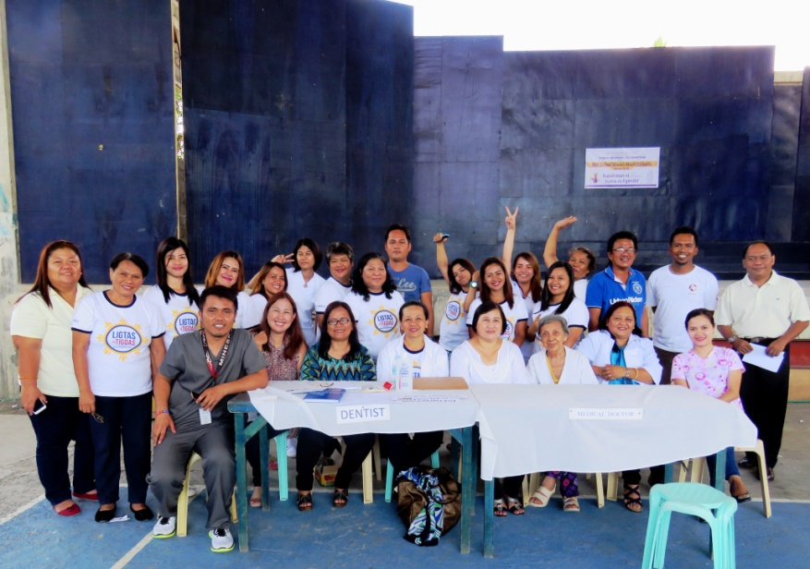
- Well done. The medical outreach team: doctors, dentists, nurses, medtechs and barangay health workers gather with the AMVI medical team at the tail-end of the event.
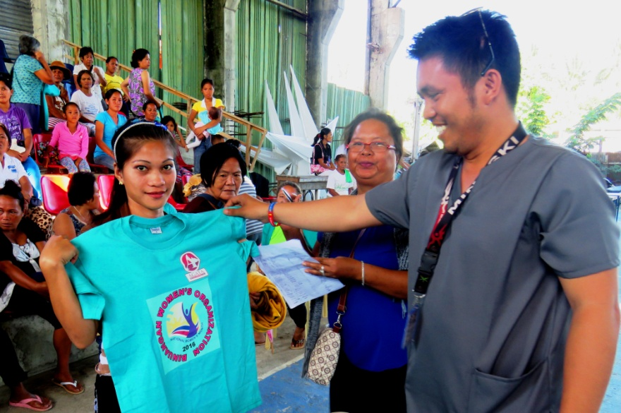
- Specially-prepared shirts were provided by Agata to Barangay Binuangan, Lawigan, and Tagpangahoy women’s organizations.

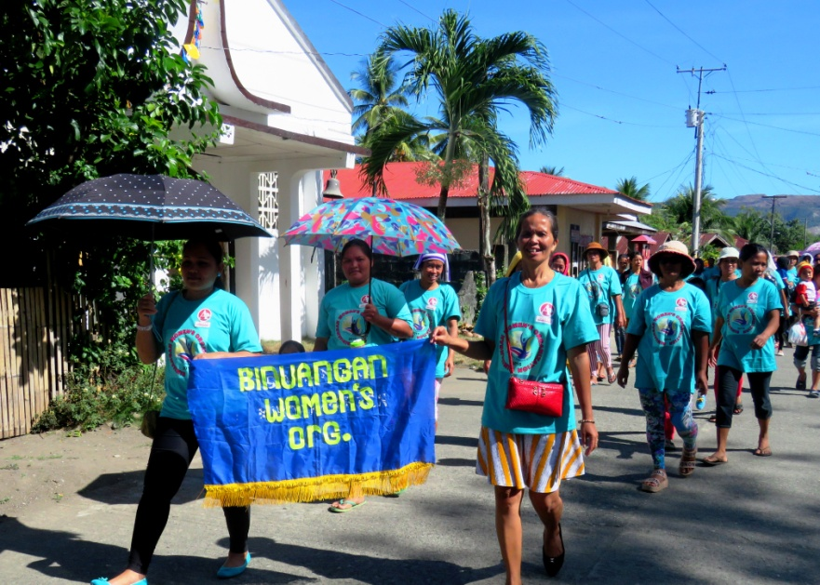
- Walking with pride. The Binuangan Women’s Organization takes their participation to the streets during the parade around town.

About TVI in the Philippines
TVI Resource Development Philippines Inc. (“TVIRD”), is the local affiliate of TVI Pacific Inc. (TSX: TVI), a publicly-listed Canadian mining company focused on the exploration, development and production of precious and base metals from district-scale, large-system, high-margin projects located in the Philippines. Concurrent ownership of ventures is shared with partner company, Prime Resource Holdings Inc.

The commercial operations of Agata Mining Ventures Inc. (AMVI) marks the third successful mining project that TVIRD brought on-stream in the past 10 years. The company is committed to exploration and mining practices that promote transparency, responsible stewardship of the environment, and the inalienable rights to life, dignity, and sustainable development of its host communities.
www.tviphilippines.com

Contact:

Kaycee Crisostomo
Corporate Communications Director
TVI Resource Development Philippines Inc.

Email: kaycee.crisostomo@tvipacific.com.ph
Phone: +63 2 728-8491 ext. 103
Mobile: +63 917 579-1528
Fax: +63 2 728-8515

