N E W S R E L E A S E

Agata Marks Significant First:
Receives PMIEA Titanium Award on Year One
Agata Mining Ventures Inc. is this year’s PMIEA Titanium Awardee

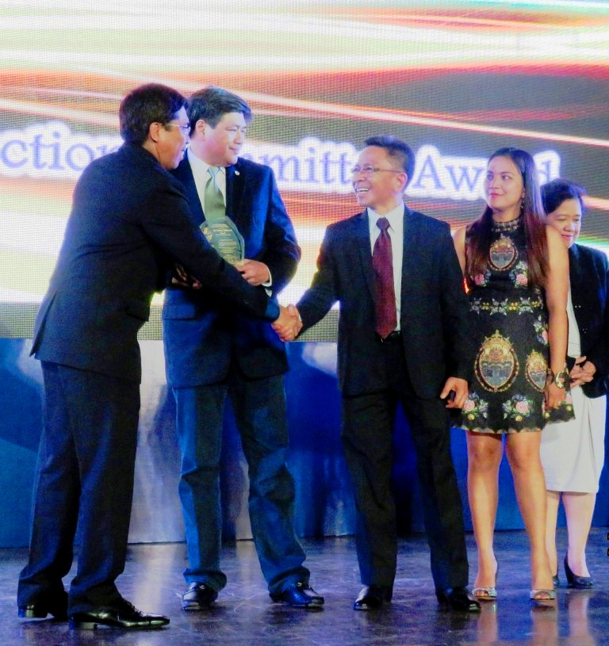
From the chief. DENR Mines and Geosciences Bureau Director Leo Jasareno (left) congratulates AMVI General Manager Rufo Cabanlig for being the first mining company presented with the PMIEA Titanium Award on its first year of mining operations. Joining them on stage are Agata President and TVIRD Board Member Michael Regino and Environment Manager Jesalyn Guingguing.

Baguio City / December 2015 – Agata Mining Ventures Inc. (AMVI) was recently conferred a Titanium Award – the first for a Philippine mining company that has been operating for one year – and an exceptional recognition for the successful implementation of its approved Environment Protection and Enhancement Program (EPEP), Social Development and Management Program (SDMP) and its ongoing Occupational Health and Safety Program that clocked-in 2 million safe man hours. This is testament to its zero tolerance for accidents and constant improvement of work and safety standards for both employees and the community, especially for its host Mamanwa and Manobo indigenous tribes. AMVI is a joint venture of MRL Nickel Philippines Inc. (MRL) and TVI Resources Development Philippines Inc. (TVIRD), which operates the Agata Nickel Project.

AMVI’s Titanium Award comes as an integral recognition from the Philippine Mine Safety and Environment Association (PMSEA) during the organization’s recently-concluded Philippine Mineral Industry and Environmental Awards (PMIEA) at the CAP Conference Center in Baguio City.

Held yearly in the City of Pines, the PMIEA comes on the heels of the 62nd Annual National Mine Safety and Environment Conference (ANMSEC) – the industry summit that is said to have gathered over 2,000 participants from both here and abroad in its most recent run. It likewise ran parallel to the Asia Pacific Economic Congress (APEC) and supports the Philippines’ initiative to promote employment, livelihood and address environmental concerns.

A record-breaking achievement
For the first time in ANMSEC history, a mining company received a Titanium Award during its first year of operations. Gaining this recognition has added more significance to AMVI’s operational track record as well as validates the sustainability of both its environment and social programs.

The company’s record-breaking achievement is also one of a kind, especially when considering the speed at which AMVI developed the Agata Nickel Project. After commencing construction in the first quarter of 2014, the company established mine and access roads as well as other mining facilities that will enable it to bring operations on-stream, including a private port and causeway from which it can ship to direct markets in Asia.

In October 2014, the company cast-off its first successfully-loaded vessel from the Agata private port – its maiden shipment only a mere six months after beginning construction. As lead operator, TVIRD has likewise positioned itself among the ranks of major nickel producers in the country through its nickel laterite direct shipping ore (DSO) operations and planned future nickel processing activities at the Agata Mining Project.

This rapid development also validates AMVI’s entrepreneurial freedom, its sustainable roadmap and its strong adherence to laws and regulations of the Philippine mining industry. AMVI’s workforce is likewise a diverse mix of dedicated skilled workers and professionals who keep the company equally-focused on occupational health and safety, social development, environmental protection and conservation programs – thus paving the way that led-up to winning its Titanium Award and ultimately contributing to national development.

“This year, let us heed the call of our theme to be inclusive. Let us realize that by uniting our efforts to improve our impact areas with relevant development that are aligned to the country’s development agenda we can send a tangible message to the leaders of our country that we are deeply concerned with the welfare of the Philippines as a whole – that the industry is true to its potential and is worth supporting,” said PMSEA President Louie Sarmiento, citing the various achievements of the industry in upholding its development goals.

Setting the standards
Prior to its operations, AMVI was the first mining company to conduct a coral relocation project before constructing its port facilities. Following this, the DENR recognized AMVI for the successful implementation of its Coastal Resource Management Program (CRMP) during the agency’s 27th anniversary celebration in June 2014. AMVI’s CRMP also includes the protection of two marine sanctuaries in coordination with the local farmers and fisher-folks associations and the local government unit of Tubay Municipality, which hosts its operations.

Another distinction that AMVI shares with another Philippine mining company is its Community Royalty Development Plan (CRDP), which is duly approved by the National Commission on Indigenous People (NCIP). The CRDP is crafted on the basis of pursuing a common development roadmap and underscores the overall sustainability of the company’s indigenous host communities. To date, the company employs nearly 800 people – making it one of the major employers in the municipality

The Agata Nickel Project is located in Agusan del Norte Province and is situated within the CARAGA mining region, which along with Surigao, has been a major supplier of nickel ore to processing plants in Australia, China, Korea and Japan. The commercial operations at Agata marks the third project that TVIRD has successfully brought on-stream in a period of 10 years.

AMVI follows the TVIRD tradition of excellence in developing sustainable programs for both the community and the environment. At the height of TVIRD’s operations, the company was successively recognized “Best of the Best” among the recipients of the Presidential Mineral Industry Environmental Awards. It was likewise proclaimed the most-awarded metal miner by the same organization in recent years.

*******
Press photos:

- Hope springs. Children of Barangay Tinigbasan enjoy the constant availability of clean water in their community – one of several key infrastructure projects supported by AMVI’s SDMP for the benefit of its host communities.

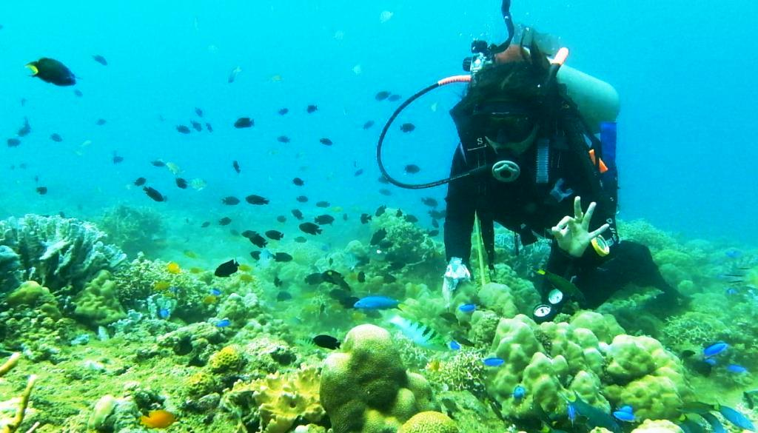
- Coral relocation. AMVI Environment Manager Jesalyn Guingguing flashes an OK sign, signifying the healthy condition of relocated corals within the marine sanctuary of Barangay Tinigbasan where AMVI’s private port is located.

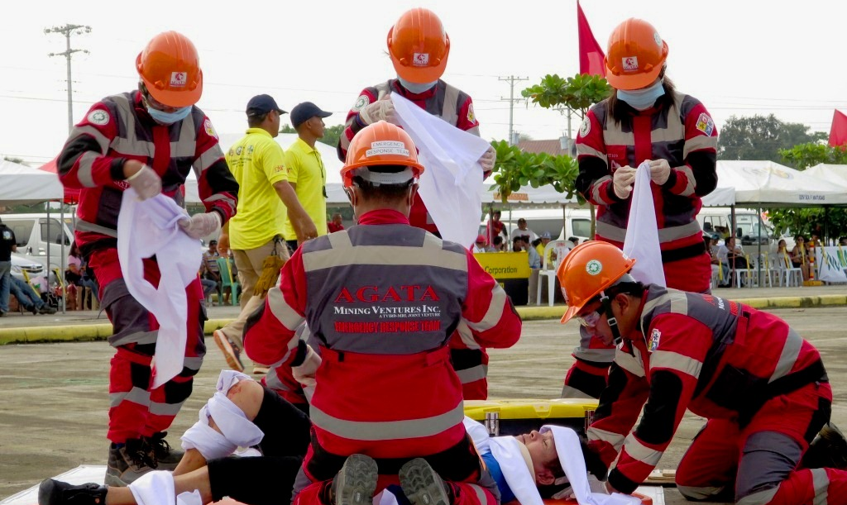
- Safety First. The Agata Emergency Response Team competes in a simulated emergency response scenario during the 3rd CARAGA Mining Symposium and Safety Competition in Gaisano Mall Parking Lot in Surigao City.

- Early flight. (In photo): An egret is seen taking-off beside a young indigenous tree along Kalinawan River’s adopted area. Migratory egrets come to Kalinawan to feed in its rich natural environment that is abundant with various river species.

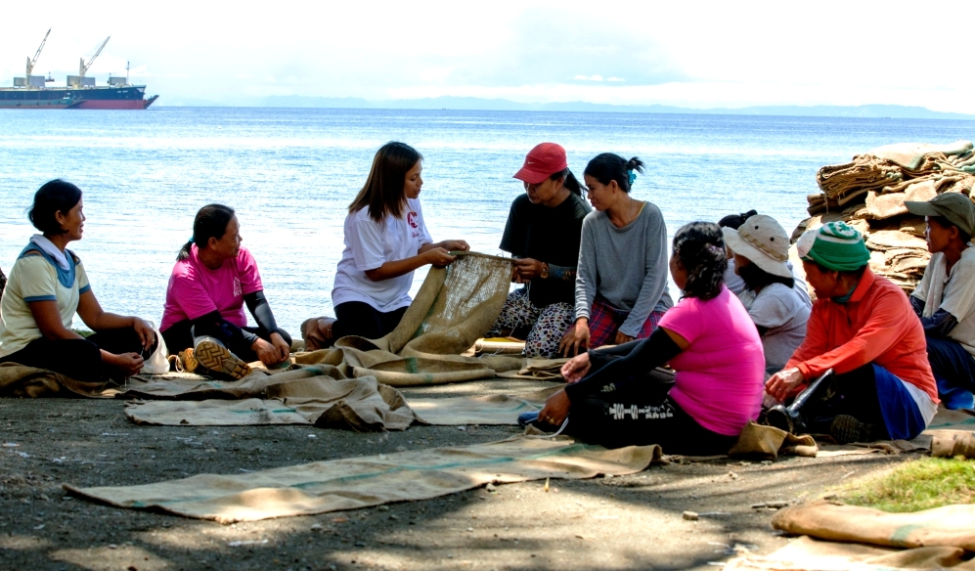
- Women’s livelihood for the environment. AMVI engages women from Sitio Payong-Payong in weaving coco nets used for environmental protection. These nets are made into “silt curtains” that prevent siltation from spilling from the company’s causeway into the ocean.

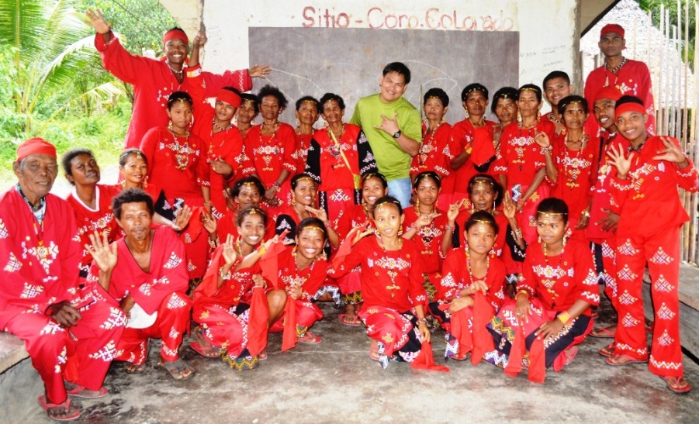
- Preserving indigenous culture. AMVI Engineering Manager Hilario Gingo shares a light moment with IP Coro Sector council members. AMVI’s Engineering department has built several community infrastructures to benefit its IP hosts – which has been accelerated by its CRDP.

About TVI in the Philippines
TVI Resource Development Philippines Inc. (“TVIRD”), is the local affiliate of TVI Pacific Inc. (TSX: TVI), a publicly-listed Canadian mining company focused on the exploration, development and production of precious and base metals from district-scale, large-system, high-margin projects located in the Philippines. Concurrent ownership of ventures is shared with partner company, Prime Resource Holdings Inc.

The commercial operations of Agata Mining Ventures Inc. (AMVI) marks the third successful mining project that TVIRD brought on-stream in the past 10 years. The company is committed to exploration and mining practices that promote transparency, responsible stewardship of the environment, and the inalienable rights to life, dignity, and sustainable development of its host communities.
www.tviphilippines.com

Contact:

Kaycee Crisostomo
Corporate Communications Director
TVI Resource Development Philippines Inc.

Email: kaycee.crisostomo@tvipacific.com.ph
Phone: +63 2 728-8491 ext. 103
Mobile: +63 917 579-1528
Fax: +63 2 728-8515

