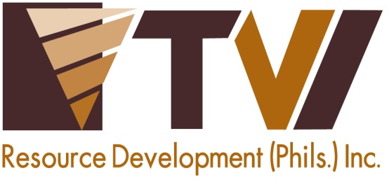
N E W S R E L E A S E

Agata Ushers Overall Sustainability of
Indigenous Host Communities
AMVI supports the continuous implementation of IP Community Royalty Development Plan (CRDP)

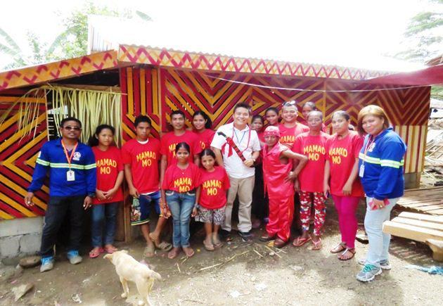
On the right track. AMVI Community Relations personnel join the Mamanwa Tribal Management Organization (MTMO) led by Chieftain Dakula Rico B. Ayrag during the inauguration of their new Tribal Hall made possible through the proper implementation of their CRDP.

Santiago, Agusan del Norte / October 2015 – Making good on its commitment for the welfare and development of its Indigenous host communities, Agata Mining Ventures Inc. (AMVI) collaborates with the National Commission on Indigenous People (NCIP) in ensuring the timely release of royalty shares to the Mamanwa and Manobo tribes while ensuring the proper implementation of its Community Royalty Development Plan (CRDP). Early this year, the Mamanwa and Manobo Ancestral Domain Management Organization (MAMADMO) – the rightful indigenous claimants at the Agata Nickel Project – was granted CRDP approval and the release of their first royalty shares, as witnessed by both AMVI and NCIP at the agency’s central office in Quezon City. The formal handover was presided by AMVI President Michael G. Regino and the four tribal chieftains. To date, AMVI released two royalty tranches: the first based on the company’s fourth quarter earnings in 2014 and the second based on the first quarter earnings of the current year.

CRDP accomplishments
AMVI sent its Community Relation officers to inspect physical CRDP accomplishments vis-à-vis Royalty Shares expenditures of each of its four IP host communities. Among these major accomplishments are: the construction of a new Tribal Hall for the Duyangan Sector, IP scholarship grants for the Mapaso Sector, hog raising livelihood for the Coro Sector, and medicines for members of the Agata Sector.

Major components of the CRDP focus on Infrastructures, Education, Health and Livelihood projects while minor components are mainly focused in supporting the Socio-Cultural Activities of the IP communities. Noting that malnutrition, lack of access to adequate health services and quality education, shortage of necessary community infrastructure and the absence of alternative livelihood opportunities present a big problem for IP communities, the CRDP runs parallel to AMVI’s Social Development and Management Program (SDMP) to specifically address the needs of its IP host communities.

“With the approval and the successful implementation of the CRDP in managing IP royal shares, AMVI hopes to slowly guide its indigenous host communities in attaining sustainable development in years to come,” said AMVI Community Development Officer Kahlil Tabernero at the end of the CRDP accomplishment inspection.

En route to development
As part of guiding its IP host communities through the proper implementation of their CRDP, AMVI also initiates regular audits of the accomplishments made by each of its four IP communities. The regular inspection helps to keep each IP community on track towards development and progress

“We are grateful that AMVI has not only kept its promise of releasing each of our corresponding royalty shares but continues to guide and teach us in properly making the CRDP our common roadmap towards the development for our people,” said Ayrag.

AMVI closely follows TVI Resource Development Philippines Inc. (TVIRD) – lead operator of the Agata Nickel Project – in its sustainable programs that successfully raised Siocon in Zamboanga del Norte from a fourth class to first class municipality. TVIRD has initiated several social development programs and partnered with organizations like Gawad Kalinga to help its host Subanons to build a proper community with individualized housing units at the height of its flagship project in Canatuan, Zamboanga del Norte.

AMVI is a joint venture between MRL Nickel Philippines Inc. (MRL) and TVIRD. The joint venture is currently moving forward with its nickel laterite direct shipping ore (DSO) operations for major markets in Asia.

“The company started as MRL then partnered with TVIRD in forming AMVI. Although several changes and transitions have been made through the years, we are glad that the promise of development through royalty shares made during MRL’s time had been passed and carried over to AMVI,” concluded Ayrag.

*******

Press photos:

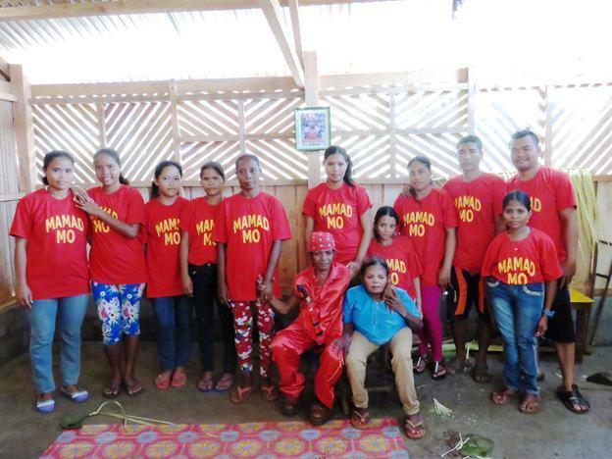
- The MAMADMO – MTMO members of Duyangan Sector led by Dakula Rico B. Ayrag (sitting, center) during their first gathering inside their new Tribal Hall.

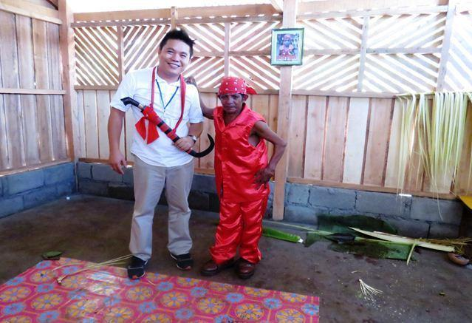
- AMVI Community Relations Superintendent Andre Bon Clarabal and Duyangan Sector Tribal Leader Dakula Rico B. Ayrag resonate a genuine partnership for development.

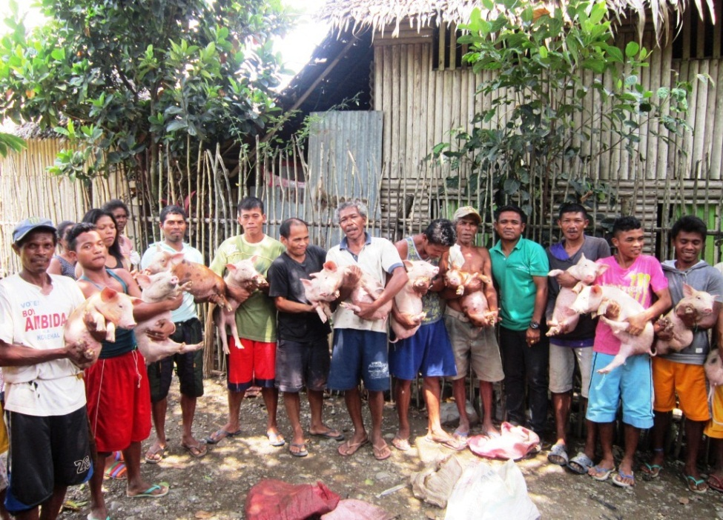
- Timely royalty shares enable the tribal community’s hog raising livelihood program, which is guided by AMVI and their CRDP.

About TVI in the Philippines
TVI Resource Development Philippines Inc. (“TVIRD”), is the local affiliate of TVI Pacific Inc. (TSX: TVI), a publicly-listed Canadian mining company focused on the exploration, development and production of precious and base metals from district-scale, large-system, high-margin projects located in the Philippines. Concurrent ownership of ventures is shared with partner company, Prime Resource Holdings Inc.

The commercial operations of Agata Mining Ventures Inc. (AMVI) marks the third successful mining project that TVIRD brought on-stream in the past 10 years. The company is committed to exploration and mining practices that promote transparency, responsible stewardship of the environment, and the inalienable rights to life, dignity, and sustainable development of its host communities.
www.tviphilippines.com

Contact:

Kaycee Crisostomo
Corporate Communications Director
TVI Resource Development Philippines Inc.

Email: kaycee.crisostomo@tvipacific.com.ph
Phone: +63 2 728-8491 ext. 103
Mobile: +63 917 579-1528
Fax: +63 2 728-8515

