N E W S R E L E A S E

Tubay’s Flight to Progress and Development
Supported by Agata Mining
AMVI supports the 68th founding anniversary of Tubay host municipality

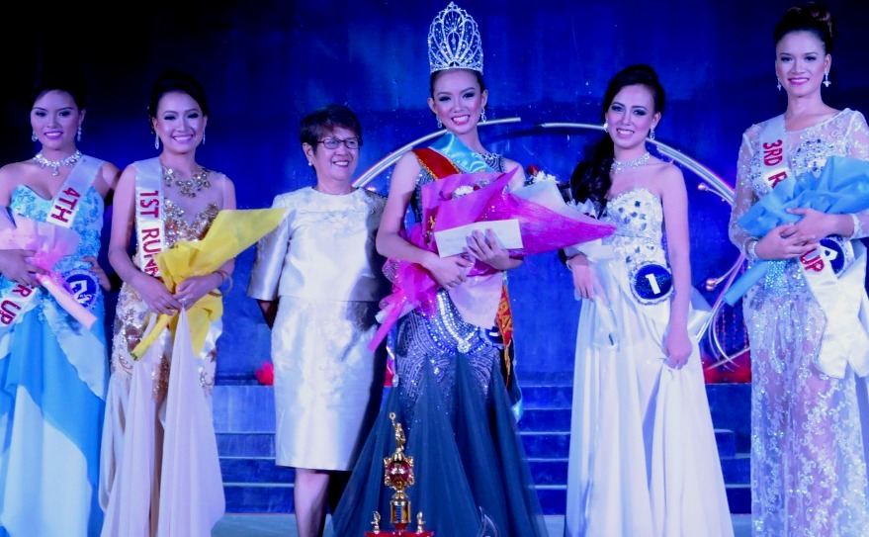
Ms. Tubay caps founding anniversary. Miss Tubay 2015 and AMVI’s new Goodwill Ambassador Gwyneth Amanda Yutiamco takes center stage with Tubay Women’s Federation (TWF) President Madam Fe Delia Garcia. She is joined by Miss Tubay runner-ups.

Tubay, Agusan Del Norte / October 2015 – Signifying its unrelenting support and partnership towards sustaining progress and development, Agata Mining Ventures Inc. (AMVI) joined the whole municipality of Tubay in its five-day 68th founding anniversary celebration – which culminated in the annual Miss Tubay beauty pageant last 19 October 2015 at the town’s social hall. The event was attended by members of the local community, led by Mayor Fidel E. Garcia Jr., his daughter and the former Mayor Sadeka Garcia Tomaneng, Agusan del Norte 2nd District Representative Congressman Erlpe John M. Amante and other local government officials from the neighboring cities of Cabadbaran and Butuan. As a major partner in the town’s economic development, AMVI likewise assumed major sponsorship and crowned Miss Tubay 2015 Gwyneth Amanda Yutiamco as its new Goodwill Ambassador for sustainable long-term progress and development.

“The presence and unwavering support of AMVI strengthens our endeavor to move forward and work together towards sustaining progress and development,” said Binibining Tubay Pageant Committee Chairperson Madam Fe Delia Garcia (wife Mayor Garcia) in her opening speech.

“They (AMVI) have initiated and partnered with us in launching several successful community and social development programs, trainings and medical missions and we hope to continue working together as partners in years to come,” she added.

Miss Tubay is organized by the Binibining Tubay Pageant Committee through the municipality’s Tourism Office and is likewise supported by public and private organizations, particularly the Department of Education (DepEd), as well as other sponsors. The five-day anniversary activities included a basketball tournament, inter-school cheerleading competition and a folk-and-ballroom dance competition among barangays, including the indigenous tribal community.

Goodwill advocate
Miss Tubay candidates represented the town’s various groups and organizations. As the roster was narrowed down to the top five candidates, scores and support poured-in from the local community that filled the town’s social hall to witness the event.

After winning majority of the awards, including Best in Evening gown and Miss Photogenic, 15-year old high school scholar Gwyneth Amanda Yutiamco from barangay Poblacion District One was crowned Miss Tubay 2015. Yutiamco speaks both Mandarin and English, and has recently travelled to China in pursuit of alternative studies. Her success is attributed to her confidence during the question and answer portion, during which she shared her enthusiasm in inspiring others to contribute towards the future of Tubay.

Yutiamco was also conferred the concurrent title of Agata Goodwill Ambassador by MRL Vice President Edsel Abrasaldo and will help foster unity and active engage with the community. She will likewise represent AMVI’s responsible mining practices, environmental protection programs and conservation efforts as well as social and community development programs.

Partners in progress
The annual foundation day celebration is one of Tubay’s several programs that is strongly supported by AMVI, which holds the bulk of its mining operations within the town – and which extends to neighboring Jabonga and Santiago municipalities that comprise its 4,779-hectare Mineral Processing Sharing Agreement (MPSA) area. Both Tubay and AMVI share a common development roadmap in harnessing its vast mineral resources and its dedicated human capital.

AMVI enhances economic activity in the area through direct employment and the generation of several livelihood programs specifically designed to the needs, resources and capabilities of its host communities. It likewise protects the environment and enhances the community by implementing the same successful social development model of TVI Resource Development Philippines Inc. (TVIRD) – lead operator of the Agata Nickel Project.

Moreover, both company and municipality continue to strengthen a partnership that dates back to the exploration days of MRL Nickel Philippines Inc. (MRL) – TVIRD’s partner in the joint venture. Both TVIRD and MRL are well-recognized by the DENR in the promotion of responsible mining practices in the Philippines.

*******

Press Photos:

- Congressman Erlpe John M. Amante and Bb. Tubay 2014 Mary Maritoni Catapang crown Gwyneth Amanda Yutiamco as the new Bb Tubay 2015 during the town’s 68th Founding Anniversary.

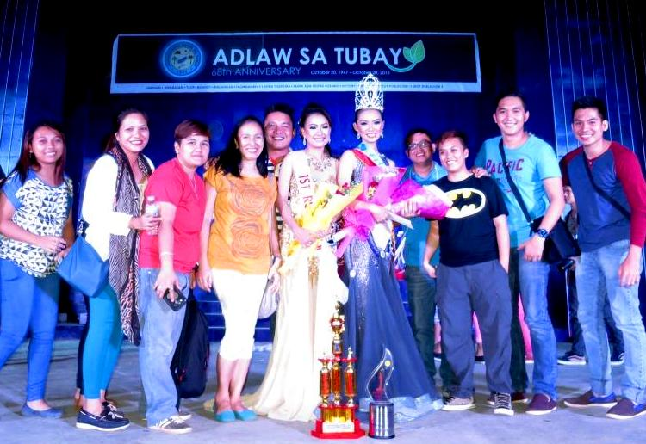
- AMVI Managers and Officers together with AMVI Goodwill Ambassador and Bb. Tubay 2015 Gwyneth Amanda Yutiamco in a group photo at the event’s conclusion.

About TVI Philippines
TVI Resource Development Philippines Inc. (“TVIRD”), is the local affiliate of TVI Pacific Inc. (TSX: TVI), a publicly-listed Canadian mining company focused on the exploration, development and production of precious and base metals from district-scale, large-system, high-margin projects located in the Philippines. Concurrent ownership of ventures is shared with partner company, Philippine Resource Holdings Inc.

TVIRD is committed to exploration and mining practices that promote transparency, responsible stewardship of the environment, and the inalienable rights to life, dignity, and sustainable development of its host communities.
www.tviphilippines.com

Contact:

KayceeCrisostomo
Corporate Communications Director
TVI Resource Development Philippines Inc.

Email: kaycee.crisostomo@tvipacific.com.ph
Phone: +63 2 728-8491 ext. 103
Mobile: +63 917 579-1528
Fax: +63 2 728-8515

