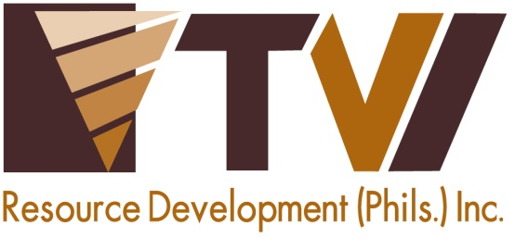
N E W S R E L E A S E

Agata Mining Clocks-in Two Million Safe Man Hours
AMVI Safety Department joins 3rd CARAGA Mining Symposium and Safety Competition

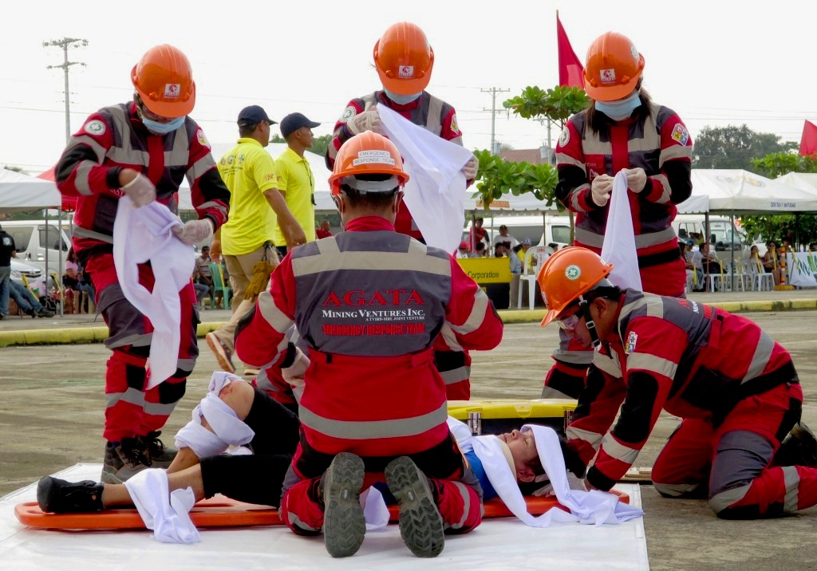
Safety First. The Agata Emergency Response Team competes in a simulated emergency response scenario during the 3rd CARAGA Mining Symposium and Safety Competition in Gaisano Mall Parking Lot in Surigao City.

Surigao City, Surigao del Norte / October 2015 – Since it commenced Direct Shipping Ore (DSO) operations in October last year, Agata Mining Ventures Inc. (AMVI) achieved 2 million safe man hours – testament to its constant improvement of work and safety standards for both employees and the community as well as its zero tolerance for accidents through its growing Safety Department. Highlighting this achievement, the company participated in the 3rd CARAGA Mining Symposium and Safety Competition last October 2 to test its mettle against its contemporaries in the Philippines mining industry.

The two-day event was held at Parkway Hotel in Surigao City, Surigao del Norte and was spearheaded by the Chamber of Mines of CARAGA Region Inc. (CMCRI), the CARAGA Mine Safety and Health Council (CMSHC) and in cooperation with the DENR’s Mines and Geosciences Bureau Regional Office XIII (MGB-RO 13). The gathering was participated by 32 Mining Companies operating in the Provinces as well as neighboring Surigao del Sur, Agusan del Norte and Agusan del Sur.

2 Million and counting
AMVI believes in prevention and mitigating – or in most cases, completely removing – anyone or anything that can be a potential risk. The company also implements programs and procedures to promote safety practices among all company employees, including the different communities within the company’s Mineral Processing Sharing Agreement (MPSA) area.

It maintains its “Zero Accident” record owing to superior safety practices it has acquired from joint-venture partners MRL Nickel Philippines and TVI Resource Development Philippines Inc. (TVIRD), which operates the Agata Nickel Project in Tubay, Santiago and Jabonga Municipalities. Both companies hold exceptional track records that are recognized for the successful implementation of their respective programs.

In the same grain, AMVI is actively pursuing continuous improvement in all areas of safety, health and environmental management – which paved the way for achieving 2 million accident-free work hours in its first year of operations.

Safety and Health Policy
By policy, AMVI operates under the proper stewardship and protection of human life and the environment. It implements preventive and technically-proven measures that surpass the minimum legal safety requirements. The company provides and ensures that employees wear adequate Personal Protective Equipment (PPE) that are part of standard issue work paraphernalia. And under no circumstances will the Safety Department allow employees to enter the mining area without the appropriate PPE.

“There are a lot of safety guidelines and procedures being implemented in every type of work. This includes commercial, public, residential and construction work, among others. Working in a mining company’s safety department is more challenging because you have all these components and each has a unique set of guidelines,” according to AMVI Safety Superintendent Aldrin Arieta.

He also explained that the specific guidelines for each component comprises the company’s safety handbook that AMVI constantly updates to cover changing scenarios, areas and responsibilities relating to each employee’s line of work.

“The attitude of an employee towards work is guided by their individual principle and behavior. To establish a safe environment, we continuously enforce safety practices among new and existing employees as well as administer disciplinary measures for non-compliance. The ultimate goal is create a culture of understanding that comes as second nature,” added Arieta.

AMVI also follows a set of General Safety Objectives which are aimed at promoting consciousness through an effective monitoring and investigation system. It strictly implements Safety and Health Rules and conducts regular training to comply with various government regulations.

This further ensures that the Emergency Response Team (ERT) is well equipped to support even the Local Government Units (LGUs) in the event of natural disasters and calamities.

*******

Press photos:

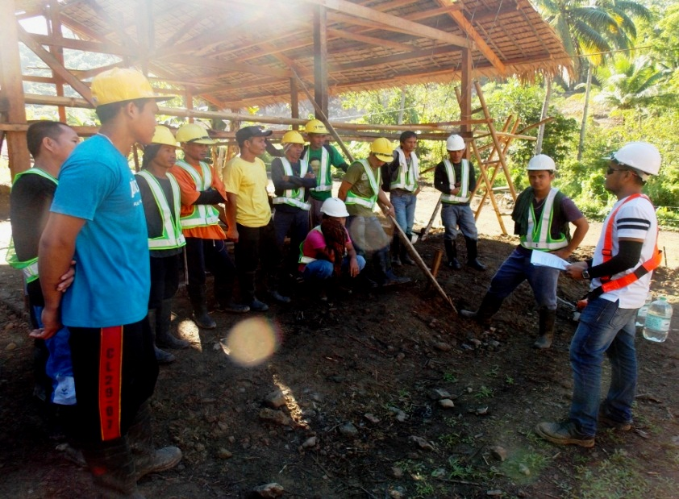
- AMVI Safety Officer Jake Absin conductes daily safety briefings to field workers on site.
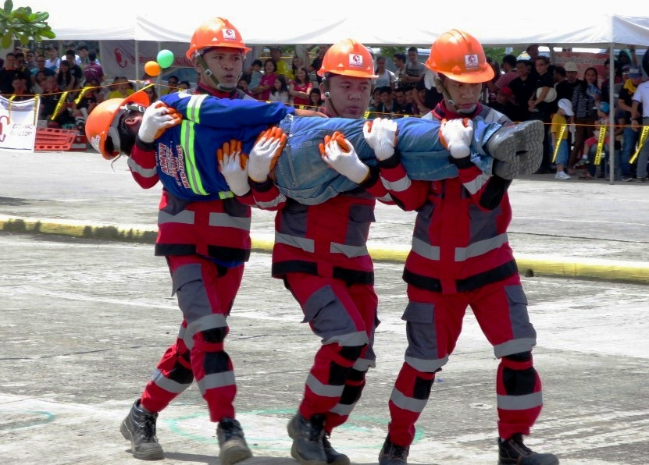
- AMVI Emergency Response Team transporting an “accident victim” during the Safety Competition in Surigao City.

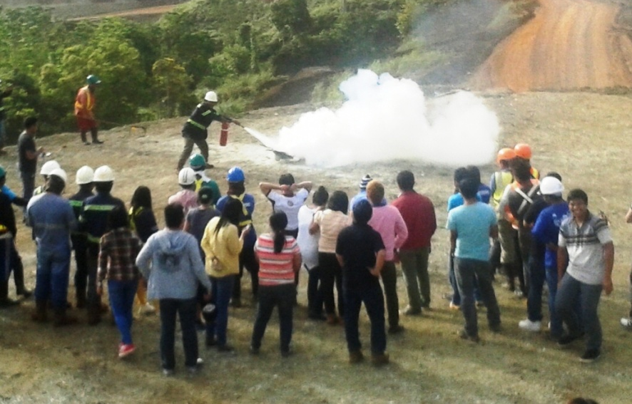
- Fire Prevention Exercises initiated by AMVI Safety Department during the Bureau of Fire Protection’s (BFP’s) Fire Prevention Month.

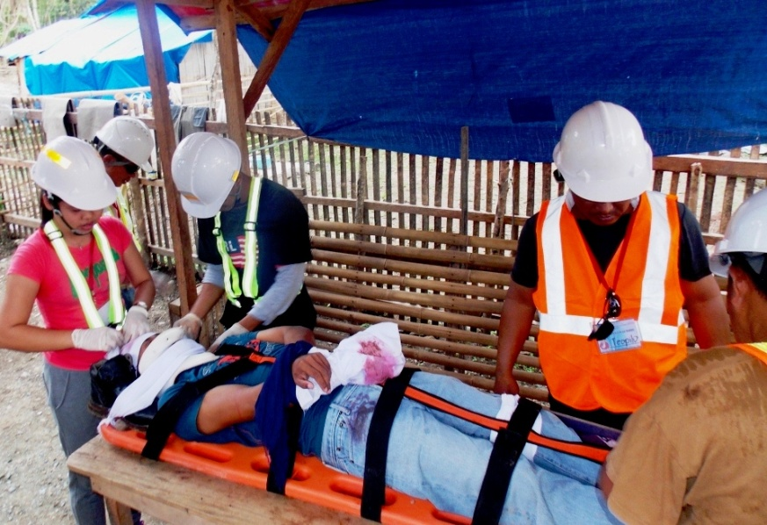
- AMVI Safety Officers lead the first aid and emergency response drill.

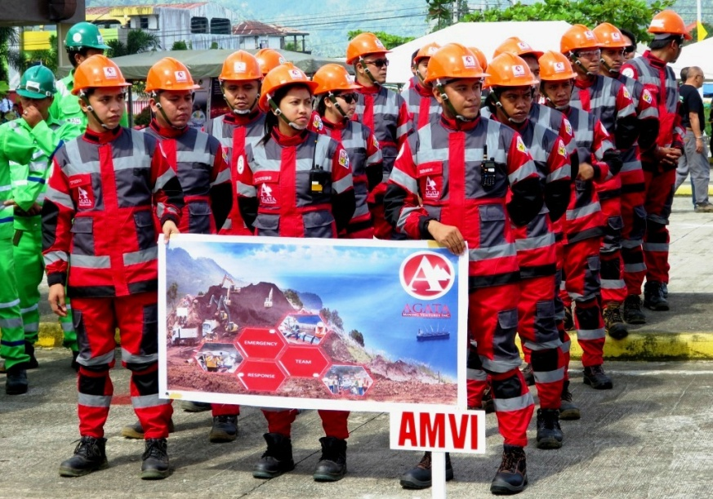
- All Geared-up. AMVI Emergency Response Team (ERT) at the start of the Safety Competition in in Surigao City.

About TVI Philippines
TVI Resource Development Philippines Inc. (“TVIRD”), is the local affiliate of TVI Pacific Inc. (TSX: TVI), a publicly-listed Canadian mining company focused on the exploration, development and production of precious and base metals from district-scale, large-system, high-margin projects located in the Philippines. Concurrent ownership of ventures is shared with partner company, Philippine Resource Holdings Inc.

TVIRD is committed to exploration and mining practices that promote transparency, responsible stewardship of the environment, and the inalienable rights to life, dignity, and sustainable development of its host communities.
www.tviphilippines.com

Contact:

Kaycee Crisostomo
Corporate Communications Director
TVI Resource Development Philippines Inc.

Email: kaycee.crisostomo@tvipacific.com.ph
Phone: +63 2 728-8491 ext. 103
Mobile: +63 917 579-1528
Fax: +63 2 728-8515

