N E W S R E L E A S E

Clean Water Finds its Way to Grateful Tubay Communities
Agata Mining initiates water system improvements for its host communities

Hope springs. Children of Barangay Tinigbasan enjoy the constant availability of clean water in their community – one of several key infrastructure projects supported by AMVI’s SDMP for the benefit of its host communities.

Santiago, Agusan del Norte / October 2015 – In active response to the growing need and importance of social infrastructure for long-term community development, Agata Mining Ventures Inc. (AMVI) initiated two major water system improvements for Barangays Tinigbasan and Lawigan in its host municipality of Tubay. The company likewise supported minor structural repairs for water systems that link nearby Barangays Tagpangahoy and Tagbuyacan – effectively providing all communities constant access to clean water.

Originally constructed years ago, the water systems of these barangays that once irrigated spring water from the surrounding mountains have incurred significant wear and tear, compounded by defective, clogged and dirty pipe connections that cause water shortages and pollution. Alarmed by the health risks to the communities, AMVI formed and led a Community Technical Working Group (CTWG) composed of barangay members, peoples’ organizations and volunteers to conduct a comprehensive evaluation and eventual implementation of system enhancement.

“The (old) barangay water system had a lot of problems, including the needed replacement of old rubber hoses to more durable steel PVC pipes and re-routing the connections to ensure that every household has equal access to clean water,” according to Barangay Tinigbasan Captain Dante Mandam.

As community members depend greatly on the constant supply of water for both domestic and agricultural use as well as for their livestock, today’s improved and more reliable systems provide them essential access to one of life’s most basic needs. The necessary maintenance and improvement of these water systems will likewise continue to support their barangays’ growing population.

Flow of progress
Improving the community water system, like any strategic infrastructure project, provides a positive effect in sustaining other aspects of social development such as livelihood, responsive education, health and sanitation – key elements that comprise the Quadrants of Development of TVI Resource Development Philippines Inc. (TVIRD), which leads the Agata Nickel Project.

AMVI adopts the same development model in its mining contract area Agusan del Norte Province, confident that it will generate the same positive results that elevated TVIRD’s host town of Siocon into a first-class municipality in the Zamboanga Peninsula. The company likewise believes that the proper installation of key infrastructure will help address community health issues and sustain their various livelihood projects.

“We are glad that AMVI is our strong partner towards progress and development. Its unrelenting support to the needs of our communities – whether it be in several livelihood projects, health and sanitation programs or infrastructure projects – helps improve our people’s living standards,” added Mandam.

Stream of service
In carefully assessing the distinct requirements of each community, AMVI coordinates with both public and private sectors to identify practical solutions to address specific community needs. This is in order to maximize benefits and increase the efficiency of its programs.

Among its successful infrastructure projects are the repair and construction of new elementary school classrooms and day care centers, the fortification of the schools’ perimeter fences, the construction of access roads, the establishment of waiting sheds and even the repair and maintenance of barangay halls. AMVI also actively engages the community in clean-up drives, most notably its Solid Waste Management Program (SWMP).

AMVI is a joint venture between MRL Nickel Philippines Inc. and TVIRD, which operates the Agata Project located in a 4,995 hectare Mineral Processing and Sharing Agreement (MPSA) across the municipalities of Tubay, Santiago and Jabonga. The joint venture aims to ramp-up its high iron laterite direct shipping ore (DSO) operations, increasing its mining and shipping activities to major markets in Asia.

*******

Press photos:

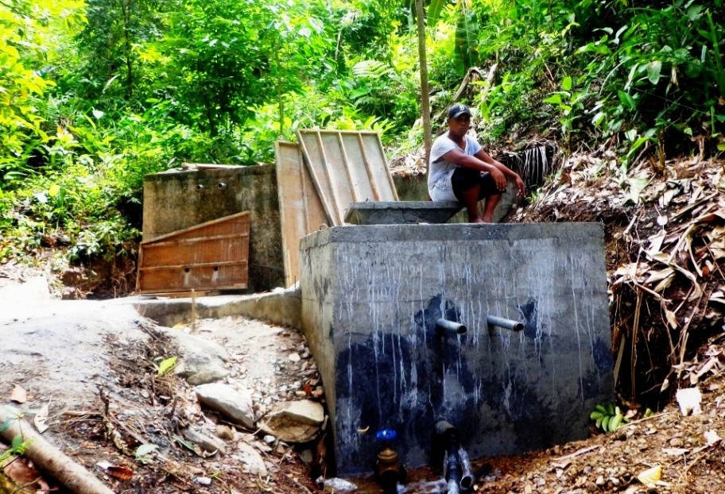

- On-going construction and system upgrade of Barangay Tinigbasan’s water system.

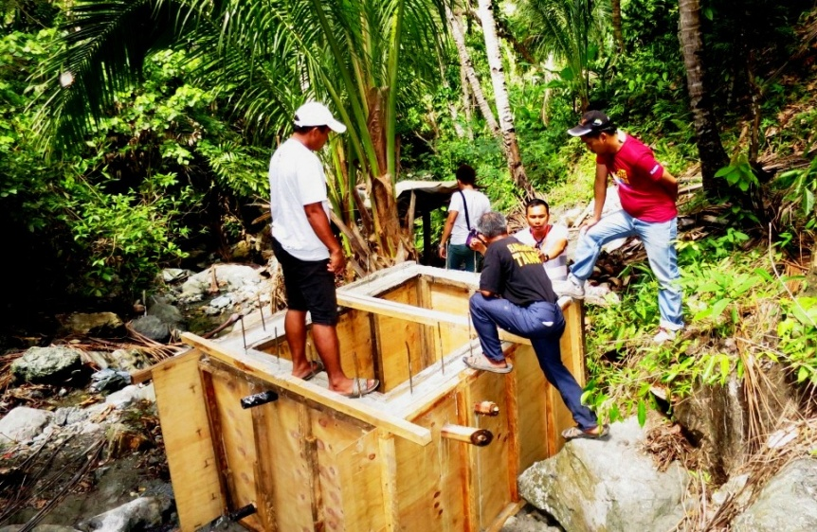

- Joint inspection. AMVI Personnel and Barangay Lawigan Council Members inspect the progress of their water system.

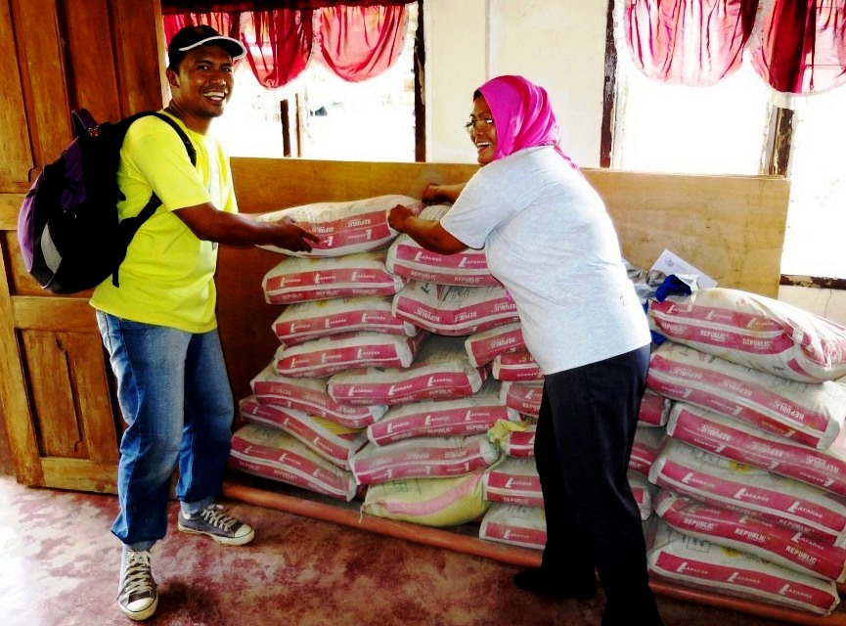

- Barangay hall repair. AMVI Community Relations Officer Tyron Salas turns-over construction materials to Councilor Thelma Villeza.

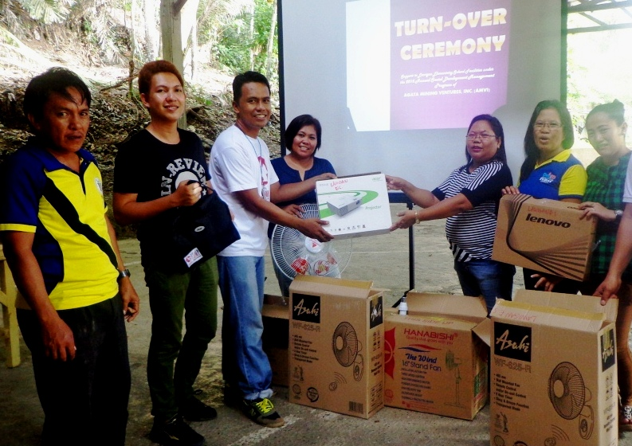
- AMVI Personnel turnover appliances and multimedia equipment to Barangay Lawigan Elementary School Teachers, day care personnel and council members.

About TVI in the Philippines
TVI Resource Development Philippines Inc. (“TVIRD”), is the local affiliate of TVI Pacific Inc. (TSX: TVI), a publicly-listed Canadian mining company focused on the exploration, development and production of precious and base metals from district-scale, large-system, high-margin projects located in the Philippines. Concurrent ownership of ventures is shared with partner company, Prime Resource Holdings Inc.

The commercial operations of Agata Mining Ventures Inc. (AMVI) marks the third successful mining project that TVIRD brought on-stream in the past 10 years. The company is committed to exploration and mining practices that promote transparency, responsible stewardship of the environment, and the inalienable rights to life, dignity, and sustainable development of its host communities.
www.tviphilippines.com

Contact:

Kaycee Crisostomo
Corporate Communications Director
TVI Resource Development Philippines Inc.

Email: kaycee.crisostomo@tvipacific.com.ph
Phone: +63 2 728-8491 ext. 103
Mobile: +63 917 579-1528
Fax: +63 2 728-8515

