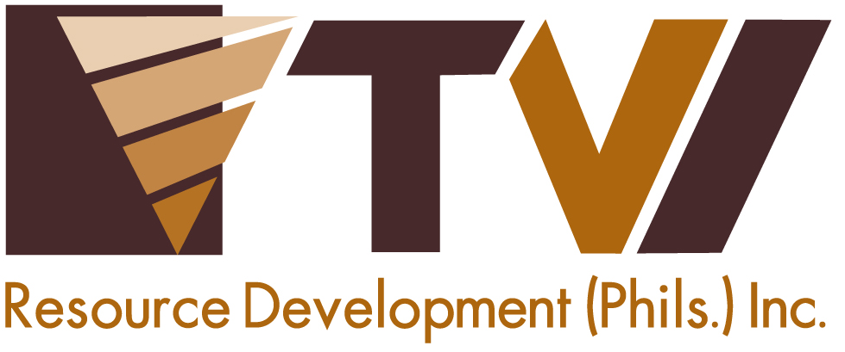
N E W S R E L E A S E

Agata Mining Backs Caraga’s Biggest Humanitarian Mission
AMVI-supported Bombo Medico reaches 1,600 beneficiaries in Butuan

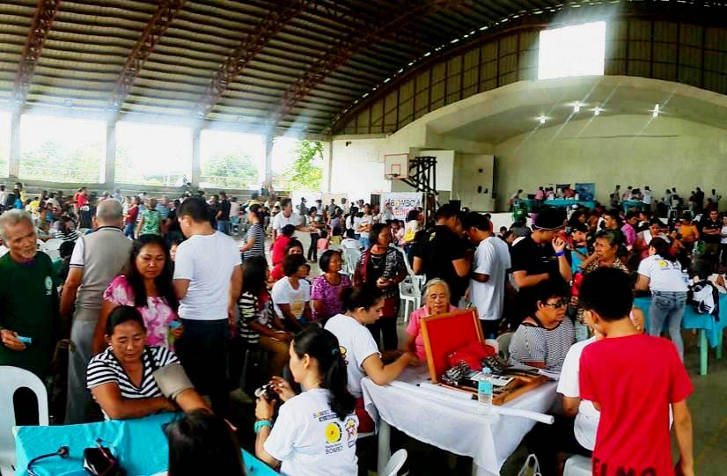
Providing access to healthcare. AMVI partners with Bombo Radyo in an impressive turn-out of the radio network’s successful annual medical mission, Bombo Medico 2015.

Butuan City, Agusan del Norte / September 2015 – Underscoring its commitment to public health, Agata Mining Ventures Inc. (AMVI) sent its dedicated personnel to support DXBR Bombo Radyo’s medical mission at the Agusan del Norte Provincial Capitol Covered Gymnasium in Butuan City last 16 August 2015. The delegation joined other volunteers in providing immediate relief to common ailments, on-the-spot check-ups and medical assistance to beneficiaries from all over Butuan, including small communities located in the outskirts of the city. AMVI assumed major sponsorship for the annual activity and donated essential medicines through its mission partner, Sociedad Española de Beneficencia Inc. (SEB-Manila) – a charitable institution dedicated to the care of both Spanish and Filipino indigents in the country.

The mission was also supported by the Provincial Government, Mayor’s Office, Department of Health (DOH), Philippine Charity and Sweepstakes Office (PCSO), Rotary Club and pharmaceutical companies.

AMVI and Bombo Radyo’s shared commitment towards public health runs parallel to the Health and Sanitation programs of TVI Resource Development Philippines Inc. (TVIRD), which leads the Agata Nickel Project in Tubay, Santiago and Jabonga Municipalities. AMVI works with various government agencies including non-government organizations in launching several programs and activities geared towards social development and environment protection - which closely follows TVIRD’s lead in promoting responsible mining practices.

More Every Year
As Bombo Medico increases its offered medical services each year, so does the number of beneficiaries and the type of diagnosed medical conditions during the activity. This year, the mission was able to record an increase in Prostate, Cardiovascular, Pulmonary, Pediatric, ENT, Dental and Optical-related diseases along with some Obstetrics and Gynecological-related ailments. Respiratory, Cardiovascular and other related ailments diagnosed for most adult participants are commonly attributed to an unhealthy lifestyle, which includes excessive alcohol intake and cigarette smoking, while skin and gastro-related ailments affect the majority of children and infants and are commonly attributed to poor hygiene and sanitation in households within impoverish communities.

“I believe that prevention is better than the cure. If we can work closely with local government units in launching intensified Information and Education Campaigns (IECs) that promote public health, personal hygiene and proper sanitation to communities prior to launching medical missions, it would provide a lasting impact on communities in relation to health and wellness,” said AMVI Community Development Officer Zeus Lumancas in the sidelines of the medical mission.

Nevertheless, Bombo Medico is well-stocked with much-needed medicines from various sponsors while the mission itself was able to dispense the right type and quantity of medicines prescribed for each of the beneficiaries.

Over 55 Thousand Beneficiaries nationwide
Bombo Medico is the network’s annual medical mission conducted simultaneously nationwide by its radio stations located in key cities all over the Philippines. This year, AMVI’s support to DXBR Bombo Radyo concluded with a total of 1,600 recorded beneficiaries in Butuan City alone – which adds to the Bombo Medico 2015 overall total of 55,187 recorded beneficiaries nationwide – an impressive and significant outcome towards the improvement of public health and community wellness in the country.

“Agata Mining is proud to be part of the very successful turn-out of Bombo Medico 2015. The company likewise congratulates Station Manager Benjie Balansag and the rest of DXBR Bombo Radyo Butuan team for their integrity, journalistic excellence and public service as well as their unrelenting pursuit to uplift public health standards by bringing adequate healthcare to marginalized communities,” said AMVI Corporate Communications Officer Michael Luigi Figueroa.

AMVI remains Bombo Radyo’s strong partners in social development and has been continuously supportive of the radio station’s sustainable programs. Last year, the company supported the network’s annual nationwide blood donation drive, Dugong Bombo, which was able to collect over 3 million cc of blood. Prior to AMVI’s support to Bombo Medico this year, the company also supported Debate sa Bombo – an intercollegiate series of debate competitions that aims to empower young minds through a healthy exercise of well-sourced research and well-executed academic reasoning.

AMVI is a joint venture between Mindoro Resources Ltd. (MRL) and TVI Resource Development Philippines Inc. (TVIRD), which operates the Agata Project. The joint venture aims to move forward, initially with high iron and nickel laterite direct shipping ore (DSO) operations that is expected to usher increased economic activity and employment in its host municipalities.

*******

Press photos:
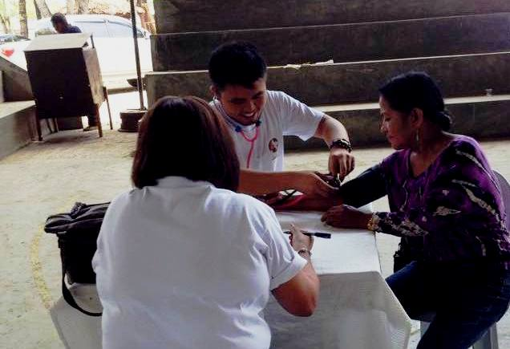
- AMVI Company Nurse Jimmy Ceballos and Community Relations Officer Marie Beth Sagala record the vital signs and information of every Bombo Medico participant.

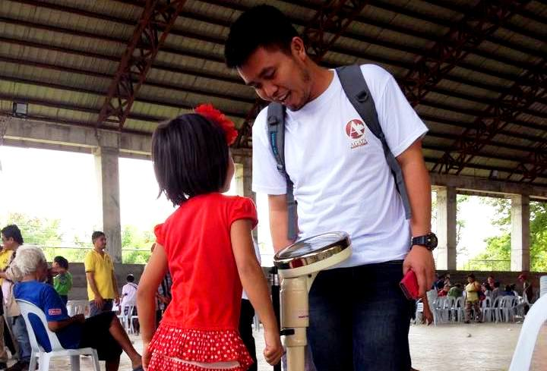
- Care for kids. A Bombo Medico participant has her height and weight recorded by AMVI Company Nurse Jimmy Ceballos.
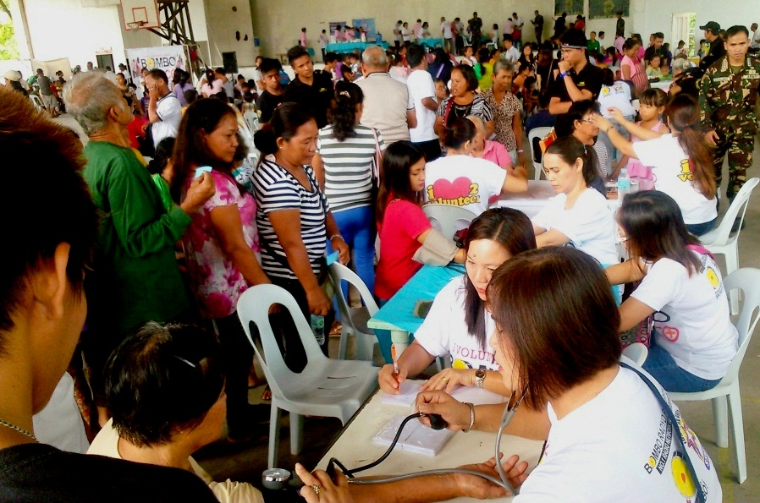
- Beneficiary-patients from all over Butuan City queue-in for much-needed medical consultations, medicines and other health services offered at Bombo Medico 2015.

About TVI Philippines
TVI Resource Development Philippines Inc. (“TVIRD”), is the local affiliate of TVI Pacific Inc. (TSX: TVI), a publicly-listed Canadian mining company focused on the exploration, development and production of precious and base metals from district-scale, large-system, high-margin projects located in the Philippines. Concurrent ownership of ventures is shared with partner company, Philippine Resource Holdings Inc.

TVIRD is committed to exploration and mining practices that promote transparency, responsible stewardship of the environment, and the inalienable rights to life, dignity, and sustainable development of its host communities.
www.tviphilippines.com

Contact:

Kaycee Crisostomo
Corporate Communications Director
TVI Resource Development Philippines Inc.

Email: kaycee.crisostomo@tvipacific.com.ph
Phone: +63 2 728-8491 ext. 103
Mobile: +63 917 579-1528
Fax: +63 2 728-8515

