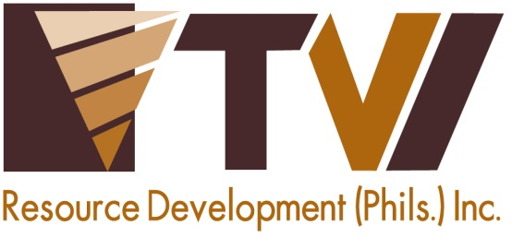
N E W S R E L E A S E

Agata Mining Conducts First Blood Donation Drive
with the Philippine National Red Cross
Employees volunteer for AMVI’s company-wide blood-letting activity

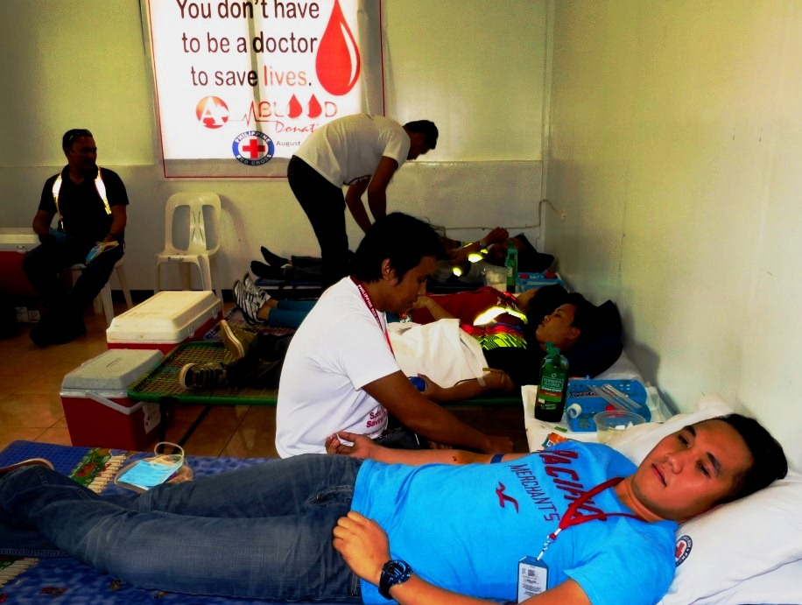
Drawing first blood. AMVI personnel as well as contractor, 4K Development Corporation, volunteered as qualified blood donors during the company-wide blood-letting activity.

Santiago, Agusan del Norte / August 2015 – In the same spirit of solidarity that drove several successful blood donation activities of TVI Resource Development Philippines Inc. (TVIRD) – lead developer of the Agata Nickel Project – Agata Mining Ventures Inc. (AMVI) mobilized both its on-site and field-based employees along with dedicated personnel of its mining contractor, 4K Development Corporation, to actively participate in its first blood donation drive. The activity was conducted in partnership with the Butuan City Chapter of the Philippine National Red Cross last August 14 at the company’s Base Camp in Santiago – one of the three municipalities encompassed by its Mineral Processing Sharing Agreement (MPSA) area.

The event was organized by AMVI’s Human Resources and Administration department as part of the company’s promotion of employees’ health and wellness as well as creating awareness among community members and stakeholders.

“This first company-wide blood donation drive was conducted successfully with the help of the Philippine Red Cross and the cooperation of supporting AMVI departments. Most of all, it is successful because every volunteer gave their time to willingly donate blood and help save lives,” according to AMVI Company Nurse Jimmy Ceballos, who is already planning to scale-up the event in the future.

In addition to employee-volunteers, AMVI’s first blood donation drive was also supported and participated by the 2nd Agusan del Norte Special Civilian Active Auxiliary (SCAA) detailed by the Armed Forces of the Philippines’ 29th Infantry Battalion.

“Next time, we plan to engage the support and assistance of local government units and peoples organizations from our host and neighboring communities. This way, we can exceed today’s results and achieve a much larger scope that can include our indigenous hosts,” he added.

Every Drop Counts
The Red Cross also imposed strict guidelines for qualification as an eligible blood donor. High-blood pressure, lack of sleep, menstrual periods, recent foreign travel, scheduled flights within 24 hours and a very physical nature of work disqualified several donors. Nonetheless, the activity was able to collect significant quantities of blood that will not only help save lives but also give each donor valuable health benefits in terms of improved blood circulation and cardio-vascular function.

“The Philippine National Red Cross has worked with AMVI in several trainings and seminars geared towards work safety and emergency response. This activity is a testament to AMVI’s commitment in prioritizing health and safety programs and we are proud to be part of the company’s first blood donation drive. We likewise hope to join and support the company in other meaningful programs in the years ahead,” said the organization’s medical technologist, Mae T. Ravidas.

Same bloodline
AMVI continues the TVIRD tradition of uplifting the community’s health standards through strategic programs and partnerships with key organizations. TVIRD conducted several blood donation activities in partnership with the Red Cross, earning the recognition of being the organization’s leading supporter in the Zamboanga Peninsula. Moreover, TVIRD’s Health and Sanitation Program established a 24/7 lying-in clinic operated by full-time doctors, nurses and midwives and received close to 14,000 consultations and admissions every year.

On its part, AMVI programs under its Social Development and Management Program include the improvement of barangay health centers, increasing medicine supplies and providing additional medical equipment for community health centers. AMVI also actively initiated medical missions and likewise supported public health-oriented activities of media partners, Bombo Radyo and Radio Mindanao Network (RMN) in 2014. This year, the company will draw more focus on social programs to elevate the living standards of its host communities.

“When I was younger, I was fascinated with doctors and medical personnel knowing that they are regarded as heroes who have the power to save lives. Growing up, I realized that there are several ways one can be a hero and save lives – and today this is one of them,” said AMVI General Manager Rufo S. Cabanlig at the sidelines of the maiden activity.

“A simple blood donation can definitely save countless lives while the act also benefits the donors’ own health. I stand here today, proud to say that I work with heroes everyday!” he concluded.

*******
Press photos:
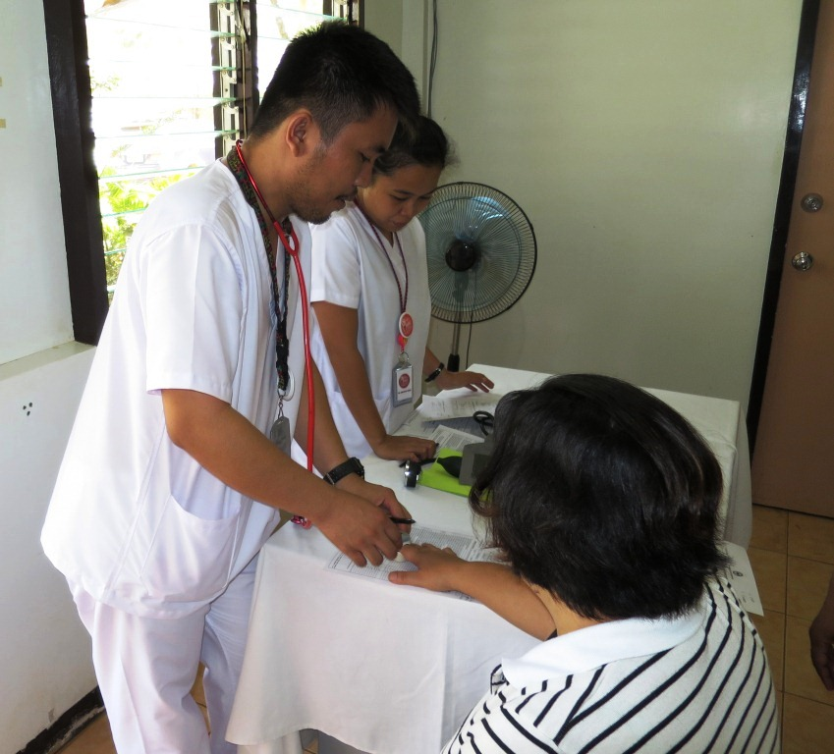
- AMVI company nurses Jimmy Ceballos and Izette Therese Lim took the blood pressure and recorded the heart rate of every donor who was screened during the blood donation drive.

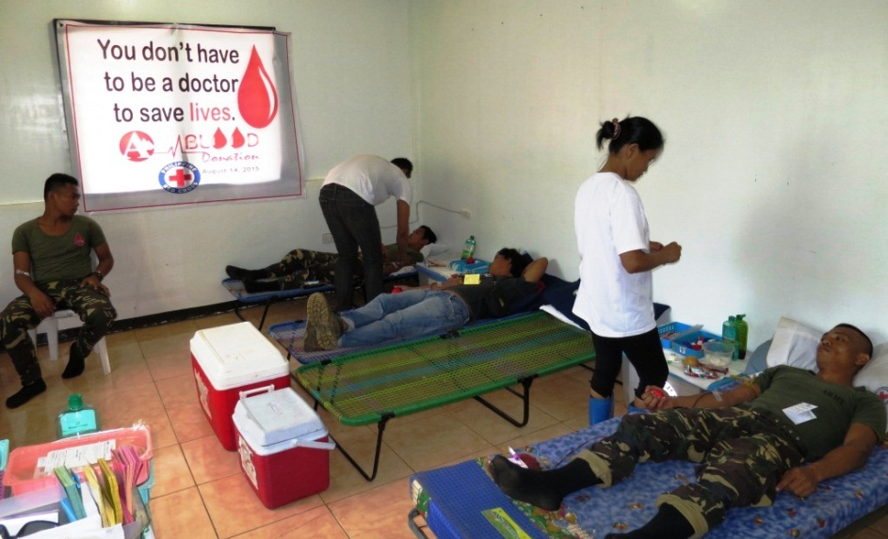
- Members of the Special Civilian Active Auxiliary (SCAA) queued and actively participated in AMVI’s first blood donation drive.

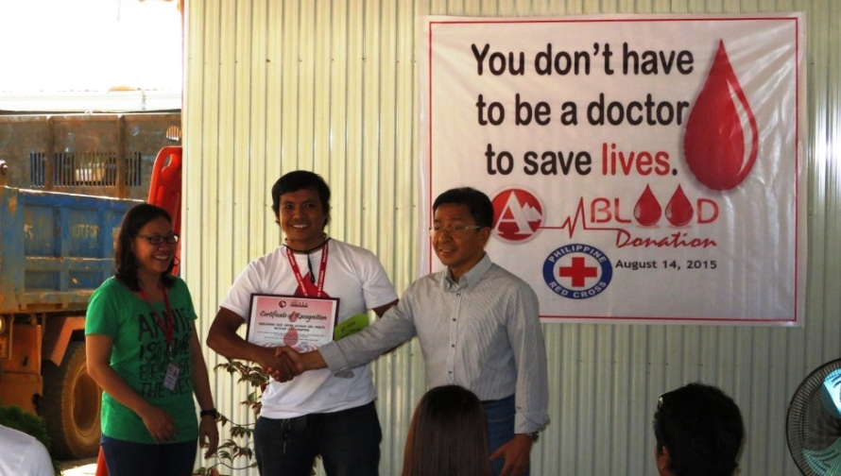
- AMVI Human Resources Superintendent Jul Christine Goles and AMVI General Manager Rufo S. Cabanlig present a Certificate of Appreciation to the Philippine National Red Cross for supporting the company’s first successful blood donation drive.

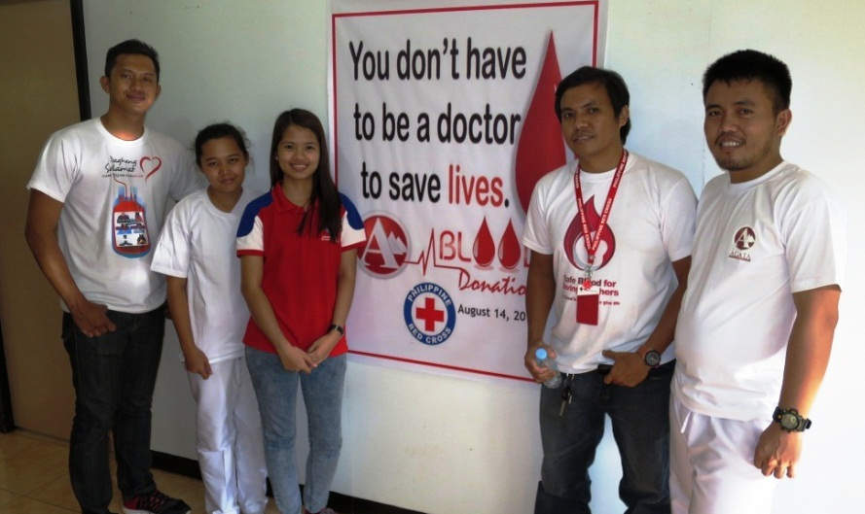
- The joint AMVI and Philippine National Red Cross medical come together for the successful conclusion of the first blood donation drive at Agata.

About TVI in the Philippines
TVI Resource Development Philippines Inc. (“TVIRD”), is the local affiliate of TVI Pacific Inc. (TSX: TVI), a publicly-listed Canadian mining company focused on the exploration, development and production of precious and base metals from district-scale, large-system, high-margin projects located in the Philippines. Concurrent ownership of ventures is shared with partner company, Prime Resource Holdings Inc.

The commercial operations of Agata Mining Ventures Inc. (AMVI) marks the third successful mining project that TVIRD brought on-stream in the past 10 years. The company is committed to exploration and mining practices that promote transparency, responsible stewardship of the environment, and the inalienable rights to life, dignity, and sustainable development of its host communities.
www.tviphilippines.com

Contact:

Kaycee Crisostomo
Corporate Communications Director
TVI Resource Development Philippines Inc.

Email: kaycee.crisostomo@tvipacific.com.ph
Phone: +63 2 728-8491 ext. 103
Mobile: +63 917 579-1528
Fax: +63 2 728-8515

