N E W S R E L E A S E

CARAGA Livelihood Programs spurred by
Villar SIPAG and Agata Mining
The Villar SIPAG program partners with AMVI in promoting more community livelihood programs.

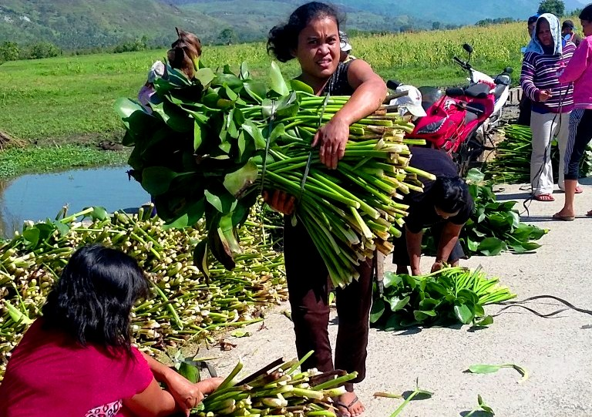
For environment and livelihood. Members of the Barangay Tagbuyacan Women’s Organization harvest water hyacinths from the AMVI-adopted Kalinawan River. These will be used as raw materials for the joint Villar SIPAG-AMVI Water Lily Handicraft livelihood program.

Santiago, Agusan del Norte / August 2015 – In a joint commitment towards sustainable social development, the TVIRD-led Agata Mining Ventures Inc. (AMVI) and the Villar Social Institute for Poverty Alleviation and Governance (Villar SIPAG) – an organization dedicated to the welfare of overseas Filipino workers and assistance to their families – recently undertook the initiative to establish income-generating projects for communities situated within AMVI’s mining concession area. As AMVI has previously created community livelihood programs as part of its Social Development and Management Programs, the partnership aims to interface the company’s existing development mission with new and innovative livelihood projects conceived by Villar SIPAG.

This year, the institute teamed-up with AMVI and provided seminars, skills development training and the basic technology for women organizations in the riverside barangay communities along Kalinawan – the company’s adopted tributary. The program also provided business orientation that helped pave the way for women to produce traditional bags (bayong), baskets, sleeping mats (banig), floor mats and other marketable products in the future. The sustainable livelihood program employs a zero-cost approach that effectively cleans the river on one hand, and enables women to engage in a viable livelihood that contributes to the overall development of their barangays on the other.

Founded in 1992 by Hon. Senator Cynthia Villar, the institute strives to improve the Filipino’s quality of life, especially OFWs and their families. Villar SIPAG, which was formerly known as the Villar Foundation, is also a staunch advocate of environmental conservation and preservation as precipitated by its earlier program, Pagtatanim Para Sa Kinabukasan (Planting for the Future). It also promotes the use of raw materials derived from wastes and other organic sources to provide alternative and eco-friendly livelihood at very little or no capital needed.

AMVI likewise conceived its existing livelihood programs from the successful blueprints of TVI Resource Development Philippines Inc. (TVIRD) – lead joint venture partner at the Agata Nickel Project in Tubay, Jabonga and Santiago Municipalities. At the height of TVIRD’s mining operation in Canatuan, Zamboanga del Norte, the company generated employment for some 1,200 people, including its indigenous Subanons hosts, and introduced various downstream livelihood programs – both of which contributed to Siocon town’s elevation to a first-class municipality.

“Knowing that both AMVI and Villar SIPAG are equally committed towards community empowerment, it is high time that we work together in providing economically-viable livelihood projects to benefit the communities that we both serve,” said AMVI Liaison Officer Genome Fortun.

Water lily handicraft
Water Hyacinths (Eichhornia Crassipes), more commonly known as water lilies in the Philippines, is a variety of freshwater plants that originated from South Africa and has been regarded as the world’s “most troublesome” aquatic plant. But prior to this, it has been widely propagated as a water ornament. Today, several countries face the enormous task of controlling the alarming increase of water lilies that form vast blankets covering lakes, rivers and ponds, which in turn cause problems for fishing, water transport and biodiversity.

In the Philippines, water lily “infestations” have caused severe flooding in different areas during monsoon season and rampant fish kills as it blocks sunlight and starve fish species from oxygen. While several local government units waged several attempts to mitigate this, Villar SIPAG established its water lily handicraft program primarily to rid the Zapote River and the Las Piňas City waterways of the aquatic pest.

What started as a backyard industry nearly a decade ago grew to an enormous livelihood program as more people take notice of the wide range of products that can be made from the common water weed. And as the institute promoted water lily-based livelihood projects to different areas in the country, its journey to success is now history.

Vegetable farming
Aside from nickel and iron-rich mineral deposits, the Agusan del Norte Region is also known for its vast agricultural land. And while mineral-rich areas are not suitable for supporting vegetation, the acquisition of agricultural land also does not come cheap.

As a workaround, AMVI engaged the communities and promoted fruit and vegetable farming in their respective households. Following TVIRD’s successful agro-forestry development in Zamboanga del Norte, AMVI also used organic fertilizers to get the livelihood project started. Parallel to this, Villar SIPAG also has a project for schools titled as “Gulayan sa Paaralan” (Vegetable Farming in School) wherein fruit and vegetable seeds as well as organic fertilizers were donated by the institute to several schools across the country.

AMVI and Villar SIPAG then merged both frameworks and adopted these for households – which enabled the two organizations to launch the “Gulayan sa Kabalayan” (Vegetable Farm at Home) livelihood program. The program was rolled-out in Tubay and Santiago Municipality - and since the program’s successful launch - families from barangay communities have established fruit and vegetable supplies that can either sustain their households or be sold to provide them an alternative source of income.

Since the implementation of its SDMP, AMVI has initiated a number of programs that are tailor-fitted to suit each of its host and neighboring communities. These include Coconet Weaving, a Barangay Mini-Junkshop, Vermi-culture Fertilizer Production, Barangay Rice Granery and Mini Grocery, among others.

With the advent of the partnership between AMVI and Villar SIPAG, both stand on the threshold of achieving sustainable community development and connecting their various programs to potentially provide a continuous stream of income for its participants.

*******

Press photos:

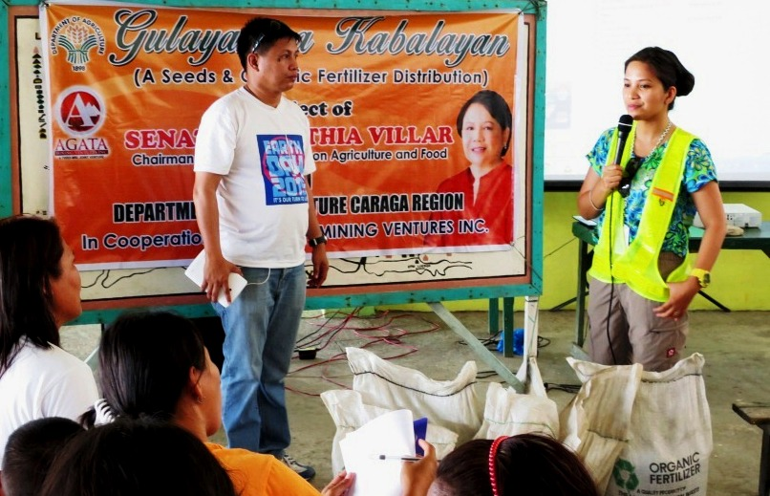
- AMVI Liaison Officer Genome Fortun and AMVI Environment Manager Jesalyn Guingguing discuss the mechanics of the “Gulayan sa Kabalayan” livelihood program prior to seed and fertilizer distribution to Barangay Tinigbasan community members.

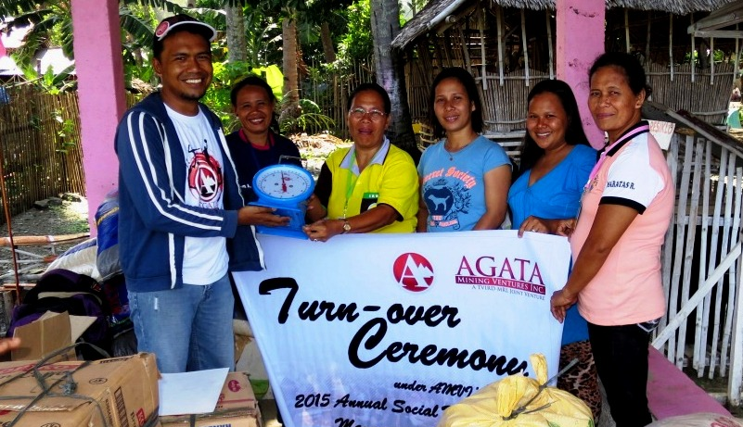
- Getting started. AMVI Community Relations Officer Tyron Hans Salas turn-over supplies and initial inventory to the Binuangan Women’s Organization for its “Barangay Bigasan and Mini Grocery” livelihood program.

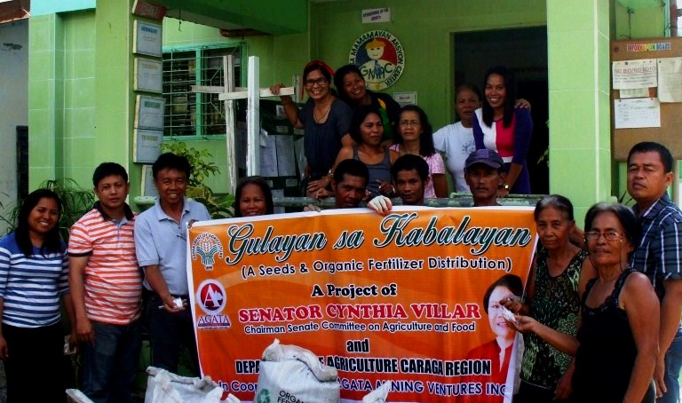
- Getting started. AMVI Environment Officer Sheila Mae Arcala and AMVI Liaison Officer Genome Fortun turn-over seeds and fertilizers to barangay La Paz for its “Gulayan sa Kabalayan” livelihood program.

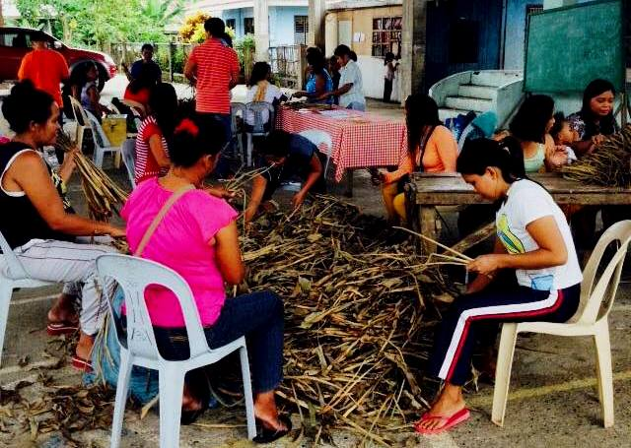
- Dry it, Weave it, Sell it. Members of the Tagbuyacan Women’s Organization sort their dried water hyacinths (water lilies) in preparation for converting them into raw materials for bags, floor mats, baskets and various other weaved products.

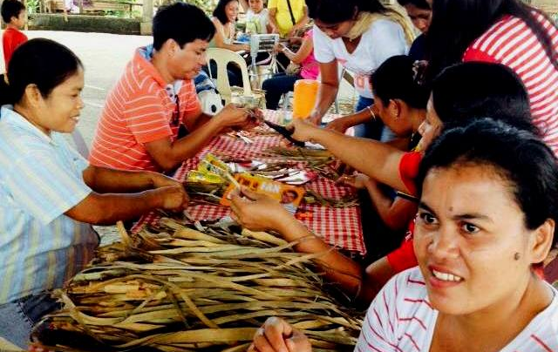
- The dried water lily raw materials are inspected prior to weaving them into marketable products.

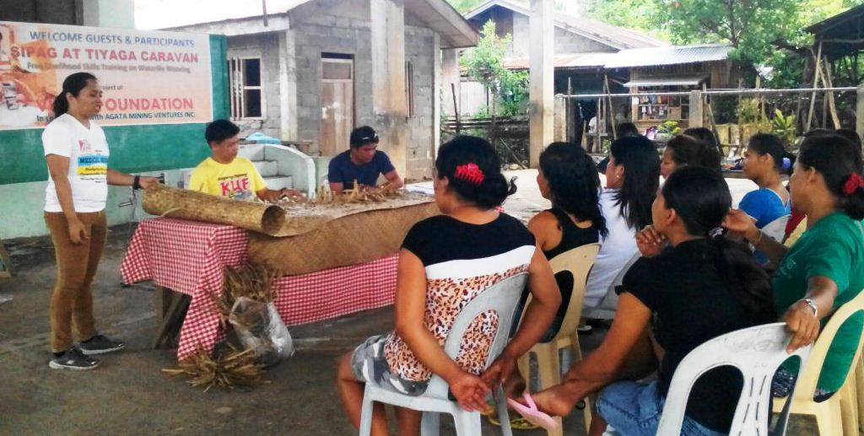
- AMVI Environment Officer Sheila Mae Arcala, AMVI Liaison Officer Genome Fortun and Tagbuyacan Barangay Chairman Carlito Balinos Jr. inspect the final water lily handicraft products presented by the Tagbuyacan Women’s Organization.

About TVI in the Philippines
TVI Resource Development Philippines Inc. (“TVIRD”), is the local affiliate of TVI Pacific Inc. (TSX: TVI), a publicly-listed Canadian mining company focused on the exploration, development and production of precious and base metals from district-scale, large-system, high-margin projects located in the Philippines. Concurrent ownership of ventures is shared with partner company, Prime Resource Holdings Inc.

The commercial operations of Agata Mining Ventures Inc. (AMVI) marks the third successful mining project that TVIRD brought on-stream in the past 10 years. The company is committed to exploration and mining practices that promote transparency, responsible stewardship of the environment, and the inalienable rights to life, dignity, and sustainable development of its host communities.
www.tviphilippines.com

About Villar SIPAG
Social responsibility is the guiding principle of the Villar SIPAG, a non-stock, non-profit organization established in 1995.
Since its inception, Villar SIPAG has initiated, implemented, and supported various projects aimed at improving the quality of life of the people in the communities where we live and maintain a business presence.
One of Villar SIPAG's earliest programs was 'Pagtatanim Para Sa Kinabukasan', a tree-planting program, to create urban forests in open spaces of subdivisions, residential communities, and schools.
Over the years, its advocacies and beneficiaries have expanded and diversified in order to reach more people and sectors of the society. These include the poor and underprivileged; overseas Filipino workers and their families; the youth; women; the church; the environment among others.
Villar SIPAG's programs and projects include (but are not limited to) nutrition caravan (regular feeding programs for schoolchildren); medical and dental missions; river rehabilitation program; religious projects such as building of churches; repatriation of distressed overseas Filipino workers; livelihood and entrepreneurship.
By sharing our resources with the Filipino people who have made possible the success of our endeavors, we shall strive to provide opportunities to the underprivileged and the economically disadvantaged, for them to rise beyond their limitation and pursue meaningful lives as productive members of society.
Ultimately, we envision a healthy, peaceful, decent, and productive life for all Filipinos.

www.villarsipag.org

Contact:

Kaycee Crisostomo
Corporate Communications Director
TVI Resource Development Philippines Inc.

Email: kaycee.crisostomo@tvipacific.com.ph
Phone: +63 2 728-8491 ext. 103
Mobile: +63 917 579-1528
Fax: +63 2 728-8515

