N E W S R E L E A S E

Agata Rallies CARAGA Mining Companies
in Celebration of Environment Month 2015
AMVI leads environmental awareness activities participated by 32 mining companies in CARAGA

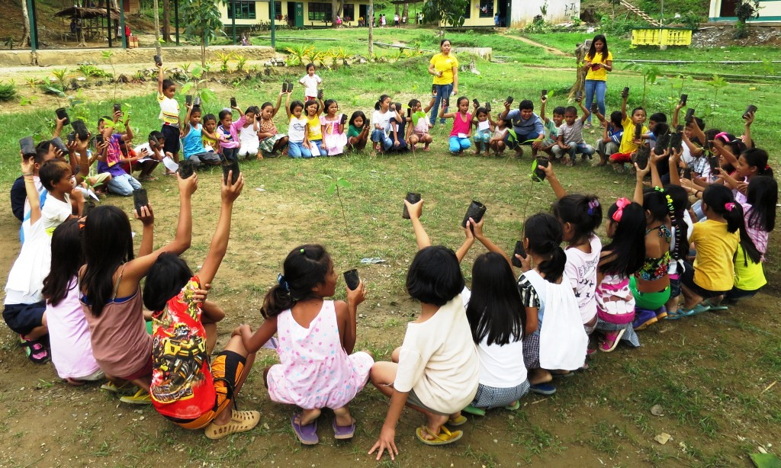
Children take the lead. AMVI provides elementary students the opportunity to take the lead in a series of Environment Month tree-planting activities to help support environmental conservation and awareness.

Surigao City, Surigao del Norte / July 2015 – In strong support to the mandate of the CARAGA Mine Environment Management Council (CMEMC) and the DENR’s Mines and Geosciences Bureau (MGB) for environmental management and protection, Agata Mining Ventures Inc. (AMVI) mobilized various youth empowerment activities in observance of World Environment Day – an annual global event celebrated every 5th of June with this year’s theme: “Seven Billion Dreams, One Planet, Consume with Care.” In line with this, the month of June was also declared as the Philippine Environment Month by virtue of Presidential Proclamation No. 237 signed by then President Corazon C. Aquino.

The main activities of the CMEMC and the MGB Environment Month celebration this year was held on 30 June 2015 at the Surigao City Provincial Capitol Convention Center where AMVI led the celebration and which was joined by 32 operational mining companies in the CARAGA region.

Initiating Environmental Awareness
In June, and prior to AMVI’s main participation in the activities of Environment Month 2015, the company’s Environment personnel conducted a series of intensified Information and Education Campaigns (IEC) – this time, the company focused on several elementary schools located within its mining concession area. AMVI again takes after environmental awareness initiatives of TVI Resource Development Philippines Inc. (TVIRD) – lead joint-venture partner for the Agata Nickel Project.

During TVIRD’s operations in Canatuan, Zamboanga del Norte, the company was able to empower students of Canatuan National Elementary and High School to take lead in environmental management and conservation efforts and for successfully supporting Environment Month activities. Moreover, the company has been recognized by both local and national award-giving bodies for its various environmental programs.

To date, AMVI’s IEC is centered on providing schools with well-organized symposiums focusing on the company’s Solid Waste Management Program (SWMP) which was immediately followed by clean-up drives, the installation of Material Recovery Facilities (MRFs) that are primarily used for waste segregation and recycling, and several tree-planting activities in pre-selected areas around the schools. The activity helps to promote conservation and awareness among the youth, who in turn, will take the lead as future leaders of their respective communities.

During the SWMP presentation conducted at the Prospero D. Salas Elementary School in Tagbuyacan – one of AMVI’s neighboring barangays – Environment Officer Sheila Mae Arcala oriented the students on the significance of MRFs instead of the standard trash bin in schools.

“It (MRF) makes it easier to segregate biodegradable from non-biodegradable wastes and also helps in classifying wastes that can be recycled and re-used,” said Grade 4 Student Mary Jane Bulan.

At the end of the IEC, Arcala commended the students for their receptiveness and commitment towards the protection and preservation of the environment. She also reminded the students to always be good examples for other community members to follow.

“I am proud to say that the students from several elementary schools in AMVI’s host communities are very responsive to the company’s Environmental Management and Protection programs. They are all fast-learners and they all immediately apply what they have learned directly from school into their respective households,” concluded Arcala.

2015 Environment Month Activities
The 2015 Environment Month activities in Surigao City started with a motorcade of participating mining companies around the city led by MGB. The different mining companies also staged an environment march toward their designated tree-planting areas, each carrying their respective banners while competing with each other’s cheers. AMVI led the introduction of each mining company’s arrival at the designated rally point and formally opened the ceremonies with MGB representatives.

“I would like to congratulate all the participants representing mining companies who continue to be our strong partners towards socio-economic development and environment protection through everyone’s promotion of responsible mining practices,” says MGB Region XIII Officer-in-Charge Engr. Daniel S. Belderol

Mining company representatives were grouped to compete among each other. Minor competitions include an environment-themed art contest, building landscaped miniature gardens, photo essay contest, extemporaneous speaking, fruit and vegetable salad-making and a quiz bowl competition on mining and environment-related topics – in which AMVI team finished in third place. Environment Officer Sheila Maffrah Espenido also bagged the Binibining Kalikasan (Ms. Environment) award with and won “Best in Talent” for her performance in the talent portion.

“The CMEMC and MGB are proud to recognize all the mining companies that are present here today – they that continue to stand firm, working tirelessly and (remain) committed in upholding responsible mining practices in the region,” declared CMEMC President Richellie Mae H. Yuson. She also handed Plaques of Appreciation to each of the mining company managers present at the tail end of the celebration.

*******

Press photos:

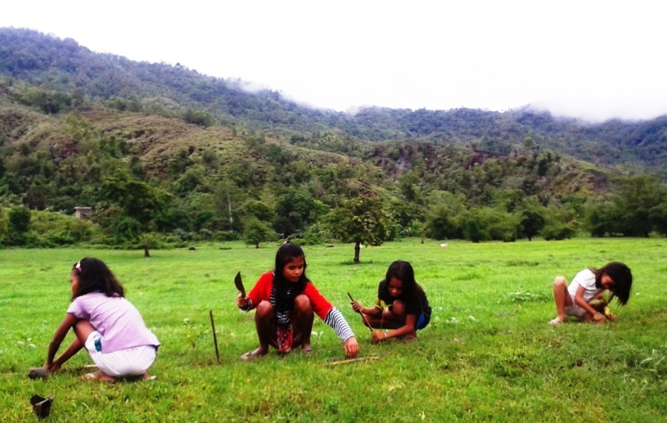
- Students of Narcisa Bermudez Elementary School in the IP community of Sitio Coro in Barangay Colorado plant trees along the Kalinawan riverside.

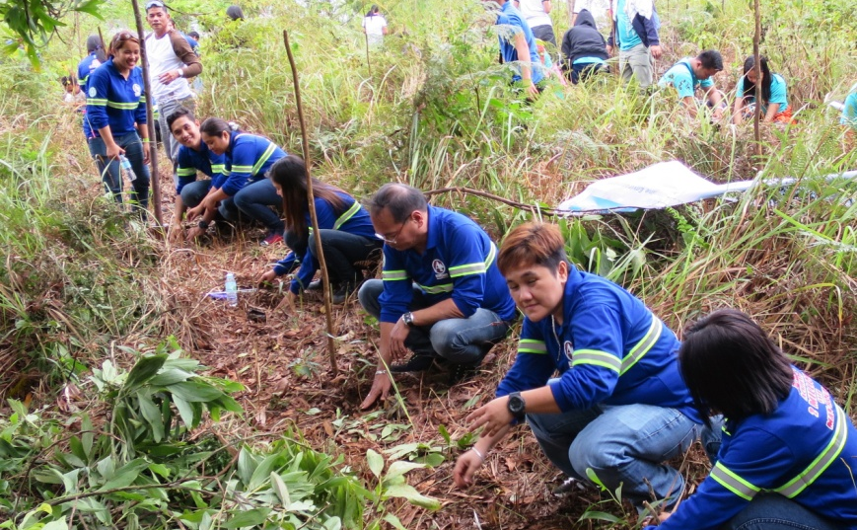
- Re-greening Surigao City. The AMVI Team plants trees side-by-side with representatives of other mining companies at the start of the Environment Month.

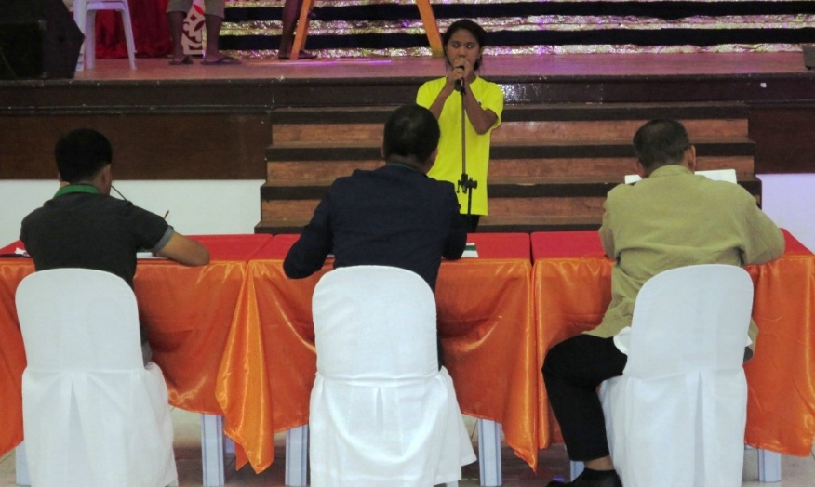
- Environment Month extemporaneous speaking qualifier Elgie Tiňa delivers her piece in front of an MGB-selected panel of judges.

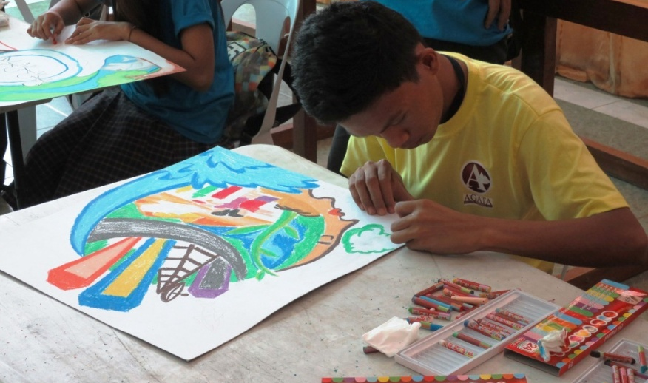
- 2015 Environment Month Poster Making Qualifier Amerson Beluan showcasing his graphic talent.

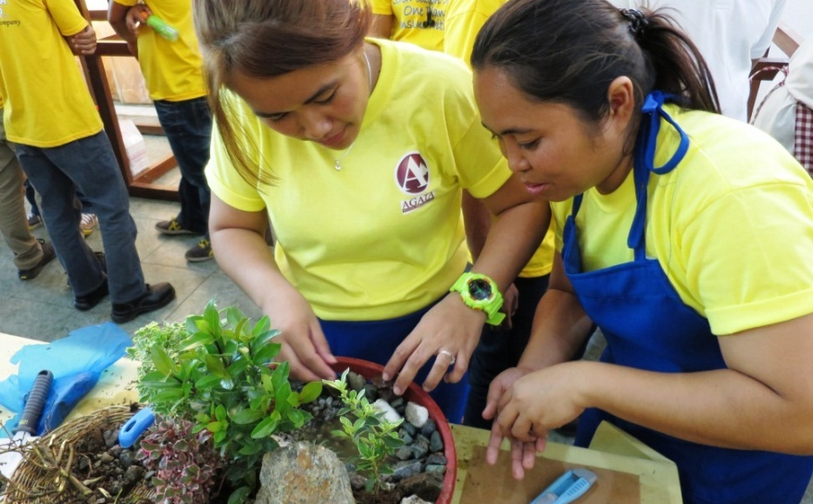
- Seeking Water for Life: the title of AMVI’s dish gardening entry, which made it as one of the event’s qualifiers.

- Best in Talent and Bb. Kalikasan 2015 1st Runner up AMVI Environment Officer Sheila Maffrah Espenido during her stunning performance at the 2015 Environment Month celebration.

About TVI in the Philippines
TVI Resource Development Philippines Inc. (“TVIRD”), is the local affiliate of TVI Pacific Inc. (TSX: TVI), a publicly-listed Canadian mining company focused on the exploration, development and production of precious and base metals from district-scale, large-system, high-margin projects located in the Philippines. Concurrent ownership of ventures is shared with partner company, Prime Resource Holdings Inc.

The commercial operations of Agata Mining Ventures Inc. (AMVI) marks the third successful mining project that TVIRD brought on-stream in the past 10 years. The company is committed to exploration and mining practices that promote transparency, responsible stewardship of the environment, and the inalienable rights to life, dignity, and sustainable development of its host communities.
www.tvird.com.ph

Contact:

Kaycee Crisostomo
Corporate Communications Director
TVI Resource Development Philippines Inc.

Email: kaycee.crisostomo@tvird.com.ph
Mobile: +63 917 579-1528
Phone: +63 2 728-8491
Fax: +63 2 728-8515

