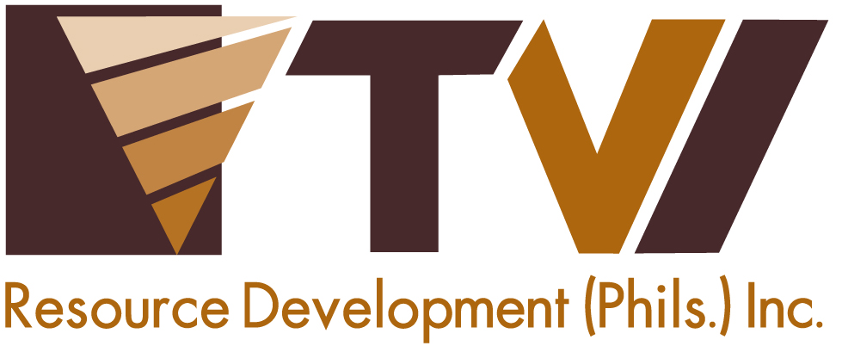
N E W S R E L E A S E

Bonding on a Community Level with Agata
AMVI unites its host and neighboring communities in celebration of Community Day 2015

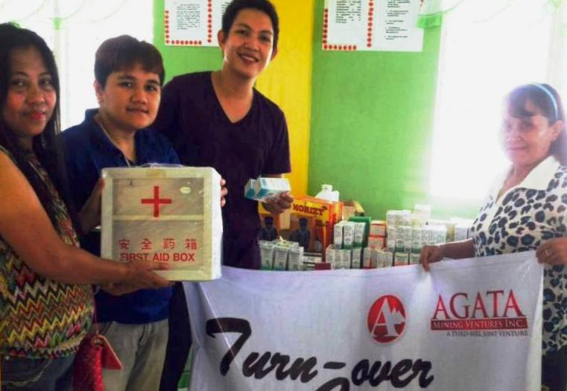
AMVI Community Development Officer Zeus Lumancas turn-over much-needed medicines and medical equipment to Barangay Colorado – one of several communities that benefit from the company’s implementation of its Social Development and Management Program (SDMP).

Tubay, Agusan del Norte / July 2015 – In a meaningful effort to unite the company’s host and neighbouring communities, including coastal barangays that are situated within the company’s Mineral Processing Sharing Agreement (MPSA) area, Agata Mining Ventures Inc. (AMVI) launched its first Community Day simultaneously in two locations: Barangay Tinigbasan’s covered gymnasium and Sitio Pitugo in Barangay Sto. Niňo. Both barangays are located within the company’s 4,995-hectare MPSA area, which encompasses the municipalities of Tubay, Jabonga and Santiago. The coastal communities were hosted in Barangay Tinigbasan’s covered gymnasium while the communities belonging to non-coastal barangays were hosted in Sitio Pitugo.

“AMVI is thankful to Barangay Council members and participants from our host communities who are present today and with whom it shares a strong partnership. While it is cold and wet outside, we are greatly encouraged by the warmth of your friendship,” said AMVI Community Relations Officer Zeus Lumancas in his opening remarks.

Prior to the event, AMVI’s Community Relations and Development Office (CREDO) coordinated with the Barangay Council Members of coastal barangays Binuangan, Tagpangahoy, Tinigbasan and Lawigan in Tubay Municipality along with counterparts in non-coastal barangays La Paz, Tagbuyacan and E. Morgado in Santiago Municipality as well as Barangay Colorado in Jabonga Municipality. Despite the rainy season in the Caraga Region and the onset of scattered thunderstorms brought about by Low Pressure Areas, AMVI pushed through with its fellowship activity with its eight participating barangays – generating very positive results from all its constituents.

“On behalf of Barangay Tagbuyacan, I would like to commend AMVI for pushing through with our very first Community Day in spite of the challenging weather condition. This only proves that AMVI is a strong partner that is committed to unite its communities towards development and progress,” says Barangay Chairman Hon. Carlito M. Balinos.

Community Day Activities
AMVI acknowledges the community’s role in supporting its operational milestones at the Agata Nickel Project. These are brought about by partnerships fostered with the collective community with whom it continues to strengthen its bond. The company’s recent activity is made even more significant by the prospect of reuniting its communities towards its common goals of progress and development – a common principle it acquired from operating company, TVI Resource Development Philippines Inc. (TVIRD), which leads the project.

During its 10-year operation in Canatuan, Zamboanga del Norte, TVIRD organized several milestone celebrations that hold great significance to its various stakeholder: Indigenous People’s Day, Earth Day, a special children’s night, Women’s Day and the respective foundation days of its host barangays, municipalities and province, to name a few.

AMVI’s first Community Day provided educational and entertaining activities like its salad-making competition that used the communities’ locally-grown vegetables, a joint tree-planting activity, an elementary inter-school quiz bee on environmental topics, a videoke singing contest and the search for the “Super Nanay” (Super Mom) with gowns designed from recycled materials.

“The whole community of Barangay Tinigbasan is very grateful for all that AMVI has done for our community. The company provided employment, livelihood programs and assistance in the repair and maintenance of community infrastructures such as the barangay hall, health center and the Tinigbasan Elementary School - but most of all, for being a sincere and truthful partner towards the development and welfare of our community,” says Barangay Chairman Hon. Dante C. Mandam.

The event culminated in a communal “Boodle Feast” (Communal Banquet) that brought all participants together in the spirit of fellowship and generosity towards each other.

Accomplishments and improvements
As part of the company’s implementation of its Social Development and Management Program (SDMP), it renews the company’s commitment to bring more support for community programs geared towards economic and social progress. As of late, AMVI launched several livelihood programs that were custom-fitted towards the available natural resources and capabilities of each community. It likewise constructed and rehabilitated schools and barangay facilities as well as supported barangay fiestas and community-related activities. It also provided medical supplies and medical equipment for barangay health centers – all the time, conducting Information and Education Campaigns (IECs) about environmental management and protection.

“I am grateful that all AMVI’s host and neighboring communities are testament that we are all united towards achieving lasting progress for the company and the communities located within its mining concession area,” said CREDO Superintendent Andre Bon Clarabal.

AMVI is a joint venture between MRL and TVIRD, which operates the Agata Project. The joint venture aims to ramp-up its current nickel laterite direct shipping ore (DSO) operations and increase its mining and shipping activities to major markets in Asia.

*******

Press photos:

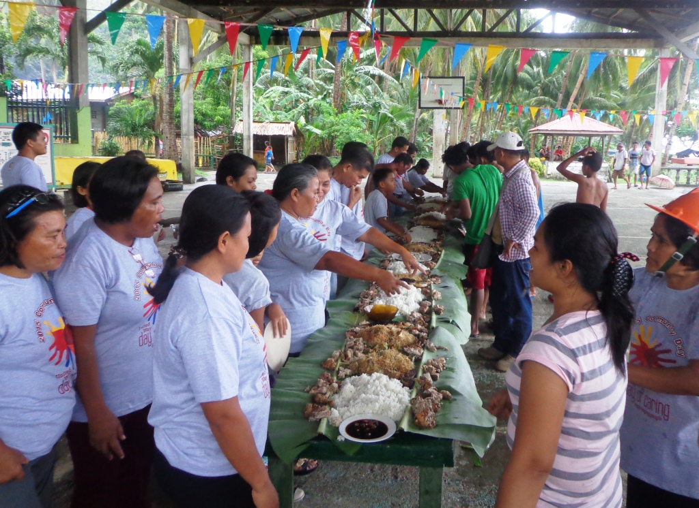
- Community dinner. AMVI fortifies its existing relationship with its host and neighbouring communities during its first Community Day, which culminated in a traditional “Budol Feast” (Traditional Filipino Communal Banquet).

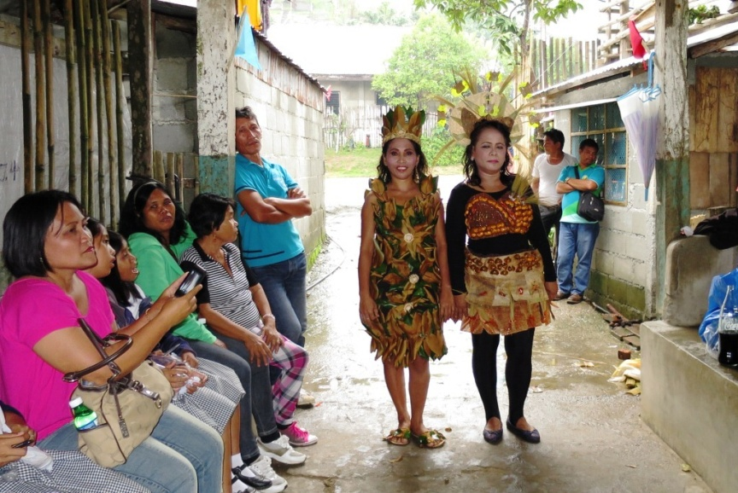
- “Super Nanay” (Super Mom) contestants from Barangays Tagbuyacan and La Paz show-off their eco-friendly costumes made from recycled materials.

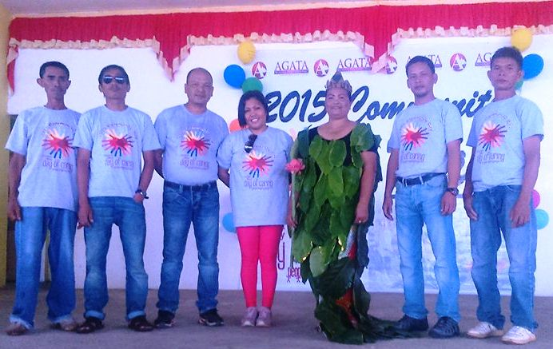
- Proclaimed “Super Nanay” Tinigbasan Kagawad Thelma Villeza (center) in a photo with fellow council members and AMVI Community Relations Officer Beth Sagala.

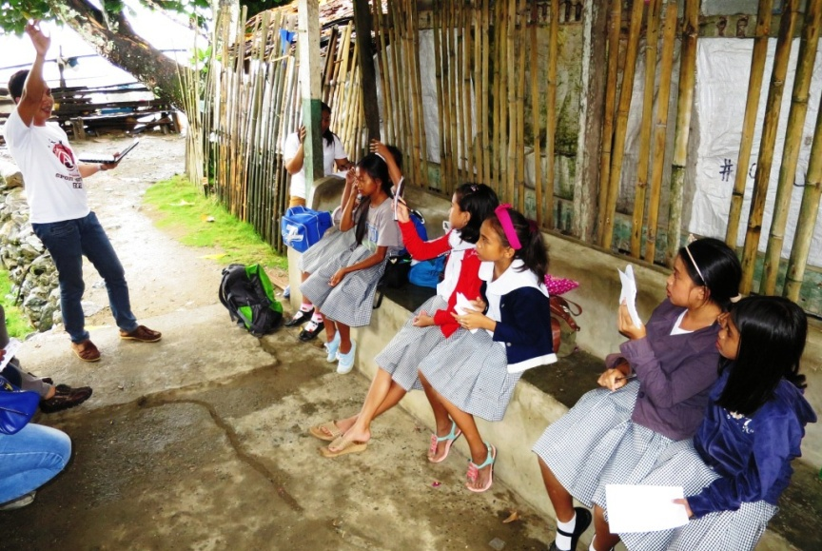
- Elementary students from Barangays La Paz, Tagbuyacan and E. Morgado battle it out during the Community Day Inter-school Quiz Bowl.

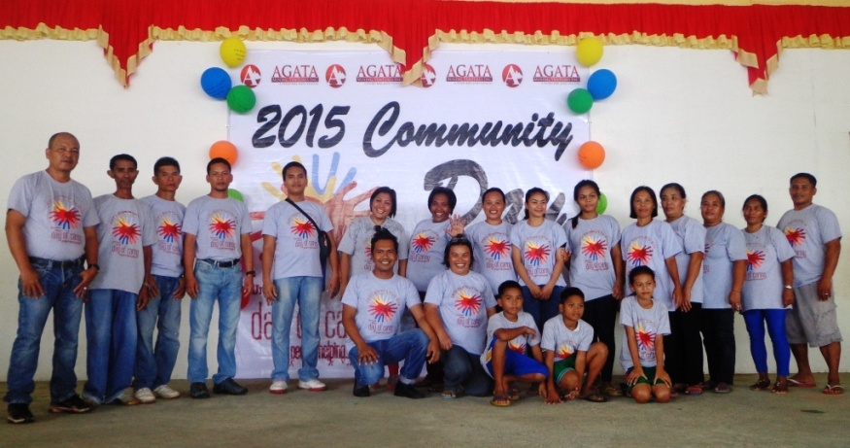
- CREDO Officers Tyron Hans Salas and Maribeth Sagala celebrate the first successful AMVI Community Day’s with host barangay officials and constituents.

About TVI in the Philippines
TVI Resource Development Philippines Inc. (“TVIRD”), is the local affiliate of TVI Pacific Inc. (TSX: TVI), a publicly-listed Canadian mining company focused on the exploration, development and production of precious and base metals from district-scale, large-system, high-margin projects located in the Philippines. Concurrent ownership of ventures is shared with partner company, Prime Resource Holdings Inc.

The commercial operations of Agata Mining Ventures Inc. (AMVI) marks the third successful mining project that TVIRD brought on-stream in the past 10 years. The company is committed to exploration and mining practices that promote transparency, responsible stewardship of the environment, and the inalienable rights to life, dignity, and sustainable development of its host communities.
www.tviphilippines.com

Contact:

Kaycee Crisostomo
Corporate Communications Director
TVI Resource Development Philippines Inc.

Email: kaycee.crisostomo@tvipacific.com.ph
Phone: +63 2 728-8491 ext. 103
Mobile: +63 917 579-1528
Fax: +63 2 728-8515

