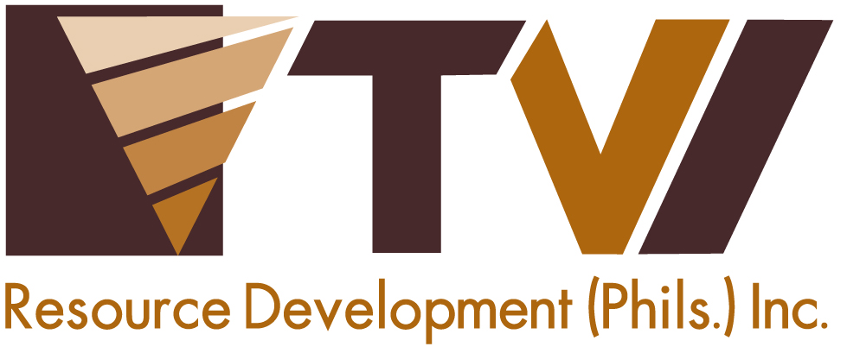
N E W S R E L E A S E

Agata Mining Delivers on First Royalty Commitment
to Indigenous Hosts
AMVI makes good on fostering long-term development with IP communities

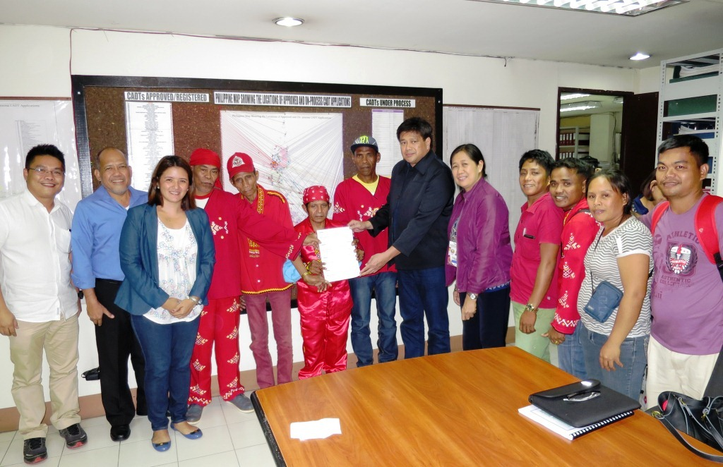
Progress and Development starts here. AMVI President Michael G. Regino (center) hands-over the first Manobo-Mamanwa royalty share to the tribes’ four Chieftains representing the IP communities in Santiago and Jabonga municipalities. The event was witnessed by NCIP Chairperson Leonor Quintayo, Officers and AMVI managers at the agency’s central office in Quezon City.

Quezon City, Manila / July 2015 – 16 years since the company started with its mineral exploration activities in the municipalities of Tubay, Santiago and Jabonga that led up to its first successful shipment in the last quarter of 2014, Agata Mining Ventures Inc. (AMVI) released its Community Royalty Development Plan (CRDP) with the corresponding first royalty share payment for the Mamanwa and Manobo Ancestral Domain Management Organization (MAMADMO) – the rightful indigenous claimants at the Agata Nickel Project recognized by the National Commission on Indigenous People (NCIP). Both CRDP and royalty were approved and witnessed by the agency at its central office in Quezon City where the formal handover was presided between AMVI President Michael G. Regino and four tribal chieftains. They were joined by NCIP Chairperson Leonor Quintayo, officers of the NCIP Regional Office XIII, key company officers and other tribesmen.

The NCIP-approved CRDP engages the company on a roadmap for the sustainable development of the Manobo Tribe of Santiago Municipality and the Mamanwa Tribe of both Santiago and Jabonga Municipalities in Agusan del Norte. The success of the entire CRDP implementation will be guided by no less than the commissioners of the NCIP Central Office and will hinge greatly on the continued cooperation between the company and the tribes.

“This landmark event marks another milestone for TVI Resource Development Inc. (TVIRD) in supporting the management of a development roadmap for its indigenous hosts at the Agata Nickel Project. It mirrors the ongoing cooperation that the company has fostered with the Subanons of Canatuan – which is based on mutual respect and reciprocity,” said Regino.

Previously, TVIRD supported the development of the Subanon Tribe in its flagship Canatuan Project in Zamboanga del Norte. The increased economic activity in the area owing to company’s mining operations also benefited the host town of Siocon, which was elevated from a fourth-class municipality to first-class status. The company likewise signed an MOA with the Subanens of Bayog, Zamboanga del Sur who provided the company with a social license to operate its Balabag Gold and Silver Project.

“TVIRD is guided by its development philosophy that prioritizes education, public health, livelihood and social infrastructure. Through its cooperation with the joint Manobo-Mamanwa chieftains, the company foresees various improvements that will redound to the overall sustainability of the tribes,” Regino concluded.

Development brought forward
The Agata mine was first explored by AMVI’s joint venture partner, MRL Nickel Philippines Inc. (MRL), in 1999. This was made possible through an agreement between the Department of Environment and Natural Resources (DENR) and Minimax Mineral Exploration Corporation (Minimax), which currently holds the Mineral Processing Sharing Agreement that covers the Agata Project.

Following the enactment of the Philippine Mining Law in 1995, all mining companies operating in the country are mandated to provide royalty shares amounting to 1% of gross income to host IP communities. Likewise, and before actual mining operations begin, mining companies should secure the free, prior and informed consent of the rightful indigenous cultural communities, including an agreed plan for their development as a tribe – which is the counterpart of a company’s Social Development and Management Program (SDMP) for non-tribal communities within its MPSA area.

Both tribes’ ancestral domain has a total population of 646 that translates into a total of 133 households. Among these, only 49% have access to proper sanitation toilet, 31% have access to electricity and only 9% have access to credit facilities. The tribes’ source of income depend largely on farming, fishing and the occasional production of herbal liniments, basket weaving, selling of rattan and seasonal employment.

Malnutrition and lack of adequate Health services are also a constant problem for each community wherein they normally depend on their elders and herbs for self medication. Likewise, education is a challenge for each community due to the proximity of schools compounded by the cost of matriculation, which is sacrificed to support other basic needs.

After 16 years, the Manobo-Mamanwa Tribes finally stand at the doorstep of progress. Moreover, as AMVI positions itself to ramp-up its current operations, so too will the rate of development for IP communities potentially gain in momentum.

AMVI’s Pledge
During the final stages of the CRDP Deliberation with NCIP Central Office Commissioners, Regino pledged that AMVI will continue providing its indigenous hosts with their quarterly royalty shares and work closely with both the NCIP and the tribes for the successful and continuous implementation of the approved CRDP.

More that adopting TVIRD’s successful Canatuan business plan, the company likewise brings its model for successfully engaging the communities at the Agata mine site. In the course of its 10-year operations in Zamboanga del Norte, the company has provided over Php250 million in royalty payments to the Subanon tribe – bringing its overall financial contribution, including SDMP and taxes, to more thanPhp850 million.

AMVI is a joint venture between MRL and TVIRD, which operates the Agata Nickel Project. The joint venture is currently moving forward with its high iron laterite direct shipping ore (DSO) operations and ships nickel ore directly to major markets in Asia.

*******

Press photos:

- A glimpse of the past. AMVI celebrates Kahimonan with Mamanwas and Manobos.

- Catching up with old acquaintances. MRL Vice President Engr. Edsel Abrasaldo initiates a short-chat with Dakula Dalmacio Capilitan and Dakula Coro Regelio Bebe.

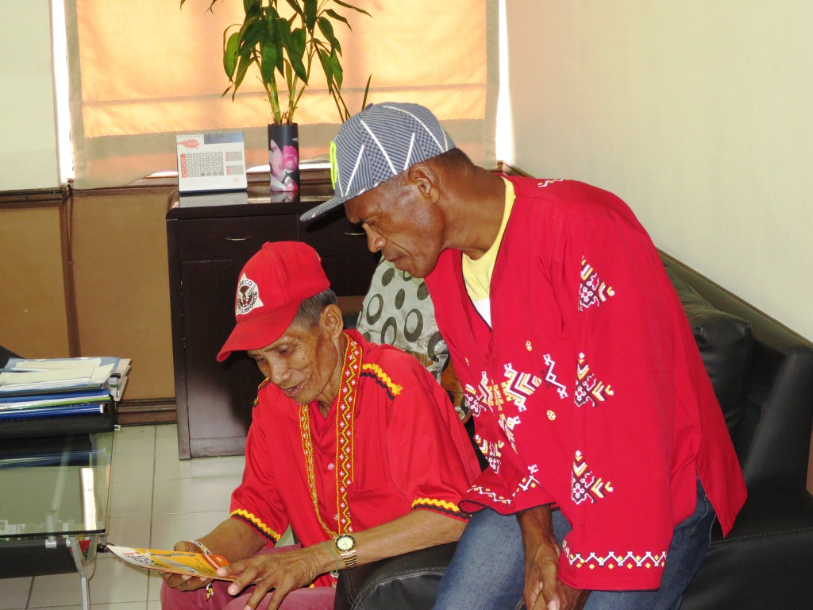
- Mapaso Tribal Leader Hawodon Mapaso Rolito Moron and Coro Sector Tribal Leader Dakula Coro Rogelio Bebe go through IP informative articles and leaflets on display inside the NCIP Central Office Chairman’s receiving area.

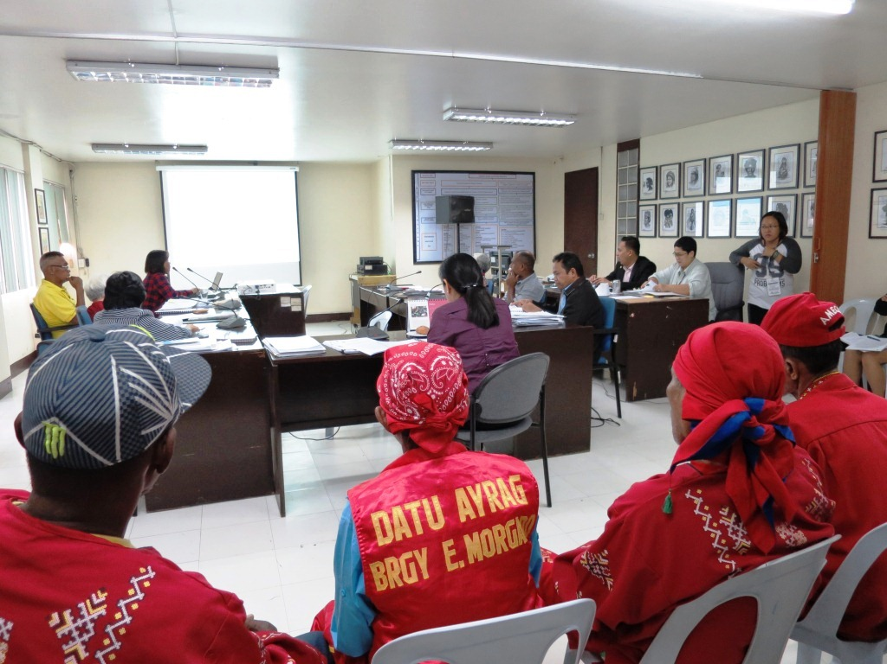
- 4 IP Tribal Leaders listens attentively as the NCIP Central Office Commissioners deliberate on the AMVI-MAMADMO CRDP as presented by NCIP Regional Office XIII Regional Director Atty. Pinky Grace P. Pabelic

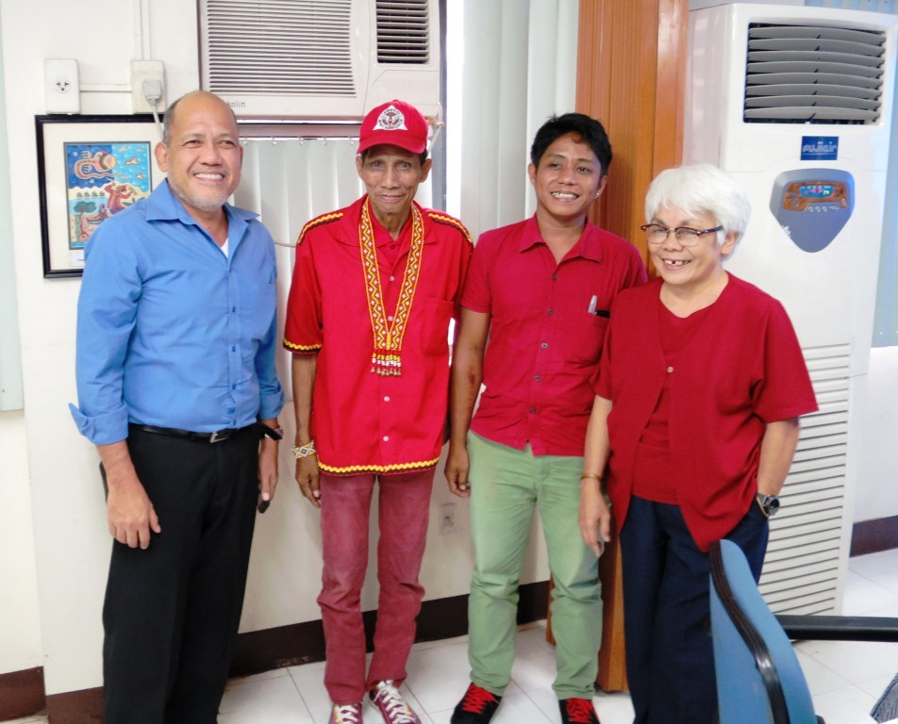
- MRL Vice President Engr. Edsel Abrasaldo, Mapaso Sector Tribal Leader Hawodon Mapaso Rolito Moron, MMTCMO Secretary Raymond P. Moron and NCIP Commissioner Ms. Zenaida Brigida H. Pawid flash smiles for a successful deliberation and approval of the AMVI-MAMADMO CRDP.

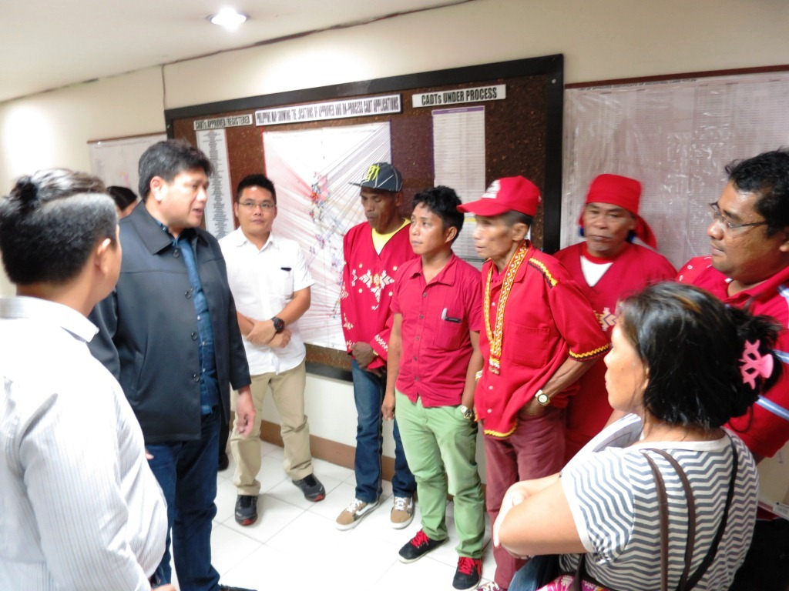
- All is well under way. AMVI President Michael G. Regino gives an inspirational message and assures IP Tribal Leaders of AMVI’s continued support to sustainable development through quarterly payment of Royalty Shares and the successful implementation of the approved CRDP.

About TVI in the Philippines
TVI Resource Development Philippines Inc. (“TVIRD”), is the local affiliate of TVI Pacific Inc. (TSX: TVI), a publicly-listed Canadian mining company focused on the exploration, development and production of precious and base metals from district-scale, large-system, high-margin projects located in the Philippines. Concurrent ownership of ventures is shared with partner company, Prime Resource Holdings Inc.

The commercial operations of Agata Mining Ventures Inc. (AMVI) marks the third successful mining project that TVIRD brought on-stream in the past 10 years. The company is committed to exploration and mining practices that promote transparency, responsible stewardship of the environment, and the inalienable rights to life, dignity, and sustainable development of its host communities.
www.tviphilippines.com

Contact:

Kaycee Crisostomo
Corporate Communications Director
TVI Resource Development Philippines Inc.

Email: kaycee.crisostomo@tvipacific.com.ph
Phone: +63 2 728-8491 ext. 103
Mobile: +63 917 579-1528
Fax: +63 2 728-8515

