N E W S R E L E A S E

In Celebration of Ocean Month 2015:
Agata Commissions New Tower House Observatory
to Protect the Coral Reef
The new facility’s turnover to TIFFA highlights the company’s celebration of this year’s month of the ocean

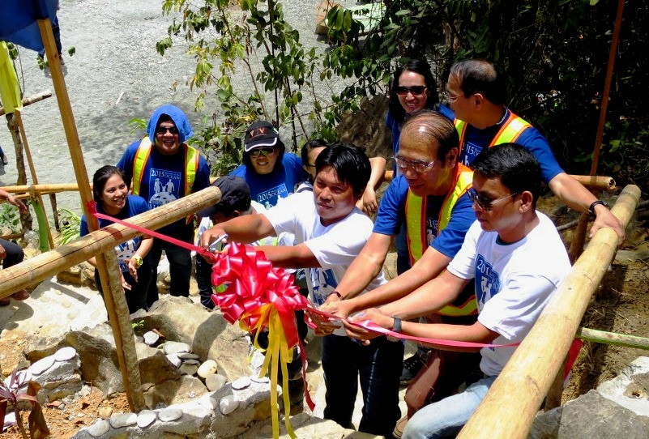
Ribbon-cutting ceremony after which the TIFFA members were accompanied by AMVI managers to their new Tower House Observatory, which significantly improves the joint environmental monitoring activities of the company and TIFFA – all for the protection of marine life and ecosystems located in the coastal waters of Sitio Payong-Payong.

Tubay, Agusan del Norte / June 2015 – In response to the Department of Environment and Natural Resources (DENR) and the Department of Agriculture’s Bureau of Fisheries and Aquatic Resources’ (BFAR) call on LGUs and the private sector to support the 16th Ocean Month 2015 theme: “Stand Up, Save Our Reefs,” Agata Mining Ventures Inc. (AMVI) rolled-out activities that promote the protection and preservation of coral reefs – particularly in its causeway area in Sitio Payong-Payong in Barangay Tinigbasan, Tubay Municipality, Agusan del Norte. As Barangay Tinigbasan acquired a protected marine sanctuary, AMVI commissioned it with an inland Tower House Observatory - which was officially turned-over by the company during this year’s observance of Ocean Month.

While the company expands and ramps-up its mining operations, so will its commitment to sustain the Coastal Resource Management Program (CRMP) and bring much needed support and assistance to the coastal barangays of Tagpangahoy and Binuangan.

“I am proud to say that AMVI was able to establish the constant monitoring, evaluation and protection of the marine sanctuaries in Barangays Lawigan and Tinigbasan in close coordination with the Lawigan Farmers and Fisher-folks Association (LAFFA), the Tinigbasan Farmers and Fisher-folks Association (TIFFA), their respective local community members, and the DENR. It is the most important among all the company’s environment management and protection program accomplishments to date,” said Environment Manager Jesalyn Guingguing.

Turnover Ceremony
Prior to the turnover of the Observatory, both company and DENR representatives delivered their messages to the community, recognizing the importance of sustaining the cooperative efforts of AMVI, the LGU and people’s organizations towards environment protection and social development.

“This mining company has changed so much over the years, but one thing remains unchanged: its constant concern and commitment in preserving and improving the source of livelihood, cultural traditions and welfare of Barangay Tinigbasan. A sincere and genuine care for the community that we have always felt and continue to feel from AMVI,” says Barangay Tinigbasan Council Member Narry Dela Sala.

Also onboard to discuss the importance of Ocean Month were Ms. Mariefe Macalisang from DENR’s Coastal Marine Management Division and Forester Barlou Aparte of Tubay’s Community Environment and Natural Resources Office (CENRO). Their respective presentations were followed by the signing of a Memorandum of Agreement (MOA) between AMVI and TIFFA that appoints both companies as co-stewards of the environment.

“The CMMD and CENRO of Tubay are honored to witness AMVI’s ceremonial turnover of the new Tower House Observatory to TIFFA and once again reaffirm our commitment to work together as partners dedicated to protect and preserve the most important ecosystem in the planet – the coral reef,” said Aparte.

Project history
AMVI’s CRMP was originally initiated by the municipality of Tubay and centers on protecting and improving the coastal environment of Barangays Lawigan, Tinigbasan, Tagpangahoy and Binuangan. The program was later adopted by the company, which was able to identify the need to support and enhance the implementation of coastal projects to each community. The company likewise mobilized its Social-Environmental Team and created a Community Technical Working Group (CTWG) from the four Barangays with the close participation of the municipal government and DENR Caraga.

The team then conducted a Training Workshop, a Marine Habitat Assessment, a Social Perception Survey and a Community Mapping that led to the CRMP’s formal launch on the 12th of December in 2008. Barangay Lawigan was the first coastal barangay selected for a protected marine sanctuary initially starting with just buoy markers up until the commissioning of a coastal Tower Observatory.

AMVI recognizes the significance of coral reefs as “underwater forests or cities” necessary in sustaining coastal marine ecosystems, as front-line barriers against coastal calamities and as an important factor in improving the adaptive capacity of coastal communities against the constant threat of global climate change. Over the years and prior to the start of its mining operations, the company has consistently been acknowledged by the DENR for its tireless dedication in the implementation of environment protection and preservation programs to the benefit of both aquatic and marine habitats.

The company has received a number of awards and recognition from DENR Caraga, including its exemplary contribution and eminent support to the Coral Relocation Project in the municipality of Tubay in 2013, Adopt-an-Estuary or Body of Water Program and the Integrated Coastal Management Program in 2014, to name a few.

AMVI partners with the DENR on various initiatives, underscoring the importance of protecting and preserving the country’s coastal areas that comprise 78% of the country’s 80 provinces – or more than have of 1,634 cities and municipalities in the Philippines.

*******

Press photos:

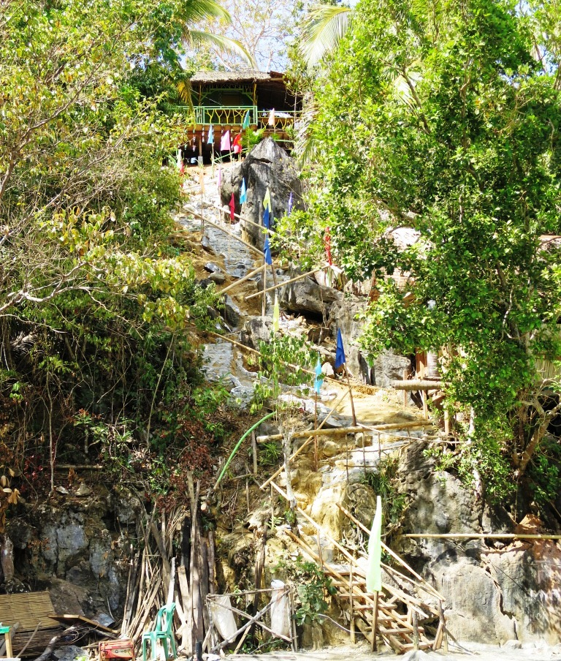
- A bird’s-eye view. The newly commissioned tower house observatory provides an excellent vantage point to monitor the coastal waters of Sitio Payong-Payong.

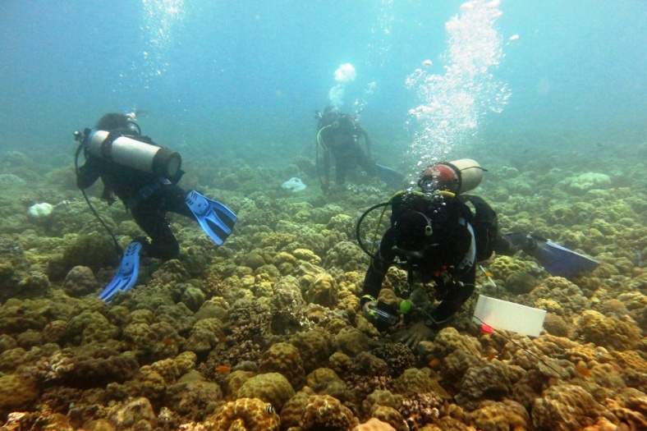
- Constant monitoring and evaluation of marine life and ecosystems in the coastal waters of Barangay Tinigbasan are led by AMVI Environment Manager Jesalyn Guingguing along with divers from the local community trained by Bantay Dagat.

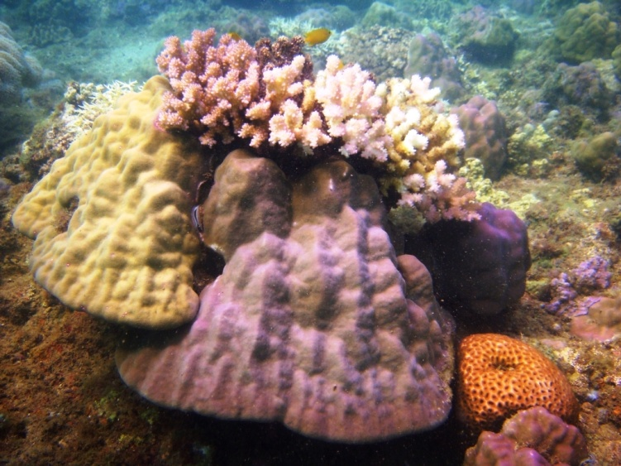
- Marine biodiversity. A thriving marine sanctuary in Barangay Tinigbasan is testament to AMVI’s dedicated efforts to protect and preserve the most important ecosystem in the planet – the coral reef.

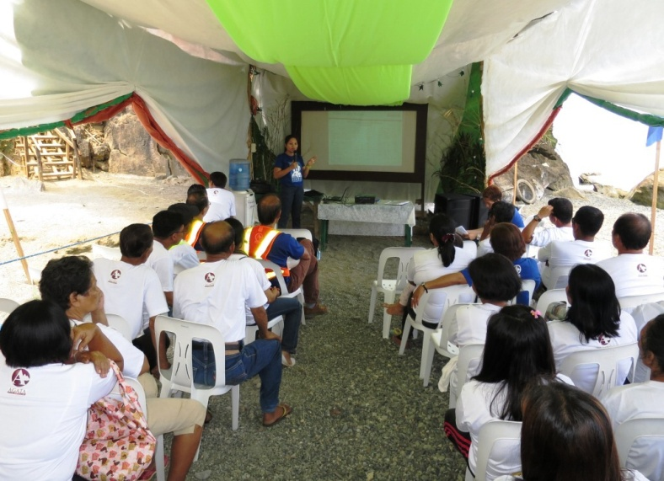
- AMVI Environment Manager Jesalyn Guingguing presents the company’s data, statistics and accomplishments in relation to programs centered on the protection of marine sanctuaries in Barangays Tinigbasan and Lawigan.

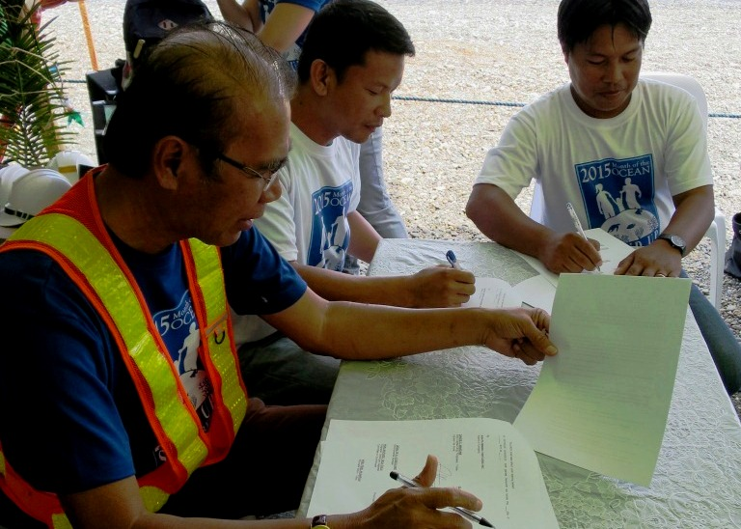
- AMVI Resident General Manager Germidas Las Piňas, Barangay Captain Dante Mandam and TIFFA Chairman Glenn Capon sign the MOA for the formal turnover of the Tower House Observatory facility to TIFFA.

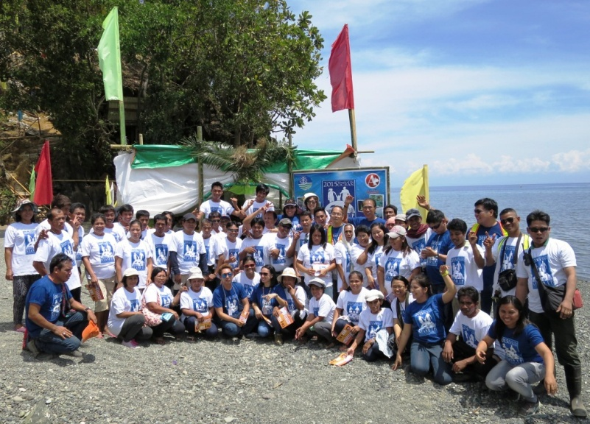
- TIFFA members, AMVI managers and DENR representatives come together at the new Tower House Observatory for a successful and meaningful Ocean Month 2015 celebration.

About TVI in the Philippines
TVI Resource Development Philippines Inc. (“TVIRD”), is the local affiliate of TVI Pacific Inc. (TSX: TVI), a publicly-listed Canadian mining company focused on the exploration, development and production of precious and base metals from district-scale, large-system, high-margin projects located in the Philippines. Concurrent ownership of ventures is shared with partner company, Prime Resource Holdings Inc.

The commercial operations of Agata Mining Ventures Inc. (AMVI) marks the third successful mining project that TVIRD brought on-stream in the past 10 years. The company is committed to exploration and mining practices that promote transparency, responsible stewardship of the environment, and the inalienable rights to life, dignity, and sustainable development of its host communities.
www.tvird.com.ph

Contact:

Kaycee Crisostomo
Corporate Communications Director
TVI Resource Development Philippines Inc.

Email: kaycee.crisostomo@tvird.com.ph
Mobile: +63 917 579-1528
Phone: +63 2 728-8491
Fax: +63 2 728-8515

