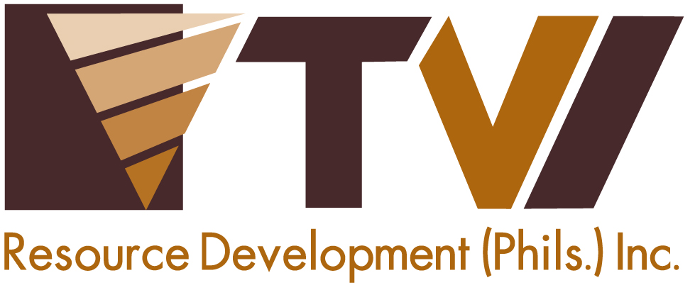
N E W S R E L E A S E

Agata Ushers School Year 2015-2016 with Brigada Eskwela
AMVI support back-to-school activities for schools located within its host and neighboring communities.

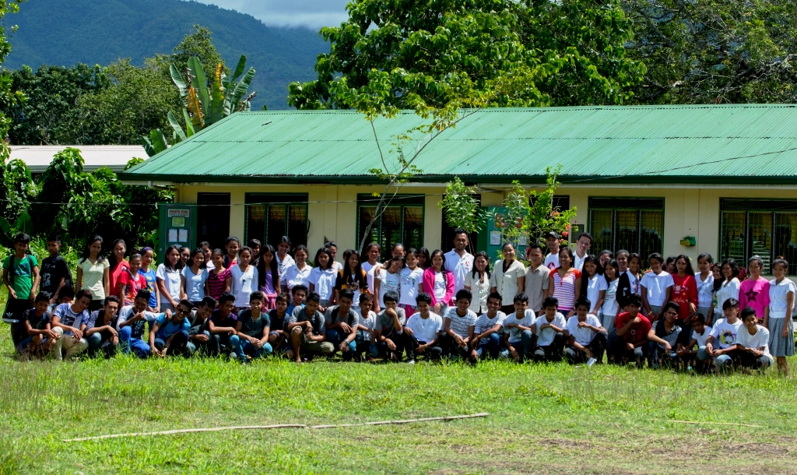
Sustained Development. Through its joint venture partner, MRL Nickel Philippines Inc., AMVI provided classrooms to Doňa Rosario National High School during its exploration days and prior to the start of the company’s mining operations. This school is among several others AMVI supported - testament to TVIRD’s tradition of promoting responsive education in its adopted communities.

Santiago, Agusan del Norte / June 2015 – In TVIRD’s tradition of ushering the new school year by making schools clean, safe and conducive to learning, Agata Mining Ventures Inc. (AMVI) mobilized its Community Relations personnel to support the Department of Education’s (DepEd) Brigada Eskwela 2015, which is also known as the National Schools Maintenance Week. The activity is a week-long activity that promotes “Bayanihan” - referred to as the Filipino spirit of unity and cooperation – and to help prepare public school facilities for the incoming school year.

On the national level, the activity commenced last May and aimed to clean and beautify the country’s public schools as well as repair and maintain its facilities. The DepEd’s Regional Offices, School Division Offices and its key officials at the agency’s Central Office selected Region XIII (Caraga) as its host region and launched a caravan to roll-out and monitor Brigada Eskwela for the year. As one of the major mining companies in the region, AMVI extended its support by providing the necessary construction materials for three schools in its host municipalities of Tubay and Santiago. Company volunteers also joined and helped the local program team from each school to implement the upkeep of each institution.

A healthy learning environment
AMVI believes that providing a healthy learning environment for students greatly increases the quality of education they receive from their schools – a common principle it acquired from TVI Resource Development Philippines Inc. (TVIRD), which leads the Agata Nickel Project in Tubay, Agusan del Norte. At the height of its operations in Canatuan, Zamboanga del Norte, TVIRD supported 10 schools with close to 4,000 students, including Canatuan Public’s School’s growing population of 850 students.

As public schools have more students than private schools do, these require more frequent maintenance and improvement. AMVI supported Binuangan Elementary, La Paz Elementary and Prospero D. Salas Elementary Schools by providing paint, brushes, wooden and steel building materials, sealants and adhesives, roofing and electrical materials, and other necessary construction equipment and supplies. The week-long activity successfully combined the help of local volunteers and company employees.

“On behalf of Binuangan Elementary School, we would like to thank AMVI for their valuable support in providing our school with the much-needed materials during Brigada Eskwela,” said Head Teacher Doris O. Mirafuentes.

Aside from maintaining the upkeep of these schools, AMVI also supports the education of five scholars, including children from the local indigenous communities. The company also conducts annual feeding programs during the National Nutrition Month spearheaded by the National Nutrition Council. In 2014, the company supported feeding programs in Lawigan Elementary, Tinigbasan Elementary and Kauswagan Elementary School.

This year, as the company ramps-up its DSO operations, more support and assistance are on the way such as providing schools with new chairs, tables, blackboards, shelves, computers, TV sets and projectors. Also included are the repair and construction of school daycare and feeding centers that are centered on enhancing the students’ learning environment – confirmation of the company’s continued dedication to sustaining the development of its communities.

“The company welcomes every opportunity to take part in meaningful programs and activities – most especially Brigada Eskwela – which promotes community and social development through better educational facilities,” AMVI Community Relations Officer Tyron Hans Salas.

Service and commitment
In carefully assessing the distinctive requirement of each community in close coordination with both public and private sectors, AMVI identifies the best solutions to address specific community needs, thus maximizing the benefits and increasing the efficiency of its programs. Its initiatives relating to Responsive Education center on improving learning facilities, providing school equipment and supplies, construction materials, and financial assistance for school activities.

The company also regularly conducts Information and Education Campaigns (IECs) among its school communities and students, and even adopted mini school parks and plant nurseries.

AMVI is a joint venture between MRL and TVIRD, which operates the Agata Project. The joint venture aims to ramp-up its high iron laterite direct shipping ore (DSO) operations, increasing its mining and shipping activities to major markets in Asia.

*******

Press photos:

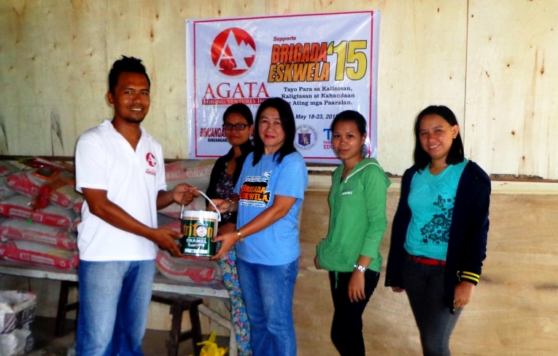
- AMVI Community Relations Officer Tyron Hans Salas hands-over paint and other construction materials to Binuangan Elementary School Teachers.

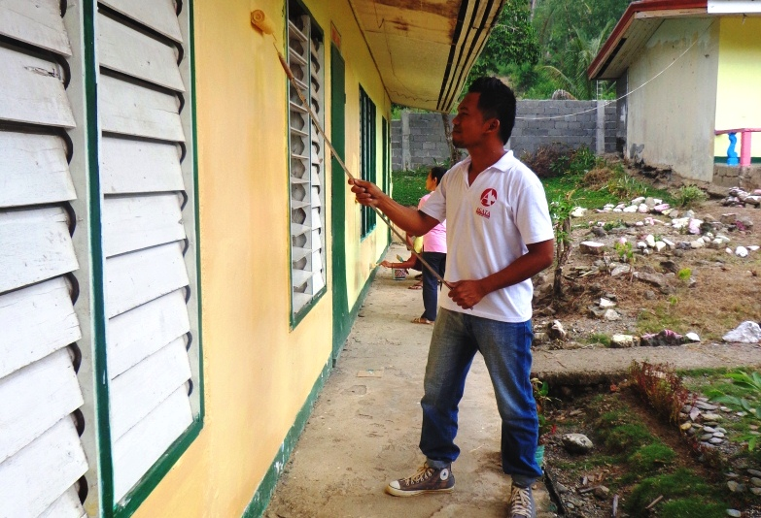
- Happy helpers. AMVI personnel lend a helping hand to Brigada Eskwela 2015 volunteers.

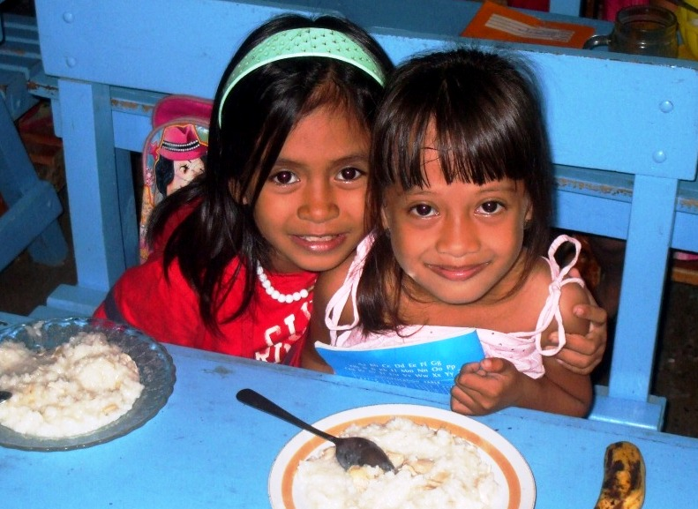
- AMVI regularly conducts feeding programs as part of both its Education and Health & Sanitation Programs. (In photo): student-beneficiaries in Tinigbasan Elementary School.

About TVI in the Philippines
TVI Resource Development Philippines Inc. (“TVIRD”), is the local affiliate of TVI Pacific Inc. (TSX: TVI), a publicly-listed Canadian mining company focused on the exploration, development and production of precious and base metals from district-scale, large-system, high-margin projects located in the Philippines. Concurrent ownership of ventures is shared with partner company, Prime Resource Holdings Inc.

The commercial operations of Agata Mining Ventures Inc. (AMVI) marks the third successful mining project that TVIRD brought on-stream in the past 10 years. The company is committed to exploration and mining practices that promote transparency, responsible stewardship of the environment, and the inalienable rights to life, dignity, and sustainable development of its host communities.
www.tviphilippines.com

Contact:

Kaycee Crisostomo
Corporate Communications Director
TVI Resource Development Philippines Inc.

Email: kaycee.crisostomo@tvipacific.com.ph
Phone: +63 2 728-8491 ext. 103
Mobile: +63 917 579-1528
Fax: +63 2 728-8515

