N E W S R E L E A S E

Coexisting Business and Environment
Highlight Agata’s Earth Day Celebration
Agata Mining kicks-off Earth Day 2015 with an ongoing commitment for a balanced ecology

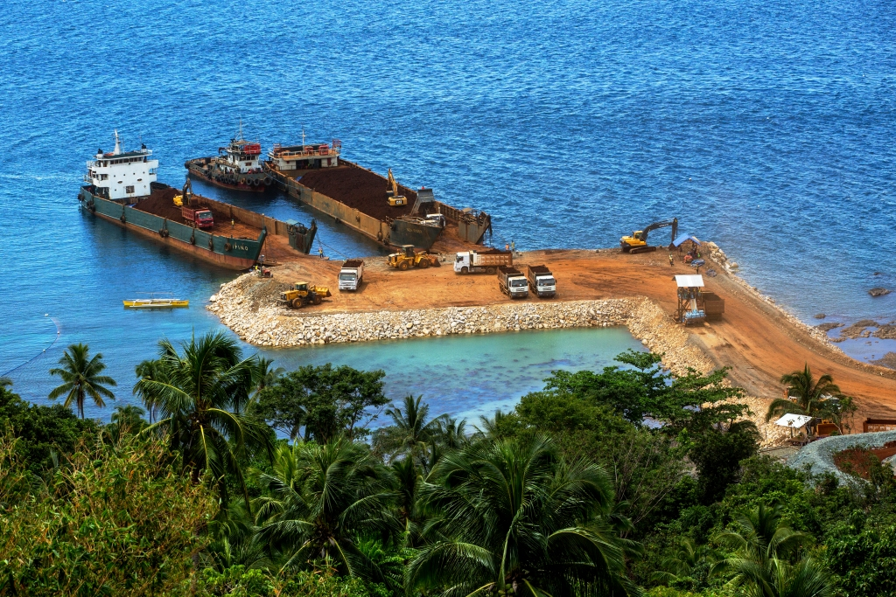
A balanced ecology. Ongoing reforestation activities, which has planted and grown over 145,000 trees at the Agata Nickel Laterite DSO Project, offsets the areas affected by mining activities. (In photo): Indigenous trees thrive right above the Agata Causeway in Tubay, Agusan del Norte.

Santiago, Agusan del Norte / May 2015 – In its company-wide observance of Earth Day 2015 – and in sustaining the momentum of its adopt-a-river program – Agata Mining Ventures Inc. (AMVI) doubled its effort to preserve the natural environment and control soil erosion along Kalinawan River by planting twice as many seedlings in the host riverside community of Barangay. E. Morgado. Employees, local government officials and community volunteers along with over 120 participants planted Talisay and rubber tree seedlings along the river, adding to some 145,664 tree seedlings the company has planted to date.

The activity kicked-off the company’s Earth Day celebration and signifies the company’s commitment to a clean and healthy environment that it carries forward from TVI Resource Development Philippines Inc. (TVIRD) – lead developer of the Agata Mining Project.

Last year, the company also supported the Department of Environment and Natural Resources’ (DENR’s) TreeVolution: Greening MindaNOW – a massive simultaneous tree-planting activity that successfully sown 3.2 million seedlings in one hour across six regions in Mindanao. According to local DENR officials, the activity broke India’s Guinness World Record as well as helped support the agency’s National Greening Program (NGP) target to plant 1.5 billion trees in 1.5 million hectares by 2016.

A 45-year tradition
The observance of Earth Day was founded in 1970 by US Senator Gaylord Nelson as an educational campaign for primary and secondary schools, colleges and universities as well as communities across the United States. Since then, it has been traditionally celebrated worldwide every 22nd of April, during which various events in over 192 countries demonstrate global support for environmental protection and preservation.

In the Philippines, Earth Day was launched in 1990 as part of a global commitment to build a safe, just and sustainable environment. Then President Corazon Aquino signed Proclamation No. 553 to support Earth Day activities, and after a decade, the DENR was nominated as the lead government agency responsible for the country’s observance.

Earth Day at AMVI
In March, the company launched its official Information and Education Campaign (IEC) for Earth Hour 2015 as well as various activities to promote the surrounding communities’ participation.

AMVI staged its first environmental run, flag-raising competition, and Earth Day pageant and talent competition on the day itself. Employees also pledged their ‘Green Acts’ for a sustainable future during the bonfire – commitments that they sent-off on sky lanterns that culminated the entire program.

AMVI closely subscribes to the TVIRD principle on environmental protection, in which the company’s responsibility begins before actual mining operations. Since its exploration days in Canatuan, Zamboanga del Norte, TVIRD planted over 416,000 trees within and around its 508-hectare Mineral Processing Sharing Agreement (MPSA) area, bringing average forest density to more than 800 trees per hectare and making the area five times ‘greener’ than before the company came in.

Over the years, AMVI has likewise initiated various environmental programs that include Solid Waste Management – a segregation process implemented in its host and neighboring communities, Vermi-Culture Livelihood for converting biodegradable waste into organic fertilizers, and a Mini Recycling Junkshop that promotes livelihood through the use of recyclable materials for seedling pots. AMVI also spearheads the Adopt-a-School Mini Park program through which the company cultivates the pocket gardens of 19 schools in Barangays La Paz, E. Morgado, Colorado and Tagbuyacan along Kalinawan River.

*******
Press photos:

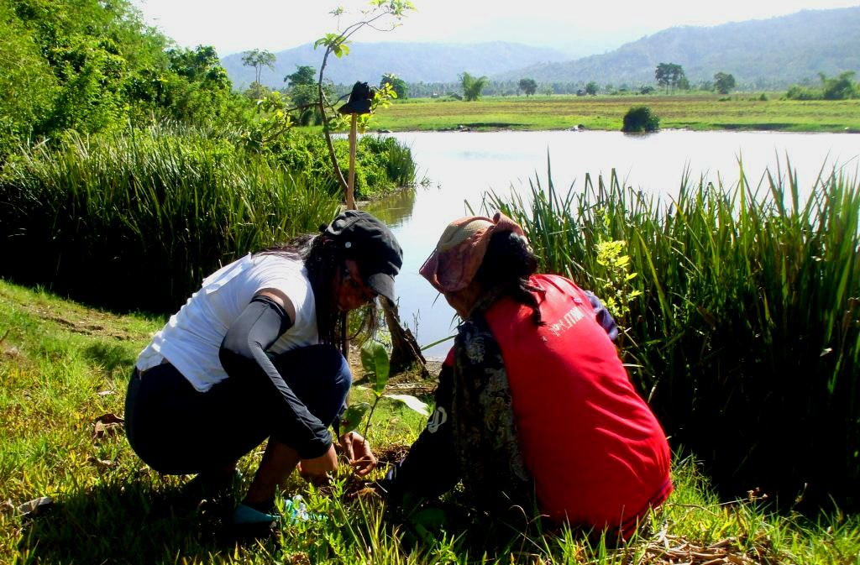
- Planting twice as much. AMVI employees double-up on ‘acts of green’ during the company’s Earth Day planting activity along Kalinawan River.

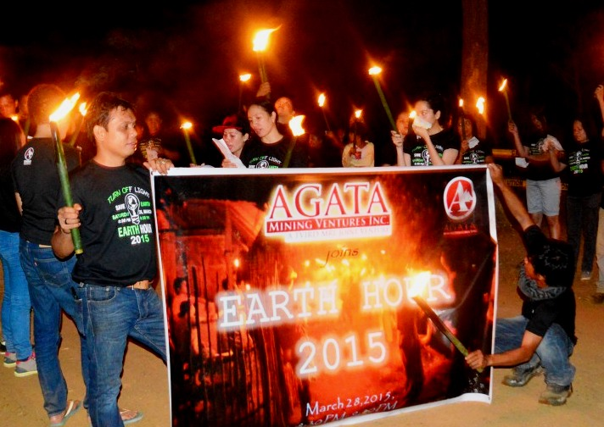
- Mob culture. AMVI Employees stage an Earth Hour awareness parade in Barangay E. Morgado in Santiago.

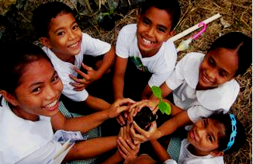
- AMVI’s Adopt-a-School Mini Park program marks improvement for 19 schools within its mining concession area.

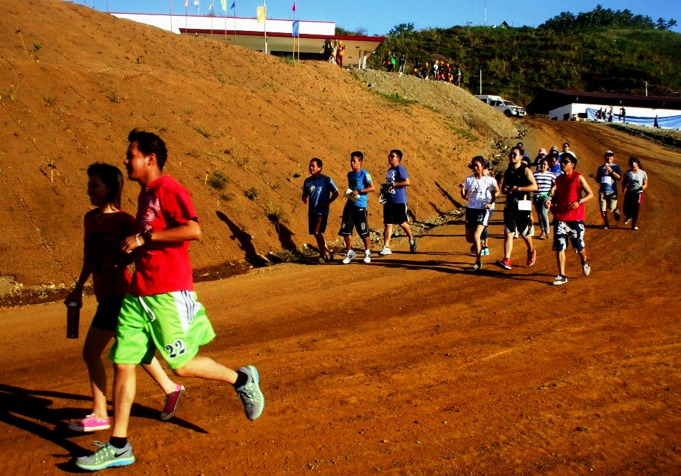
- Earth Day activities. Five Teams competed during AMVI’s first environmental run, which was followed by a flag-raising competition, and Earth Day pageant and talent competition.

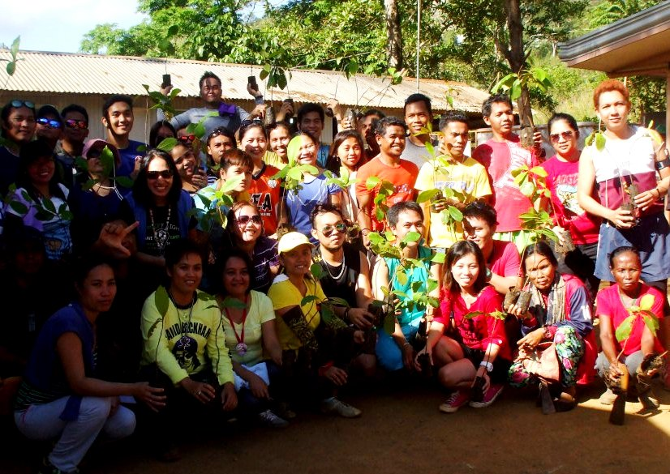
- AMVI employees join 192 countries worldwide in active support for Earth Day 2015.

About TVI in the Philippines
TVI Resource Development Philippines Inc. (“TVIRD”), is the local affiliate of TVI Pacific Inc. (TSX: TVI), a publicly-listed Canadian mining company focused on the exploration, development and production of precious and base metals from district-scale, large-system, high-margin projects located in the Philippines. Concurrent ownership of ventures is shared with partner company, Prime Resource Holdings Inc.

The commercial operations of Agata Mining Ventures Inc. (AMVI) marks the third successful mining project that TVIRD brought on-stream in the past 10 years. The company is committed to exploration and mining practices that promote transparency, responsible stewardship of the environment, and the inalienable rights to life, dignity, and sustainable development of its host communities.
www.tvird.com.ph

Contact:

Kaycee Crisostomo
Corporate Communications Director
TVI Resource Development Philippines Inc.

Email: kaycee.crisostomo@tvird.com.ph
Mobile: +63 917 579-1528
Phone: +63 2 728-8491
Fax: +63 2 728-8515

