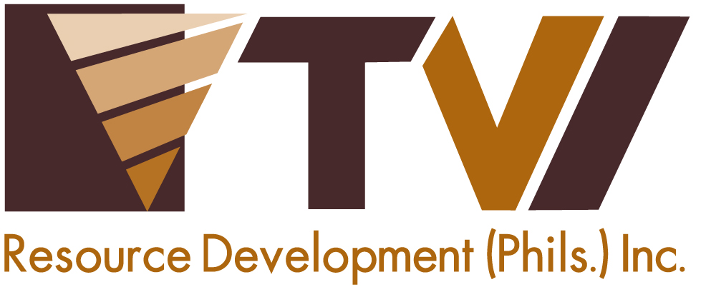
N E W S R E L E A S E

Lady Miners Make a Remarkable Difference
at the Agata Nickel Project
AMVI heralds the valuable contributions and accomplishments of women

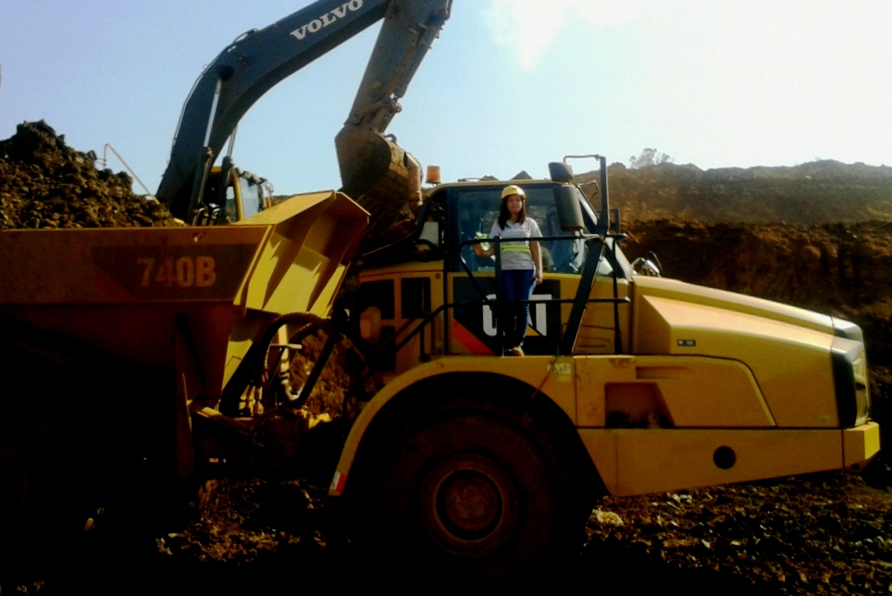
She drives monster trucks. 25-year old Joyris Gasulas began her career as an operator of Articulated Dump Trucks (ADTs) – one of the most massive transport equipment used for loading ore onto barges waiting at the AMVI causeway area. Her dedication merited her recent promotion as Site Admin for Monark – an affiliated company of AMVI’s contractor, 4K Development Corporation.

Tubay, Agusan del Norte / April 2015 – “In my line of work, the usual industry pick-up line is: ‘What is a woman like you doing in an industry like this?’ I usually encounter this every time I declare that I am a (resource) geologist,” said Kathleen “Kate” Digdigan during a 2014 edition of the Philippine Mining Luncheon titled “Women as Game Changers in Resource Development.”

“And whenever people ask me this question, I would jokingly tell them it is because most men are already taking-up nursing! So I guess it is fair enough that women penetrate and excel in a previously male-dominated profession,” she quipped at the start of her speech – to the applause and gratification of the luncheon’s audience. Kate currently heads-up the Resource Development and Special Projects unit of TVI Resource Development Philippines Inc. (TVIRD) – operator of the Agata Nickel Project – and has considerable experience in exploration, resource modeling and processing operations both here and abroad. She is also a mother of two.

In commemoration of National Women’s Month – and in recognition of the significant achievements of the women in its organization – Agata Mining Ventures Inc. (AMVI) conducted a poll among its ranks with the objective of honoring its female employees who are truly exceptional. The company’s initiative is in line with the Philippine Commission on Women (PCW) tribute: “Juana, desisyon mo ay mahalaga sa kinabukasan ng bawat isa” (your decision is valuable for the future of all), which aims to bring awareness and appreciation for the Filipino working woman.

Breaking the glass ceiling
As an equal opportunities employer, AMVI acknowledges the contribution of all women across its ranks and those who continue to lead and excel in performing their duties. Over the years, there has been a sizeable increase of women in the workforce – may it be in the office or in the field – and women are consistently breaking through. AMVI’s mining operations is not an exception.

Historically, and right up until the industrial revolution, a male-oriented workplace has been the norm that has been deeply ingrained in society. While in some industries, women continue to struggle for equal job opportunities. This cannot be said about the Philippine mining industry and AMVI, which employs a significant number of women – not only in its Mines, Admin, Finance and Community Relations Departments, but also in Safety, Security, Engineering and Environment.

There are also women who hold key positions within the company and are responsible for overseeing the company’s day to day mining operations. In fact, two lady executives hold top positions in TVIRD: Finance VP Maryknoll Zamora and Corporate Services VP Yody Marzo, who is an active and productive member of Diwata - an NGO comprised of women advocating the responsible development of the Philippines' mineral wealth.

“I encountered the biggest challenge (ever) during the company’s exploration phase when I started as the only Environmental Officer assigned to guide drilling operations to comply with the mandates of the DENR’s Mines and Geosciences Bureau (MGB). I perceived mining as a male-dominated industry, but I managed to discipline everyone to comply with both company and government rules and regulations,” said AMVI Environmental Department Manager Jesalyn Guingguing.

“In time, I assumed greater responsibilities as the company steadily increased the number of women in its workforce,” she added.

“Providing for my family is the source of my strength and inspiration in fulfilling my responsibilities with 100 percent commitment and dedication,” asserted Joyris Gasulas, whose company, Monark, is an affiliated company of AMVI’s contractor, 4K Development Corporation. Joyris is a licensed driver and operator of Articulated Dump Trucks (ADTs) – massive trucks that are used for loading and transporting several tons of nickel ore from the mine pit onto the barges.

“Adjusting to my work environment as well as getting the same treatment and respect is by far the biggest challenge I have encountered while working as an ADT operator. It was tough for me to prove that female heavy equipment operators can perform just as well as our male counterparts,” she said. As of late, Joyris was appointed by Monark as its new Site Admin for the Agata Nickel Project – a position entrusted to her by her direct supervisor.

Juana get to the top?
AMVI’s search for the “Women of Agata Mining” and the distinction of “Juana of AMVI” involved all its female employees, ultimately to honor one female employee who has exemplary qualities. The candidates were narrowed down to just three as employees cast their votes to crown the honorees—

“A woman is a mother, wife, colleague and friend; able to perform all these roles and who knows how to accept and love what she really is,” said Assay Laboratory Superintendent and second runner-up Grace Hebron. Meantime, Environment Officer and first runner-up Sheila Mae Arcala believes that, “A woman is the strength of the nation – an immeasurable role that needs to be recognized in society.”

Finally, after tallying all the votes, AMVI proclaimed Human Resources and Admin Building Utility personnel Miraflor Capon as the company’s first “Juana” – a single mother of two daughters who comes from the host municipality of Tubay.

“Being a woman lies on her ability to nurture and transform people around her. Being a woman should be an inspiration to persevere, to nurture and to succeed in spite of the challenges life offers,” said Miraflor.

AMVI continues the TVIRD tradition of empowering and providing opportunities for women to realize their potentials, most notably in Siocon, Zamboanga del Norte where it operated since 2004. TVIRD livelihood programs gave birth to women organizations for bottled sardines and food production as well as a visual arts training program for Subanon women. On its part, AMVI rolled-out its Coconet weaving program for the women of Tubay and supports a dedicated mini recycling shop, among others.

The Agata Nickel Project is operated by AMVI – a joint venture between Mindoro Resources Ltd. (MRL) and TVIRD, which leads the Agata development.

*******

Press photos:

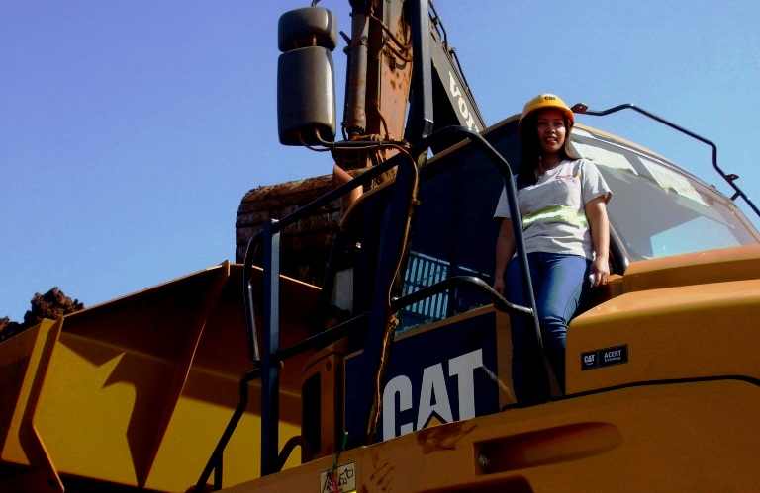
- “Providing for my family is the source of my strength and inspiration in fulfilling my responsibilities with 100 percent commitment and dedication,” asserted Joyris Gasulas.

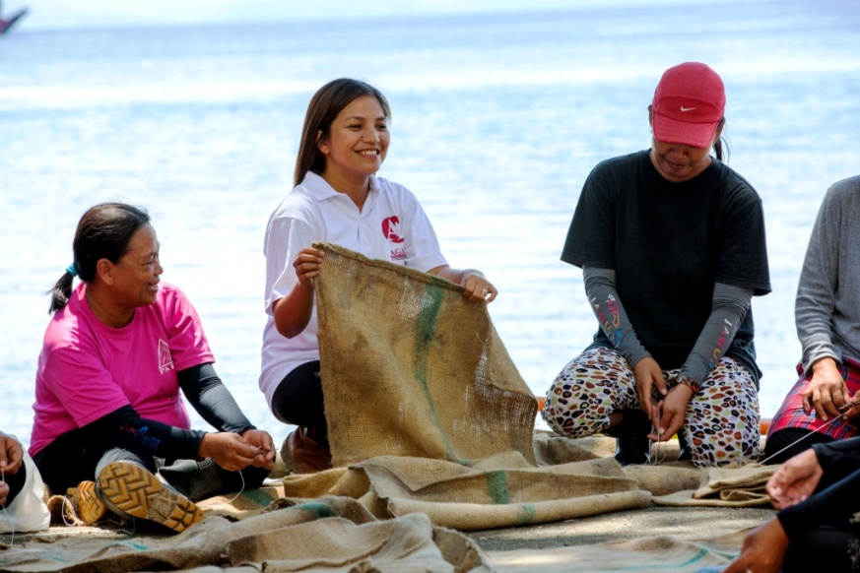
- AMVI Environment Manager Jesalyn Guingguing provides the women of Sitio Payong-Payong first-hand training on how to weave abaca sacks into coco nets, which are used as an environment control measure against soil erosion and siltation.

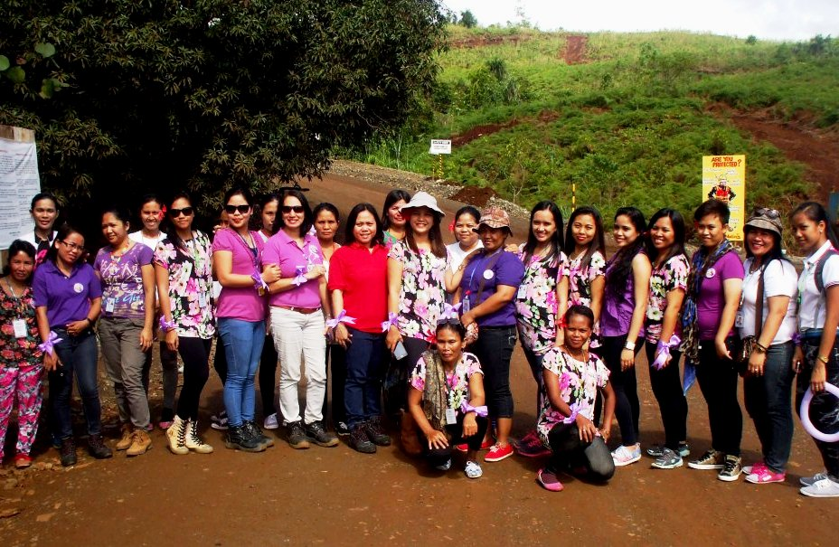
- A small fraction of AMVI’s female employees standing up for women’s rights.

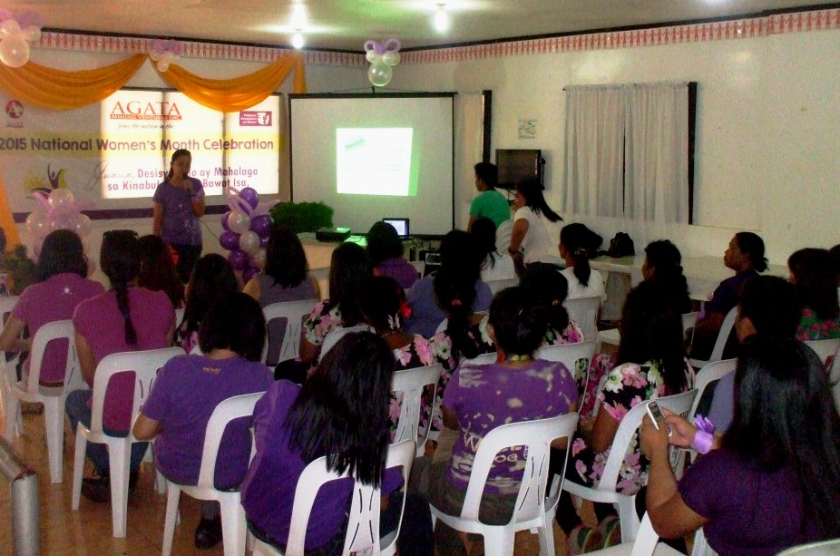
- AMVI Nurse Izette Lim delivers an educational presentation on women’s health and wellbeing in Tubay Municipality.

- “Juana of AMVI” 2015 Finalists (from L to R) Miraflor Capon, Sheila Mae Arcala and Grace Hebron.

About TVI in the Philippines
TVI Resource Development Philippines Inc. (“TVIRD”), is the local affiliate of TVI Pacific Inc. (TSX: TVI), a publicly-listed Canadian mining company focused on the exploration, development and production of precious and base metals from district-scale, large-system, high-margin projects located in the Philippines. Concurrent ownership of ventures is shared with partner company, Prime Resource Holdings Inc.

The commercial operations of Agata Mining Ventures Inc. (AMVI) marks the third successful mining project that TVIRD brought on-stream in the past 10 years. The company is committed to exploration and mining practices that promote transparency, responsible stewardship of the environment, and the inalienable rights to life, dignity, and sustainable development of its host communities.
www.tviphilippines.com

Contact:

Kaycee Crisostomo
Corporate Communications Director
TVI Resource Development Philippines Inc.

Email: kaycee.crisostomo@tvipacific.com.ph
Phone: +63 2 728-8491 ext. 103
Mobile: +63 917 579-1528
Fax: +63 2 728-8515

