N E W S R E L E A S E

In the Footsteps of Patricia Evangelista, JFK and Brad Pitt
AMVI hones young debaters, supports Bombo Radyo’s intercollegiate debates in Butuan City

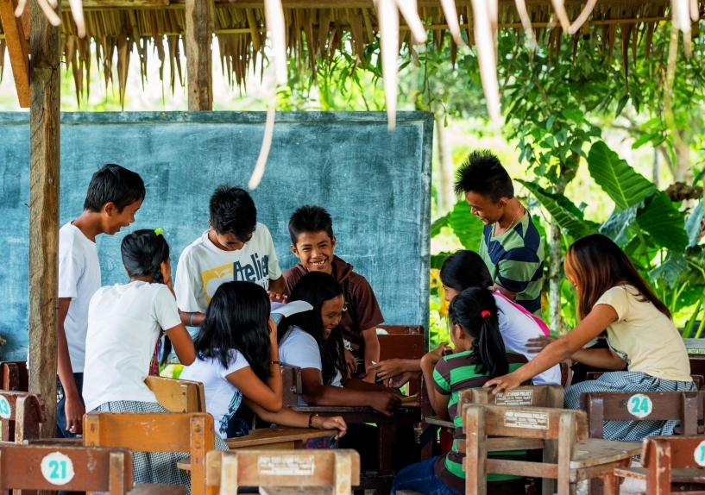School spirit. Students of Doňa Rosario National High School in Tubay engaged in an informal study group after dismissal time. The public school is one of the institutions supported by AMVI through its joint venture partner, MRL Nickel Philippines.

Butuan City, Agusan del Norte / March 2015 – Other than being widely-recognized and highly-accomplished professionals in their respective fields, what can a Filipina columnist, former American President and Hollywood actor have in common? The answer is that the three of them – at one point in their lives – have been active members of their schools’ debate teams. Patricia Chanco Evangelista is a local columnist who can add television host, producer and endorser to her credentials and is the first Filipina to win the Best Speaker award at the International Public Speaking Competition in London when she was 19. Evangelista is also an alumna of the University of the Philippines Debate Society – the same institution that produced the country’s winning team that bested 81 others in the 4th United Asian Debating Championship.

Possibly the most charismatic of US Presidents, John Fitzgerald Kennedy (JFK), once squared-off with fellow aspirant Richard Nixon in a historic series of presidential debates, which was the country’s first in 1960. While television viewers and radio listeners at the time argue who gained the upper hand, history will show that JFK, by far, was the people’s favorite. Finally, William Bradley “Brad” Pitt, who is famous for his versatile roles in multi-million productions like Troy, Mr. & Mrs. Smith and World War Z, also participated in high school debates prior to enrolling at the University of Missouri in 1982. On whether he would have made a bigger public impact as a lobbyist is, well, arguable.

In the same grain as these luminaries – and in trailing the same pursuit of academic reasoning – a Philippine mining company and a Butuan-based media outlet recently came together to harness young minds and promote youth empowerment as part of their advocacies.

Let’s agree to disagree
Bombo Radyo (DXBR) in Butuan City organized “Debate sa Bombo 2015” – a nationwide intercollegiate debate series that is supported by Agata Mining Ventures Inc. (AMVI) and includes participants from the Caraga State University (CSU), Father Saturnino Urios University (FSUU), Agusan Colleges Inc. (ACI) and St. Joseph Institute of Technology (SJIT).

“Bombo Radyo welcomes AMVI’s support for the radio station’s numerous programs that focus on education, health – and just recently – youth empowerment. (We likewise) acknowledge AMVI as a strong partner towards progress and social development, reflected by the company’s leading initiative in responsible mining,” says anchorman Edwin Bayer.

The Debate series was scheduled to hold three elimination rounds depending on how fast the competing school wins over their rival debating teams.

The second leg of the series ended after only two rounds – the first was held in SJIT auditorium where both FSUU and CSU were eliminated by ACI and SJIT, respectively, in a debate about political and current national issues. The second and final round was held at the ACI gymnasium where SJIT took-on the home court residents in a debate on whether K-12 should or should not be implemented in the Philippine education system. The visitors, SJIT, won as champions over ACI.

By supporting responsive education, AMVI continues to align both its initiated and sponsored programs to that of TVI Resource Development Philippines Inc. (TVIRD) – also in the areas of health and sanitation, livelihood and infrastructure for its host communities. Prior to concluding its operations in Siocon, Zamboanga del Norte, TVIRD supported 10 schools that provided education to close to 4,000 students.

On the right track
In the same enduring legacy inspired by TVIRD in Siocon, AMVI’s support for Debate sa Bombo aims to promote youth empowerment and allow students to theorize and find their own reason. Moreover, the program fosters the same competitive advantage that builds character and simulates real-world challenges for the participants.

In the past, inter-school debates have developed problem-solving and intuitive thinking among students, allowing them to perform extensive research and organize their data to support their arguments. They also acquire maturity and harness the opportunity to engage in a serious subject matter within an academic framework.

“AMVI believes that the debate series will improve the participants’ academic reasoning as well as both their written and oral communications. It is (the program) also a good demonstration of their knowledge on the subjects of Philosophy, History and Public Policy,” said AMVI Corporate Communication Officer Luigi Figueroa on the sidelines of the event.

“We are proud to partner with Bombo Radyo and look forward to more meaningful programs geared towards social development,” he concluded.

Parting shots
A long list of CEOs, successful lawyers, media personalities, government officials and civil society leaders can trace their professional lineage to actively participating in their schools’ debate teams. One can even draw the correlation between the foundation of debate and a country’s national development through its leadership.

John F. Kennedy once said: "Debating in high school and college (is) a most valuable training whether for politics, the law, business, or for service on community committees. A good debater must also thoroughly analyze the expected arguments of his opponent....The give and take of debating, the testing of ideas, is essential to democracy.”

And where Brad Pitt’s Benjamin Button can probably say that “Life is one contradiction after another,” the Greek philosopher Plato will likely reply: “No it’s not.”

*******

Press photos:

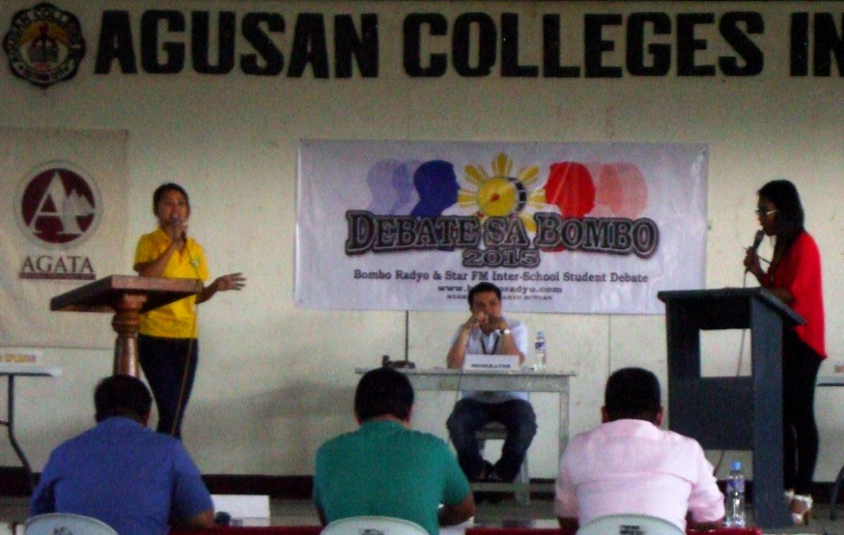
- Reasoned Argument. Speakers from both the Agusan Colleges Inc. (ACI) and the St. Joseph Institute of Technology (SJIT) debate teams present their opposing arguments based on their respective research and data.

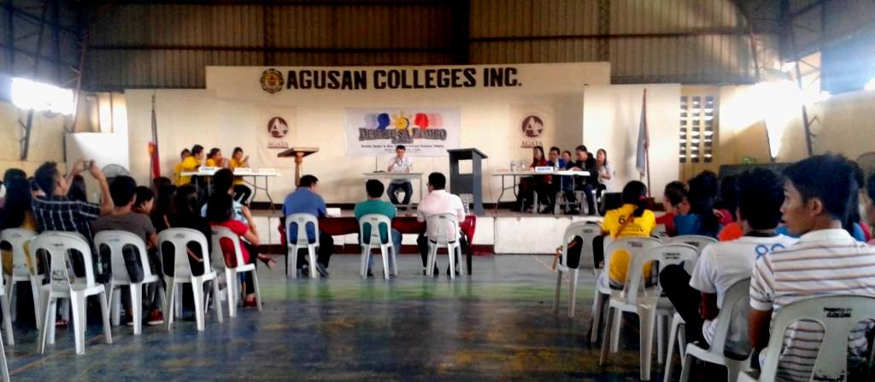
- Prior to every debate, official rules and regulations are discussed by a Bombo Radyo representative.

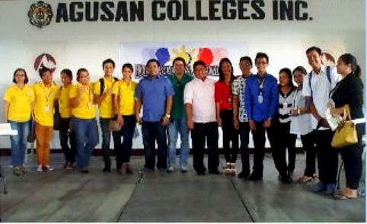
- Agusan Colleges Inc. (ACI) debating team (in yellow), the panel of judges and “Debate sa Bombo 2015” champions St. Joseph Institute of Technology (SJIT) all gather at the tail end of the series.

About TVI in the Philippines
TVI Resource Development Philippines Inc. (“TVIRD”), is the local affiliate of TVI Pacific Inc. (TSX: TVI), a publicly-listed Canadian mining company focused on the exploration, development and production of precious and base metals from district-scale, large-system, high-margin projects located in the Philippines. Concurrent ownership of ventures is shared with partner company, Prime Resource Holdings Inc.

The commercial operations of Agata Mining Ventures Inc. (AMVI) marks the third successful mining project that TVIRD brought on-stream in the past 10 years. The company is committed to exploration and mining practices that promote transparency, responsible stewardship of the environment, and the inalienable rights to life, dignity, and sustainable development of its host communities.
www.tviphilippines.com

Contact:

Kaycee Crisostomo
Corporate Communications Director
TVI Resource Development Philippines Inc.

Email: kaycee.crisostomo@tvipacific.com.ph
Phone: +63 2 728-8491 ext. 103
Mobile: +63 917 579-1528
Fax: +63 2 728-8515

