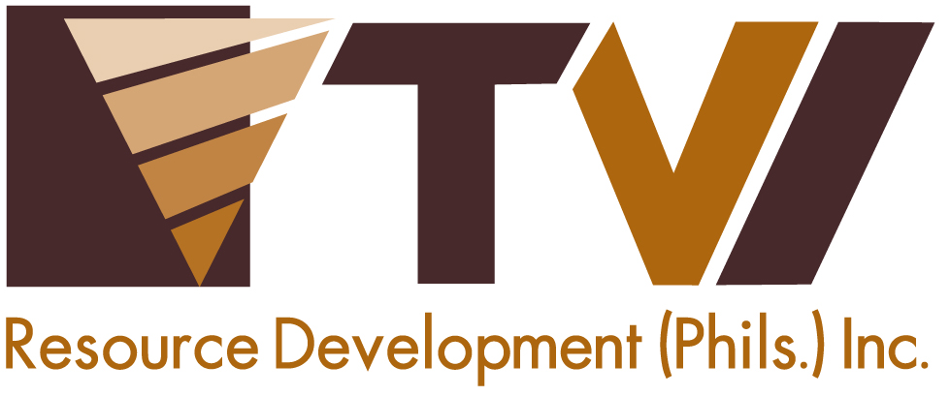
N E W S R E L E A S E

Agata and TESDA Develop Globally-Competitive
Heavy Equipment Operators
Skills development training produces competent operators of Hydraulic Excavators

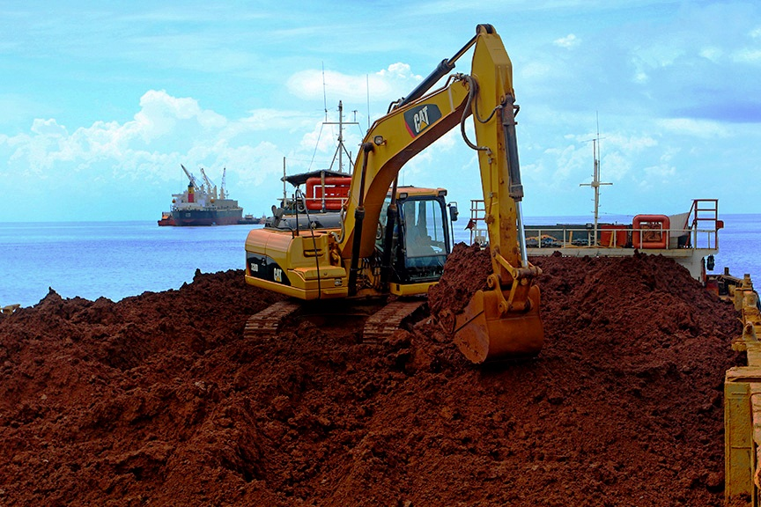
Fully loaded. AMVI loads shipments of approximately 55,000 wmt of high-iron/low-nickel ore every three to four weeks with shipping rates expected to ramp-up to 2.5 million wmt per year in 2015. (In photo): an excavator compacts nickel ore on a barge, which will then transport the cargo to a bigger vessel (in background).

Santiago, Agusan del Norte / March 2015 – In active support of the Agusan del Norte Provincial Government’s directive, Agata Mining Ventures Inc. (AMVI) recently partnered with the Technical Education and Skills Development Authority (TESDA) for the specialized operators training for Hydraulic Excavators. The program developed 23 trainees from the company’s host municipalities of Tubay, Jabonga and Santiago – which are all located in the company’s Mineral Processing Sharing Agreement (MPSA) area. All trainees completed the course and will be conferred with Level 02 National Certificates (NC-II) that officially validate their eligibility as skilled professionals for both local and overseas employment.

At the onset, while the recent training program provides each apprentice a higher eligibility for employment over the short term, they also earn the opportunity to explore opportunities overseas in the future.

“AMVI subscribes to the development of the country’s rich human capital and expanding the opportunities of qualified skilled workers. Moreover, it remains committed to the common development roadmap that it shares with its host municipalities,” stated Corporate Services Vice President Yody Marzo.

“AMVI also draws from TVIRD’s experience in Canatuan (Zamboanga del Norte) where it employed some 1,200 workers at the height of its operations,” she added, referencing TVI Resource Development Philippines Inc., which leads the AMVI joint ventures and which likewise counted a significant number of indigenous Subanons among its ranks.

Developing human capital
AMVI believes that the implementation of relevant skills development programs in its host and neighboring communities is the right way towards inclusive growth.

“The Municipality of Tubay is grateful for the opportunity to once again work with AMVI in providing a sustainable training program through a partnership with TESDA. This will provide the participants great opportunities for employment locally and internationally – skills that they can further develop and continue to benefit from long after mining ends,” said Tubay Mayor Fidel Garcia whose Municipal Office earlier requested to use the AMVI site as venue for the training program, which is a project of the Provincial Government.

As the company enhances its mining operations this year, it also anticipates a greater demand for skilled workers from the immediate communities. The company hopes to provide the right opportunities to qualified individuals from these communities as well as skilled workers and professionals to join the company’s growing workforce.

“Having completed the training and being TESDA NC-II certified, we are now more confident that we have an edge in successfully landing a job,” says TESDA Trainee Anthony L. Santillan.

The TESDA Hydraulic Excavator training program consisted of a one-week theoretical and lecture module followed by a 10-day practical portion, which included the participants’ familiarization with the Hydraulic Excavator and the execution of its basic controls for excavation, loading and unloading.

The trainees were also provided on-site practical tests that consisted of the repair and widening of existing Silt Collector Samps (SCS) – AMVI’s water pollution control facilities – which surround the mine pit areas. These were supervised by skilled operators and served as a requisite for completing the training program.

Towards progress and development
Prior to the TESDA training program, the company also rolled-out various livelihood education programs such as Vermi-Culture, which focuses on manufacturing organic fertilizer from food waste and other biodegradable waste. It also introduced Coconet weaving – which is used as erosion control and silt traps in slopes around the mine site.

Also in the pipeline are special livelihood programs for women organizations and the indigenous Mamanwas in the community.

TVIRD leads the development of AMVI’s nickel laterite direct shipping ore (DSO) operations in the project area, which is located in a 4,995-hectare MPSA. TVIRD also leads the development of skilled human capital in the region and has been consistently recognized for its employees health and safety practices. It was likewise awarded by the Department of Labor and Employment (DOLE) for being the most outstanding employer in Zamboanga del Norte where its flagship Canatuan Mining Project is located.

Press photos:

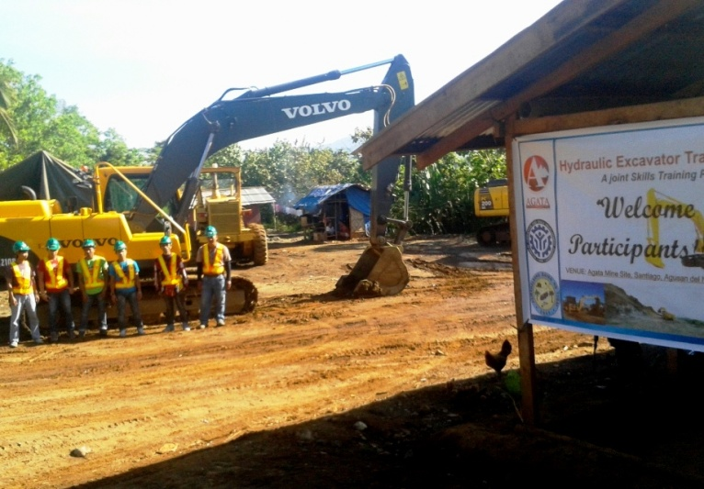
- Paving the way for success. Working hand-in-hand with the Tubay Municipal Office towards developing its human capital, AMVI engages TESDA in producing skilled Hydraulic Excavator operators – all of whom are from the company’s host and neighboring communities

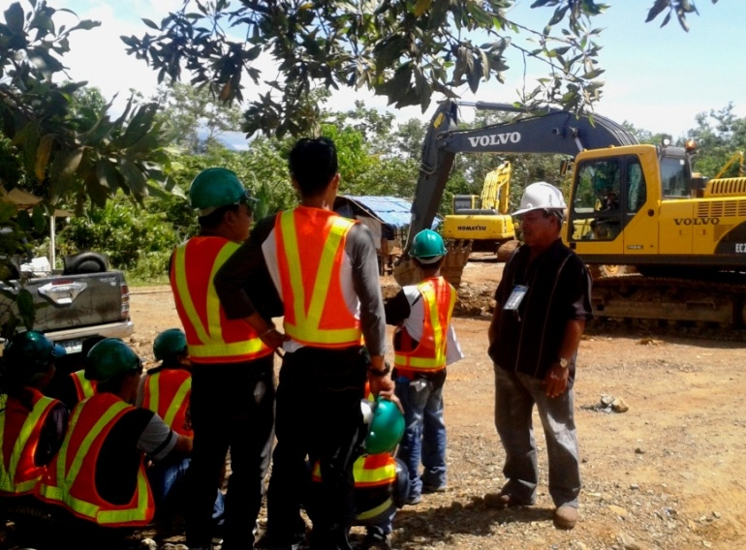
- TESDA Community-based Trainer Laurente Aguilar supervise the actual equipment training and practical exams. The program consisted of a one-week theoretical and lecture module followed by a 10-day practical portion

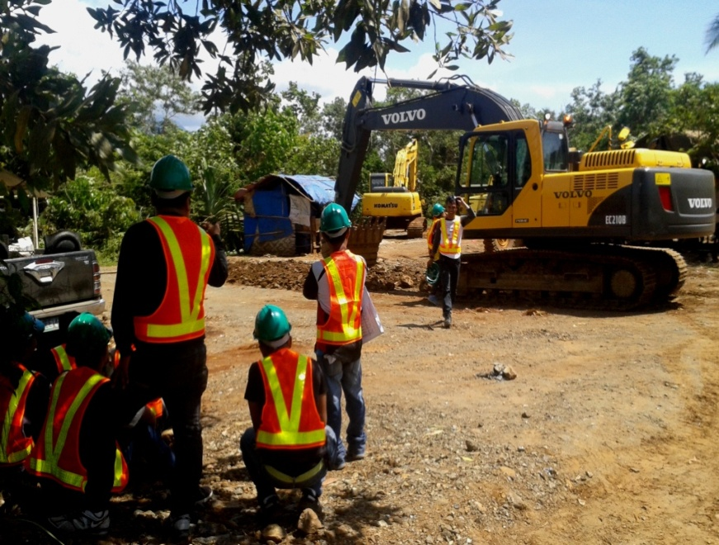
- Trainees take turns with actual equipment familiarization exercises. They were provided on-site practical tests that consisted of the repair and widening of existing Silt Collector Samps (SCS).

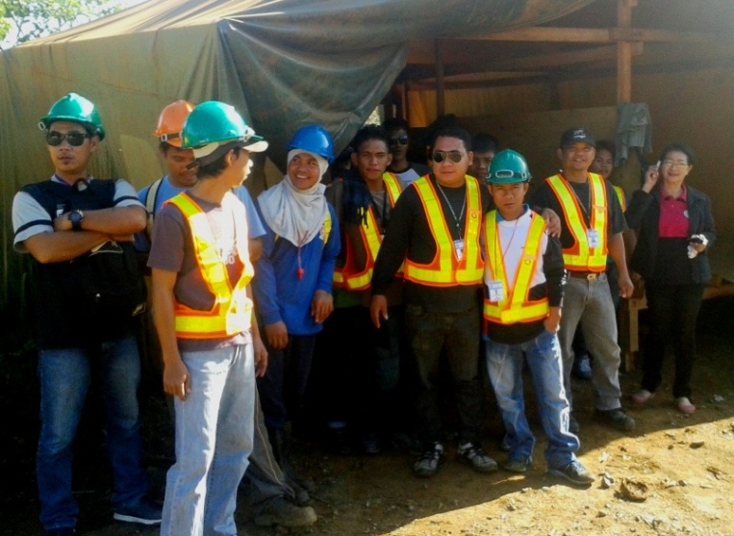
- 23 trainees successfully complete the training program and will be conferred with Level 02 National Certificates (NC-II) that officially validate their eligibility.

About TVI in the Philippines
TVI Resource Development Philippines Inc. (“TVIRD”), is the local affiliate of TVI Pacific Inc. (TSX: TVI), a publicly-listed Canadian mining company focused on the exploration, development and production of precious and base metals from district-scale, large-system, high-margin projects located in the Philippines. Concurrent ownership of ventures is shared with partner company, Prime Resource Holdings Inc.

The commercial operations of Agata Mining Ventures Inc. (AMVI) marks the third successful mining project that TVIRD brought on-stream in the past 10 years. The company is committed to exploration and mining practices that promote transparency, responsible stewardship of the environment, and the inalienable rights to life, dignity, and sustainable development of its host communities.
www.tviphilippines.com

Contact:

Kaycee Crisostomo
Corporate Communications Director
TVI Resource Development Philippines Inc.

Email: kaycee.crisostomo@tvipacific.com.ph
Phone: +63 2 728-8491 ext. 103
Mobile: +63 917 579-1528
Fax: +63 2 728-8515

