N E W S R E L E A S E

TVIRD and Kabasalan Celebrate Unity and Cultural Diversity
TVIRD-supported “Gabii sa mga Tipaka sa Kagahapon” culminates Kabasalan’s 78th Founding Anniversary

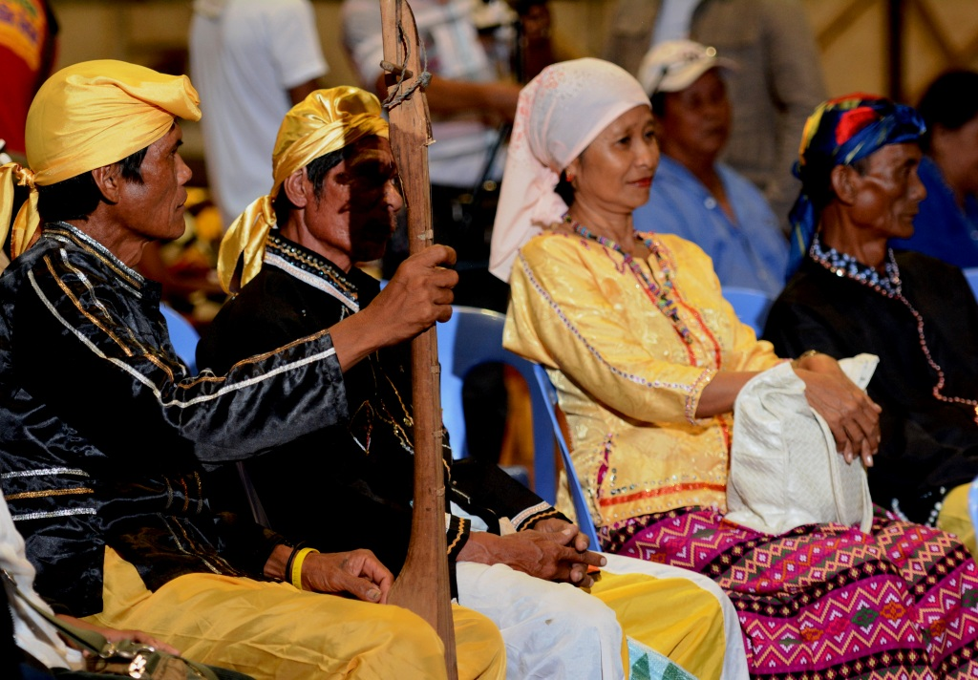
Unity in Diversity. The Subanen tribe, one of the many cultures represented during Kabasalan’s anniversary program, went on to win the grand awards. Previously, the collective Subanon leadership granted TVIRD the social license to operate in Bayog.

Bayog, Zamboanga del Sur / February 2015 – In recent history, the Municipality of Kabasalan has undergone various transitions that melded cultural diversity into a progressive roadmap for the development of its citizens. Acknowledging this – and the common development roadmap it also shares with the town – TVI Resource Development Philippines Inc. (TVIRD) supported the commemoration of Kabasalan’s 78th Founding Anniversary, which culminated after a week-long celebration last February 17 in the town’s gymnasium.

The grand awards night, titled “Gabi sa mga Tipaka sa Kagahapon” (Glimpses ot the Past), showcased talents on native “balak” (poetic literature), “harana” (serenade) and “sayaw” (dances) that were judged by representatives of ethnic groups from neighboring municipalities. The event had a significant impact to both Kabasaleños and visitors, bringing forth a renewed realization of union, respect and peace despite differences in culture and religion.

“The real difference is making a difference. And this is the night – a simple yet totally different (celebration) of Kabasalan’s heritage,” said Mayor George Cainglet on the sidelines of the culminating event. He also cited TVRD’s support among partners and guests in the town’s thriving economic activity today.

Kabasalan is a first class municipality whose population brought about a thriving economy primarily driven by rubber plantations.

Cultural diversity
The week-long celebration highlighted the town’s unity in addressing various challenges and diversity. It also underscored the harmonious relationship of its citizens who belong to diverse cultural groups composed of Ilocano, Ilonggo, Cebuano, Zamboangueño, Waray, Cebuano, Chavacano, Waray, Bol-anon, Bicolano and Chinese ethnicities. Also represented were both the Catholic and Muslim faiths as well as the indigenous Subanen tribe.

“This (mix of cultures) is very interesting and I thank every Kabasaleño for participating – no matter what tribe we are in. Let us continue to be proud of our origins and let us be proud to be a Kabasaleño,” proclaimed Mayor Cainglet.

The town’s commemoration of its foundation day was spearheaded primarily by the municipal government and by different stakeholders in the community, including the religious and business sectors, the Department of Education (DepEd), the Philippine National Police (PNP), the Armed Forces of the Philippines (AFP) and the municipality’s constituents.

Emerging industry
TVIRD is located in a 4,779-hectare Mineral Processing Sharing Agreement (MPSA) area that spans the town of Bayog as well as Barangays Lacnapan, Peñaranda and Siolan in Kabasalan Municipality. Once its gold and silver operations come on-stream, the company expects to bring both employment and livelihood opportunities to the town’s communities.

In cooperation with the Sibugay Provincial Government, TVIRD undertakes a joint commitment to protect the environment. Gov. Wilter Palma specifically emphasized Sibuguey River’s conservation, being the source of water that irrigates thousands of hectares in the province’s rice granaries.

In 2014, the company entered into a memorandum of agreement with the indigenous Subanens, effectively earning a social license to operate from host tribe – in addition to approvals given by both provincial and municipal governments to develop mineral resources in the area.

*******

About TVI in the Philippines
TVI Resource Development Philippines Inc. (“TVIRD”), is the local affiliate of TVI Pacific Inc. (TSX: TVI), a publicly-listed Canadian mining company focused on the exploration, development and production of precious and base metals from district-scale, large-system, high-margin projects located in the Philippines. Concurrent ownership of ventures is shared with partner company, Prime Resource Holdings Inc.

The commercial operations of Agata Mining Ventures Inc. (AMVI) marks the third successful mining project that TVIRD brought on-stream in the past 10 years. The company is committed to exploration and mining practices that promote transparency, responsible stewardship of the environment, and the inalienable rights to life, dignity, and sustainable development of its host communities.
www.tviphilippines.com

Press photos:

- The community people’s theater group of Zamboanga Sibugay, Mga Magdudula sa Sidlakang Mindanaw, rendered a production number during the grand awards night. Previously, the group received training from the Philippine Educational Theatre Association in Pagadian City – which was sponsored by TVIRD in September 2012.

- Performers showcased a spiritual Muslim dance to seek good health and fight evil spirits. The ritual is also intended to drive away catastrophes.

- The judges’ table. (From L to R): Mrs. Myrna Edang, Kabasalan HR Officer Alice Sarmiento and Balabag Officer-in-Charge Col. (Ret) Valentino Edang.

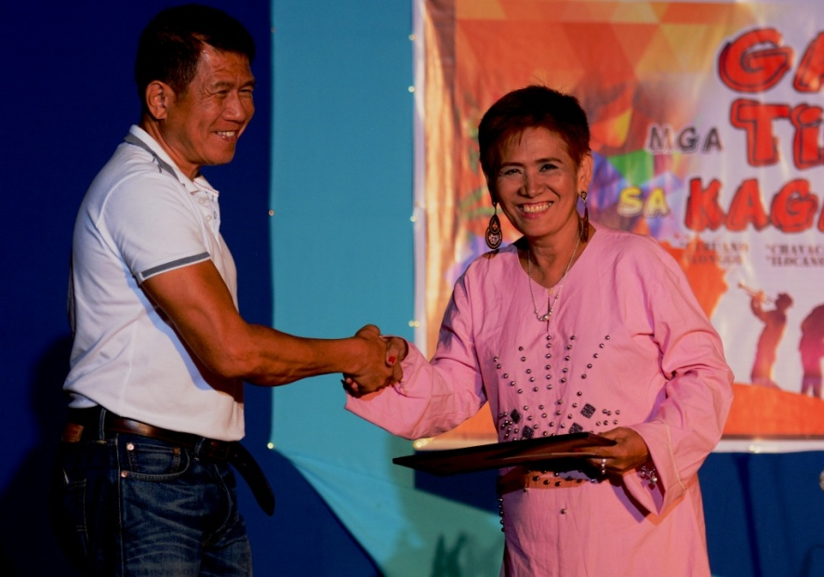
- Executive approval. Municipal mayor Hon. George Cainglet dedicates a plaque of appreciation to TVIRD Public Affairs Officer Evelyn Monasterio for supporting and emceeing the event.
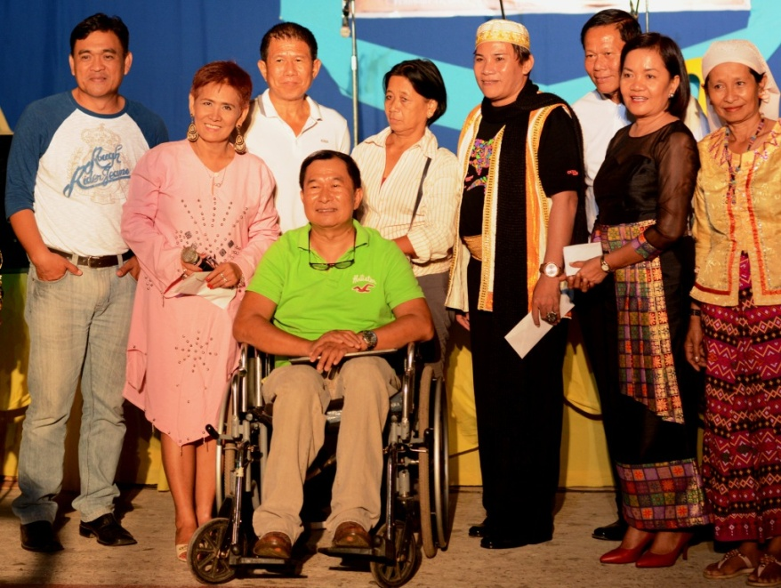
- Distinguished Guests. (From L to R): Ipil SB Member Alberto Alcoriza, Evelyn Monasterio, Mayor George Cainglet, Siay IPA Cordinator Cerila Ojas, Roland Alibon-Margosatubig, Col. Valentino Edang, Myrna Edang, Kabasalan IPA Coordinator Salome Onto. (Sitting): Siay DCI-Parish Priest and Diocese of Ipil IPA Director Rev. Fr. Laure Helar.

Contact:

Kaycee Crisostomo
Corporate Communications Director
TVI Resource Development Philippines Inc.

Email: kaycee.crisostomo@tvipacific.com.ph
Phone: +63 2 728-8491 ext. 103
Mobile: +63 917 579-1528
Fax: +63 2 728-8515

