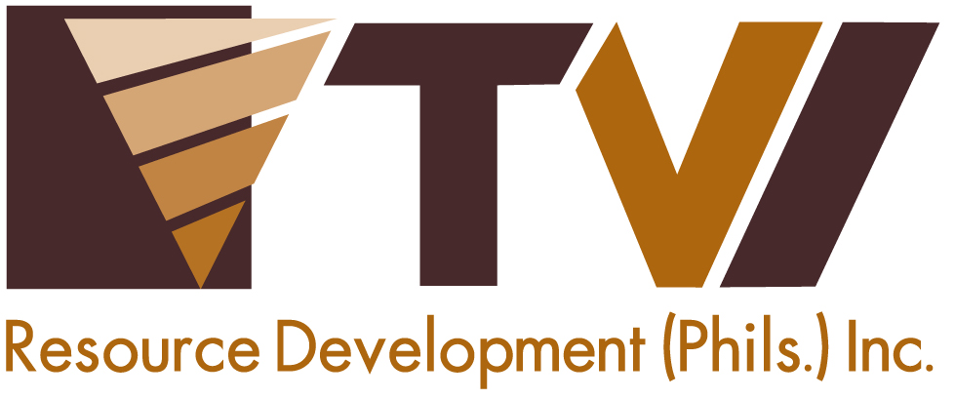
N E W S R E L E A S E

Environmental Program Generates
Downstream Industry and Gainful Livelihood
Agata Mining engages women in weaving coco nets that protect municipal waters against siltation

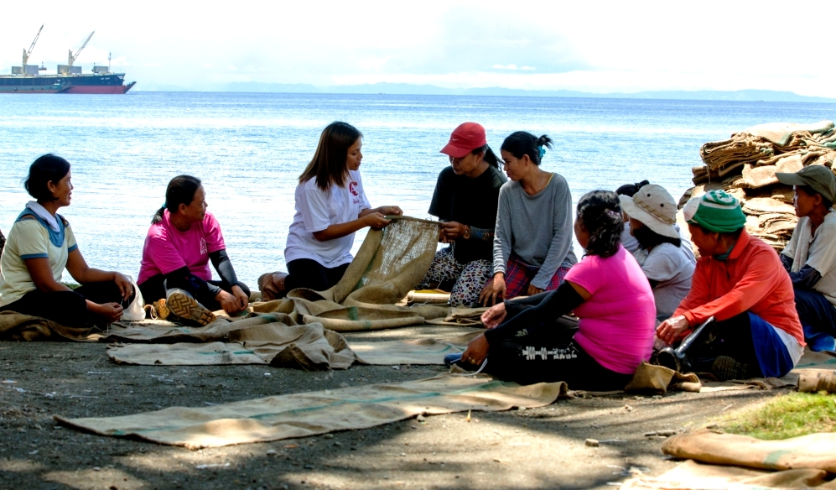
A common thread. In its endeavor to provide livelihood for the community – which it shares with the local government of Tubay – AMVI engages women from Sitio Payong-Payong in weaving coco nets used for environmental protection.

Tubay, Agusan del Norte / February 2015 – In recognition of its best practices in Sitio Canatuan, Siocon Municipality in Zamboanga del Norte where the company’s progressive rehabilitation program gave birth to the town’s downstream agro-forestry industry, the TVIRD-led Agata Mining Ventures Inc. (AMVI) initiated a coconut net weaving program for its host community in Sitio Payong-Payong, Tubay Municipality in Agusan del Norte. The program is geared towards engaging local women in producing coconut-based abaca nets that will serve as the company’s safeguard against siltation and keeping local bodies of water free from siltation and other debris.

TVIRD or TVI Resource Development Inc. leads the development of AMVI’s nickel laterite direct shipping ore (DSO) operations in the area. The project is located in a 4,995-hectare Mineral Processing Sharing Agreement (MPSA) area that spans the adjacent host municipalities of Tubay, Jabonga and Santiago.

Empowering women
AMVI acknowledges the welfare of the women of Sitio Payong-Payong in Barangay Tinigbasan where its private port is located. The net weaving program is aimed at empowering locally-hired women to create silt and erosion control or “trap nets” that serve as a filter to keep sediments and other debris from flowing down the mountain and entering the rivers.

The program is one of several livelihood initiatives that the company spearheads and supports through education and proper training. It was rolled-out last year in cooperation with the Barangay Council of Tinigbasan and supported by the municipality through the Tubay Women’s Federation (TWF). AMVI also aligns itself to the municipal government’s skills development initiatives that encourage community members to participate in various income-generating programs geared towards increased household income.

“The Tubay Women’s Federation is happy that AMVI provides equal employment opportunities (through its operations) and for its initiative in developing various livelihood programs as an alternative source of income for the community,” said TWF President Delia Garcia, who also noted on its sustainability beyond the company’s mining operations.

In addition to gainful livelihood, the program enables the women to play an active role in the economic and environmental development of their barangay. While most of the men in Sitio Payong-Payong are employed in the company’s mining operations, the women are now given a choice to pursue an alternative source of income.

Organic versus synthetic
The Agusan del Norte Region is known not only for its rich mineral deposits such as gold, silver, copper, nickel and iron, among others, but also for its various naturally-grown trees that include coconuts – for which the Philippines is the world’s largest producer. These trees are also internationally-recognized for its versatility and various uses, particularly its fiber, which is used for the commercial production of sacks and handicraft.

Compared to synthetic fibers, the coconut fiber is cheaper, more eco-friendly and very effective when used as erosion control braces, silt curtains and fences. Moreover, its source is both renewable and sustainable as these trees can be found in almost every corner of the country.

Livelihood Opportunities
Presently, each net weaver from the community earns some Php268 per day. Their task is to weave the abaca sacks into coco nets, which in turn are installed in strategic locations along the mountain slopes to serve as silt fences. These are also installed around the company’s causeway area to serve as curtains that prevent silt from floating into the ocean. The women also mend or replace damaged nets and keep a sufficient supply of nets in stock.

“The net weaving program started in September 2014. This year, and as the company ramps-up its operations, more environment mitigating measures will be implemented – which will bring forth an increase in the number of weavers to do the job,” explained AMVI Environment Manager Jesalyn Guingguing.

“For now, the abaca sacks that are weaved into coco nets are acquired by the company from other local sources. But as soon as the company expands its activities, production of the sacks – and not just weaving them together – will be sourced from host and neighboring communities”, she added.

Aside from the coco net weaving program, AMVI also has a junkshop and vermi-culture organic fertilizer program as livelihood for the women’s organization in neighboring Barangay E. Morgado in Jabonga Municipality. It also has a “Bigasan” (rice granary) livelihood program for a similar organization in Barangay Colorado of the same municipality.
*******
Press photos:
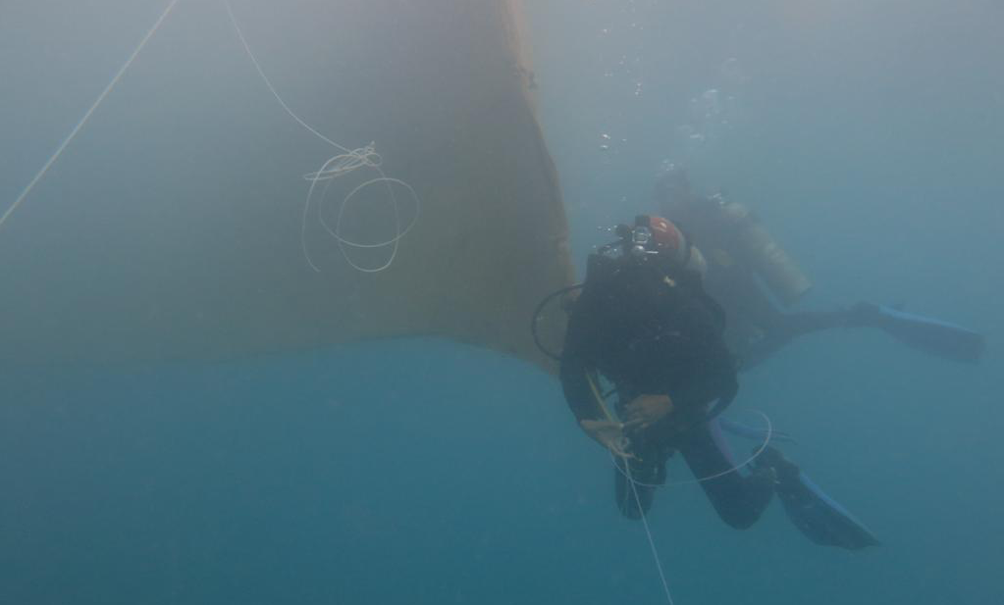
- A company-trained diver installs the coco net silt curtain around the causeway area to prevent silt from floating into the ocean.

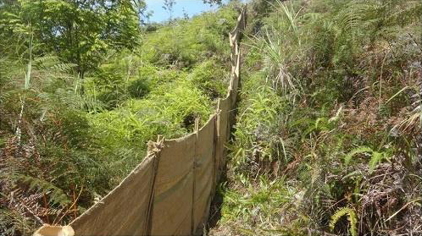
- Silt fences made from interwoven abaca sacks are installed along slopes to keep sediments and debris from flowing down the mountain and entering the rivers.

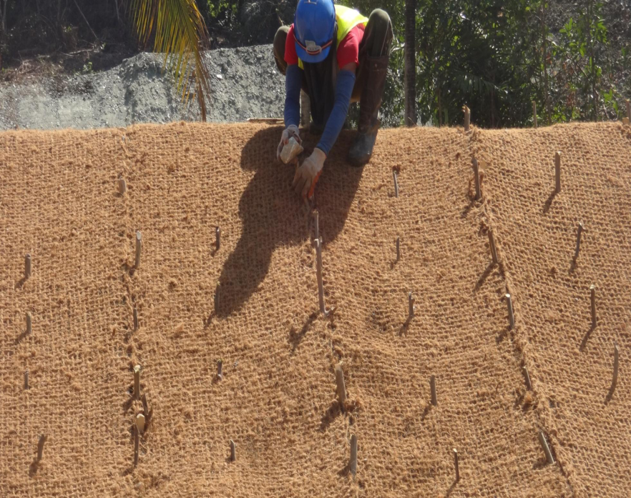
- Company personnel install interwoven abaca sacks along slopes to serve as braces to control soil erosion.

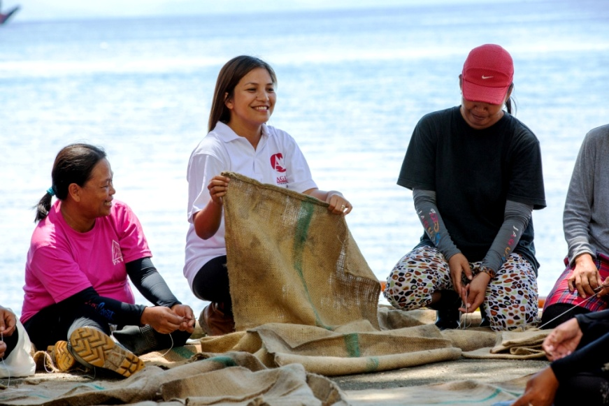
- AMVI Environment Manager Jesalyn Guingguing provides the women of Sitio Payong-Payong first-hand training on how to weave abaca sacks into coco nets.

About TVI in the Philippines
TVI Resource Development Philippines Inc. (“TVIRD”), is the local affiliate of TVI Pacific Inc. (TSX: TVI), a publicly-listed Canadian mining company focused on the exploration, development and production of precious and base metals from district-scale, large-system, high-margin projects located in the Philippines. Concurrent ownership of ventures is shared with partner company, Prime Resource Holdings Inc.

The commercial operations of Agata Mining Ventures Inc. (AMVI) marks the third successful mining project that TVIRD brought on-stream in the past 10 years. The company is committed to exploration and mining practices that promote transparency, responsible stewardship of the environment, and the inalienable rights to life, dignity, and sustainable development of its host communities.
www.tviphilippines.com

Contact:

Kaycee Crisostomo
Corporate Communications Director
TVI Resource Development Philippines Inc.

Email: kaycee.crisostomo@tvipacific.com.ph
Phone: +63 2 728-8491 ext. 103
Mobile: +63 917 579-1528
Fax: +63 2 728-8515

