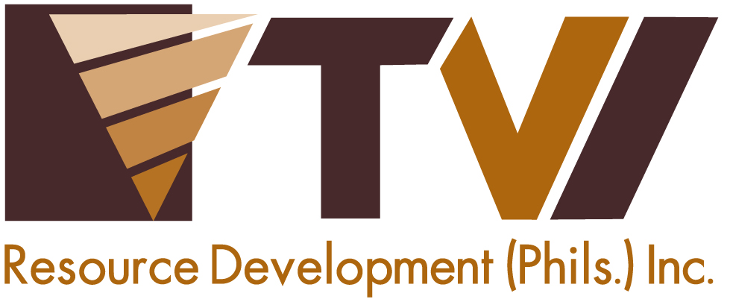
N E W S R E L E A S E

A Gift of Joy to the Children of Tubay
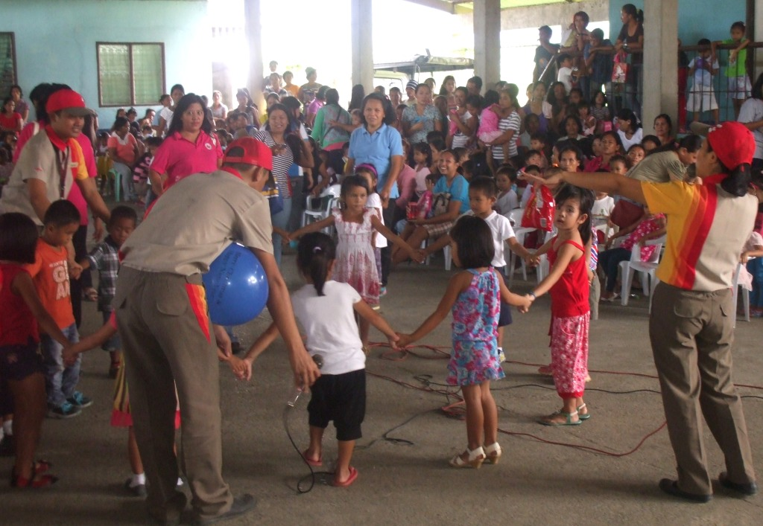
Agata Mining backs Tubay’s successful “Pamaskong Pahalipay Para sa mga Kabataan”

Looking after the future. AMVI partners with the Tubay Municipal Council for the Protection of Children (MCPC) in the latter’s annual Christmas event, which aims to benefit close to 400 children with disabilities.

Tubay, Agusan del Norte / January 2015 – Acknowledging the welfare of children in its host communities, Agata Mining Ventures Inc. (AMVI) supported “Pamaskong Pahalipay Para sa mga Kabataan 2014” (A Gift of Joy for the Children) – Tubay Municipality’s annual event that brings the festivities of Christmas to the disabled and marginalized. The affair was held at the Doňa Rosario Gymnasium last December 16 and provided treats and toys to some 390 children aged three to four years old from the 13 barangays of the municipality. It is spearheaded by the Municipal Social Welfare and Development (MSWD) office through the Municipal Council for the Protection of Children (MCPC).

“The municipality of Tubay commends Agata Mining for being a long time partner and donor to our yearly event. The local government of Tubay is proud to have the company as a strong supporter of an admirable cause and we look forward to the continuance of this partnership geared towards the benefit of the less fortunate Tubay-non children,” said Tubay Municipal Mayor Fidel Garcia, who also acknowledged the support of the Department of Education (DepEd).

Social Development
AMVI, a joint venture of TVI Resource Development Philippines Inc. (TVIRD) and MRL Nickel Philippines Inc., operates in the coastal municipality of Tubay and adjacent Jabonga and Santiago in Agusan del Norte. Led by TVIRD, the joint venture continues to move forward with high iron laterite direct shipping ore (DSO) operations, which will pave the way for the establishment of its nickel processing plant – the first in Agusan del Norte.

Both companies also have established track records for responsive social and environmental programs that contribute to the overall sustainability of its host communities. AMVI draws confidence from this and continues to engage the community in meaningful activities that promote responsible mining practices.

“AMVI is honored to once again join the local government bringing happiness to the children of Tubay. The company will continue to support this endeavor in years to come,” highlighted Community Relations Superintendent Andre Bon Claraval.

Prior to this, the company also actively engaged its host and neighboring communities in feeding programs and medical missions – all of which are part of the company’s firm commitment to social development.

AMVI joined other organizational sponsors and donors that supported the event, including the provincial government, La Fraternidad Day Care Center, local government units and non-government organizations.

More Tubay-non Children this year
“AMVI’s participation helped the MSWD to benefit a total of 390 children with disabilities and those belonging to the marginalized class. Every year, as the number of children who benefit from this event increases, so does the support coming from major sponsors like AMVI,” according to MSWD Officer Ma. Evelita Regis. The day’s activity included games, dance performances from the children as well as the La Fraternidad Day Care Center Teachers.

“We are happy to find not only sponsors; but rather, we found strong partners towards social welfare and development,” concluded Regis.

*******
Press photos:
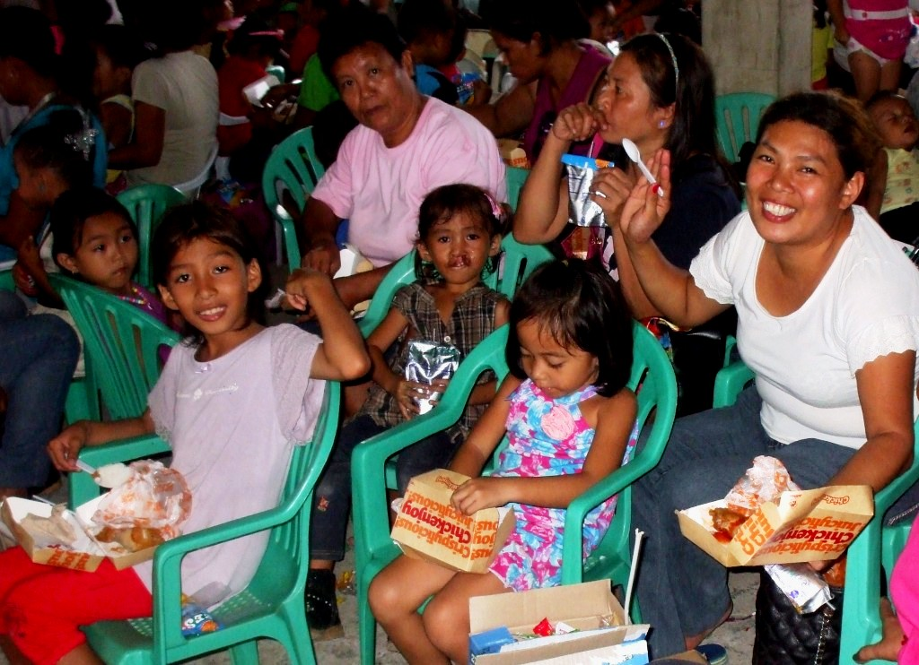

- Tubay-non children enjoying their kiddie meals while they watch the dance performance of Jollibee mascots.

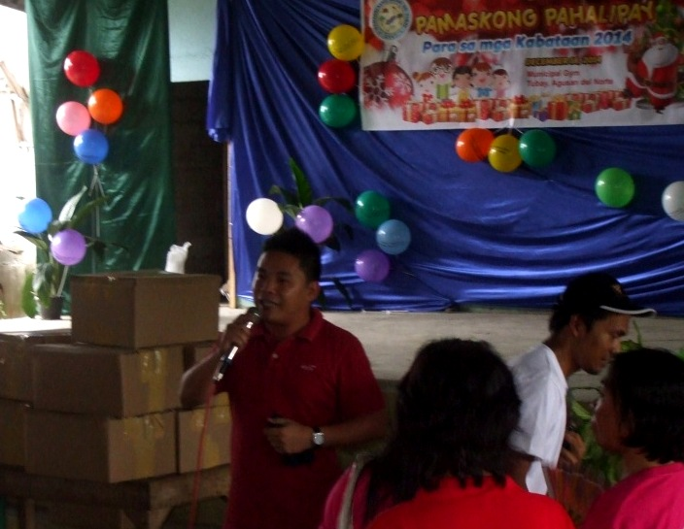
- AMVI Community Relations Superintendent Andre Bon Clarabal delivers a message on behalf of AMVI during the event in relation to the company’s community and social development programs

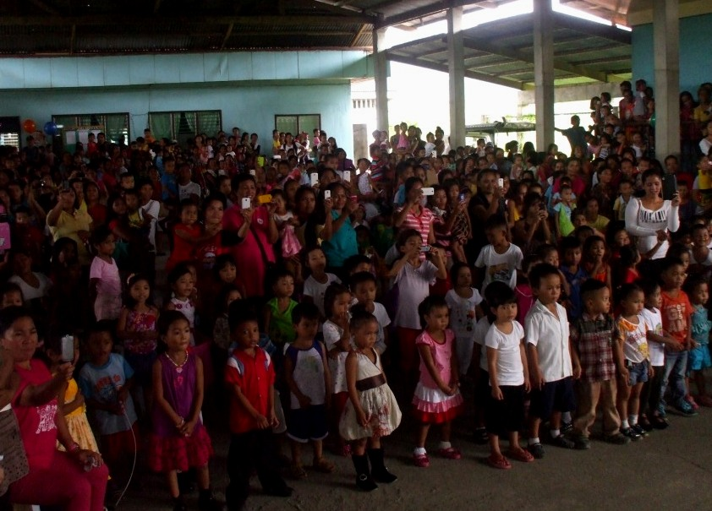
- An increasing number of children join the “Pamaskong Pahalipay Para sa mga Kabataan” spearheaded by Tubay Municipality.

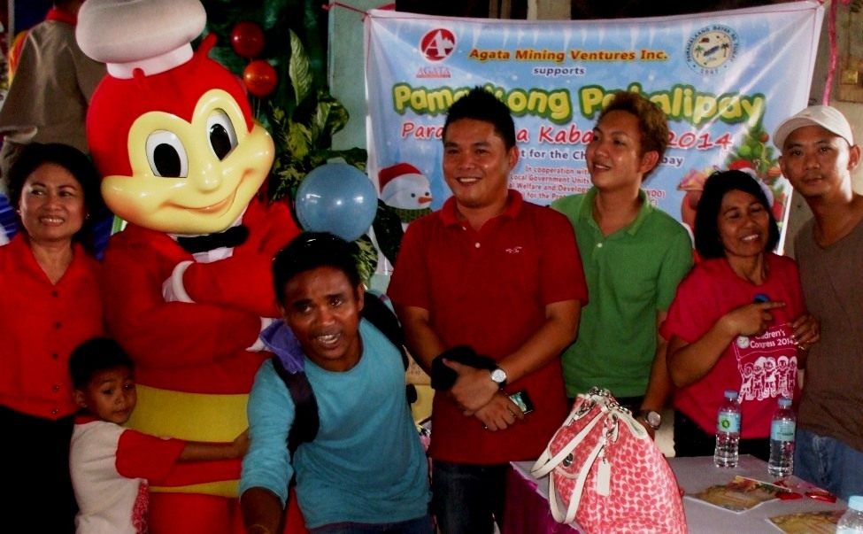
- AMVI employees conclude another successful event with both co-supporters and beneficiaries.

About TVI in the Philippines
TVI Resource Development Philippines Inc. (“TVIRD”), is the local affiliate of TVI Pacific Inc. (TSX: TVI), a publicly-listed Canadian mining company focused on the exploration, development and production of precious and base metals from district-scale, large-system, high-margin projects located in the Philippines. Concurrent ownership of ventures is shared with partner company, Prime Resource Holdings Inc.

The commercial operations of Agata Mining Ventures Inc. (AMVI) marks the third successful mining project that TVIRD brought on-stream in the past 10 years. The company is committed to exploration and mining practices that promote transparency, responsible stewardship of the environment, and the inalienable rights to life, dignity, and sustainable development of its host communities.
www.tviphilippines.com

Contact:

Kaycee Crisostomo
Corporate Communications Director
TVI Resource Development Philippines Inc.

Email: kaycee.crisostomo@tvipacific.com.ph
Phone: +63 2 728-8491 ext. 103
Mobile: +63 917 579-1528
Fax: +63 2 728-8515

