N E W S R E L E A S E

Barangay Medical Mission in Santiago Municipality
Reaches Over 300 Beneficiaries
Agata and Sociedad Española conduct follow-up mission in Barangay E. Morgado

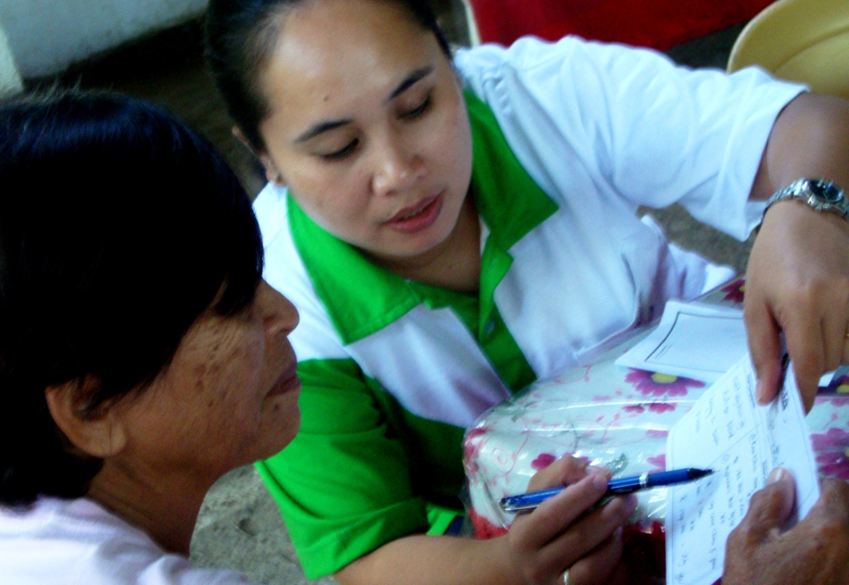
Access to Healthcare: host mining community receives adequate healthcare before the yearend holiday season. (In photo): In one of the company’s medical missions, a PNP volunteer doctor provides consultation and a prescription to an elderly beneficiary in AMVI’s mining community.

Santiago, Agusan del Norte / December 2014 – Following its first joint medical mission in Agusan del Norte coastal barangays of Tinigbasan and Lawigan in Tubay Municipality that provided check-ups, consultation and medicines to some 554 beneficiaries, Agata Mining Ventures Inc. (AMVI) and Sociedad Española de Beneficencia Inc. (SEB-Manila) conducted the second and final leg of its barangay medical missions for year last December 18 – this time in adjacent Barangay E. Morgado in Santiago Municipality. AMVI is a mining joint venture led by TVI Resources Development Philippines Inc. (TVIRD) in Tubay, Santiago and Jabonga while SEB-Manila is a charitable institution dedicated to the care of both Spanish and Filipino indigents in the country.

Volunteer doctors from the Philippine National Police (PNP) once again joined AMVI’s medical team in providing medical attention to some 338 beneficiaries within the company’s Mineral Processing Sharing Agreement (MPSA) area. The activity was likewise supported by the barangay council of E. Morgado, Santiago Municipal Police and the PNP Region XIII in Caraga.

“We are very happy that AMVI fulfilled its promise to conduct a medical mission for Brgy. E. Morgado in December as well as the continued support and assistance that it constantly provides to us,” expressed E. Morgado Barangay Captain Lucita Estrada during the event. As one of the mining company’s host municipalities, Santiago’s constituents include both tribal and non-tribal communities – most of whom do not have access to adequate healthcare.

The advent of social services
E. Morgado is an agricultural community that has limited access to social services and adequate health care. It is located between a mountain and a river and is geographically difficult to access. By nature, similar communities often face the same geographic challenges. Mining companies likewise operate mostly in the hinterlands that government services have yet to reach.

During the year, AMVI has actively rolled-out its Health and Sanitation initiatives in the area – following the best practices of TVIRD’s Social Development and Management Program (SDMP) in its flagship Canatuan project in Zamboanga del Norte. This is in active response to the need for better public health in its host communities.

“The Santiago Municipal Police is very happy to support AMVI and its joint medical mission partner, Sociedad Espaňola de Beneficencia, in providing much needed healthcare to communities in our municipality,” said Santiago PNP Chief Ernesto Telano

“The highest recorded health issue is Respiratory Tract Infection, which affects most of the beneficiaries both young and old,” added Telano.

Just like the previous mission, other health issues like urinary tract infection, hypertension, skin diseases, tension headaches, muscle spasms, arthritis and various gastro-intestinal problems, among others were also addressed. SEB-Manila provided all the required medicines for both medical missions, including vaccines, antibiotics and vitamins

Other social programs
On a yearly basis, AMVI has been conducting supplemental feeding programs, the repair and construction of school buildings, churches and public infrastructure and other social development programs that contribute to the overall sustainability of communities in the area.

“As AMVI brought its operations on stream in 2014, we foresee that our roll-out of social development programs will also gain in momentum in the coming year. The company also expects to reach more beneficiaries and provide them not only healthcare but also a thriving livelihood program as well as a safe and sustainable environment,” according to AMVI Corporate Communications Director Kaycee Crisostomo.

*******

Press photos:

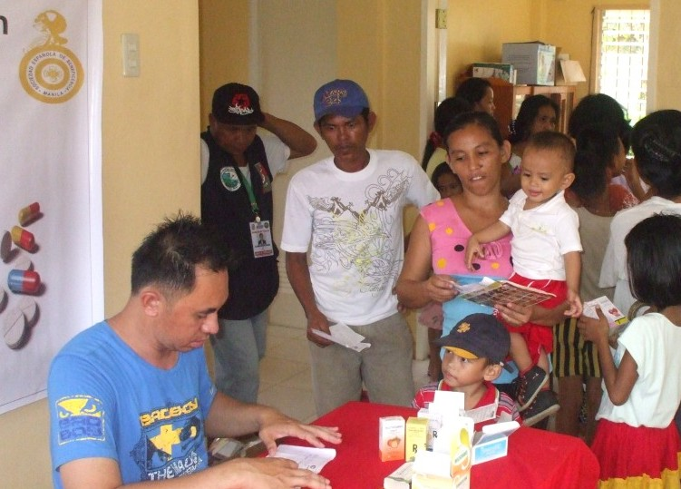
- The joint medical mission accommodated some 338 young and elderly beneficiaries who experience varied health issues, including respiratory ailments.
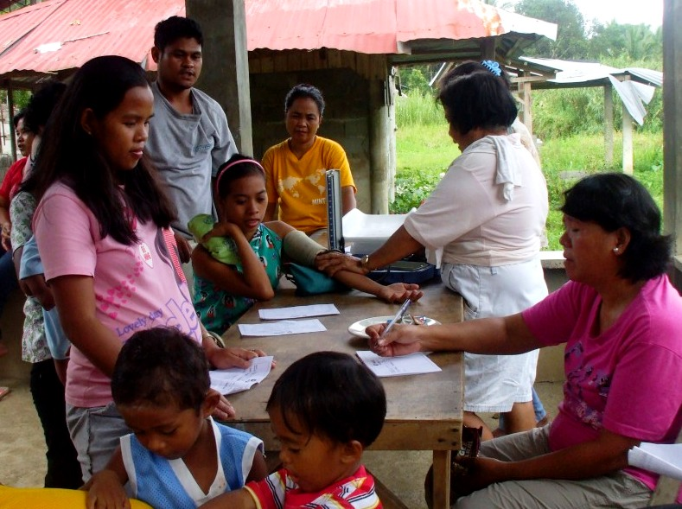
- Barangay health workers keeping up with the number of community members lined up outside the health center for the medical mission.

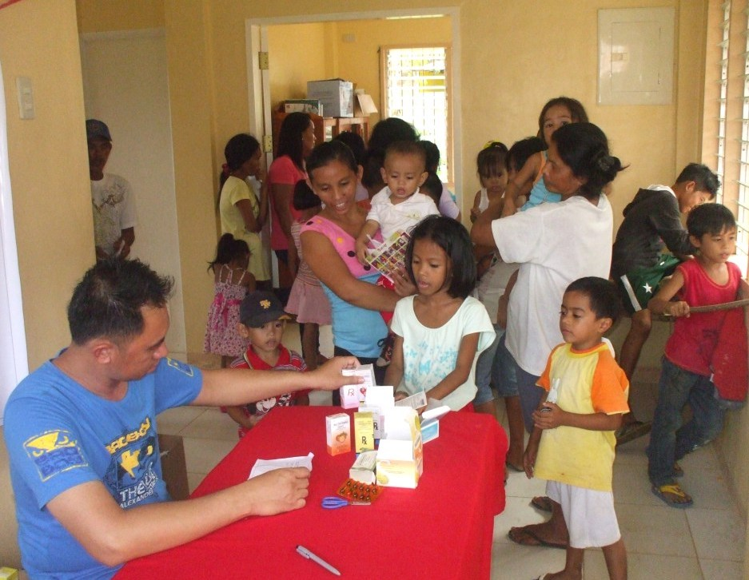
- Children, who comprise over 50 percent of the beneficiaries, head over to get their free medicines and vitamins at the dispensing area.

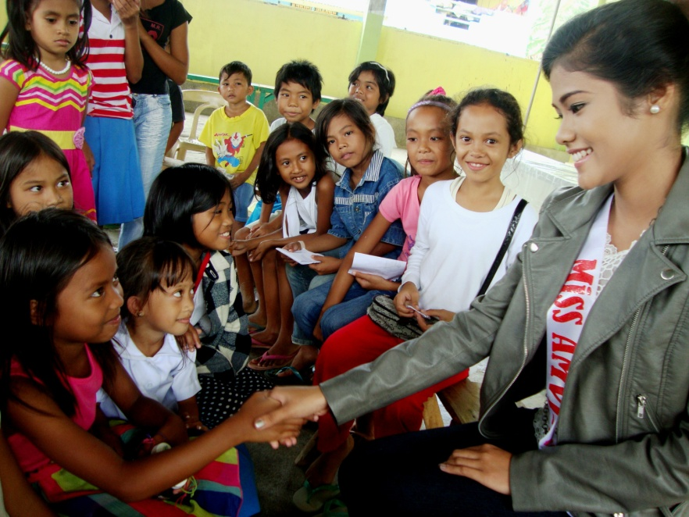
- Miss Tubay and concurrent Agata Goodwill Ambassador, Maritoni Catapang, lent a hand during the previous medical mission in Tubay. Children comprised over 50 percent of the beneficiaries.

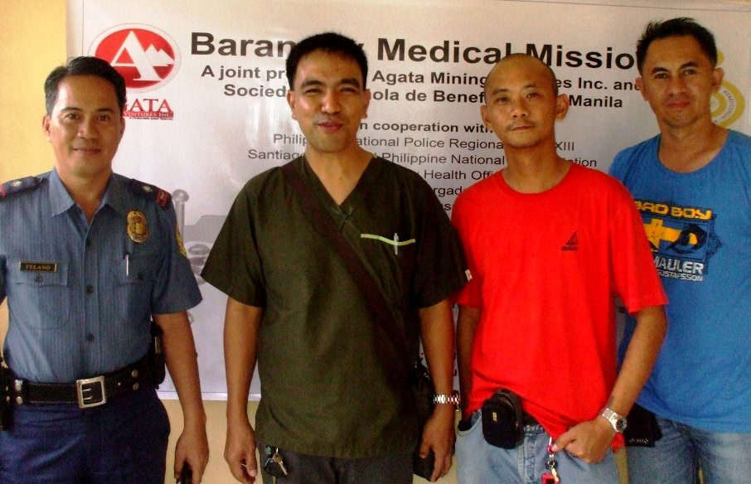
- (From L to R): Santiago PNP Chief Ernesto Telano, PNP Medical Dr. Ritche Lou Palma, AMVI Corporate Communications Staff Luigi Figueroa and a PNP security escort conclude a successful medical mission to Brgy. E. Morgado.

About TVI in the Philippines
TVI Resource Development Philippines Inc. (“TVIRD”), is the local affiliate of TVI Pacific Inc. (TSX: TVI), a publicly-listed Canadian mining company focused on the exploration, development and production of precious and base metals from district-scale, large-system, high-margin projects located in the Philippines. Concurrent ownership of ventures is shared with partner company, Prime Resource Holdings Inc.

The commercial operations of Agata Mining Ventures Inc. (AMVI) marks the third successful mining project that TVIRD brought on-stream in the past 10 years. The company is committed to exploration and mining practices that promote transparency, responsible stewardship of the environment, and the inalienable rights to life, dignity, and sustainable development of its host communities.
www.tviphilippines.com

About Sociedad Española de Beneficencia - Manila
Sociedad Española de Beneficencia (SEB) is a private charitable institution founded in 1948. Its primary goal is to protect indigent Spanish citizens and their families in the Philippines. It provides financial and healthcare assistance, hospitalization and funeral expenses, as approved by its Board of Trustees.

With the decline in the number of indigent Spanish citizens living in the Philippines, SEB has broadened its scope towards improving the living conditions of disadvantaged Filipino children and elderly across the country.

http://www.sociedadespanoladebeneficencia.org

Contact:

Kaycee Crisostomo
Corporate Communications Director
TVI Resource Development Philippines Inc.

Email: kaycee.crisostomo@tvipacific.com.ph
Phone: +63 2 728-8491 ext. 103
Mobile: +63 917 579-1528
Fax: +63 2 728-8515

